
MALDON DIVISION MONTHLY UPDATE – COUNCILLOR JANE FLEMING

CHANGES TO BUS TIMETABLES
The latest copy of Bus Passenger News provides upcoming timetable changes. The next set of timetable changes take place on: Sunday 20 April 2025.
Bus Passenger News
RECYCLING CENTRE ROUND-UP
There have been lots of exciting changes at recycling centres recently, with new services and improvements to sites.
For example, Witham recycling centre has supplied residents and community groups with donated paint.
From medical equipment collection at Clacton to Colchester Recycling Centre’s revamp, Essex County Council have rounded up all the essential facts and figures on what’s happened and what’s still to come. Read more on the website to stay updated on these developments.

SHIELD PARTNERSHIP
Essex County Council is proud to be a partner on Ofgem Strategic Innovation Funded project SHIELD (Smart Heat and Intelligent Energy in Low Income Districts).
SHIELD is a bold new initiative aimed at making the Net Zero transition accessible to low-income residents of social housing and other tenures who cannot afford Low Carbon Technologies (LCTs). SHIELD utilises innovative solutions, including distributed data centres for heating, PV and battery storage to intelligently balance supply and demand.
This innovative approach to decarbonisation seeks to address the debilitating issues faced by those who live in fuel poverty, helping to reduce both the upfront and running costs of consumers’ heating and energy. SHIELD provides a path to decarbonisation for all, which would otherwise be out of reach.
The project will last for four years and is delivered by a partnership led by UK Power Networks. Other partners include Citizens Advice Essex, Eastlight Community Homes and a range of other organisations with technical, business model and engagement expertise.

GIVING A NEW HOME TO PRE-LOVED ELECTRICAL APPLIANCES
At ten of our recycling centres in Essex, the Lighthouse Furniture Project is hard at work preventing large electrical appliances from going to waste.
Through our partnership, Lighthouse engineers repair and refurbish reusable appliances dropped off at these centres. These items are then passed on or sold at a discounted rate to those in need.
By working together, pre-loved items can stay in use for longer, benefiting both the environment and our community.
Visit our website to find out more about the project, what items are collected, and which recycling centres participate in the scheme.

SCRAP IT FLY TIPPING CAMPAIGN
Last month, Essex County Council launched the SCRAP fly tipping campaign to tackle fly tipping across Essex.
In 2022-23, 60% of fly tips in Essex contained household waste. It's crucial to dispose of your rubbish responsibly. Here are some options for getting rid of items you no longer want:
- Donate good quality items to local furniture projects or charity shops
- Try out Freegle and give away your pre-loved stuff within your community
- Use your council’s large item collection service for bulky household goods
- Check out LoveJunk - an online marketplace to find licensed waste carriers. Use the promo code ESSEX10 for £10 off your first collection
- Take items to your local recycling centre
We all hate fly tipping littering our roads and countryside, and unfortunately, illegal waste operators target everyone from householders to big businesses, with offers of cheap waste disposal.
So next time you have something to get rid of, that can't be reused, remember to follow the S.C.R.A.P. code:
· SUSPECT all waste carriers
· CHECK their registration
· REFUSE suspicious offers
· ASK what will happen next
· PAPERWORK is YOUR proof

Look out for the SCRAP Fly Tipping campaign on social media and in your area!
For more information visit loveessex.org/flytipping

TRAVEL TRAINING
Each year, Essex County Council help thousands of young people across Essex develop the skills they need to travel safely and independently. Travel Training is more than just learning to take the bus - it’s a path to greater confidence and independence. If you or someone you know could benefit from Travel Training, visit here to learn more.

BUS SHELTER PARTNERSHIP
As part of a 10-year partnership with Clear Channel, Essex Passenger Transport are making public spaces more accessible, safe, and commuter-friendly. The latest bus shelters include:
- Seating & wheelchair space for a more inclusive experience
- Motion sensor lighting to enhance safety
- Clear timetables for seamless journeys
- One-day installations for minimal disruption

TRAVEL ESSEX JOURNEY PLANNER
In response to valuable passenger feedback, TravelEssex.co.uk has introduced several enhancements to improve your journey planning experience. New features now include:
- Live bus map toggle – A new option allows users to switch bus stop visibility on and off, offering a more flexible way to check local departure times.
- Clustered Bus Stops – Stops now cluster together at certain zoom levels for a clearer, more streamlined map view.
- Timetable improvements – Issues with trip ordering and the display of post-midnight times have been fixed.
- Route map enhancements – Users can now zoom and pan more freely along TravelEssex routes on mobile, tablet, and desktop.
- Expanded Social Media Links – In addition to ‘X’ (formerly Twitter), TravelEssex now features Facebook and Instagram icons for easier access to updates.
EARLY EDUCATION ENTITLEMENT
From September 2025, eligible working parents will be entitled to up to 30 hours of childcare per week term time or up to 1,140 hours if it is accessed all year round. Funding can be accessed from the term after your child turns 9-months-old up to school age.
If you are already accessing 15 hours of Funded Early Education Entitlement (FEEE) and are planning to increase to 30 hours, please talk to your childcare provider. Read more about upcoming changes to accessing early years and childcare places.

ACTIVE ESSEX
Visit Find Your Active's Activity Finder to search for opportunities to help you get moving for free or at a low cost in your area.

ESSEX ACTIVATE
Across Essex and Thurrock, more than 200 fun and exciting clubs will be offering free activities for eligible school aged children, helping to keep them active and engaged during the holidays.
If your child receives pupil premium or income related free school meals, check your emails for your Holiday Activities voucher code, to book free spaces at local holiday camps.
Easter holiday clubs with Essex ActivAte are now live to book.

COMMUNITY SUPERMARKETS IN ESSEX
Residents can now shop cheaper essentials at our two new community supermarket sites. Fresh food and cupboard essentials are available at cheaper prices than big supermarkets. We’re bringing at least one community supermarket to each district in Essex. Find your nearest community supermarket.

LOVE JUNK
There are so many ways to get rid of things we no longer need or want. You can donate to charity, give things away, use the recycling centre, or book your council’s large item collection service. But what if they can’t take it?
Essex County Council have partnered with LoveJunk, an online marketplace that connects you with licensed waste collectors. It’s a great option for things that your local council can’t collect. The best part is that 98% of collections are reused or recycled.
Just follow these simple steps:
- take a photo and post your job
- choose the best quote
- enter promo code ESSEX10 for £10 off your first collection
- pay after removal
Got unwanted items to get rid of?
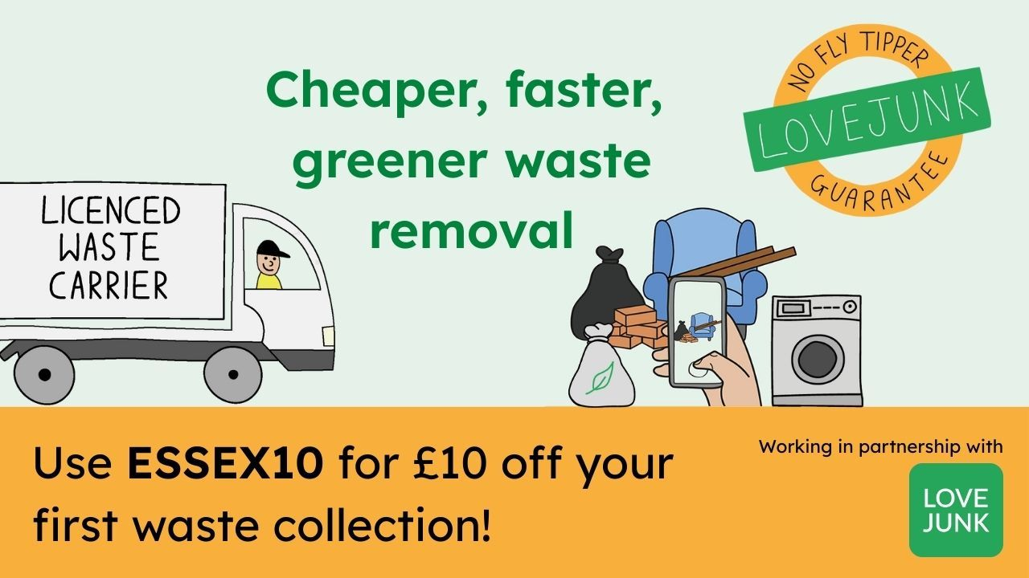

SUMMER READING CHALLENGE
We’re looking for volunteers to help us run our annual Summer Reading Challenge, a fun activity that takes place through the summer break to encourage children to keep reading during the holidays. This year’s theme is Story Garden.
If you – or someone you know - is looking for something interesting and fun to do over the summer, this is the perfect opportunity!

ESSEX BOOK FESTIVAL IN JUNE
Library events are taking place at Basildon, Billericay, Chelmsford, Frinton, Maldon, Shenfield and Witham.
Essex Library Service will be hosting seven fantastic authors as part of the Essex Book Festival in June. We’ll announce the line-up on Thursday 3 April when the festival box office opens. Find more information about Essex Book Festival online.

HELP ACCESSING NHS ONLINE ACCOUNT AT THE LIBRARY
Would you, or someone you know, like help accessing your online NHS account?
Come along to one of our free help sessions, where we’ll guide you through how to use the NHS app’s features, such as viewing your GP records, ordering your own repeat prescriptions, and more!
We can help you access your health in the NHS app, or their online page, using your own device, or our library computers.
Drop into your local library to find out when your sessions are, or find them on our website.
Find an NHS help session near you.
STARTING SCHOOL BAG
At Essex Library Service, we want to help your child prepare for the big step into school life. Thanks to an initiative supported by Essex Year of Numbers, TLC, ACL Essex, and the Child and Family Wellbeing Service, you can borrow a Starting School bag at participating Essex libraries.
Each book bag contains a carefully selected collection of books designed to help families talk about and prepare for starting school. Inside, parents and children will find:
• Three engaging stories about starting school, helping children understand what to expect.
• A book celebrating the joy of reading, encouraging a lifelong love of books.
• A fun-filled story about numbers, supporting early numeracy skills in a playful way.
• A book for parents, offering guidance and tips on helping their child transition smoothly into school life.

Reserve a Starting School Bag.

ESSEX COMMUNITY ENERGY GROUPS – EMPOWER MALDON
Communities are stepping up, collaborating, and creating innovative pathways towards a sustainable future. Empower Maldon has officially submitted its incorporation application to become a Community Benefit Society (CBS). This milestone represents a significant step towards creating a more resilient, community-focused energy future. Essex County Council’s Energy and Low Carbon team has been working closely with members of Empower Maldon to organise a community-led energy planning workshop.
GREATER ESSEX DEVOLUTION CONSULTATION
The UK government’s Greater Essex Devolution Consultation closed on the 13^{th of} April. The consultation sought views on the proposal to form a Mayoral Combined County Authority for Greater Essex – the area represented by Essex County Council, Southend-on-Sea City Council and Thurrock Council.
The consultation invited those who live and work across Greater Essex to share their views on:
- the proposed geography
- the effect of establishing a Mayoral Combined County Authority in Greater Essex
- how the Mayoral Combined County Authority will make decisions
Essex County Council launched the 'Devolution Explained' campaign to support residents in completing the UK government's consultation.
Devolution is the transfer of powers and funding from UK government to a more local level – in our case, this would be a Mayoral Combined County Authority. It is important, because it means decisions are made closer to the local people, communities and businesses they affect.
A Mayoral Combined County Authority (MCCA) is a body that enables two or more county councils or unitary councils to work together and make decisions on issues which affect the whole county. The MCCA would have a directly elected Mayor, who would chair the combined authority and oversee decisions for Greater Essex. Watch the short video about Greater Essex devolution.
Devolution aims to improve public services and the local economy. It means decisions are made by people who understand our county best. This change could allow Greater Essex to have more control over key decisions, leading to:
- better transport coordination
- smarter spending on adult education, jobs and skills
- more strategic planning for healthcare, housing and public services

