Evesham 18 May
We will have a brief coffee/loo/change of footwear stop on the outskirts of Evesham. The coach will then drop us near the Almonry which is the town’s museum and tourist information centre, adjacent to Abbey Park. The Almonry, two churches, bell tower and cloister arch are all that remain of what was reportedly the third largest abbey in England. A medieval fair will be taking place in the Abbey Park so it will be very busy, keep together unless you’re planning to stay in town rather than come on the walk. Leaflets for self-guided walks are available in the TIC.
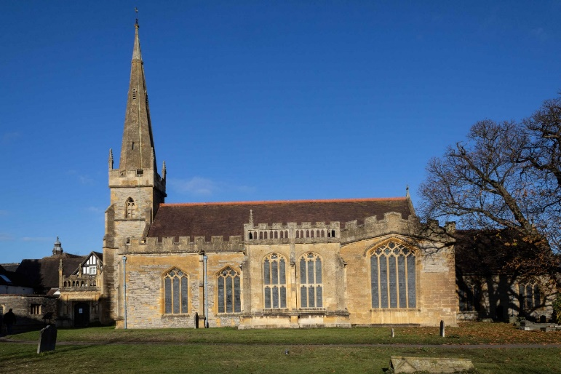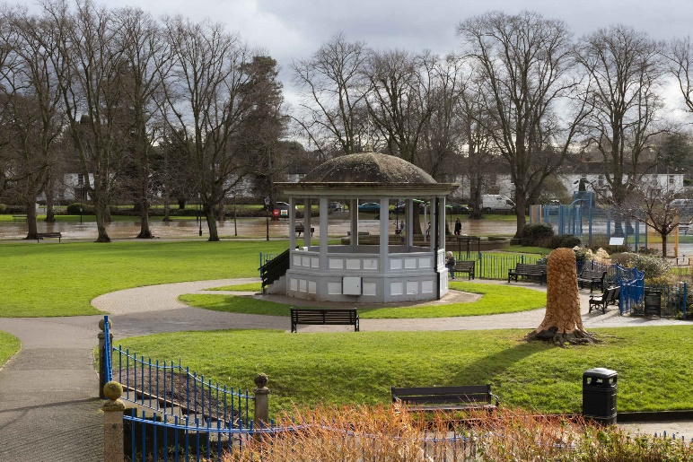
All Saints Church Abbey Park
We will walk alongside the River Avon as it loops round the south end of the town. See Round Evesham Walk leaflet for details of some of the points of interest.
The path starts as a hard surface but changes to grass so will be muddy/slippery after wet weather. Waterproof boots/wellingtons/walking poles advised. There will be a few short slopes but not strenuous. Two busy roads to cross.
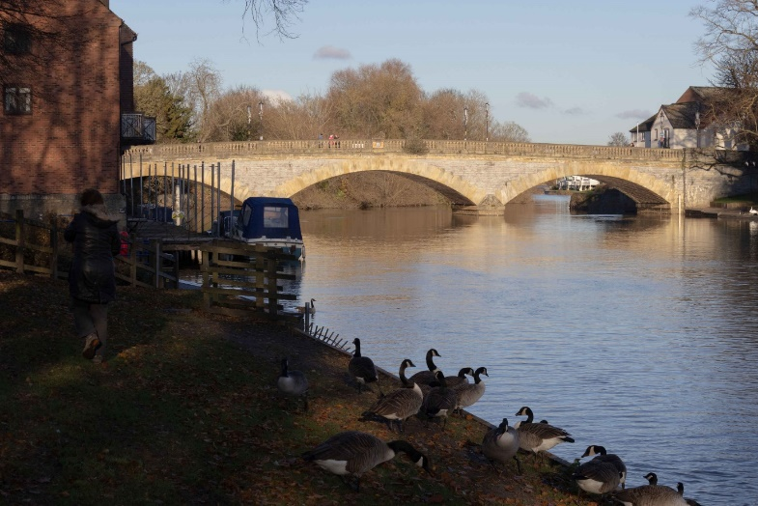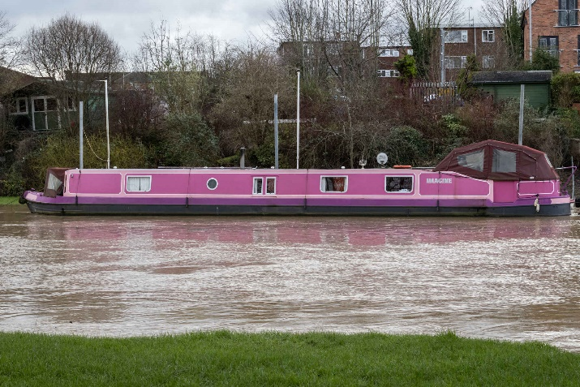
Workman Bridge Messing about on the river
Our halfway stop will be close to the site of the Battle of Evesham (4th August 1265) where Simon de Montfort was defeated by the future King Edward I leading the forces of his father Ing Henry III. De Montfort and his baron allies were trying to force the king to rule with a council of barons rather than just his favourites.
Return to Almonry by 1-1.30. Packed lunch in Abbey Park (or wherever space can be found, allowing for the medieval fair). Loos available.

In the afternoon the coach will take us to Evesham Country Park north of the town for a short walk (3 miles at most) along another section of the river. (Northernmost section of Evesham Country Park Walk 1, but in reverse order.) Alternatively you can stay in The Valley shopping centre which is adjacent to the coach park, and admire the Valley Railway Adventure (miniature railway) https://www.valleyrailwayadventure.co.uk/ adjacent to the Valley. Again, it’s likely to be muddy and there are some short steep slippery sections. Leave for home around 5pm.
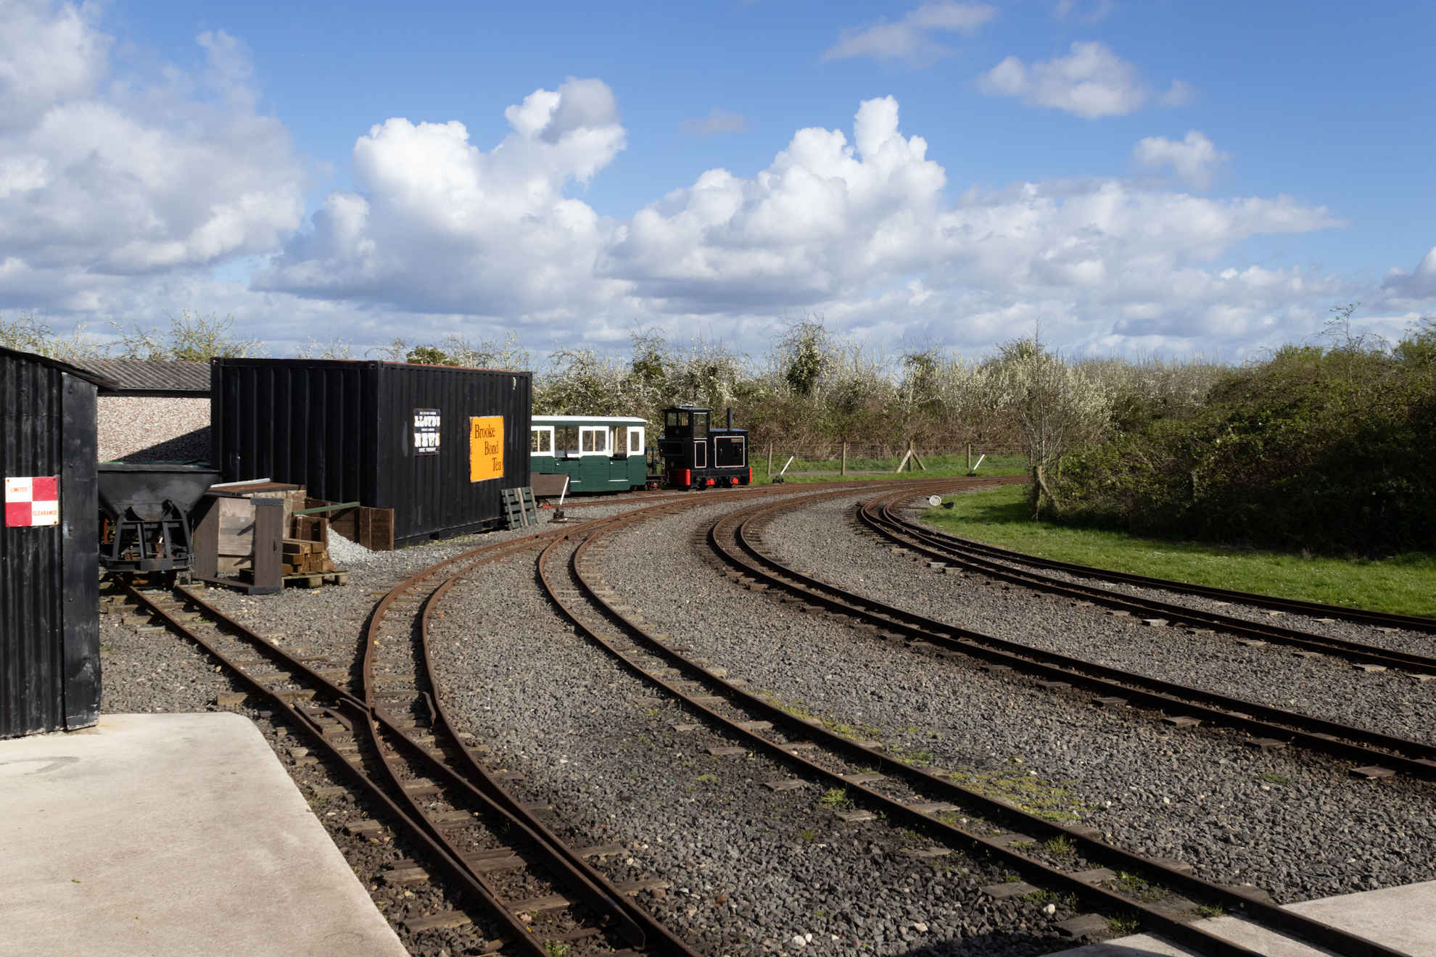
Valley Railway Adventure
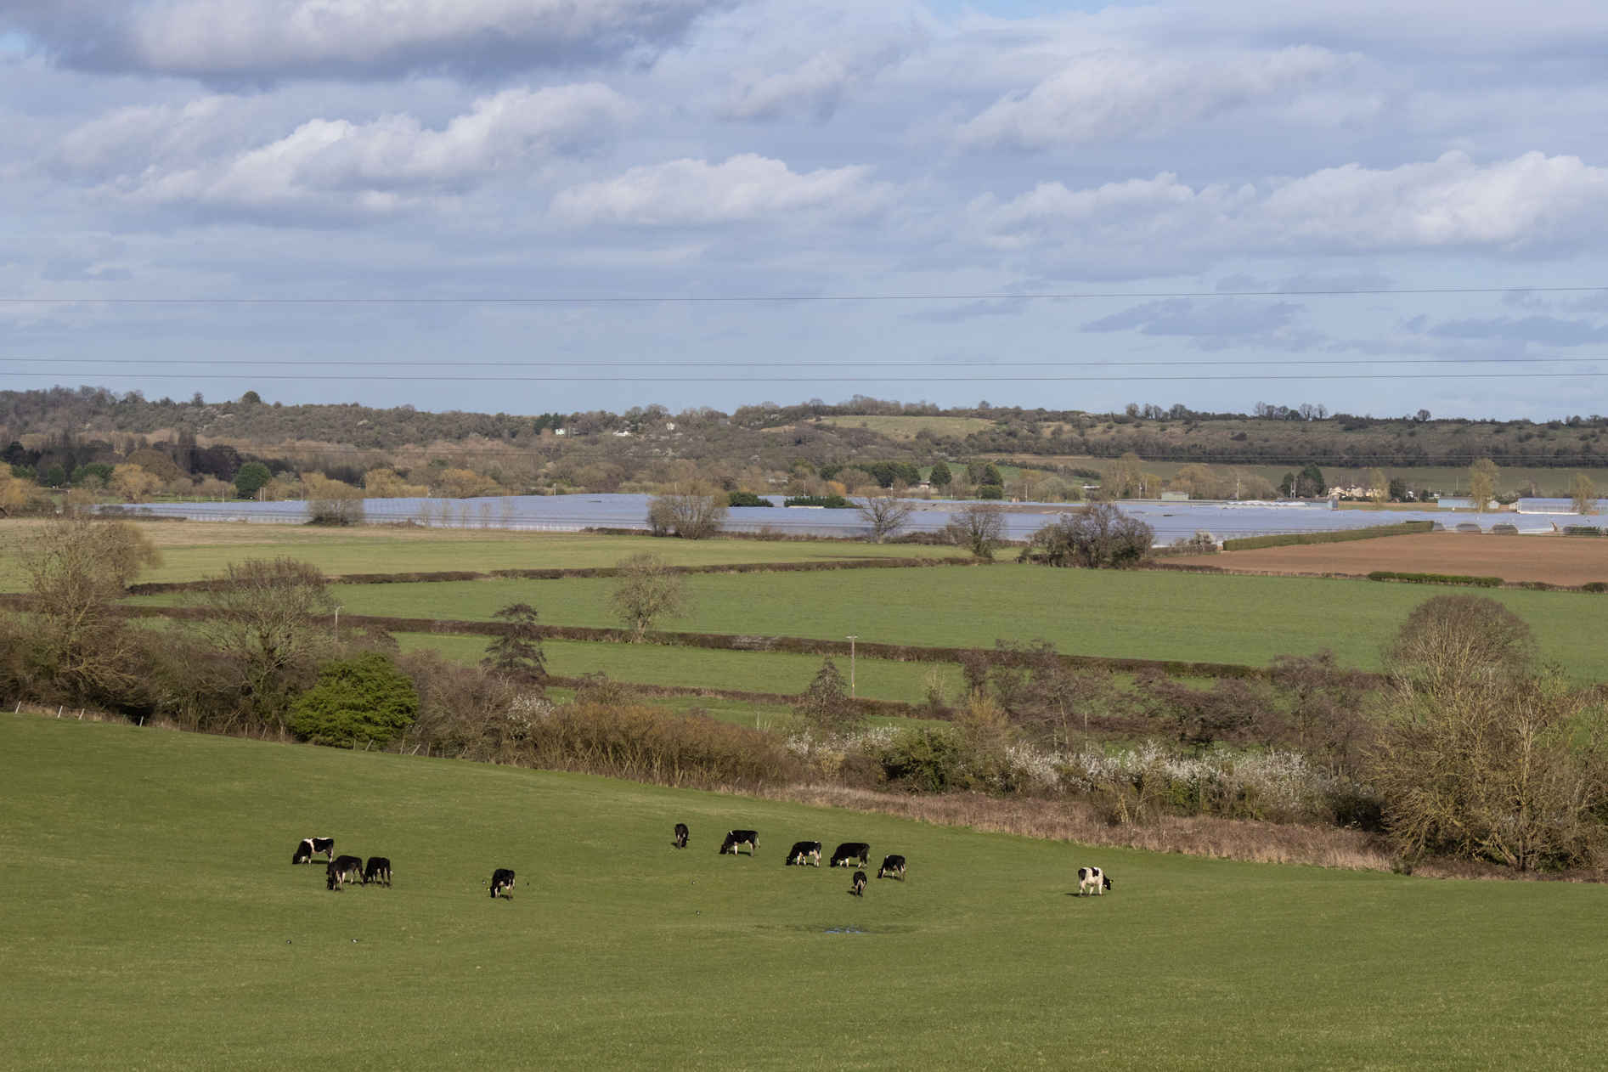
View from country park Photos © John O’Dwyer

