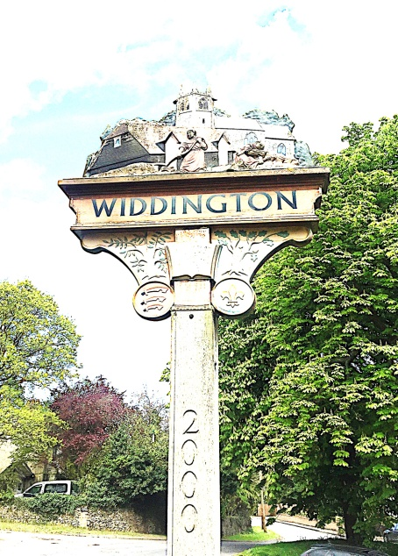

WIDDINGTON NEEDS AN ADDITIONAL PARISH COUNCILLOR
No experience is necessary
The work is voluntary
Our clerk is paid, and does most of the administration
We divide responsibility for village matters between us

WE HELP TO RUN OUR VILLAGE AND MAKE DECISIONS THAT AFFECT OUR COMMUNITY
We have a say in what goes on in the village and we try to represent everyone
Therefore, we welcome everyone as we want diversity

PARISH COUNCILLORS NEED TO BE

Over 18
An elector
and
Have been a resident or worked in Widdington or within 3 miles of its parish for the last 12 months

WE MEET
11 times a year
on the first Thursday in the month
at 8pm
in the village hall
Our meetings usually last about 90 minutes
Additionally, we spend about 4-6 hours each month on Parish Council business

If you are interested please contact Amanda Lindsell
on
clerk.widdington.pc@gmail.com
or
01799 542569

