Meeting Sunday 29th May 2022

Present:

P Bryan (Chair) , John Grimshaw (Secretary) , Gill Turner (Treasurer) Margaret Townsend (Wildlife Officer), , Karen Carr, Kim Gray, Simon Gray, T Rixon

Apologies: Dennis Murray (Poultry), Barry Morton (Plot Allocation)

Note: T Kenyon has opted to leave the committee and presented such at the meeting – we wish her well on her plot!

This is the last meeting whereby officers only discuss sensitive issues before it is open to other non-executive members- however as a prelude to future meetings all committee members must ensure that sensitive information is not discussed outside of the meeting with other parties at any time and that GDPR rules are maintained.

- Plots Let / Plots vacant/ Plots vacated or terminated

Plot Number No update although one plot is not let due to unserviceable area and would require major works to being back into cultivation state.

- Individual Plot concerns / Rule breach concerns

May saw the officers of this committee conduct an initial walk around – several letters of improvement and for safety reasons sent out – records of these maintained with the tenancy sheets for the individual plot holders – these are time dated and follow the procedures being used from the present constitutional documentation / SMBC guidance.

NOTE the plot holders’ names, plots and details do not form part of the minutes for data protection reasons.

Overall the site looks good, plot holders are cultivating and the overall look is very positive – credit to those working the plots.

- Poultry plots issues

None raised by poultry rep (apologies sent with no issues to report)

- Plot holder issues (including greenhouse / shed applications)

1 shed 1 greenhouse– approved – records kept with the rent agreements. These on existing building footprints and the same sizing.

- Committee issues

NOTE: Mentioned in previous minutes and raised by persons present at this (May) meeting: the subs for the year 2021 had not been paid by the previous committee to Allotment Stockport therefore no National Society membership by default.

Neither had the rents been paid to the landlord (SMBC), the present committee , once notified immediately raised a cheque and hand delivered it to the council - there is electronic mail records from the SMBC to previous committee members in September 2021 regarding payment but this was not acted upon.

The committee officers SMBC are investigating the background to this at the present time as part of work with SMBC themselves – more below in the minutes.

- Council

SMBC is conducting various investigative routes due to the large number of complaints received regarding mostly previous committees, inconsistency, behaviours etc, the actual validity and provenance of complaints content etc and a host of other issues, some going as far back as 2012. This is leading to the trustee and the officers of the committee having to investigate previous complaints etc and work with the council (in our own time)

Due to the volume of complaints from certain parties, this is leading the council to consider rescinding the lease – where this would lead is anyone’s guess but would not be of benefit as it would dissolve the society, there would be no maintenance of things like the toilet facilities and existing funds potentially divided for local charitable reasons and the reality of Whitehill ever being self-running again would be remote – there are of course other more onerous issues that may arise from the council re-taking the lease and therefore the land rights.

Therefore it is strongly recommended that if you have issues then you use the post-box on the office to post your issue and it shall be investigated, if required, with SMBC assistance and therefore as a society we can justify that we look after the site and all that entails, including where personal details are redacted summarisation within the monthly minutes. Remember though committee members are VOLUNTEERS we do not get paid and use our own time and resources to support the processes.

Constitution

There have been several debates over which, what and who etc ratified, used or introduced the above. However this is a moot point , as there is a process of review being undertaken to ensure that the Society has a new robust version. This is being undertaken with input from both SMBC and allot Stockport. Although there are ‘off the shelf’ versions this is the one that is derived from the head lease and is ,even in the present form, the one that SMBC wish us to use (albeit updated and modernised) this will take many months to do in reality and is not an easy task – however it does not mean the society is rudderless and reference to the general governance contents for running of the site has to all intents and purposes been agreed at this time with SMBC in light of the changes proposed to structure and content going forward.

- Site wide (including site repairs / maintenance issues / work parties )

Toilet improvement, inclusion for disabled members on going, office area conversion of old garage completed and used for this meeting.

Grants are to be applied for now we are gaining planning permission and have a set of drawings for submission to support the desired outcome.

One letter received from a fellow society member regarding the disgraceful condition that the toilet was left in on one occasion recently with excrement across walls and floors as well as the toilet itself.

This has occurred on at least one more occasion – the dates and times, if such an occurrence was to recur shall be noted – although there is little that can be effectively done if persons decide to abuse the facilities. It was suggested from the floor at the meeting that a contact phone number for such things be available – this is agreed in principle, if someone would consider volunteering perhaps from the society membership to be this point of contact? - however again this is a voluntary committee, we would hope others respect facilities or if find them in this condition offer to clear the area, this goes for the site as a whole, the committee is there to assist the society in good governance and running but cannot be reasonably expected to manage this full time due to other commitments not only to their plots but also work and family and other interests.

- Expenses

Treasurer reiterated that the receipt book for petty cash transactions is readily available , especially at committee meetings to review if required. Full transparency is there should you wish to look at it. Financial report:
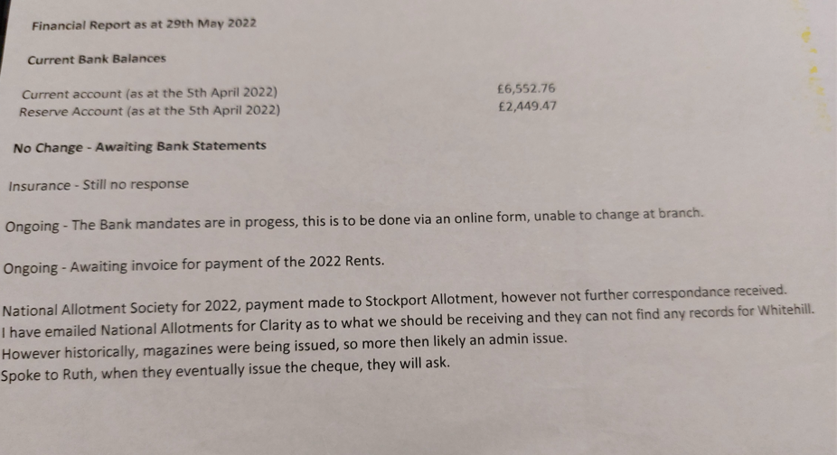

- Stores / Tool maintenance

Same as previous months entry, due to voluntary nature of the committee, no time to review and the roof needs attention on the container ASAP (as it opens out up into the heavens at the front): At this time no news to report to the members until the container is emptied and we have established what’s is of use and what isn’t! – another task ….as some might need repairs or be sent away for a service dependent on what we discover.

Some petrol is now on site stored with the machinery should anyone wish to borrow such, however at present there is no one trained and competent to give out these items to the general society members – If you would like to assist please let the committee know, via a letter in the post-box with contact details and we shall get back to you – its not a lot of work but does require heath and safety risk assessment training and instruction.

- Proposed future projects – (Improvements / Social etc)

See other agenda items as these are linked into those headings for the time being.

- AOB / Date of next meeting

Web Site There is a draft web site set up for the society
( https://e-voice.org.uk/whitehillallotmentstockport/ ) to act as a repository for information such as monthly minutes , constitution, health and safety, GDPR policy etc – although this is ‘fledgling stage’ at the moment one of the committees has agreed to look at it – ACTION JG to forward TR details as acting IT guru!.

Talk of a non-internet laptop being made available to use for constitutional advancement work – this would need careful consideration as mention of using memory sticks etc came into the conversation and therefore this entails virus protection for all. Something for further discussion.

ACTION: KC and TR where to look at the possibility of old laptop and power bank. Further discussion next meting

Manure on site: The SMBC has discussed storage of manures on site and following the 2018 legal changes, this is now not possible as was historically at the two areas allocated. This is because manure cannot be stockpiled within 50m of any water course , drain or spring. The site is riddled with springs , drains and a flowing stream that runs across the site underground. Therefore you can get some in and spread it about on your plot etc but not store in bulk for any extended period. Bagged manure does not come into this, if it is bagged of course.

Policy / Procedures, due to the ongoing constitution rewrite – there has arisen the need for more policies and procedures – this need drafting and discussion at executive level as well as possible presentation to the membership once consolidated.

ACTION:

MT – Wildlife policy for the Society
KG/ MT – other polices such as bullying, harassment etc in line with National guidance documents

Wildlife / conservations area – This is now to be looked along with guidance from Cheshire wildlife trust

ACTION: MT to lead this project and suggested a subcommittee – MT to advise on members of subcommittee and what this is to entail over the coming meetings as part of wildlife officer remit.

Committee only communication platform /Society members info platform

To aid in comms it was suggested that a committee only info sharing platform be created – also that a society Facebook page be also created – ACTION KG to review and suggest ways forward

POST MEETING NOTE :Not all members wish to use or have access to this type of ‘electronic’ facility so this must be borne in mind and access must be open to all, passwords for moderators / owners must be shared amongst the committee so that if there are any changes this can be altered ,amended etc to provide longevity and ensure ownership to the society not to individuals.

Next Meeting Sunday 26th June 2022

10.00 AM committee office

