Meeting Sunday 27th March 2022

Present:

John Grimshaw (secretary) , Margaret Townsend, P Bryan (Chair), Gill Turner (Treasurer) , Barry Morton (Plot Allocation ), Karen Carr, Kim Gray, Simon Gray, T Rixon

Apologies: Dennis Murray (Poultry), Tracy Kenyon

The meeting was in two parts the minutes reflect collective information. Initial meeting is for officers of the committee and is to protect GDPR sensitive information should it arise – Chair, Treasurer , Secretary , plot allocation officers acting in these roles. Second session (10.30 onwards) General members of the committee / support officers.

- Plots Let / Plots vacant/ Plots vacated or terminated

Plot Number 19 let out in the interim period between meetings. 49 and 6B available but in poor state.

- Individual Plot concerns / Rule breach concerns

No walk round this month – this will start late April to allow for growing to commence to see who is on and who is not using their plots to the society’s benefit / rules etc. No rule beaches brought to the attention of the committee via post-box or other means

- Poultry plots issues

None raised by poultry rep (apologies sent with no issues to report)

- Plot holder issues (including greenhouse / shed applications)

1 shed 1 greenhouse plots 9a and 38 respectively – approved – records kept with the rent agreements

- Committee issues

1A raised concerns again over DEFRA / Bird flu containment of poultry (letter 5/2/22) Committee stated that the DEFRA guidance is quite clear on the matter and poultry plot holders must follow this advice, the committee is not a ‘police force’ although they would chat to poultry members about using the advice. Poultry plot holders are expected to adhere to DEFRA guidance and talk to neighbouring plots if they feel there is an issue as a member of the society...

- Council

Chair has been in touch with SMBC over planning permission for toilet improvement project – still awaiting answers – process going ahead and architects’ drawings being sourced for this and the hut refurbishment.

The committee had received communication that the previous committee had been contacted in September for rent settlement & subsequently had not settled the 2021 rent account, this has been rectified within a week of notification from SMBC and cheque hand delivered to SMBC for payment.

The 2022 rents are awaiting a final invoice and shall be attended to swiftly to ensure the above does not occur again.

SMAGA (as was) invoice received in process of being paid – this also includes ‘national’ subs and after repeated requests from one member the code for the website will be made aware to members on the noticeboard as soon this has been received.

NOTE: Again the subs for the year 2021 had not been paid by the previous committee and therefore careful negotiation is required with SMAGA.

- Site wide (including site repairs / maintenance issues / work parties )

Toilet improvement , inclusion for disabled members on going, office area conversion of old garage progressing.

ACTION: Chair requested volunteers in advance once we are established for the office paint out to brighten the interior.

Notice Board – refurbishment pending - new lock, new easy to pin on backboard – this will be the central communication area for site wide society information due to its proximity to the main entrance.

NOTE: As with all projects on site there shall be notices posted on the board at the entrance asking for volunteers in good time before needed going forwards into 2022 for any work group.

- Expenses

Treasurer reiterated that the receipt book for petty cash transactions is readily available , especially at committee meetings to review if required. Full transparency is there should you wish to look at it. Financial report:

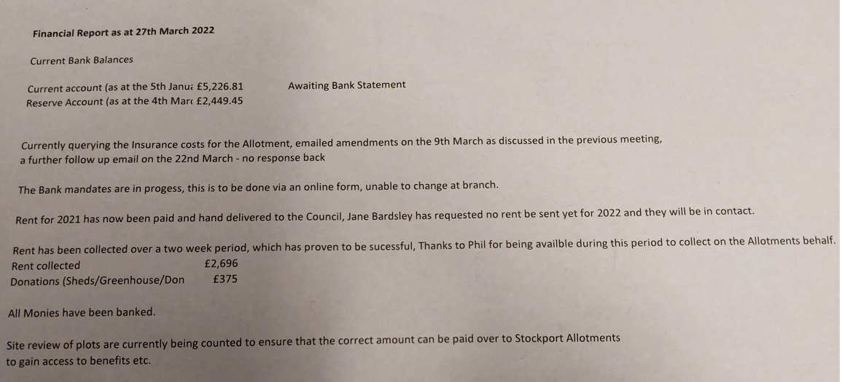

- Stores / Tool maintenance

Same as previous month entry due to voluntary nature of the committee no time to review and the roof needs attention on the container ASAP as it opens out up into the heavens at the front.: At this time no news to report to the members until the container is emptied and we have established what’s is of use and what isn’t! – another task as some might need repairs or be sent away for a service dependent on what we discover.

- Proposed future projects – (Improvements / Social etc)

See other agenda items as these are linked into those headings for the time being.

- AOB / Date of next meeting

Beekeeper has come on board after the sad news that the previous one had passed away. They shall be starting in earnest in around late May into July. They are to be charged ½ rent for the plot for 2022 to allow for demonstrable commitment to maintaining the area. Good news for late crop pollination!

KG raised a subject regarding site rules and which are the ones applied to the site. Committee confirm that the rules that apply are the ones contained in the ratified 2006 Constitution.

KG then raised that the tenancy agreement (councils ’Head Lease’ version) should also be a signatory document copy potentially given to all potholders.

Committee stated that this has never been the case on site and would seek clarity, however taking this on board.

KG also then wished to discuss GDPR and applicability and application with regards members information, if there is a GDPR statement and how this is communicated etc. Committee stated at present the details were stored securely off site in a safe until such time as the office can be made secure and the information transferred to there.

NOTE: It was raised from the floor over the direction questions take during the meeting from previous members of the past committee in 2021 and prior to that.

It is three months into this committee’s tenure and therefore issues should have been raised earlier if they pose questions as to the running of the site and if these were critical to running of the society. If so why have these not been addressed by those parties previously during their tenure?

The present committee is liaising fully with SMBC & allotment Stockport having now established strong working relationships with the contacts for those organisations on an open basis, ensuring that rules , regs and consultation are ‘as should be’ and naturally gathering support for the society…Strengthening bonds and looking for improvement opportunities.

NOTE: If members of the wider committee , or even the Society in general have issues then please raise them in a constructively critical manner , research pragmatic and pro-active measures that can be taken to mitigate, address and remove the issue and provide such to the meeting. The committee as officers are dealing with lots of items and areas and this would assist and substantiate areas of improvement and illustrate that concerns are not just raised without aforethought to actions needed to facilitate removal.

Additional information (from discussions at the meeting):

Development Projects for the site and Society membership

The floor discussed projects, how the society can progress them, communication of plans as well as opportunity for representations as members of the society to external parties on behalf of Whitehill Allotments Society as an organisation.

For clarification any project that involves the site, society and its membership must have a plan submitted to the Committee officers for discussion , this is no more onerous than doing so for shed / greenhouse applications. This ensure that the society is not involved in contacting the same organisations on multiple applications for grants, expertise or missing opportunities and that representations are made in full and open transparency of what is involved therefore not harming the Society , its name, reputation or members.

The project plan is simple enough and should detail the following:

The project title(s)
The project aims and objectives
The number of persons required to complete / involved and name / plot number
Costs – materials , hiring, sub-contracting, machinery (itemised)
Duration and expected timescales (including timescale to delivery if applicable)
Outside resources required
Outside grant funding streams to be approached (on approval)
Outside organisations contacted for expertise and input
Impact / benefits on society members
Health and Safety risk assessment of processes , areas, activities involved (where applicable)

Other important information (drawings , sketches, support material not mentioned elsewhere etc)

Next Meeting Sunday 24th April 2022

10.00 - 10.30 Officers of the committee (including potential site walk round)
10.30 -11.00 General committee members – location site hut

