Minutes were made available to be handed out during the Walk around on the 11th September 2022 @ 10.30am, where is was agreed that Committee members meet to discuss a certain plot (Plot 51), as a termination letter is to be issued and committee members need to ensure that all documentation has been issued and timeframes given as set out in the rules/Constitution)

Whitehill Allotment Society Minutes
31st July 2022

Present
Phil Bryan, Simon Gray, Karen Carr, Gill Turner, Kim Gray, Terence Rixon, John Grimshaw, Barry Nixon (Late Attendance)
Apologies ? To be confirmed, Signing in sheets don’t show Margaret or Barry signing in
Margaret Townsend (Attended Late?)

Minutes from June 2022 read through, amendments discussed and altered to be represented at the next meeting.
The Next meeting will be on the 25th September 2022 due to Holiday Commitments and Bank holiday.

Minutes from the previous meeting of June discussed and alterations made.
Please make further changes as required and as Gill typed them up and has access to these on her PC, please leave any further amendments in the greenhouse on Plot 44.
Gill agreed to take minutes on behalf of John as she took the previous minutes in June and was fully aware of the Action Points, agreed prior to the meeting starting.
Kimberley Gray pointed out that that Dennis Murray (Poultry Rep) be removed from the committee as he has missed three Committee Meetings. It was agreed for a letter to be sent to Dennis thanking him for his time and guidance. Action 1
Phil also requested it be noted that Jackie resigned with immediate effect as Grants Officer. It was agreed that a letter be sent to Jackie thanking her for her time and guidance. Action 2

1)Plots
Plot Allocator not Present at time of point 1 on the agenda
2) Individual Plot Concerns –
None
3) Poultry Plot Issues
None
4) Site Wide (Including Site Repairs/Maintenance Issues)
Discussion of Manure to be stored on site.
Ongoing, Previous drops of manure were dropped with no Trade waste license and nowhere to stored as previous location is right by the Ponds and running waters. Simon said that there wasn’t any waterways, but it was said that you hear the running water in the drain by the side.
It was said that personal drops were fine, but nothing on the main site in communal areas until information could be clarified as proper standing ground with a run off tank would need to be installed.
Plots in need of improvements, Kim and Simon carried out their own site inspection and provided a list of plots in their opinion that were needed to be looked at during the next walk around.
All Committee members invited for the next walk around. Initial discussion for Phil, Gill, Karen and Simon to complete (Action 3)
5) Council
The Committee have been invited to a meeting with the Council and Stockport Allotments on 16th August 2022. This is to discuss the Issues raised and the Councils findings to the investigation.
6) Plot Holder issues/Shed Applications
Simon Gray is intending to put an application in, Greenhouse arrived at site, yet to be glazed and application to be submitted.
7) Committee Issues
Chairman advised that a letter of complaint has been received against a committee member and that as the complaint has come from another committee member, then he was unable to deal with this and this would have to be passed to the trustee.
8)

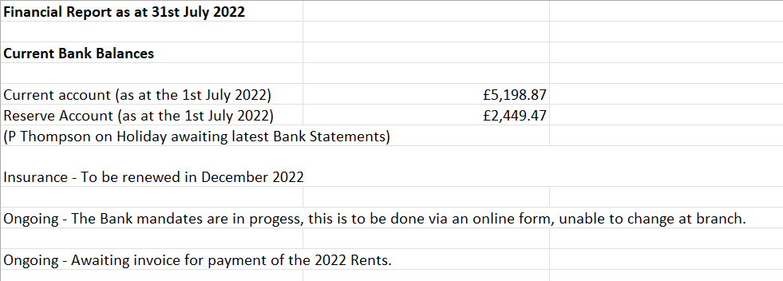
Finances – Kimberley Gray requested to see the finances in a letter addressed to ‘Officers of the Committee’, including bank statements, Petty cash receipts. Information provided after the meeting no questions arose.

9) Tools
Simon has carried out an inventory of the Tools shed, and Thanked Karen and Kim for assisting and marked each item with a sticker. Inventory list to be provided and explanation of the stickers/barcodes Action 6
10) Proposed future plans
Toilet area showed to committee members, plans to be reprinted and chase up council to confirm in planning permission has been granted.
Wildlife area, information still to be provided to Committee
11) AOB/ Date of next meeting
25th September 2022, no meeting in August due to Holidays.

Actions Carried forward from Previous Minutes still ongoing/Outstanding
New Actions from July’s meeting
Action 1 & 2 Letters to be issued to Dennis and Jackie thanking them for their time and guidance (GT to complete)
Action 3 – Walk around to be carried out. Time and date agreed.
Action 4 – Simon to provide an inventory of the Tools and explanation regarding the stickers and how they are to work so that tools can be let. Tool box talk needs to be discussed and demonstration to committee. Terrance has agreed to help Simon put this online
Outstanding Items from Previous Meetings.
Action 5– Letters to be looked at, Committee members think that the letters are to negative. Photos to be provided in next walk around and other members of the committee should carry out the walk around for improvements or concerns. Suggestion, that two committee members in attendance on the previous walk around be joined by one other member and keep the walk around to 3 Persons.

Action 6 Website. The Council advise that an online presence would be helpful, not compulsory. Terrance has looked at the website and as it is currently an e-voice system, it is archaic and not very accessible or usable.
Action 7 Terrance to provide more information regarding costings and URL Rental yearly costs as well as security costings. Agreed for Terrance to provide information at the next meeting, nothing has yet been designed.
Action 8 Minutes are now to be approved at the next committee meeting before being issued to the notice board. Kimberley Gray has raised concerns that this is not the case and wants previous minutes revisiting and amending.
Action 9 Policies and Procedures are being looked at by Kimberley Gray and Karen Car and will work together to write and bring to the next meeting
Action 10) Kimberley to source sign for no parking
Action 11) Swop Shop needs to be agreed to close by the Committee, Plot holders need to be aware and agree to this. be agreed at the next meeting. Terrance suggested that the ‘new website when up and running have an area for swopping. It was highlighted that not all Plot holders are IT savy and would it not be best to communicate and ask around if items are in need of repurposing.
Action 12) Constitution. This is still outstanding. It was asked where this was up to and which constitution was being used. GT previously queried as in the prior meetings it was agreed that a spare laptop and power bank were to be brought onsite after the committee meetings to work on as collective. Kimberley Stated that she was already working on this.
Stockport Allotments and Stockport council have already added their input to the constitution, which is the constitution that has been ratified previously due to lack of information from historical committees.
It was agreed that a final date of September 2022 and as a group effort to finalise the constitution before being present to plot holders for final agreement and sign off.

Action 13) It has been raised that people are not aware of people on the committee and their location of plots.
List to be provided on the notice board for information – Who is going to complete this ?

