Meeting Sunday 27th February 2022

Present:

Karen Carr, Barry Morton, Tracy Kenyon, Kim Gray, Simon Gray, P Bryan, Gill Turner, John Grimshaw, Margaret Townsend

Apologies: Dennis Murray (Poultry)

The meeting was in two parts the minutes reflect collective information. Initial meeting is for officers of the committee – Chair, Treasurer , Secretary , plot allocation officers acting in these roles. Second session (10.30 onwards) General members of the committee / support officers.

- Plots Let / Plots vacant/ Plots vacated or terminated

4 plots let, no vacant plots on site

- Individual Plot concerns / Rule breach concerns

No walk round this month – this will start after the rents are collected so we have full contact data and can link in with those who may go at this time. No concerns- broken glass after the recent storms has been dealt with by members in a sensible and quick manner.

- Poultry plots issues

None raised by poultry rep (apologies sent with no issues to report)

- Plot holder issues (including greenhouse / shed applications)

1 application for the refurbishment of a poultry plot – this submitted (plot 2) and agreed by the officers of the committee as it held to the SMBC specifications

- Committee issues

None of note – JG stated the forms for rental collection are now completed to aid in collection on site (more later in these minutes)

- Council

Chair has been in touch with SMBC over planning permission – do we need it? Questions for disabled toilet attachment to the member’s hut. – no response and he is still chasing this matter.

- Site wide (including site repairs / maintenance issues / work parties )

Grants being pursued for roof replacement on the members hut along with windows and internal refit to make this a more pleasant and welcoming area for our membership to use along with the voluntary societies and the possibility of schools and other organisations to use as we develop the site going forward.

Roof from the members hut to be re cycled and used for the container and the garage unit – which shall become the site ‘office’ again plans to install windows and a door and remove the swing doors and brick it up accordingly. This mean the members hut is just that – the members hut, as it was many years ago and hopefully this will foster more communication and society feeling on site.

- Expenses

No incidental or petty cash expenses in the period.

Financial report:

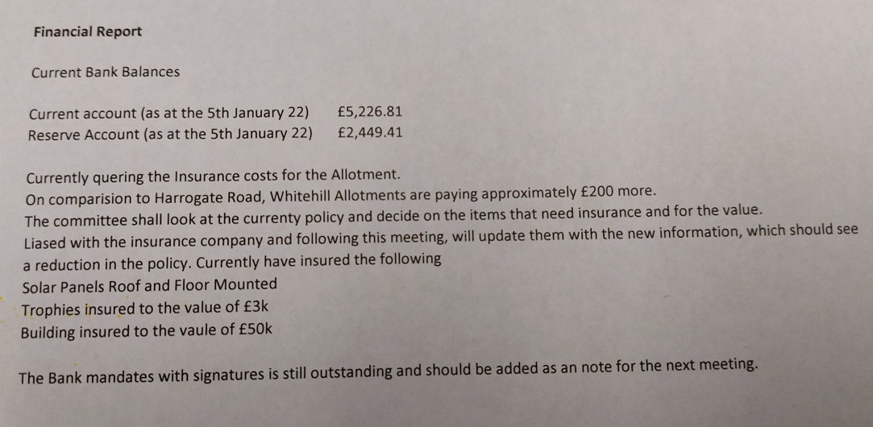

- Stores / Tool maintenance

At this time no news to report to the members until the container is emptied and we have established what’s is of use and what isn’t! – another task as some might need repairs or be sent away for a service dependent on what we discover.

- Proposed future projects – (Improvements / Social etc)

See other agenda items as these are linked into those headings for the time being.

Note the wildlife area is ‘out of bounds’ at present until such time as a survey of the safety of this can be ascertained. This does not preclude anyone from looking into ideas though! – it shall also be accessible for wheelchairs as part of the ongoing improvements. However reality is that unless members can get together to organise something this may be in 2023 with te repairs and projects needed so far.

However the side where there is a ‘neater area’ along the fence line from the Apiary, the plot holder at the end plot requested if they could keep that area tidy etc – which is no issue as long as they remain in the ‘safe zone’ in essence the proximity of the shallow reed pond area which they stated they shall.

- AOB / Date of next meeting

RENTS – This discussed – prices to be set and displayed on the site noticeboards. Collection is to from the 7th March every day for 2 weeks (including weekends) at the Chairman’s plot 43 from 9 until approx. midday (due to the office and members hut being unsuitable at this moment in time)

Again this information shall be posted on the site notice board and gates as appropriate so the membership is aware.

REMINDER: the tenancy agreement is a legally binding document and therefore the legislation and SMBC requirements are for one named tenant only for each plot allocated – it is then their responsibility to maintain the plots(s) according to the rules. Naturally close members of family etc can assist however where friends become involved the potholder must be aware that this could be misconstrued in some cases as ‘subletting’ and in the unfortunate scenario of persons ‘falling out’ it can lead to acrimonious situations – in this area the stance has to be that the signatory on the tenancy agreement is the only person the committee deal with. This however is subject to separate discussions if this does arise taking into account the facts of the individual situation.

After Q from the floor on what the money in the membership fee is for, it was stated that the membership fee is rolled into the rents itself now therefore making it one payment as such, it was also explained that the payment goes towards the items that are required on site such as memberships and insurance, improvements , contributions to grants we need to demonstrate we are capable of managing some input into these at times (dependent on the issuing agency) etc.

NOTE – the council do offer a rebate on the rents back to the site, however this is all we receive from them. The council do not budget for allotment site repairs or improvements – that is the sites responsibility. Therefore if we are to maintain our standards and improve on them as well as ensure our membership is both protected and can enjoy a reasonable site, then this is the money we have to use for these purposes in conjunction with any grants etc.

Q from the floor over access to the NAS members page, Clarification: the membership subs to both NAS and Allotment Stockport was not paid in the preceding year by the committee as was, this therefore means that access is not available at present. The Chair stated the present committee is rectifying this and as soon as any information is forthcoming NOTE: this shall be disseminated accordingly to the membership via the noticeboard.

Q from floor – the state of Bird Flu recommendations and what is applicable to the poultry section. This is an area where e the committee can only advise that the DEFRA web sites be read and information

gathered from this source by the plot holders it affects. The committee will not advise on this subject – DEFRA and government requirements must dictate what poultry plot holders’ responsibilities are.

Keys / Security – the floor debated the subject on whether to change the gates lock back to a keyed one or maintain the numerical version as at present – after much discussion no real solution agreed. This is something that may arise again and will be discussed as a set item once the subjects in other areas have been addressed.

Margaret Thompson (Plot 1a) – showed the floor and committee offices alleged side wall spiking to a tyre on her car that occurred near the wood chip area on Wednesday previously at around midday. This malicious damage has been reported to the police. Margaret again stated she was of the inclination that she is subject to malicious intentions by persons not known.

The committee STRONGLY agreed with the members present that this type of behaviour is wholly unnecessary and does not condone such actions. Any member found to have maliciously damaged another’s property , plot or other personal possessions would be subject to removal from site in line with Society rules and constitution.

AGM Sign Off – the Chair passed minutes from the AGM to previous members of the committee as was to sign as a true and accurate record as required. This was done. Copy retained by Secretary.

There was a request for a copy of the council head lease agreement from a member, this was duly supplied post meeting by the secretary. They stated it was for reference purposes.

Q from floor over ‘adding’ wildlife issues to the rules – this was not discussed at length as the rules are derived from the SMBC headlease, diluted and amended only slightly via the constitution and to change rules requires a lot of research, liaison with SMBC legal dept and Allotment Stockport etc and the ones WAS use are in line with other sites in the borough due to the uniform approach by SMBC

Next Meeting Sunday 27th March 2022

10.00 - 10.30 Officers of the committee
10.30 -11.00 General committee members – location site hut

