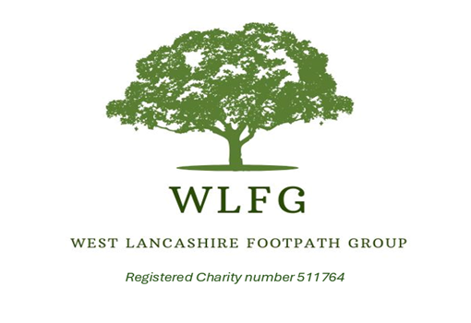
Incident Report Form
This form should be completed as soon as possible after an incident involving injury or property damage, or after a near miss.

Return the completed form to the walk leader within 24 hours of the incident, and email a copy to westlancashirefootpathgroup@gmail.com
Date of incident:

Number of participants:

Walk Leader’s name:

Leader’s e-mail address:

Leader’s contact number:

Location of incident:

Time of incident:

Description of incident and action taken:

Name of person injured or affected by the incident

D.O.B.

Is the affected person a paid-up member of the WLFG? Yes/No

E-mail address:

Contact phone no.

Details of injury, treatment and current condition (if applicable)

Details of the damage to third party property (if applicable)

Name of witness:

E-mail address: Postal address:

Contact phone No:

Additional Information:
Any further details about the incident, and how likely is a claim:

Privacy Policy:
Sensitive personal date may be collected as part of any accident reporting on a group walk or the organised event. This information may be shared with our insurance company in line with our legal and insurance obligations. When sensitive personal information is collected, we will take extra care to ensure your privacy rights are protected.

