Planning Group
County Hall
Kingston upon Thames
Surrey KT1 2DY

West Bank,
Dorking,
Surrey RH4 3DH

2nd November 2019

Your Ref: SCC Ref 2018/0037/DHB MO/2018/0640

Dear Sir,
I would like to make some comments and observations about the proposed expansion of The Priory School, Dorking and would like these comments and observations considered and taken into account before any decision is made by SCC/MVDC regarding this application.
PUPIL NUMBERS
If the proposal to increase the size of The Priory School has been based on SCC’s identified need for 300 extra school places in Dorking, please explain where these extra pupils are being schooled now, given that the number of pupils attending the school both last year and this year is well below their required PAN. If this development is allowed to progress, Surrey County Council will spend several million pounds adding extra places to a school which continues to be half empty. The school is at present 20% empty, having a total of 715 pupils out of a potential of 880. If they increase their PAN, as has been suggested, then the figures are even worse. This year (September 2019) the school’s PAN was 180, their intake is actually 107 pupils, 60% capacity.
LOCAL CHILDREN?
If the 300 extra pupils are expected to be ‘local’ where are they all living? As far as I am aware there are no major building programmes planned within walking distance of the school. This suggests that the 300 extra pupils (if they exist) will need some means of transport to the school.
CAR PARKING
There are 79 car parking spaces at the moment, on site, 4 will be removed due to the development and 5 will be added. This means they will increase their staff parking by 1 place. 300 pupils will require at least 10 new staff, assuming the school has class sizes of 30 pupils, with non-contact time this will equate to at least 11 new full-time staff. Recruiting teaching staff from the local area has never been a realistic option and so therefore one can safely assume that there will be an extra 11 cars looking for a car parking space close to the school adding to the already congested local roads. If the 6th form increases to match the ‘guestimate’ stated in the Transport Plan (i.e. from its present 50 students to the 130 ‘assumed’ in the Transport Plan) then this will add even more pressure to parking in the area. The sixth form is at present 60% empty having a total of 50 students, not the 130 quoted in the Transport Plan.

EMERGENCY ACCESS
Whatever parking restrictions are put in place will not affect the junction of Hampstead Lane and Coldharbour Lane. Access to this area during school drop off and pick up times for emergency vehicles will be impossible. Increased congestion on Longfield Road, Hampstead Lane, Coldharbour Lane and Vincent Lane is inevitable.
LOCAL ROADS AND POLLUTION
The suggestion that drop off and pick up can be from the residential streets of West Bank and Nower Road is at the very least unreasonable to local residents and at the very worst an accident waiting to happen. Both of these roads are no through roads and so even if parents can find a space to park and wait, they then have to turn their vehicles and exit the road negotiating all the extra parked cars dropping off/picking up. The extra pollution caused is totally unacceptable at a time when we should be trying to cut emissions and pollutants in the atmosphere not adding to them.
THE SCHOOL AS A NEIGHBOUR
As evidenced by the current pupil numbers the school is not a popular local choice and does nothing to try and remedy this situation. The school constantly disregards the concerns of local residents and does nothing positive to support its closest neighbours. According to the Transport Plan, 25% of the schools pupils access the school via the unadopted section of West Bank. This is a private road over which no right of way exists. In spite of repeated requests, the school has failed to address this issue allowing their students to trespass over private land both to and from school thus breaking the law. The students cause noise annoyance, drop litter and generally make a nuisance of themselves often upsetting a lot of the elderly residents of the road. Both staff and students leave the school premises to smoke and use residents gardens and planters as ashtrays. Children have also used resident’s gardens as urinals. The school also allows students to use the main vehicle entrance as a pedestrian access, in spite of the fact that no footpath exists outside this main gate and in spite of warnings about the potential for accidents the school have done nothing to address this issue.
VISUAL IMPACT
The visual impact of this development will seriously affect the views from Ranmore, an AONB, as evidenced already by the construction of the sports dome some years ago, a visual eyesore visible clearly from Denbies and Ranmore hillsides. This development shows a complete disregard for the very thing which attracts so many people to the market town of Dorking.
CONCLUSIONS
Even with a conservative estimate of 50% of the extra pupils using a car as their means of travel to and from the school this will mean 150 extra cars on the road, twice every day. If the average length of a car is 4.5 metres in length then this will add an extra 675 metre traffic jam to our local roads, one and a half times the length of Vincent Lane, all trying to negotiate the junction between Hampstead Lane and Coldharbour Lane.

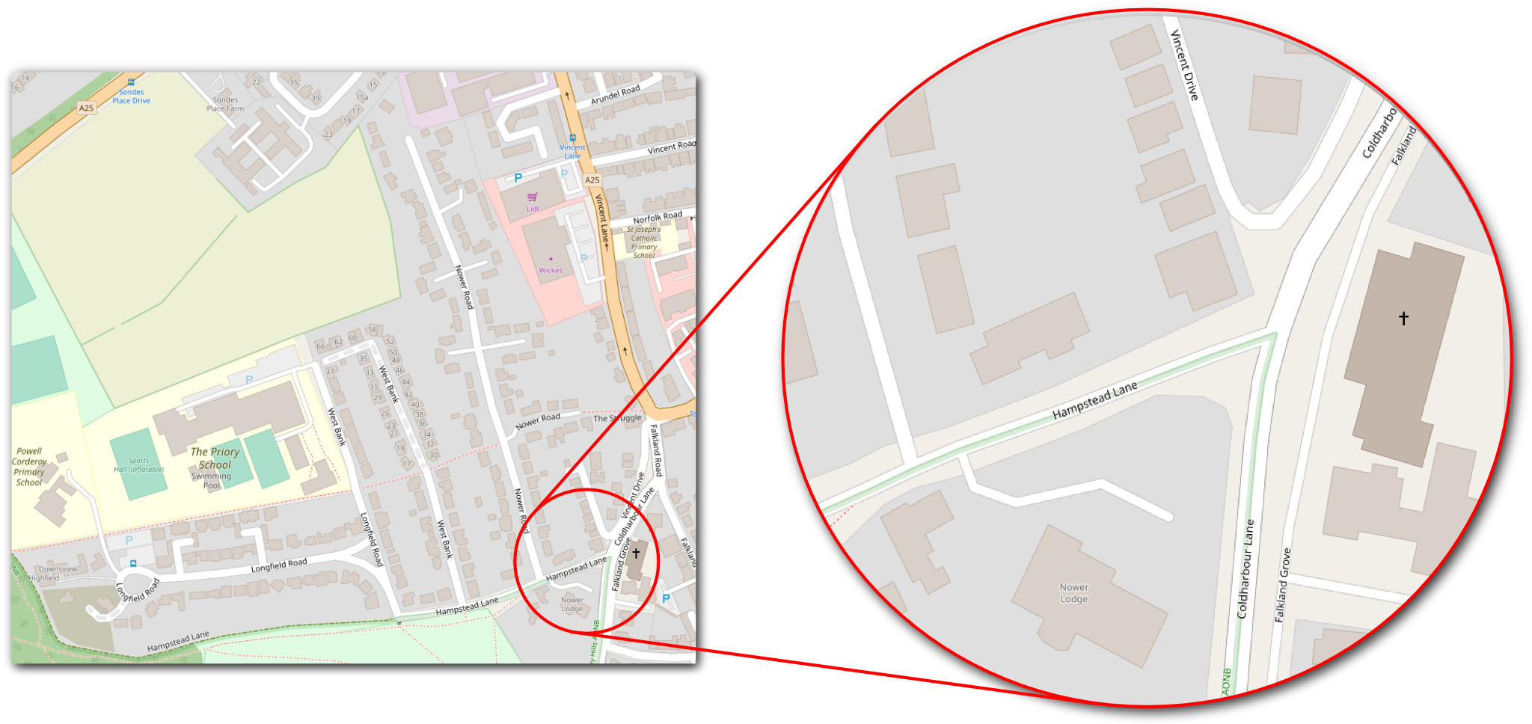
The addition of parking restrictions along Hampstead Lane and Longfield Road will not affect the free flow of coaches as suggested in the Transport Plan, the coaches often have to wait to negotiate parked cars but once they get close to the junction of Hampstead Lane and Coldharbour Lane they join the traffic jam. The bottleneck at the junction of Hampstead Lane and Coldharbour Lane is caused by traffic backing up due in the main to the weight of traffic on Vincent Lane and the coaches trying to turn right from Hampstead Lane to drive up Coldharbour Lane to access the south of the town. As Coldharbour Lane is too narrow to accommodate coaches passing cars then the coaches have to wait until Coldharbour Lane is clear which essentially relies on the traffic moving down Vincent Lane to clear the jam on Coldharbour Lane. The addition of parking restrictions will not change this. If you add in the extra cars dropping off and picking up pupils in West Bank and Nower Road you will create a complete logjam.

In conclusion hundreds of local residents will be seriously adversely affected by this development and it seems astounding to many of us that you are willing to even consider spending so much money on what is essentially a failing and inaccessible school whilst not only completely ignoring the well-being of so many local residents but making all of their lives more difficult and potentially dangerous.

Yours faithfully

