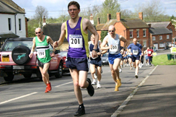

**Thornborough-10 Mile & Fun Run**

Thornborough-10 mile and Fun Run is a very popular, friendly, village event which has been running for over 35 years. (Excuse the pun)

Running concurrently with the Thornborough-10 mile road race is the 5-mile Fun Run. Young and old are warmly invited to enter. As well Thornborough villagers walking or running the course, we expect many people from nearby towns and villages, from several Clubs around the area and sometimes much further afield. If you bring a dog on the Fun Run, please keep it on a short lead at all times, we have had problems with this in past years.

The Thornborough Run is a fairly challenging, hilly course on our beautiful country roads. The route is: Start on Thornborough Village Green, up the Nash Road for one mile to Dancers Grave crossroads, left to Thornton, in Thornton turn left and come into Thornborough via Back Street. The 10-mile timed run is only for fit and experienced runners, it is twice round the 5-Mile Fun Run course.

Our experienced organizers and marshals are always in attendance, with Safety Marshals, Water Stations and a Lead Car to ensure the safety of the front runners, plus a Tail Car that also assists anyone with problems. You can park anywhere on the High Street, beside the pond or outside the village hall/school. There will be a BBQ and toilets in the village pub and the Wesleyan chapel which also serves tea/coffee on the Green by the start/finish.

**Join us on The Green, Thornborough where Registration opens at 10am.**

**The Thornborough-10 mile starts at 10:40 sharp**

**The Fun Run 5-mile starts at 11:00**

**ALL RUNNERS must enter on the day (no advance registration)**

**Fun Run - Adults £5.00, Under 18s £2.00 and Under 5s £1.00.**

**Thornborough-10 runners Entry fee is £10.00 including finishing medal.**

Race Numbers are sponsored by the Two Brewers, Thornborough.

Contact: race-secretary@tssc-mail.org.uk

[**https://www.e-voice.org.uk/tssc**](https://www.e-voice.org.uk/tssc)

Location Map

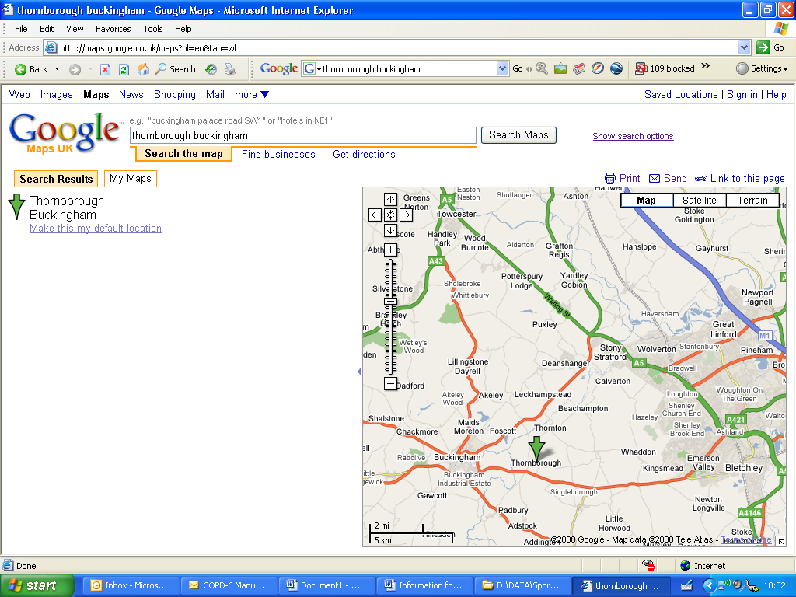

**For Sat Navs: MK18 2DQ**

**Race Route Map**

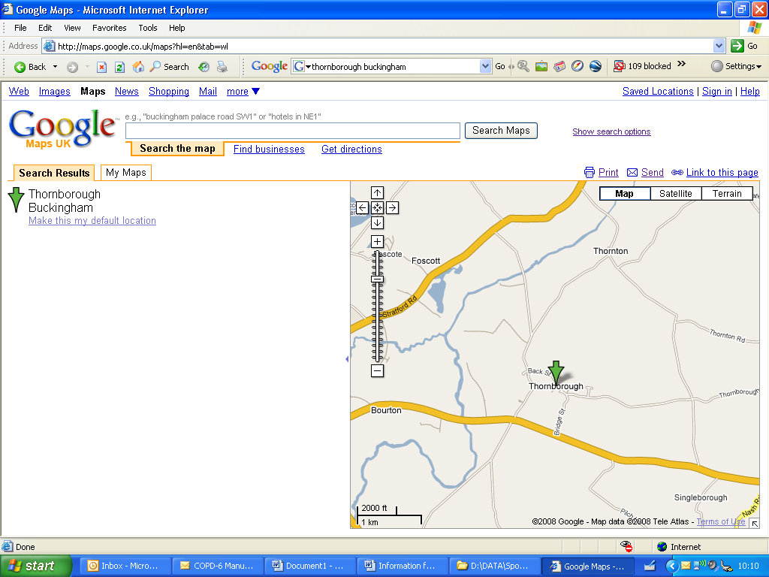



**Start / Finish**

