THEFTS FROM PERSONS
BRAINTREE
Coggeshall Road
August 21st between 14:30 hrs. & 15:21 hrs.
Suspect unknown stole victim’s wallet
George Yard Shopping Centre
August 19th between 11:25hrs and 12:35hrs.
Persons unknown removed victim’s purse from her handbag
Market Place
Between August 17th 00:00hrs & Aug. 18th 13:13hrs.
Suspect unknown stole victim’s purse containing bank cards, store cards and £25 cash from her bag.
BOCKING Courtauld Road
Between Aug. 14th 22:30hrs and Aug.16th 22:45hrs.
Suspect unidentified picked up victim’s phone after the victim had dropped it.
WITHAM Braintree Road
August 19th between 15:00hrs and 17:23hrs.
Suspect unidentified stole victim’s bank card after the victim used it to obtain a refund.

ESSEX POLICE TWITTER
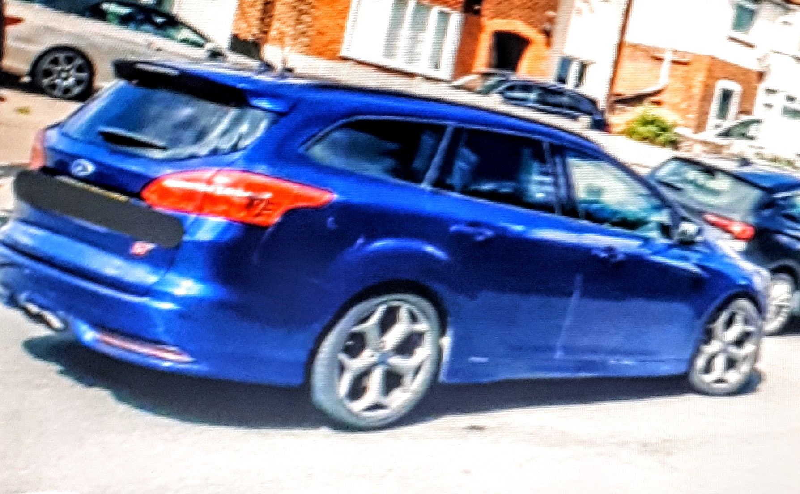
Vehicle stiopped in KELVEDON following an incident in BEDFORD . Suspect arrested fro robbery and vehicle seized.

DISTRACTION BURGLARY
MILDENHALL Field Road
Saturday 15th August 10:00hrs.
A male entered the property of an elderly women in her 80’s , and gave the impression he was there to service the radiators. He entered the bedroom and closed the door and the victim followed him and suspect left with a large amount of jewellery including necklaces, earings and sovereign rings.
Suffolk Police are apprealing for witnesses or any information please call 101 Bury St.Edmunds CID reference 37/47300/20

ATTEMPTED THEFT OF MOTOR VEHICLE
FINCHINGFIELD Spains Hall Road
August 17th 23:00hrs.
Suspects unknown entered a farm in a LandRover Discovery and gained entry to a barn and attempted to remove a Merlo Telehandler which they reversed out of the barn but it was stuck in the yard .
The victim was awoken by the machine starting up and reversing beeps and shone torches at the vehicle which “spooked” the suspects who fled in the Discovery.

THEFTS FROM MOTOR VEHICLES
KELVEDON London Road
Between Aug.18th 18:00hrs and Aug.19th 13:39hrs.
Suspect unknown drilled into victim’s white Vauxhall Crafter and opened the side panel door and stole items.
CRESSING
Jefferys Road (1)
Between August 14th 21:00hrs and 15th August 11:06hrs
Suspect unknown stole the rear index plate from a silver Peugeot 106.
Jefferys Road (2)
Between August 13th 23:59hrs &15th Aug.09:00hrs.
Suspect unknown stole the front and rear index plates from a silver Ford Galaxy.
BRAINTREE
Cressing Road
Between Aug.18th 22:00hrs and Aug.19th 07:00hrs.
Suspects unknown gained entry to a white Ford Fiesta on a driveway and stole a wallet from ther centre console .Bank cards were used for six contactless paykets locally.
BRAINTREE London Road
Between Aug.17th 18:00hrs and Aug.18th 08:17hrs.
Suspect removed both number plates from a blue Susuki Swift.

DWELLING HOUSE BURGLARY
SIBLE HEDINGHAM Delvin End
Between Aug.14th 00:00hrs and Aug.15th 10:17hrs.
Suspect unidentified entered a property by forcing a window open and removed a reel of wire valued at £60

ATTEMPTED THEFT FROM A SKIP
BRADWELL The Street
August 14th between 00:00hrs and 09:10hrs.
Suspect unidentified entered victim’s garden and attempted to remove items from a skip and when challenged made off in a white Ford Transit.

THEFT OF OIL
HATFIELD PEVEREL The Street
Aug.18th between 06:01hrs and 09:49hrs.
Suspect climbed over a roof to gain entry to gated area and removed seven tubs of oil.

HARE COURSING
Suffolk Police are appealing for witnesses following a hare coursing and fail to stop incident.
Sunday 16 August 12:25hrs.
A group of males were witnessed hare coursing in a field in Raydon but they then drove away when they were noticed. Officers attended and pursued the vehicle from Hadleigh to Higham, before the vehicle, a black Mercedes 4X4, was abandoned by the occupants, along with a number of dogs.
Officers managed to restrain two of the dogs but were unable to catch the others. The suspects were also not located.
The first two suspects are described as being two white males with shaved heads. Both males were wearing white t-shirts and blue jeans. Two other younger males, who with the other two males, possibly teenagers, were wearing yellow t-shirts.
Officers would be keen to speak to anyone who may have captured any dash-cam footage of the pursuit in the Hadleigh area. Particularly, anyone who may have captured the oncoming black Mercedes travelling towards them in the other lane. Further enquiries still continue to be carried out regarding the dogs and anyone with any information or who may have found a lost dog in the Higham area, is asked to contact police.
Anyone with any information that they believe could assist officers with their enquiries, is asked to contact Pc 1293 Johnson of Hadleigh Safer Neighbourhood Team, quoting crime reference: 37/47456/20
Email – Niall.Johnson@suffolk.pnn.police.uk phone 101.

TELEPHONE SCAMS


EDITORS NOTE:
YES there are incidents not on “your doorstep” again in this week’s newsletter but it does bring to your attention what is happening in Essex/Suffolk so please do what you can to prevent this happening near you by being more vigilant in protecting your property and helping those to do the same who may feel vulnerable - that is what Neighbourhood Watch is all about. Keep a chain on the door if you are feeling vulnerable even during the day! The newsletter is a summary of crime incidents . and is distributed to:- Acton, Alphamstone, Ashen, Belchamp St. Paul, Belchamp Walter, Bocking, Borley, Bradwell , Braintree Town areas, Bulmer, Bures, Burtons Green, Castle Hedingham, Chelmsford , Clare, Coggeshall, Colchester, Colne Engaine, Cornish Hall End, Cressing, Earls Colne, Fairstead , Feering, Finchingfield, Foxearth, Gestingthorpe, Gosfield, Great Bardfield , Great Henny, Great Maplestead, Great Notley, Great Saling, Great Yeldham, Great Waldingfield, Greenstead Green, Halstead, Hatfield Peverel , Hitcham, Kelvedon, Lamarsh, Leigh-on-Sea, Little Baddow, Liston, Little Henny, Little Yeldham, Little Maplestead, Long Melford, Middleton, Ovington, Panfield, Pattiswick, Pebmarsh, Pentlow, Radwinter, Rayne, Rivenhall, Shalford, Sible Hedingham, Silver End, Stambourne, Stisted, Stoke by Clare, Southend, Sturmer, Sudbury, Terling, Tilbury Juxta Clare, Toppesfield, Twinstead, Wethersfield, White Ash Green, White Colne, Wickham St. Pauls, Witham.

