TOPO Sorting Office "What next?" meetings, 5 Nov, 27 Nov, 2 Dec, 2013
SUMMARY

3 meetings took place soon after the Sorting Office part of TOPO became available to rent in October 2013, the month that we published the 1st edition of the TOPO Prospectus. 4 of Steering Group viewed it (see http://tinyurl.com/o6wxe4 for details), and thought it could be an exciting (if challenging) community cultural space/cafe, but a "Plan B" was clearly needed. So:

MEETING #1, Tues 5th Nov pm, Steering Group (SG) meeting #9 to plan open meeting, to share info and work out next steps with stakeholders and supporters.
Present: Marilyn (MM), Peter (PM), David (DR), Jean (JV), Aniela (AZ)

1. The space was described as basically an empty shell (of about 500 sq m), that could be used for some of the ideas generated at previous meetings: indoor markets, events, meetings, rehearsals, exhibitions, storage, + an entrance area large enough to be a cafe, that could extend on occasion (e g, a pop-up supper club) into the bigger space. These uses were possibly incompatible with use for office/work space, which might have to wait for the rest of the building to become available to the community, so Plan A (using the whole building for a wide range of inter-related activities) still stood as our ideal, though the Sorting Office space could be a start.

But the rent being asked was very high (see notes from Meeting 2 below), and the venue would need to pay its way, i e, we needed to identify users prepared to pay for it, or partners, or sources of funding, or an enterprise (possibly the cafe or another lead tenant) to manage the premises, sign a lease etc. It also needed to be fitted out, and all this while maintaining affordability for community users. We probably needed to ask for a rent holiday while fitting out and fund-raising, developing uses and recruiting users. We suspected it would be hard for anyone to run this venue at this rent + all the overheads and make ends meet.

The building seemed sound but would need:

- A structural survey
- Loos
- Kitchen
- Heating

- Flooring
- Flexible dividing screens?
- Storage

- Furnishing - tables, chairs, stage, cupboards, display boards...

2. It was agreed to book C-SCAIPE for an evening meeting for supporters and stakeholders (t b invited via JV's shared list, expressions of interest, TOPO Facebook, websites inc TOPO, TTK and KEC). A second meeting for RBK councillors was also planned, but the initial date chosen proved impossible for councillors so this was later postponed.

3. Other follow-ups: it was also agreed to phone David Atkins, Chief Executive of Hammerson, weekly to ask for his comments on Prospectus (sent mid-October) and for a meeting, and to keep SG informed of any contact; to take up offers from Cllr David Cunningham/Kathryn Woodvine to facilitate meeting with Hammerson ; to take other opportunities to engage and gather support as they arose; to design an A5 flier based on Prospectus that we could print out cheaply and hand out at meetings, until we had funds to print (revised) Prospectus.

MEETING #2, Wed 27th Nov, "What next?" open meeting, C-SCAIPE, 7.30 - 9.00pm
Present: Jean Vidler (Chair, Steering Group); Marilyn Mason (Communications, Steering Group); Peter Mason (Spatial planning, Steering Group); David Randall (Business, Steering Group); Maisie (Circus Suburbia); Caroline Hutchings; Sheila Griffin (Vice-Chair Kingston Arts); Neil Webster
Apologies: Aniela Zaba. Thank you to Fiona Quinn for letting us in and setting up the computer

1. After introductions MM shared what SG done and found out so far, so that we could plan together with as much background info as possible. The SG had:
    - set up a TOPO website and a Facebook page, kept it relatively up to date;
    - published on the website and disseminated a 1st edition of Prospectus to: all RBK councillors (Town Neighbourhood cllrs first); Kingston Arts; RBK Arts Officer, Business Dev, planners; KEG; TTK; 2 local MPs; K Voluntary Action; supporters via Fb page and website; Kingstonfirst; and Hammerson, TOPO site owner/developer (but no response);
    - created a small flier to be printed off ad hoc for meetings etc;
- applied for a small Neighbourhood Grant from Kingston Council to cover printing, postage and other admin costs, currently carried by members of the SG;
- in various combinations SG had met with: 2 leaders of Kingston Council; Cllr responsible for sustainability; RBK officers in planning dept: Darren Richards; Roy Thomson, Head of Place; Claudette Forbes (i/c Regeneration, Kingston Futures); Karl Limbert, RBK Head of Property; Community groups: Kingston Voluntary Action and others involved in other central Kingston "community hubs" incl ASK and the Rose Theatre.; Kingston Arts. And TOPO proposals have been flagged up to other potential stakeholders and community groups as opportunities occurred. These had all been positive meetings, ranging from cautiously encouraging (Council officers and members who appreciated the input of ideas but couldn't fund anything) to keen enthusiasm (potential users). People could see that TOPO was suggesting something different and useful to Kingston, that didn't clash or compete with other community organisations, including Council priorities;
- + a fair amount of research. 2 of SG had attended a conference on the future of town centres at Kingston Uni, and SG had kept an eye on media discussion of "the death of the High Street", growth of internet shopping etc - which strengthened the TOPO case for something different from retail on that site. SG had looked into RBK planning guidelines, confirmed that our proposals fitted within their broad strategy and that there are no other community gain priorities for that site; confirmed current ownership by Hammerson and that there were no planning proposals in the pipeline; and also established that RBK didn't communicate with Hammerson and knew little more about their intentions than we did. (Latest news on Hammerson was that they are starting work on a huge retail development in Croydon.) SG members had visited and been impressed by various community arts and environment centres in other towns (some featured in the Prospectus). SG had begun researching possible sources of funding and expert advice.

2. PM described the site and building, with illustrations, including a floor plan of the Sorting Office (as below) and some facts and figures:
Costs:
- Rent asked: £75,000 pa (with 6 months in advance as deposit) for a 4.5 year lease
- + Overheads: heat, light etc
- + Fitting out – estimated at £100,000 (by the estate agent)
Space (Grade-2-listed so external work not possible):
- 20m x 20m usable space (= 2 tennis courts) + loading bay and toilet block with drains etc (but no toilets), no kitchen...
- Only 2 (fire) exits - so limited to 200 chairs? 200 people? or 40 small office/studio spaces? (More exits would permit more people)
- Good overhead natural light, but hard to heat and light at night?
- How to divide up for a variety of uses?
Big Q: how to keep this space affordable for users while meeting the costs?

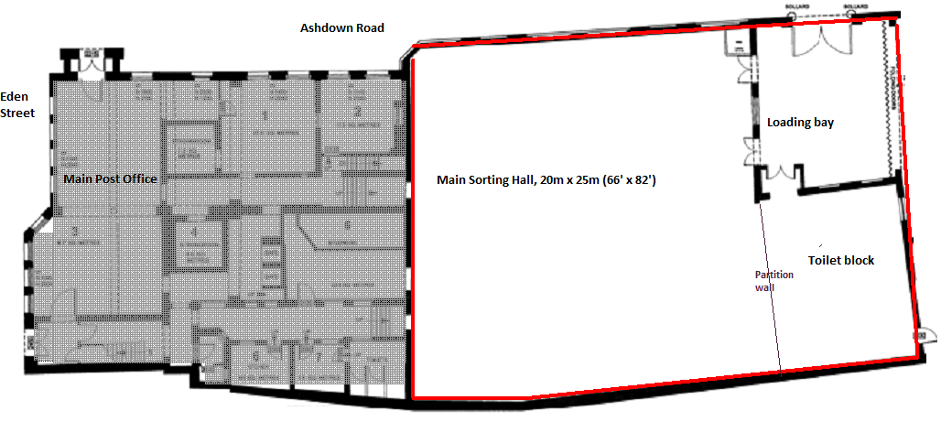

3. Group discussions on next steps, led by JV. Unfortunately, few present had been at previous meetings or read the TOPO Prospectus based on ideas gathered then and subsequent researches, so there was some reiteration of earlier ideas along with some new ones.

Ideas for use included: creche, rehearsal space for Circus Suburbia, Ockham's Razor and others; games (pool, table tennis, roller disco, volley-ball, netball, table football, footsal (sic)...; artists' open studios; revolving exhibitions; indoor market - food, crafts; Kingston Green Radio; orchestra; studios and hot desks; cafe in loading bay space; medical check-ups; courses/training; tourist info; sustainability centre; job fairs...

Ideas for next steps included: negotiating for some kind of pop-up exhibition in the (cleaned up) building to demonstrate the potential; hoping that no other organisation could afford the high rent and negotiating a lower rent or a meanwhile tenancy; getting sponsorship/advertising to cover some costs.

Challenges and questions:
- Were some of these activities incompatible (e g, noisy and quiet, adults and children, private rehearsals and public cafe...)?
- Where were all the people who'd expressed an interest in using the space - have they lost interest?
- We should stop generating ideas (too many to accommodate already?), and find and hand over to people/organisations/investors/operators, or form an umbrella group/consortium, that could actually implement some of them and negotiate with Hammerson or its successor. Would any of the people who filled in Expressions of Interest be useful/capable (but they weren't at the meeting)? A commercial operator (cafe, market) that might value our list of potential tenants for some of the space and see benefits in co-location?
- Who were the other community groups who have viewed the Sorting Office - can we work with them in some way?
- How best to divide up the space for a range of activities + storage?
- Who was going to make the building (which has no fittings, probably inadequate heating, and contains a lot of clutter) fit to use, even temporarily?
- Who would manage the space, ensure it was maintained and let most of the time? Would it need a professional manager (not so far built into our business plan)?
- The rent was too high and the lease too short to be viable for anyone, even a commercial tenant - was the developer just trying it on?
- Some conversions, e g to indoor market, would be relatively cheaper than others, e g offices/studios with sound-proofing and heating requirements...
- What were the regulations re setting up yet another market in an ancient market town? Would Kingstonfirst know?

MEETING #3, Monday 2nd Dec, pm, Steering Group meeting #10 to plan progress
Present: Marilyn, Jean, David. Apologies: Peter, Aniela

Notes above from open meeting had been circulated and 2 main possible actions arising from that were proposed - and could proceed in parallel:

- A week-long event in April to explore and showcase possible uses, to include: market stalls (craft, voluntary sector, organics...); a pop-up cafe; pop-up Environment Centre and other work-spaces; exhibition and performance areas; music; a panel discussion...

- Approaching possible "uber-landlords" who would be capable of negotiating with landlord and open to working with community groups to mutual benefit.

While remaining mindful of the difficulties (no communication so far with owners Hammerson, excessive rent, sourcing funds, management of a one-off event, including need for porta-loos and other furniture and fittings, mess in the building...), and these and other issues around long-term management of the building, the SG would approach possible sources of help and advice amongst their stakeholders and networks, and continue to plan for both the actions above.

UPDATE, 19/12/13
The Sorting Office is now apparently Under Offer, which once again changes the situation and TOPO's options. JV has initiated a SURVEY of our supporters, particularly potential tenants, to find out what action there is support for from a bigger group than attended the 27 November meeting. She will publish the results when responses are all in, and organise a further meeting for potential tenants at Kingston Environment Centre in January.

