The Old Post Office (TOPO)
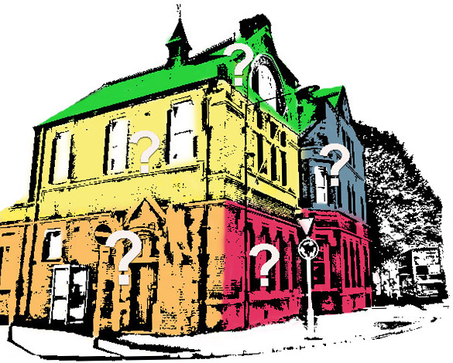

TOPO is a consortium of community groups that think these fine old listed buildings in central Kingston should be serving the Kingston community.

What do we want?
- Conservation and sustainable community/cultural use of these local landmark, heritage Grade-2-listed buildings;
- A permanent and visible base for a public-facing Kingston Environment Centre;
- An attractive and sociable meeting/drop-in space;
- An organic-vegetarian café as the heart of this community hub;
- Affordable, flexible spaces for regular or "pop-up" shops, classes, workshops or events;
- Affordable work and office spaces/hot-desks for small businesses, sole traders, start-up enterprises, local charities and groups...;
- Affordable art and craft studios/workshops, with space to exhibit and sell art;
- Affordable multi-purpose meeting room(s) for rehearsal and performance space, public events, film shows, exhibitions...
- A piazza "pocket park" as a model sustainable garden.

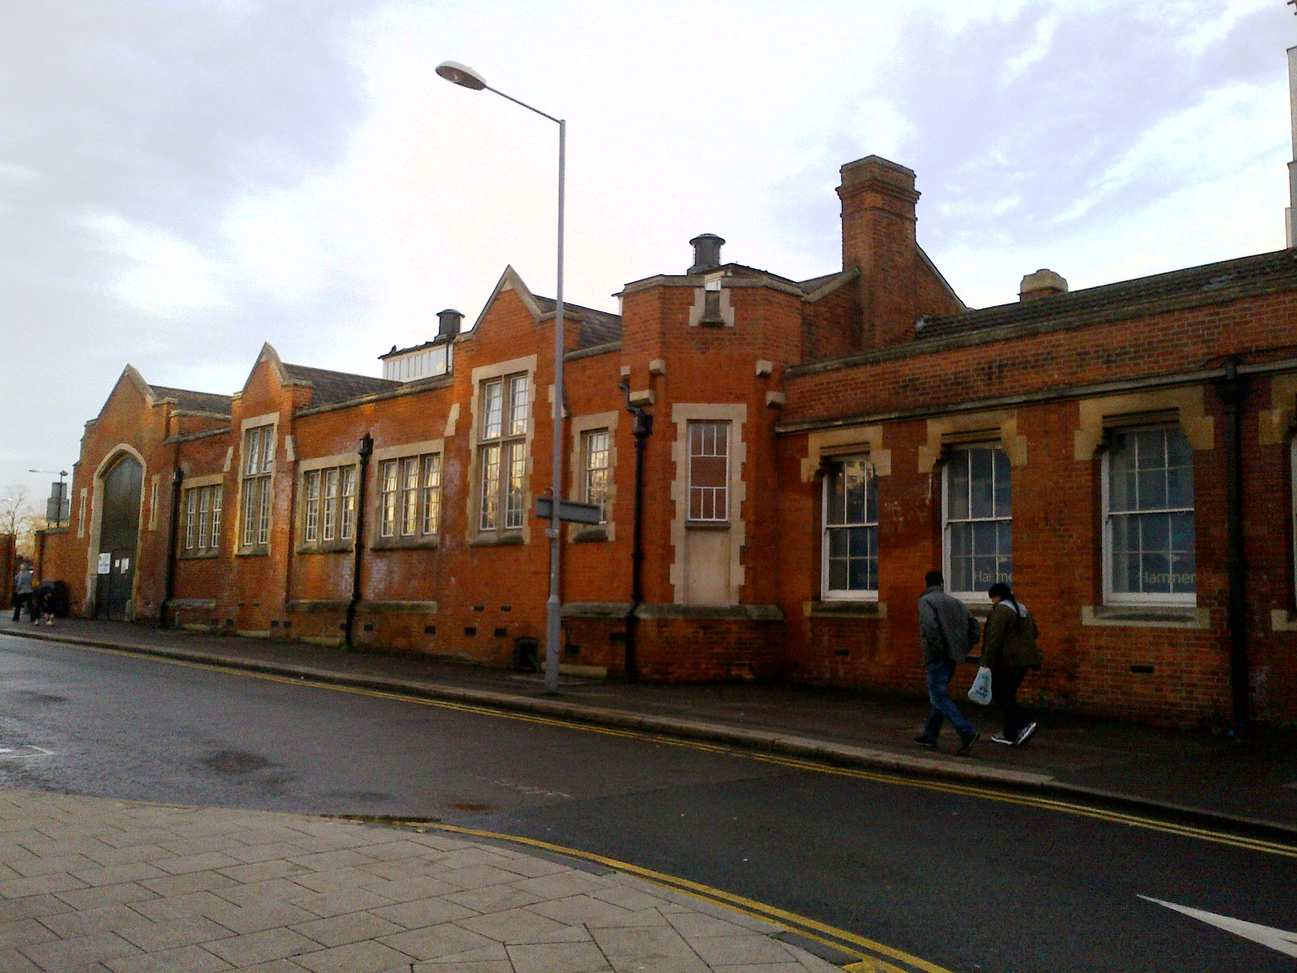
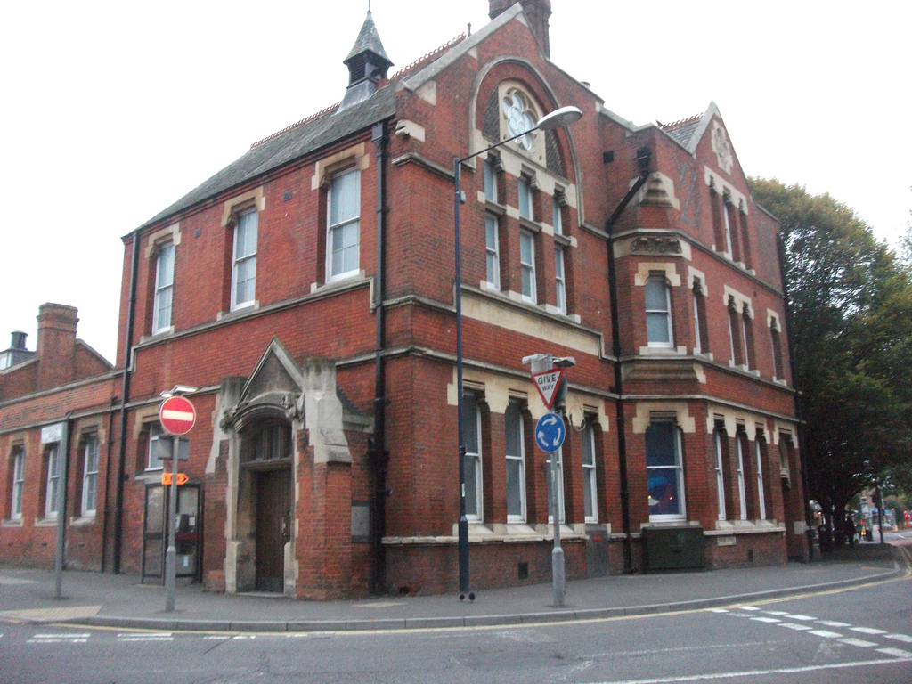

See http://e-voice.org.uk/topo/ for more information about the project and to read the full TOPO Prospectus.

What the TOPO steering group has done so far
    - We've held open meetings for potential users and stakeholders, to gather ideas and support, and collected Expressions of Interest.
    - We've set up a website and a Facebook page.
    - We've had positive meetings with some Kingston Councillors and relevant Council officers.
    - We've met with other Kingston community groups, including some that are also interested in developing community hubs (and found little or no overlap with our proposals).
    - We've written and disseminated a Prospectus, so far published only on our website at http://e-voice.org.uk/topo/files/view/TOPO_prospectus_lr_Oct2013.pdf.
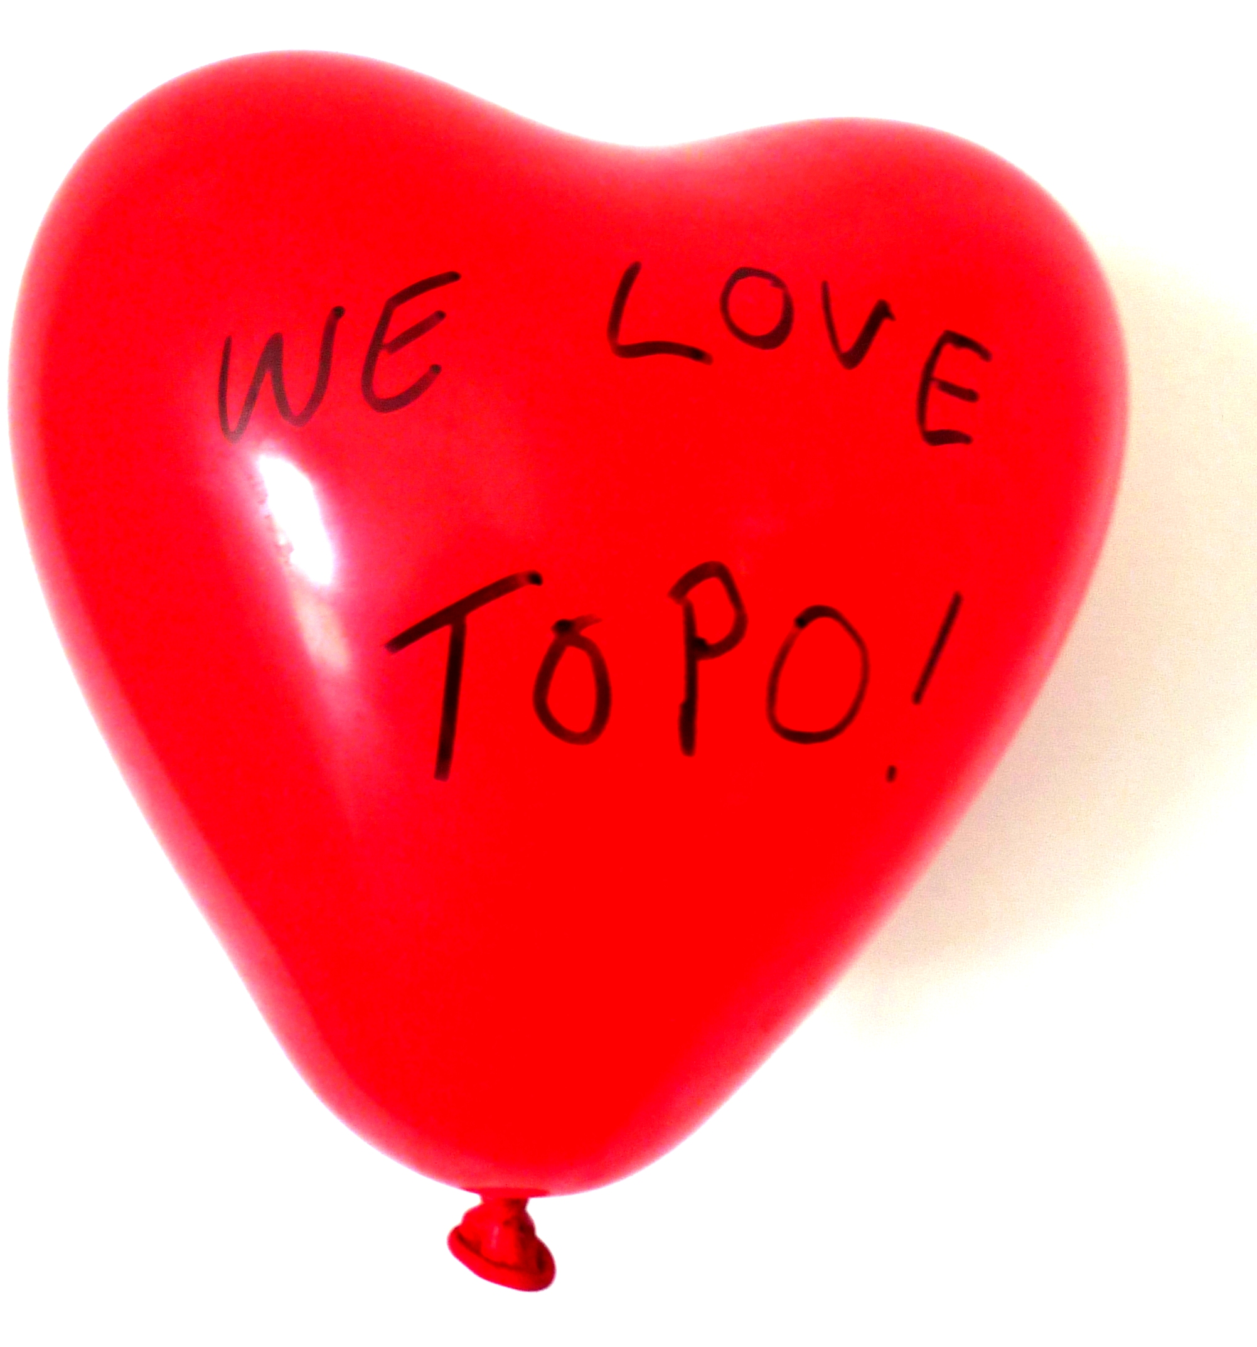
    - We've researched possible sources of funding and expertise, and applied for a small Neighbourhood Grant from Kingston Council to cover printing, postage and other admin costs, currently carried by members of the steering group.
    - We've viewed parts of the building, including the former Sorting Office.

How you can support TOPO
- You can help us to engage with others and to build support for community use by telling people about the TOPO proposals, writing to your councillors, the Surrey Comet, your MP... (plenty of good arguments and ideas in the Prospectus).
- Are you a surveyor, an architect, a builder, a lawyer...? We may need your expertise quite soon.
- Do you have experience of managing a cafe or a venue? We may need your expertise one day.
- Are you a friendly millionaire - or can you help us to access the funding we will need to rent and fit out this venue?
- Donations large or small are always welcome!*
- You could help the Steering Group with general admin, campaigning, and fund-raising.
- You can get TOPO updates and join in discussions on our Facebook page https://www.facebook.com/groups/topokut/.

*TOPO funds will be held temporarily by Kingston Environment Centre.

