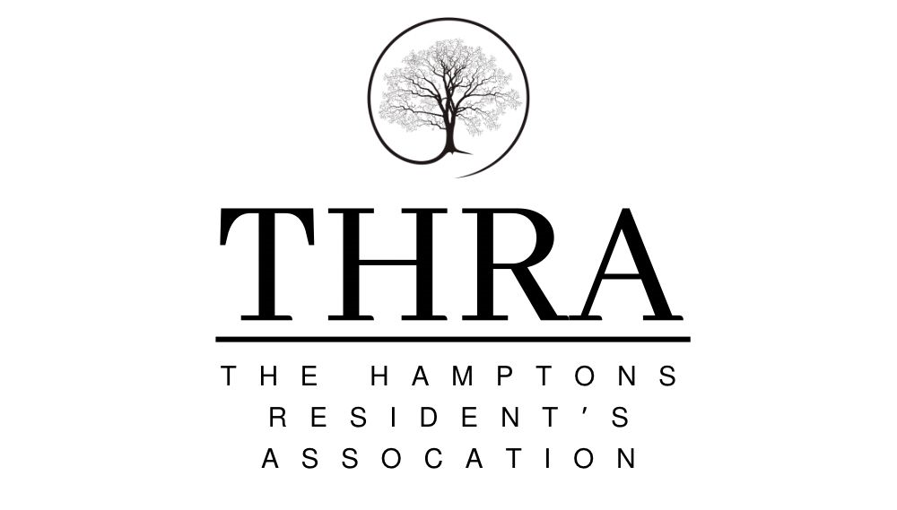

Constitution

Our Association is called The Hamptons Residents Association and we cover the housing estate development formerly known as The Hamptons, The Orchards and Merrybrook Park off Pershore Road in Evesham.

Aims

We are a totally independent and non-political group set up to:
- Ensure the designated landscaped areas and ‘country park’ are well managed and that the management is carried out in the best interests of, and in the most cost effective manner to the residents.
- Improve the estate including environment, facilities, community spirit and services for all residents.
- Represent and support the interests of the residents of the area and to help solve any problems which may affect the estate and put forward the collective view of the area following active consultation with residents.
- Work proactively with Meadfleet Ltd, Bellway/Bloor (until the entire estate is handed over/adopted), Worcestershire County, Wychavon District & Evesham Town Councils, their partners and other agencies/organisations to improve the quality of life for all residents of the estate.

Our Association will:

- Be run in a fair and transparent manner, including financial matters.
- Seek funding from external statutory bodies to meet our aims and meet the funding body’s requirements with regard to applications.
- Be open and welcoming to all who live in the area regardless of their nationality, race, colour, sexuality, gender, disability, age, religion, political opinion, tenure, marital status, parental status, health, criminal record or any other reason which may arise. We will encourage the participation of all sections of our community so that they have an opportunity to have a say.
- Use a range of ways to maintain regular contact and encourage the involvement of residents using various methods, including meetings, newsletters, the internet, social networking sites and face-to-face discussions.
- Take part in discussions, events and consultations with any and all relevant bodies, in order to promote the involvement and participation of residents in improving the community.
- Work positively with other agencies, for example local community organisations, charities and West Mercia Police, in relation to services provided or other issues raised by residents affecting the area and seek solutions to any problems which may arise

Meeting of the association

Everyone is welcome to attend meetings but must follow the code of conduct.
We will hold an Annual General Meeting (AGM) every 12 months to elect a new Committee and to report on our progress over the past year. We will give at least 21 days notice of this meeting to all residents and interested parties.

The date of our next AGM will be 15th May 2023

For ordinary meetings we aim to give a minimum of 7 days notice to residents and interested parties. These will be held at least 2 times in a year. All meetings will have an agenda and a start and finish time.
If a Special General Meeting (SGM) is requested, either by the Committee or by at least 6 households to discuss important issues, we will give no less than 10 days notice to all residents in our designated area.
All meetings must have a minimum number of residents attending (known as a quorum) before decisions can be made. If the quorum is not reached, those present can decide if the meeting can go ahead as planned. Other than that decision no further decisions can be made without further consultation. Our quorum for an open meeting is no less than 3 members of the Committee and 6 local residents from different households. For a Committee meeting our quorum is 3.

Running the association

The Association will be run by a Committee consisting at a minimum of a Chair, Vice-Chair, Treasurer and Secretary. These will be elected at an AGM. Other members can stand as ordinary committee members or have a specific role, such as membership secretary, etc. These should ideally be elected at an AGM but may be co-opted onto the committee at an open meeting.
Their duties are to ensure that the aims of the Association are met and undertake the general running of the Association. Details of each role will be clarified when the member is elected.
Minutes of all meetings will be kept and made public, including online, once agreed. We will send these to other interested parties who have a valid request for a copy.
We will undertake consultations and provide information for residents which will ensure that there is a collective voice for the community. We will work with other agencies in the area in order to improve the area. We will give feedback to residents about events, consultations and discussions that we have taken part in and how their views have been represented.

Representatives of our committee will meet with representatives from Meadfleet Ltd, Bellway/Bloor (until the entire estate is handed over/adopted), Worcestershire County, Wychavon District & Evesham Town Councils, their partners and other agencies/organisations as required. We will apply for support funding offered from the any of these sources as appropriate and discuss any improvements that can be made.
We will produce a Chairs and Treasurers report annually which will show what we have achieved and what we aim to achieve for the coming year. This will be published at our AGM.

Changing our constitution

We can change our constitution at any time via an item placed on the agenda at an open meeting; however we must formally adopt those changes at the next AGM.

Closing down the association

If the association is no longer able to continue then the Committee, or remaining Committee members can dissolve the Association. If dissolving the association is the only option, residents will be informed.

Changes to this constitution were made on 06/03/2023
and formally agreed at the AGM held on ……………………………………

Signed ………………………………………………………………………
(Chair of The Hamptons Residents Association)
Witnessed by ……………………………………………………………….
Agency represented………………………………………………………..

Document version 1 agreed by interim committee on 06/03/2023.

