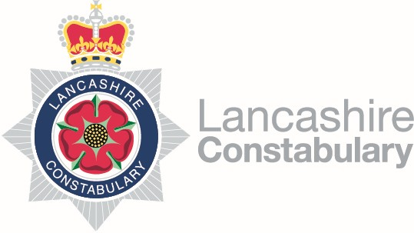
Hello,

Firstly, please accept our apologies for not attending in person, but with over 40 Parishes in the Ribble Valley, we feel this is most efficient way to introduce ourselves.
The Ribble Valley Rural Taskforce is made up of 4 Police Constables. We are Micky Woods, Scott Fairclough, Paul Wood and Matt Hartup. We are based at Clitheroe Police Station.
We are one of five Rural Task Force teams, the others being based at Rossendale, Ormskirk, Garstang and Morecambe. Between us, we cover Lancashire and often work in support of each other.
The Ribble Valley Rural Taskforce was set up in April 2021 by the Police & Crime Commissioner, following a prolonged period of budget restrictions. We are four experienced Police Officers, with specialisms that allow us to investigate and target a wide range of matters that impact on rural communities.
Our primary focus is rural specific crime that affects the rural communities, targeting travelling criminality and organised crime. This ranges from burglaries, thefts of vehicles and farming equipment, drug importation and dealing, poaching, anti-social / illegal use of vehicles both on and off road, damage to SSSI’s. We have received additional role specific training to allow us to further understand the rural communities, the issues they face and the best means to tackle those issues. This training is ongoing, and we’re also picking up great tips and hints from those we work alongside.
We work alongside our colleagues in the local neighbourhood and Immediate Response (day to day) Policing teams. We also work alongside various partners such as RSPCA, RSPB, Land Agents, Keepers, Forestry England and United Utilities and are keen to further develop relationships within our community.
The best way to get hold of us directly is to email: RibbleValleyRuralTaskForce@lancashire.police.uk. We aim to reply to emails within a day or two (depending on our shifts) and can provide mobile phone contact details if required.
For those of you who follow Lancashire Constabulary online, we update the Lancs Rural Police and Ribble Valley Police social media feeds on a regular basis. Lancashire Talking is also a good way to receive updates.
http://www.stayintheknow.co.uk/LancashireTalking has more information relating to Lancashire Talking.
If anyone wishes for us to attend a Parish Council meeting to discuss specific rural issues please get in touch and we will try and facilitate this. Likewise, if there has been particular issues we have dealt with in a specific area we will try to attend and update with what work we have done.
Regards,
Ribble Valley Rural Taskforce

