
In this Newsletter your Council will summarise some of our work on behalf of our residents during 2025.

Chairman’s Message
As I have said before, as a parish council we have limited powers and resources, but we have focussed on a number of areas where we can make a difference and where we are able to make an impact on the appearance of our neighbourhood. As you will see in this Newsletter, successful work has been done on road signage including the signs and gateways as you enter the parish where Muddy Hudson Hilliard Brewitt and Rod Angood have been particularly active. Other initiatives have included organised litter picking and the reporting of fly tipping under the supervision of Heather Brady. The refurbishment of the Phone Box which is a listed structure has been completed and was purchased by the Parish Council from BT earlier this year. During Autumn we have also continued to provide bulbs for planting throughout the parish to add some cheer when Spring arrives. We hope to continue this idea on an annual basis.
There are other areas of responsibility where we have been frustrated. Essex Highways is responsible for traffic calming measures throughout the county. We are still struggling to make progress towards having speed limits imposed together with road markings and warning signage. However, we continue to lobby the relevant parties and have made several formal applications to Essex Highways supported by written submissions and photographic evidence of accidents which have happened in Mount Road in particular.
Local government is changing in Essex with the County Council being replaced by unitary authorities. We are monitoring the position and hope that the promised changes will strengthen our position in due course by bringing the decision-making process closer to the local community.
As ever, we keep a close eye on planning applications in our parish and close to our boundaries. Councillor Keith Farrow leads the way when we consider planning matters.

Many of you have expressed concerns about the travellers' site in Epping Lane. We have been informed that the gas company which owns and maintains the national gas main that passes under the site has recently obtained a High Court injunction aimed at protecting the gas pipework. Furthermore, our local MP, Alex Burghart and The Environment Agency have now shown interest in the problem of the site. We are hopeful that the use of the site may be coming to an end. If you see signs of activity on the site, please ring the Environment Agency emergency number 0800 807060.
As to social events, please see the report below and look out for planned activities in 2026. In the meantime, we at the Parish Council wish you a very Merry Christmas and a happy and healthy New Year.
Peter Connell
Chairman Theydon Mount Parish Council.

Telephone Box
As Peter mentioned in his introduction our iconic Telephone box in its renovated state is now proudly owned by Theydon Mount Parish. Sadly, vandals stole the door. This has now been replaced. It was vital that we installed a lock to ensure that it is now fully secure. Signage and cameras have also been mounted. We are currently having power sockets installed so that we can dress and illuminate our 2025 Christmas tree and we will be planning with the help of parishioners other seasonal events to be displayed in the phone box.
We are very keen to use the box for seasonal displays and would love to have suggestions and volunteers to decorate for festivals such as Easter and Harvest Festival. It is planned also to display information of interest for walkers, cyclists and others.

Village Gateways
We have recently undertaken an extensive clean-up of our village gate ways with the assistance of willing volunteers. It is planned to extend these activities to clean all the signage in the area. The grass on the main junctions at Epping Lane and Tawney Common has been mowed back to keep them properly maintained.

Fly Tipping
We all have specific roles on the Parish Council. Our Councillor, Heather Brady, who has tirelessly championed fly tipping and littering in and around our Parish is your go to person.
Heather not only organises our regular litter picking initiative but also logs many fly tipping incidents to Epping Forest District.
If you suspect or see fly tipping, littering please report to Heather or directly to EFDC

Bulb Planting
This major and on-going initiative as Peter alluded to has seen over 2000 daffodil bulbs planted parish wide this Autumn. As part of this scheme, we had help from a Duke of Edinburgh’s award scheme volunteer, Izzie Brewitt, with the planting and our local Councillors also got in on the act.
To quote our volunteer “The aim of the scheme is to challenge young people to develop new skills, get active, volunteer, and undertake an expedition. For my volunteering section, I will be helping the local Parish Council and take part in volunteer projects in and around the local area. I have always enjoyed helping others and the community, so this was the perfect opportunity for me to learn more about the workings of the local area and work towards my award.
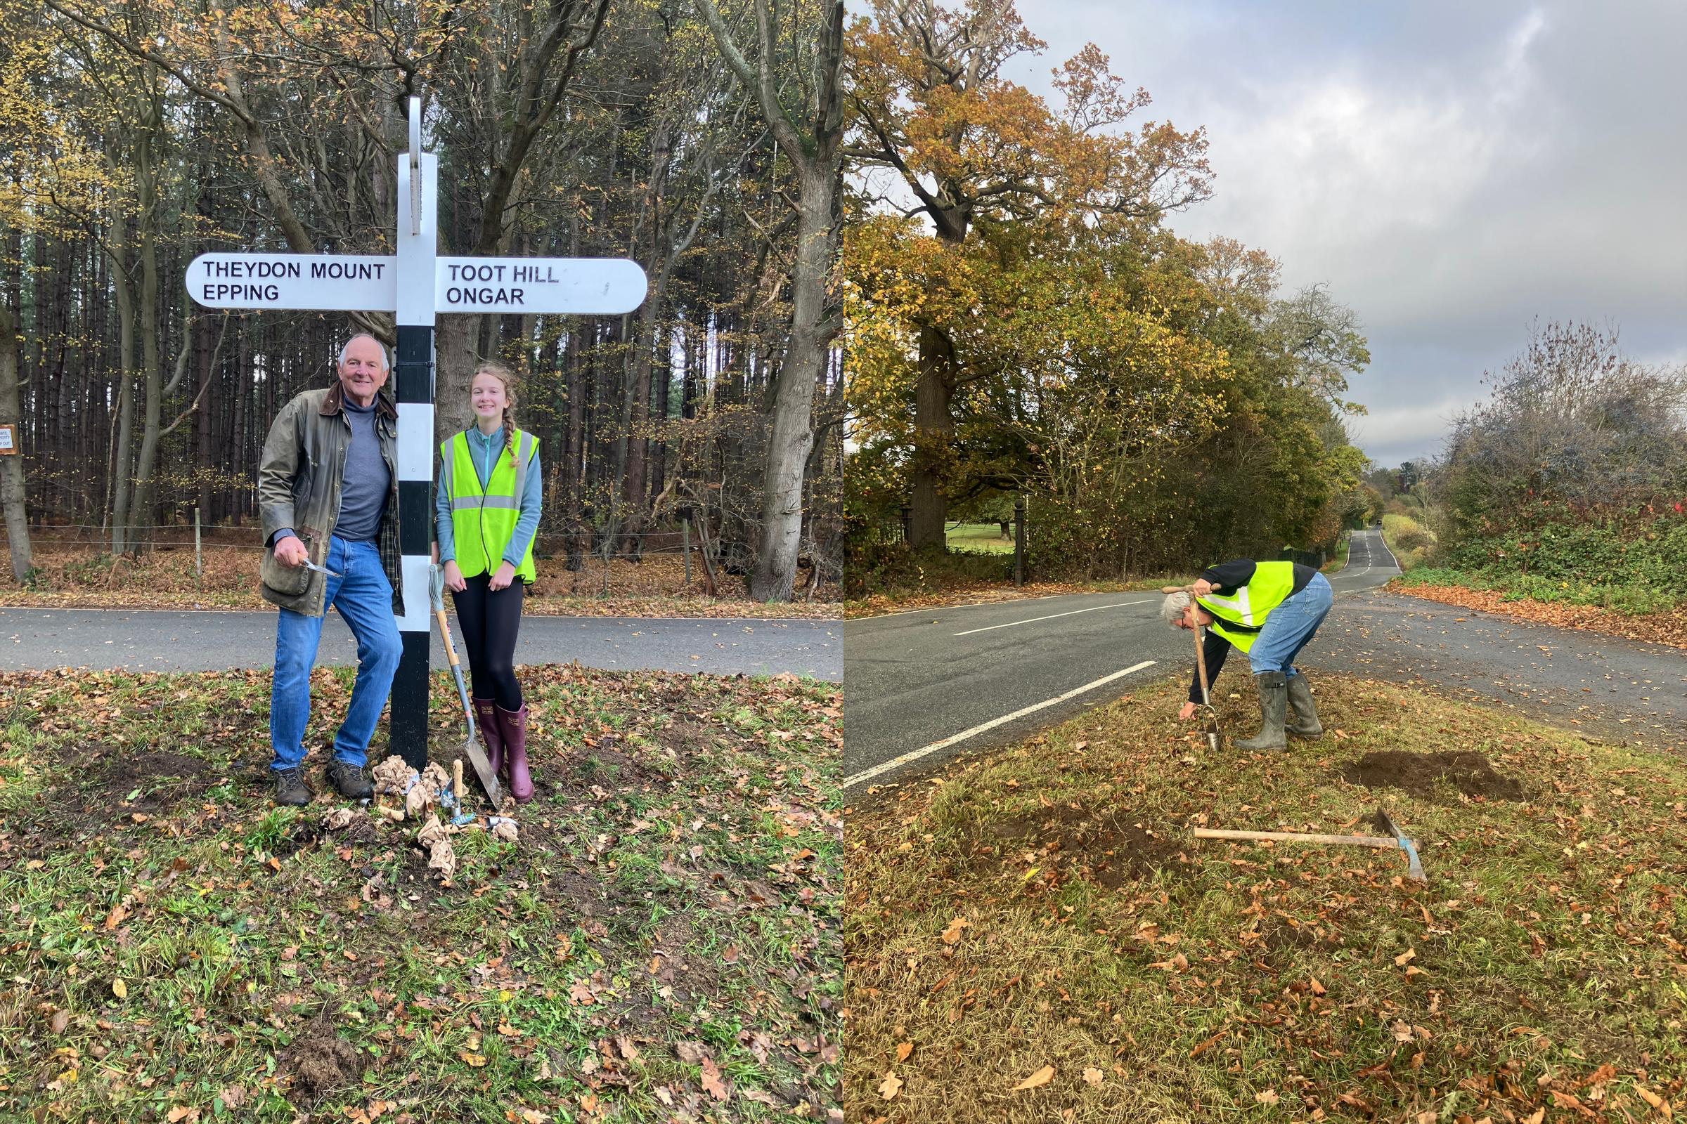

Summer Event 2025
Thanks to the generosity of Ricky & Denise Rankin our Summer event was held in their stunning garden at North Farm. The Pizza Oven & BBQ were enjoyed by all. New additions to the events included our Parish Clerk’s Horse Racing game and a nearest the flag golf competition.
Big thanks go to Greg & Rachel for organising and playing the music plus Tom the wonderful MC who kept the proceedings on time. The day’s events and raffle were a big success which was made possible by many generous contributions.
This allowed the Parish to donate to Denise & Ricky’s chosen charity The National Autistic Society.
The Horse Racing Game, again in aid of charity, will hopefully be coming to you again some time in 2026.Watch out for announcements.

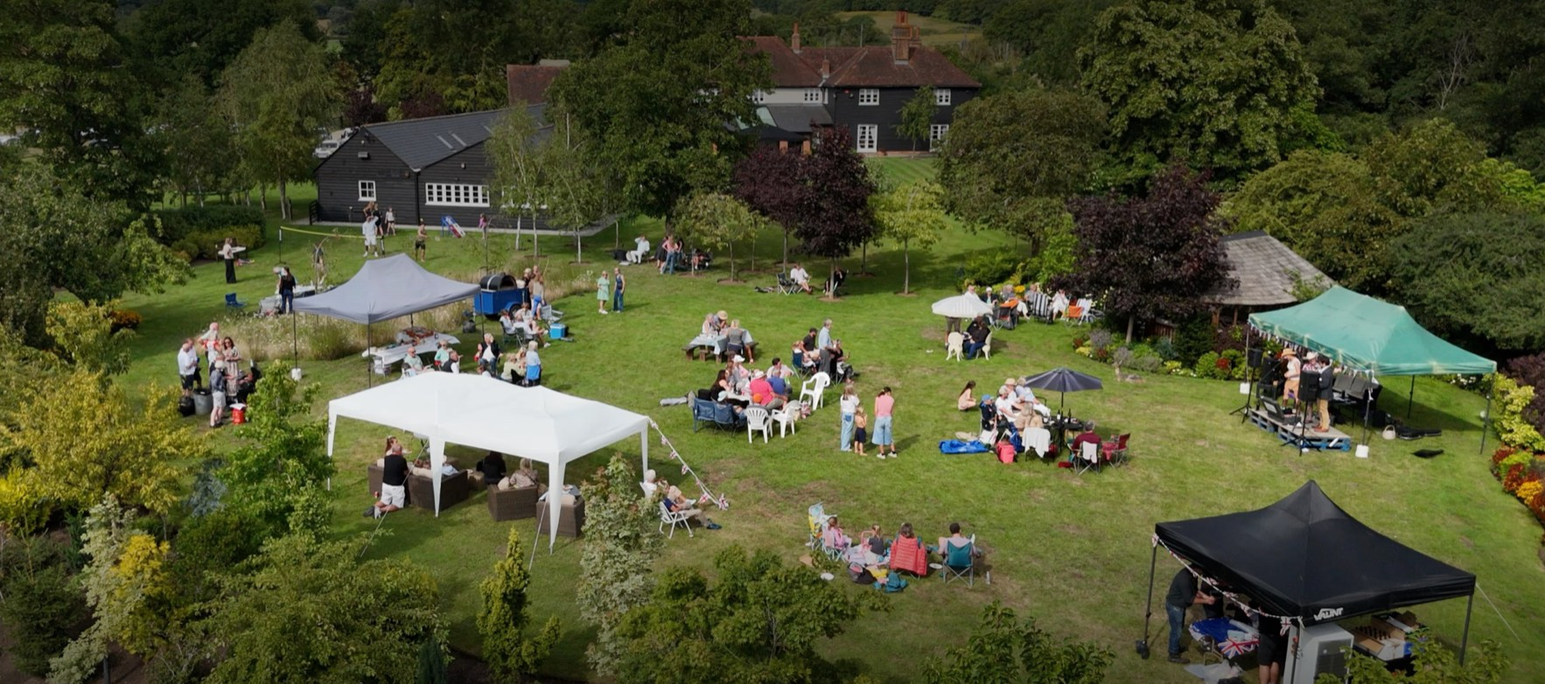
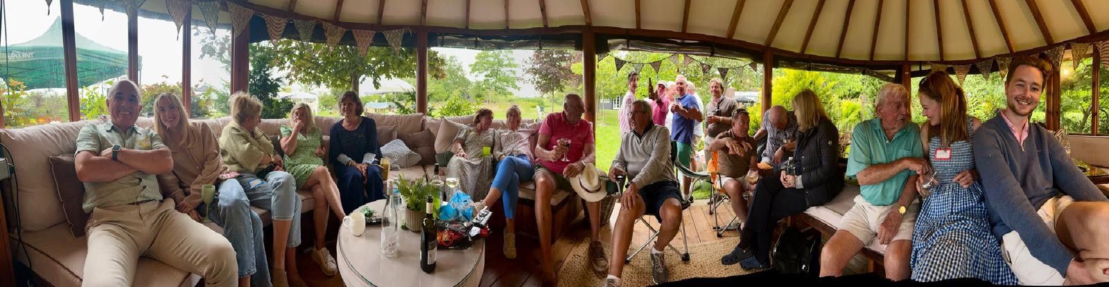

Planning
Councillor Keith Farrow comes from a planning background working for a local authority and oversees monitoring planning applications that could impact our Parish.
Currently we are maintaining a watching brief on the preparation of the Essex Local Minerals Plan that could impact us greatly if it were to proceed. We are expecting to hear more news during 2026.
Our objections presented by Keith to EFDC to the development at Hornes Farm due to the increase in traffic flow around a local accident black spot was unfortunately rejected. As you may have observed the refurbishment and new barns are now being constructed.

Thrift Solar Farm
In our neighbouring Parish of Stapleford Tawney, the residents have set up a fund to engage expert help to argue the case against the development of this solar farm on Tawney Common located behind the Dog House pub. This would be the second such scheme in the area, abutting the Nickerlands Solar Farm development.
Your Parish Council has joined Stapleford Tawney PC in objecting to the scheme and is adding help and support where possible.

