DUNTISBOURNES PARISH COUNCIL
EXTRA ORDINARY MEETING OF THE COUNCIL
TO BE HELD AT 7.00PM ON 8TH AUGUST 2023
IN THE VILLAGE HALL

Welcome
Attendance recorded (anticipated as Parish Councillors Jane Edwards, Valerie Dyson, Mick Lowe, Andy Beckett, Julian Weston) & members of the public
Apologies for absence received accepted to be recorded
Parish Councillor Rupert Lane
Declaration of Interest for matters on the agenda to be invited
Council to note the independent internal auditors report and to agree any actions
Council to re-consider its annual governance statement in relation to 22/23
Council to consider external auditor’s advice regarding independent internal auditor reports
Public Participation to be invited
Council to agree resolution to Council to exclude members of the public/press/members of other Council bodies under Public Bodies (admission to meetings Act 1960) by reason of the confidential nature of the business to be transacted regarding employment matters

Council to consider and agree actions on the above matter
Meeting to be closed
Next meeting matters cfwd
donation to Church – Clerk has referred Councillors to NALC L01-18 financial assistance to the Church
Event for ex-Councillor to be held in September
CIL reserves that need to spent- agenda item for meeting- Clerk to check if able to give to Village Hall for new roof
Emergency plan update
Highways -Centurion garage area

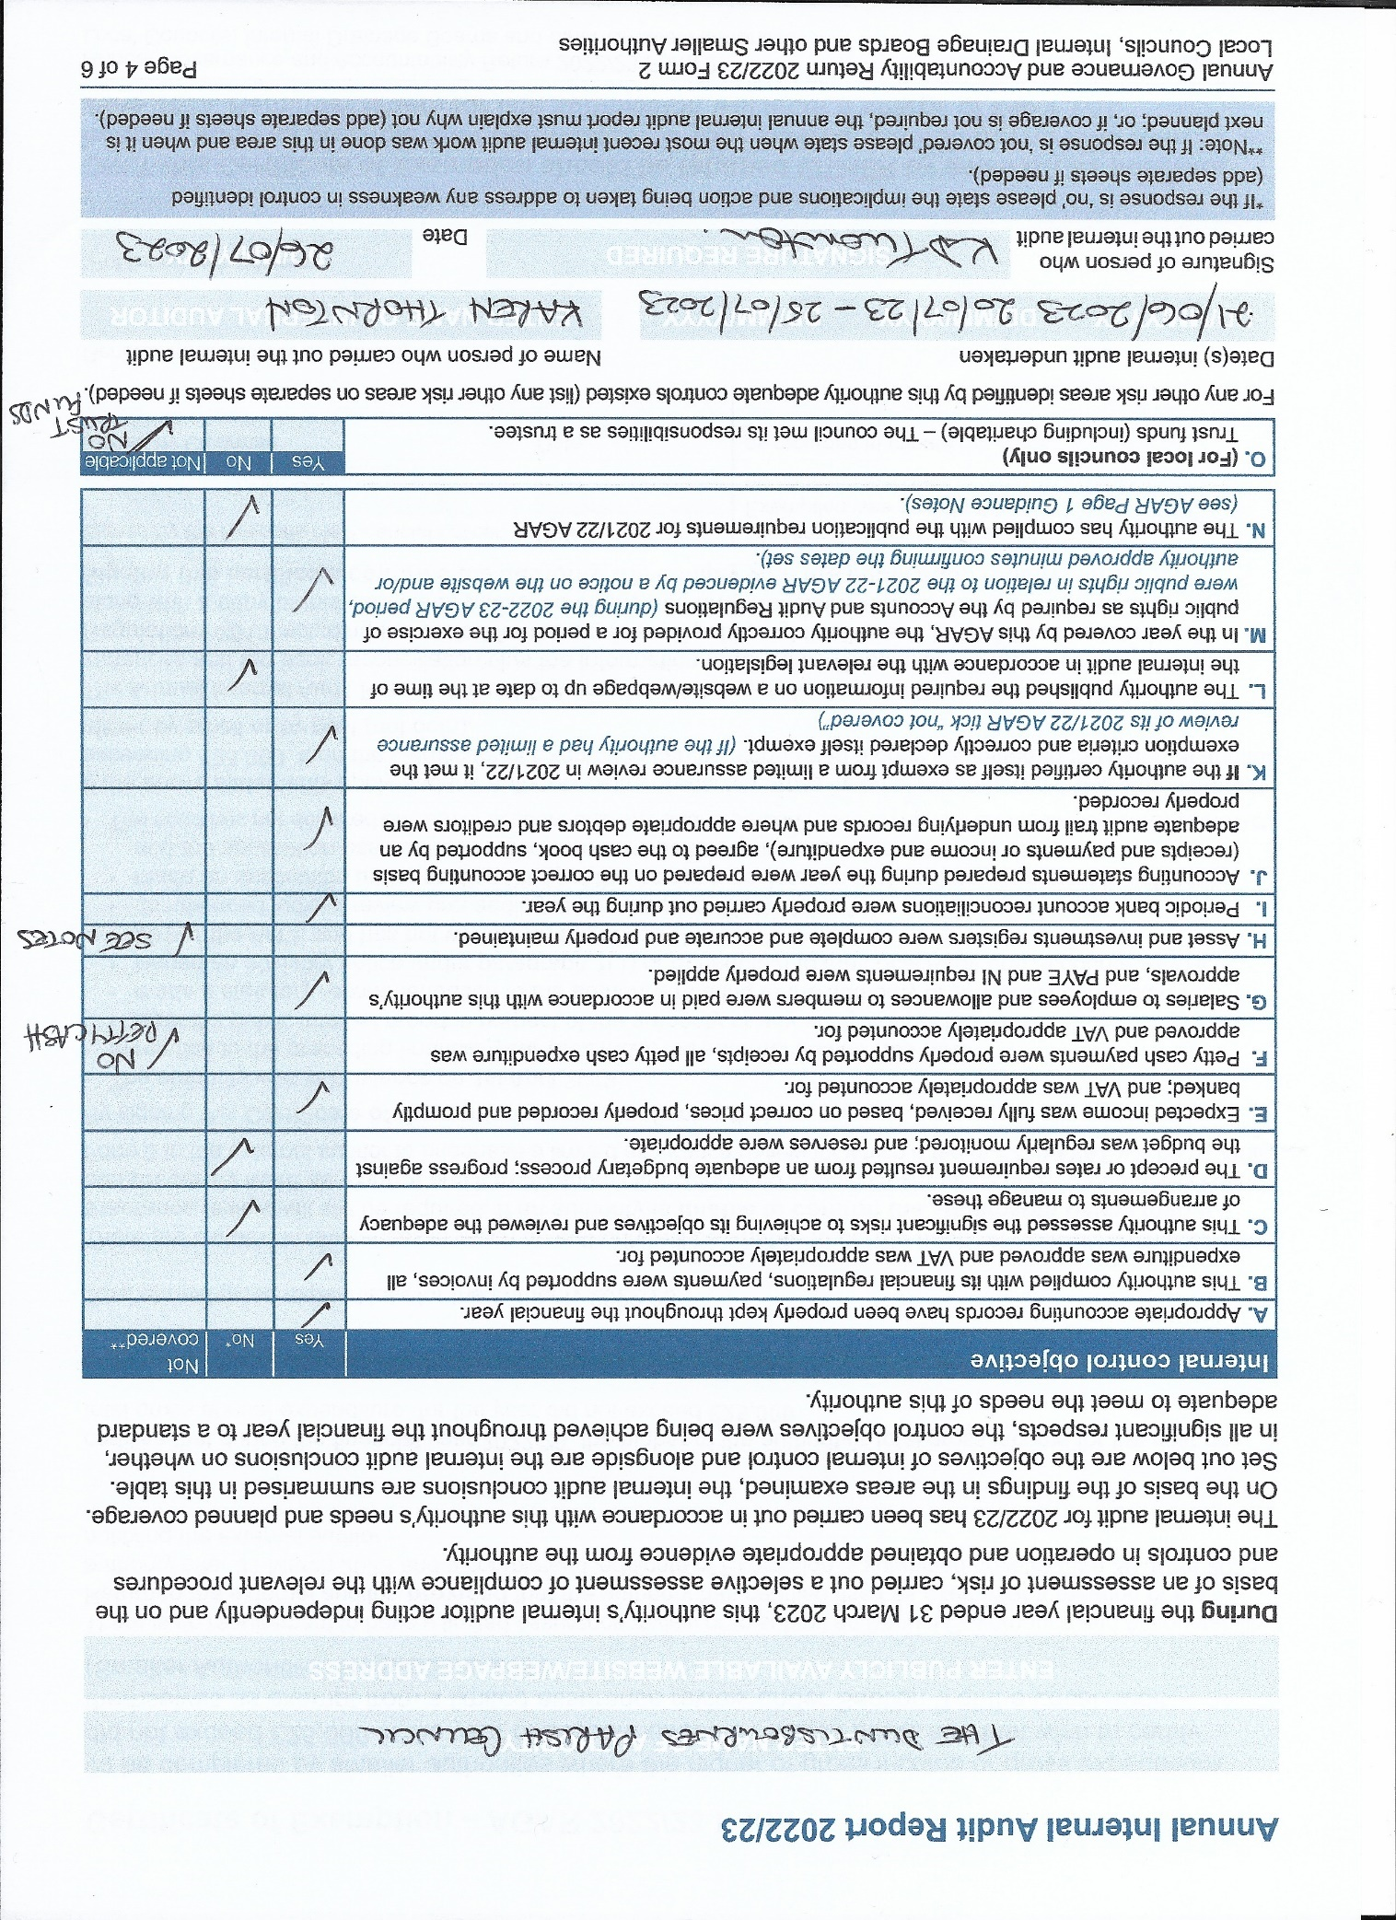

supporting Paper for 2022/23 AGAR Internal Audit Report to The Duntisbournes Parish Council

Clarification of what is covered in this audit:
The Audit is an internal one. It is intended to assist the Council in ensuring adequate internal control arrangements in the year. It is also asked to look at the formal publication requirements within the year. As a result, the 2022/3 checklist looks at financial reports for 22/23, budget setting for 23/24, and legal document publication for 21/22.
Important Note: whilst this is the internal audit to allow completion of the 2022/23 AGAR form it was not carried out at a time which would have been appropriate to help support the council with its internal control responsibilities or enable proper completion of the Governance Statement.
The council should have been in receipt of this audit prior to signing their accounts and the Annual Governance statement. However, the statement and accounts were signed on 24th May 2023 and auditor approached on 25th May 2023. Going forward, if internal audit feedback is to continue being annually only, this must be done prior to signing of the accounts.

Items marked other than yes:
C. Assessing significant Risks:
I have been told that there were discussions surrounding risks for the authority. There is, however, insufficient documentary evidence of these discussions or the conclusions they came to. With the passage of time and/or personnel changes, a continued lack of documentation will hamper the Council’s ability to apply consistency in its planning.
D. Precept setting:
I have found no documentary evidence of the council’s reason for the 10% increase in precept for the 23/4 financial year. Figures presented to the council included significant additions to reserves (already boosted to an adequate level in 22/3) but with very limited detail on their intended use. The total projected spend, including these additions to reserves, still amounted to less than the 22/3 precept. There therefore appears to be no justification for any increase at all in 23/4, let alone one as high as 10%
By the end of the current financial year reserves for this small council, which has committed spend annually of less than £4,000, will be around £12,000. Without a formal and comprehensive plan for their usage I believe this to be excessive.
H. Asset Register:
The council has limited assets. The clerk informed me that these consist of just the bank account and notice boards. Even so, there should be an asset register included with the yearend accounts, particularly given that the council plans maintenance on the Notice Boards. Given that the Council is also establishing a reserve for the Defibrillator maintenance/replacement, consideration should be given to its inclusion on the register also.
L and N. Published information:
The Council has not published evidence of an internal audit since June 2020. Minutes of May 2022 and 2023 both state that the internal auditor is me. 25th May 2023 was the first time I was asked to conduct an internal audit and as such I would like the May 2022 minutes formally corrected please.
The absence of an internal audit report for 2021/2 prevents the end of year publications in May 2022 from being complete (please also see the footnote to these notes on the internal audit for 23/4). Question 6 on section 1 of the Annual Governance Statement specifically asks whether the Council “…maintained throughout the year an adequate and effective system of internal audit….”; in both 21/22 and 22/23 the council’s response clearly should have been ‘no’, but it ticked yes. Question 5 in this same report also makes specific reference to documentation, which I have noted above as lacking.
Karen Thornton July 2023

Note for 23/4 Audit:
Due to an information error at the outset; the lack of time for the auditor, and availability of the Clerk, the July 1st deadline for the 2023 publications has not been fully achieved. This is not relevant to this audit but already means that next year’s audit will also have a “no” for publication compliance.
It should be noted that I do not consider that any of the issues raised require significant changes to resolve them. The purpose of this report is to identify areas where improvement is needed, and I feel certain that this council can deliver those simple changes quickly. I hope that these notes help in that respect.

AGAR advice
Guidance notes on completing Form 2 of the Annual Governance and Accountability Return (AGAR) 2022/23, Sections 1 and 2
• An authority that wishes to declare itself exempt from the requirement for a limited assurance review must do so at a meeting of the authority after 31 March 2023. It should not submit its Annual Governance and Accountability Return to the external auditor. However, as part of a more proportionate regime, the authority must comply with the requirements of the Transparency Code for Smaller Authorities. • The Certificate of Exemption must be returned to the external auditor no later than 30 June 2023. Reminder letters will incur a charge of £40 +VAT for each letter. (done by DPC on 26/6/23)

• The authority must comply with Proper Practices in complete Guidance notes on completing Form 2 of the Annual Governance and Accountability Return (AGAR) 2022/23, Sections 1 and 2

• An authority that wishes to declare itself exempt from the requirement for a limited assurance review must
do so at a meeting of the authority after 31 March 2023. It should not submit its Annual Governance and
Accountability Return to the external auditor. However, as part of a more proportionate regime, the authority
must comply with the requirements of the Transparency Code for Smaller Authorities. (done by DPC)
• The Certificate of Exemption must be returned to the external auditor no later than 30 June 2023. Reminder
letters will incur a charge of £40 +VAT for each letter. (done by dpc)
• The authority must comply with Proper Practices in completing Sections 1 and 2 of this AGAR and the
Certificate of Exemption. Proper Practices are found in the Practitioners’ Guide* which is updated from
time to time and contains everything needed to prepare successfully for the financial year-end.
• The authority should receive and note the Annual Internal Audit Report before approving the Annual
Governance Statement and the accounts. (not done by dpc- however it is always the intention of the RFO to call an extra ordinary meeting on receiving the independent internal auditors report if there are any matters to report or which would call for a revision of the annual governance statement)

• The Annual Governance Statement (Section 1) must be approved on the same day or before the Accounting
Statements (Section 2) and evidenced by the agenda or minute references (done by dpc)
• The Responsible Financial Officer (RFO) must certify the accounts (Section 2) before they are presented
to the authority for approval. The authority must in this order; consider, approve and sign the accounts. (done by dpc)
• The RFO is required to commence the public rights period as soon as practical after the date of the
AGAR approval. (done by dpc)
• Make sure that the AGAR is complete (no highlighted boxes left empty), and is properly signed and dated.
Any amendments must be approved by the authority and properly initialled. (done by dpc)
• Use the checklist provided below to review the AGAR for completeness at the meeting at which it is signed off. (done by dpc)
• You must inform your external auditor about any change of Clerk, Responsible Financial Officer or
Chairman, and provide relevant authority owned generic email addresses and telephone numbers.

• The authority must publish numerical and narrative explanations for significant variances in the accounting
statements on page 6. Guidance is provided in the Practitioners’ Guide* which may assist. (as part of regular minutes)
• Make sure that the accounting statements add up and the balance carried forward from the previous year
(Box 7 of 2022) equals the balance brought forward in the current year (Box 1 of 2023). (done by dpc)
• The Responsible Financial Officer (RFO), on behalf of the authority, must set the commencement date for the
exercise of public rights of 30 consecutive working days which must include the first ten working days of July. (done by dpc)
• The authority must publish, on the authority website/webpage, the information required by Regulation 15 (2), Accounts and Audit Regulations 2015, including the period for the exercise of public rights and the name and address of the external auditor before 1 July 2023.including Sections 1 and 2 of this AGAR and the Certificate of Exemption. Proper Practices are found in the Practitioners’ Guide* which is updated from time to time and contains everything needed to prepare successfully for the financial year-end. (deadline missed see below advice )

Unfortunately, if the Authority is unable to meet before the end of June to approve its AGAR, it would not have not met its statutory requirements for this year. We would recommend holding an extraordinary meeting to meet statutory approval and publication deadlines.

With regards to the Internal Audit which was not undertaken in the previous year the Council should consider the implication of this when answering Assertion 6 of the Annual Governance Statement. Please also ensure that explanations for any “No” responses to assertions are also published with the AGAR once approved.

Reserves reconciliation
 |  | y/e 21 | y/e 22 | y/e 23
Election costs (vired from community plan as agreed by pc in nov 22) | As set by CDC 23/24 | 1000 | 1000 | 1000
GENERAL | Overspend/unplanned expenditure | 63 | 445 | 1918
Community assets | Formerly dog bins and notice bins | 1250 | 1100 | 1550
CiL | 4 years to spend |  | 1121 | 1121
Underspends | identified at financial year end are moved to general or allocated to specific reserve at the beginning of the next financial year
precept | Recommended to be up to 1 year’s precept |  |  | 2500
defibrillators | Maintenance and replacement |  |  | 67
bank balance at year end |  | 2313 | 3666 | 8156

Underspends of £472 are now shown in general reserves

For information
Agreed minutes of
Meeting held on 22nd November 2022 at 7pm
At the Village Hall

Introductions and Welcome from Chair of Council
Council agreed application (Samantha Scott White) for the co-option vacancy and the meeting was paused for signing of appropriate forms and then Samantha was invited to join the Council- Register of members form to be emailed.
Attendance recorded as Parish Councillors Jane Edwards (Chair), Rupert Lane, Valerie Dyson, Eammon Cuthbert,.
Apologies for absence recorded from Parish Councillors Julian Weston & Jamie Eykyn, District Councillor Julia Judd and County Councillor Joe Harris
Declaration of interests from Parish Councillors on matters on the agenda were invited- none
Clerk has previously advised on declaration of interests on matters where decisions may be in the personal/financial interests of individual councillors
Public Session: members of the public were invited to ask questions and raise points of interest on matters on the agenda and then may remain to observe the remainder of the meeting- none
Council approved the minutes of the meeting held on 27th September 2022
T&P forum attended by Cllr Edwards and gave feedback.
Council noted report from District Councillor Judd is sent via email
A417 missing link approved 2023-2027
Council invited report from County Councillor Harris -none
Council considered implications of CDC election recharging policy-
4 yearly elections:
Duntisbourne Abbots £396.19 (50% in 2023 and 100% in 2027)
Duntisbourne Rouse £251.45 (as above) total cost for 2023 £323.81
By-elections can be called at any time and any number of times – Cost for DA=£1562.85 and DR= £1340.95 – chargeable at 50% in 2024, 75% in 2025 and 100% in 2026
Dates of election noted and will be posted on the website/noticeboards
Council approved payment list as discussed
Clerk Expenses £34.92
Council approved the salary increase in line with national agreement and contract of appointment back dated to 1/4/22 with an additional day holiday going forward £62.40
Standing order will need to be reduced to reflect higher level of PAYE being deducted from Jan 23
Council approved financial reports to 28/10/22
Council considered & approved budget and precept for 2023/24 -£8800
Council considered highway matters including
Long Ford update
Council considered any actions that it may wish to take when the work is completed eg voluntary restricting access to the Long Ford
Council agreed that any consultation process before any decision is made with regard to a TRO (prohibition of highway) and funding of such would need to be within precept- no additional provision made in 2023/24 budget
Stopping up does not meet the criteria as it is a class 5 highway
TRO would need be enforced by police
GCC do not feel that the physical blocking is viable
Residents have been asked and there is not a consensus
It was suggested that volunteers may look after it but there are liability issues.
Repair has been undertaken by Glos Highways and now a culvert has collapsed and is waiting repair.
Council may investigate a “listing” – cfwd to next agenda

“Green Pits Lane”- PC agreed it does not wish to take any action on this matter ( a decision should not be revisited within 6 months subject to standing orders)

Local signage for heavy goods vehicle access – email from CC Harris received stating that -Additional signs on the A417 and advisory signs at Tall Trees. Clerk to respond that location suggested is acceptable
Stone troughs as gateway to village (Cllr Dyson)
Council agreed they wished to proceed with “gates” – as a potential CIL project and Clerk to research the costs and steps needed to take the project forward
Planning matters noted/considered
Applications on portal were noted
- Manor farm -Middle Duntisbourne – tiles – permitted
- Erection of single storey extension – amendment to previous application – permitted
- Cotswold farm – solar panels- PC supported
- Replacement windows – Bottom Barn – permitted
- Brewers Cottage – extension -permitted
- Church Farm – extension – PC supported – waiting decision
- Newbold Barn- new plans for planting in front of the barn doors and change of doors – privacy issues raised by resident. Conservation officer has raised concerns. PC has objected previously but wish to object again support the concerns raised by the Conservation Officer.

- Church Farm -Wild life pond 3000mx 30m deep –– waiting decision – delegated report received from CDC officer & statutory consultees have no objections, whilst the PC has already objected. It was felt after lengthy discussion and reviewing of documents that there were no material reasons for submitting to Scrutiny Panel
District Councillor will be advised of the above decision by Chair of Council
- Well-Hill conversion of stables- waiting decision

Any other planning matters

20/04673/FUL | Provision of a new secure roadside truck stop facility, -update from D.C Judd – it was noted that an appeal has been lodged.
Defibrillator update- original scheme included free replacement batteries. Cllr Edwards is to investigate.
Date of next meeting Monday 6th March 2023 at 7.00pm at Village Hall.
Any other business for information sharing purposes followed by close of meeting

Questionaire received from CDC – Dark Sky – Cllr Dyson will circulate and submit on behalf of the Council

Meeting closed at 20.50

Financial reports for November 22 meeting

Bank reconciliation
01/04/2021 | OPENING BANK BALANCE |  |  | 3666.36
 | EXPENDITURE FOR PERIOD |  | 2090.38
 | INCOME FOR PERIOD |  | 8000.00
 | NET EXPENDITURE
as at above | BANK BALANCE AS ABOVE |  |  | 9575.98
as at 31/10/22 | BAL PER S/M |  |  | 9729.98
 | LESS U/P CHEQUES
 |  | 218 | 94.20
 |  | 223 | 59.80
 |  |  |  | 154.00
 |  |  |  | 9575.98

Reserves for information
earmarked reserves |  | y/e 2021 | y/e 2022
COMMUNITY PLAN |  | 1000 | 1000
GENERAL |  | 63 | 445
DOG WASTE BINS |  | 250 | 500
NOTICE BOARD |  | 1000 | 600
CiL | 4 years to spend |  | 1121
bank balance at year end |  | 2313 | 3666

Budget reports
budget to date | BUDGET | ACUTAL YEAR TO DATE | BALANCE AVAILABLE TO SPEND | notes | agreed 23/24
PRECEPT | 8000.00 | 8000.00 |  |  | 8800
CIL RECEIPTS | 0.00 | 0.00
inter account trans | 0.00 | 0.00
wayleave | 0.00 | 0.00
VAT to be reclaimed | 0.00 | 0.00
other receipts | 0.00 | 0.00
 | 0.00 | 0.00
INCOME | 8000.00 | 8000.00 | 0.00 |  | 8400
Clerk salary | 1890.00 | 933.57 | 956.43 | Includes 22 pay award | 2010
ADMIN EXPENSES | 610.00 | 251.84 | 358.16 | wfh+mileage | 400
INSURANCE | 160.00 | 140.00 | 20.00 |  | 160
GRANTS & DONATIONS (church/village hall) | 600.00 | 500.00 | 100.00 | Village events/grants | 1100
payroll costs | 90.00 | 95.40 | -5.40 |  | 100
SUBSCRIPTIONS (GAPTC & open spaces) | 100.00 | 76.22 | 23.78 |  | 100
NOTICE BOARDS & other community assets | 200.00 | 0.00 | 200.00 | Reserves if not spent | 450
GRASS CUTTING/VERGE COSTS | 300.00 | 93.35 | 206.65 |  | 300
DEFIBRILLATORS | 150.00 | 0.00 | 150.00 | Reserves if not spent | 150
AUDIT & LEGAL FEES | 150.00 | 0.00 | 150.00 |  | 150
DOG BINS (remove- moved to community assets) | 250.00 | 0.00 | 250.00 | Reserves if not spent
Change to election costs | 1000.00 | 0.00 | 1000.00 | Reserves if not spent | 1000
to RESERVES | 2500.00 |  |  |  | 2000
TO CIL RESERVES
Expenditure | 8000.00 | 2090.38 | 3409.62 |  | 7920
contingency/balance |  |  |  |  | 880

Points considered- Council wish to make
Provision for CDC election costs-see above
Provision for TRO or funding other highway schemes -none
Cost of Defib pads/batteries approx. £400 – noted and further investigations
Clerk advised that Council does not have the power to make donations to Churches, its grounds or services but Council wishes to make provision for donations for community amenities in the Church/Village Hall
the Council wish to re-allocate funding for community plan to election costs

