The Poulter Brothers

The Poulters and this Council Museum history are intertwined – the Architects designing the first council building and their cousin George set up the successor to this Museum, Camberley Museum which was in the original Council offices. The museum had drawings (sometimes two versions) and photographs. Work varies pen and ink, watercolour, crayon and mixed media.
Their influences are varied, though underpinned with the Arts and Crafts legacy in which Briant was trained. Mix of stules – Queen Anne, Tudor an dVioyesque. The style is retrospective rather futuristic and re-used materails – Tudor beams on their office building, slates etc.

The drawings were passed to the old Camberley Museum – show deterioration due to the acidic card they were mounted on. In 1994 Dr.Twort, a former local resident brought further sketches in , discarded as rubbish during the house clearance at Collingwood Place following the death of historian and museum founder George Poulter.

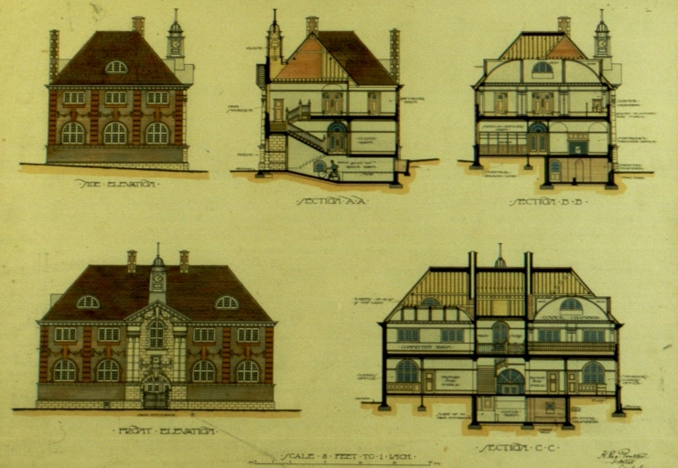

Frimley & Camberley Urban District Council Offices (1903), London Road

Drawings underwent a costly restoration and conservation process of drawings and watercolours.. Designed many buildings, some built, some demolished and some never built – Tekells Castle, turned down St.Tarcisius. BriantsTheir designs were shown at the Royal Academy in Royal Society of Arts and the British Empire Exhibition in 1924.

Their Professional Lives

They set up business in 1903 in 2 London Road (now Thai House) and competed for chance to design the new Frimley UDC Municipal Buildings (only open to local architects) on London Road. It is thought Briant did most of the designs and art work, whilst Harold acted as the business man. The Poulters were responsible for re-facing the front of the building with Tudor style timber work most likely from Norfolk or Suffolk (they were known to use salvaged building equipment).

The drawings on display are mainly Briant’s work, who won a MVO in 1956 from the Queen for his work on Milford Sanatorium (Member of the Royal Victorian Order i.e. a Knighthood). Briant was elected a Fellow of the Royal Society of Arts in 1910 and exhibited at the Royal Academy. Reginald, although a trained architect took on more of the business side.
They designed many large private houses, local Churches, Camberley Heath Golf Club and local shops work; the work was commissioned by local business men, professionals and army officers. Both had many Royal commissions. Briant was responsible for restoration work at Craigwell House, Bognor where George V convalesced in 1929 after contracting sceptaceamia in Nov 1928 and was the Architect for Milford Sanatorium. During the Second World War, Briant was Controller of the Croydon Area War of the Damage Commission. Reginald designed Mulroy House for King Alphonso X111 of Spain and altered Criagmyle at Sunningdale for the Prince of Wales (later Kind Edward V111). He was personally appointed architect to Empress Eugenie at Farnborough Hill.

Their Family Lives

Harry Reginald ((1879) and Briant Alfred (1881) - Poulter Brothers. Their Father was Harry George Poulter, a prominent Lawyer in Camberley and Bagshot who campaigned for Camberley to have its name changed from Cambridge Town in 1877 (due to postal disruption and the forthcoming arrival of the railway). Three other siblings Alfreda, Mary and Horatio (Olympics). The family moved to Surrey House in 1869 (junction of Portsmouth Road and London Road).
Both brothers were educated at Farnham Grammar School and University College, Reading and worked for Reading based Architect firms.As well as professional acclaim they were also great Sportsmen – Reginald became Individual Croquet Champion of England, representing his country abroad and Briant was Secretary of the Camberley Hockey Club and Surrey County Chess Association. They had professional acclaim throughout their lives and died within 8 years of years of each other (Reginald 1966 (Collingwood Place) and Briant 1974 (Warlingham in 91st year). Briant left behind a wife and 3 sons.

