1950’s Britain
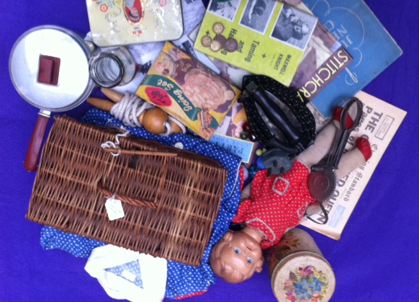

General Information

The 1950’s brought a lot of change for Britain. People became richer, the monarchy changed over, ladies fashion developed, Pop Art first appeared and life slowly got easier for the British people. Between 1945 and 1951 the Labour government increased the number of new houses, signalling a fresh start after a long period of war and recession. On the same day as the coronation of Queen Elizabeth II (2 June 1953), the news that a group of British explorers had climbed to the top of Everest reached Britain. This all helped to make people more hopeful about the years ahead. By 1954 all rationing had come to an end and the increase in available jobs meant people started to have money to spend on luxuries. This created a rise in the purchase of labour saving devises, as people start filling their homes with electrical goods and luxury items. After the coronation, a television became the new must have item.

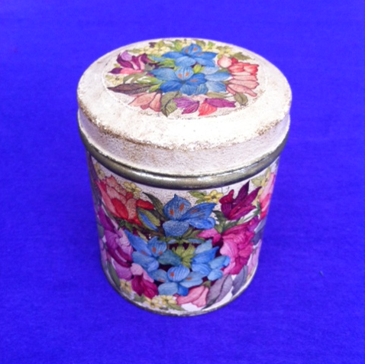
Storage Tin

Storage Tin

This tin was used for storing dry food such as tea or coffee or even perhaps biscuits. Plastic food containers didn’t come to the UK until the 1960s so most kitchen’s in Britain would have stored their food in tins similar to this one.
The 1950s saw a change in how and what people bought and advertising developed greatly in this period. The packaging of products and the design of things for the home became very important in order to attract people to buy them. A new consumer society was born.

Coins
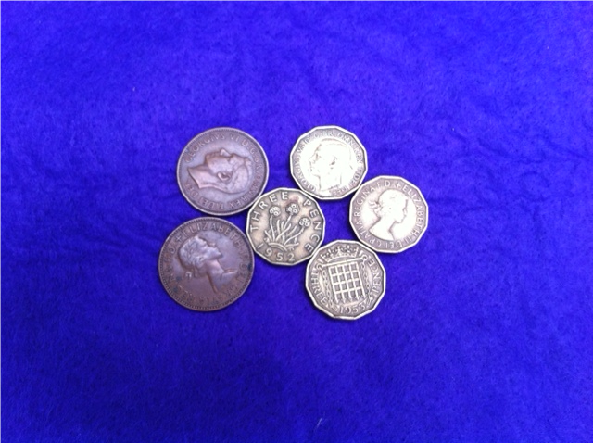

Coins
These coins show us two things about the 1950s.
1. The UK currency was different to what we have today. The coins here are Three Pennies and Half Pennies. Old money was made up of farthings, pennies, shillings, florins, crowns and pounds.
4 farthings = 1 penny
12 pennies = 1 shilling
2 shillings = 1 florin
2 shillings and 6 pence = ½ Crown
5 shillings = 1 Crown
4 crowns = 1 Pound
20 shillings = 1 Pound
Look at the ‘extra money sheet’ to see what some of these looked like.
UK money changed to the decimal currency (what we have today) on 15th February 1971.
2. There was a change of monarchy within this decade. The earlier dated coins have King George VI on them. However, coins dated 1953 onwards have the present Queen Elizabeth II on them. This is because King George died on 15th February 1952 and his eldest daughter, Elizabeth, succeeded him to the throne.
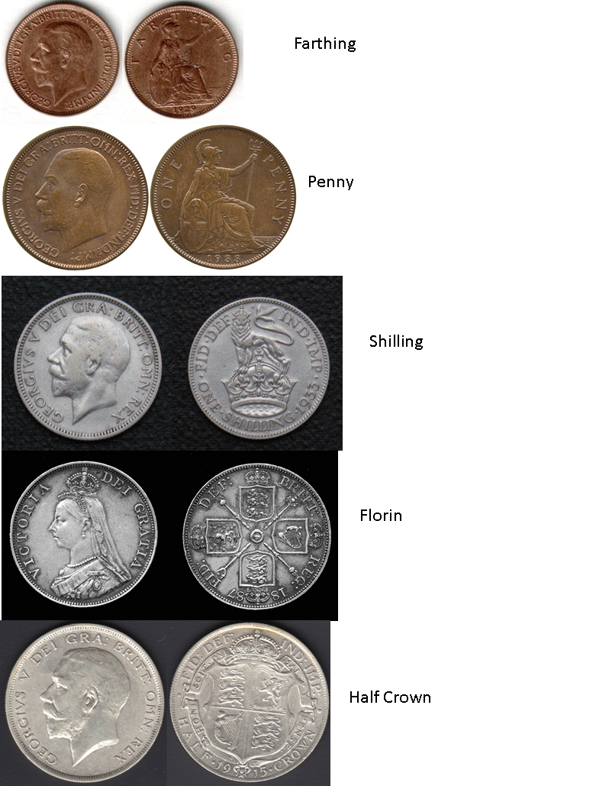
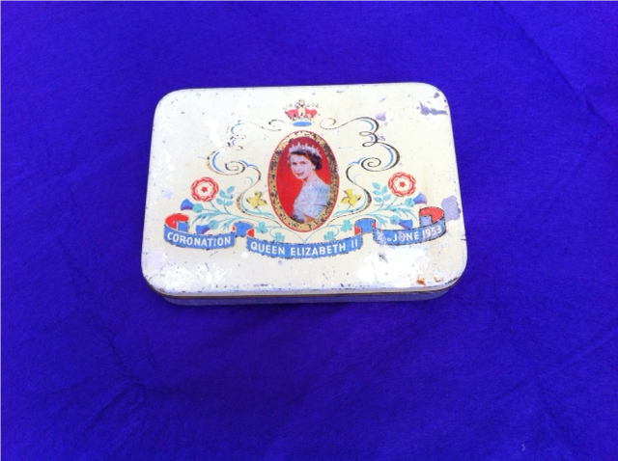
Coronation Tin

Coronation Tin

On the 2nd June 1953 Queen Elizabeth II was crowned at Westminster Abbey.
It was a very exciting time for the people of Britain and many people had coronation parties. Rationing was still in place, but to celebrate the coronation everyone was allowed an extra pound of sugar and four ounces of margarine. It was also the first time that a coronation had been on TV and so many purchased televisions for the first time just to watch it. If you didn’t have a television yourself, you went around to a friend’s house to watch it. Television though was still in black & white.
Coronation merchandise, like this keep sake tin, was produced to celebrate the event.

Doll
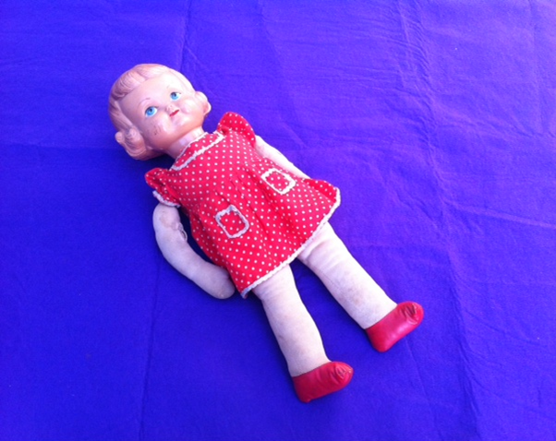
Doll

Dolls have been around for thousands of years and used all over the world. In Victorian times dolls weren’t actually intended for playing with, but were made as ornaments, dressed in fabulously detailed clothes of the period. However, as toys got cheaper, dolls became more of a toy item than an ornament and many dolls were bought for girls to help them learn the skills of motherhood.
The image of dolls changed considerably in the 1950s. Dolls in the early 1950s represented young girls, however by the late 1950s and early 60s dolls portrayed glamorous teenagers with a variety of clothes to try on. Little girls could dress their dolls with "grown-up" ball gowns, party dresses and casual wear that were smaller versions of teen-age glamour of the late 1950s.

This early 1950s doll was made by the Palitoy company. Her body is made from cloth but her head is made from Celluloid with a painted face and hair. Celluloid was an early form of plastic which was invented in the USA in the 1860s. It was mainly used to make doll’s heads and bodies, but also for combs, cutlery handles and costume jewellery. It was very brittle and highly flammable and so is not used today.

Please pass around with adult supervision.
Her head is brittle and slightly damaged.
Please do not pick her up by her arms.
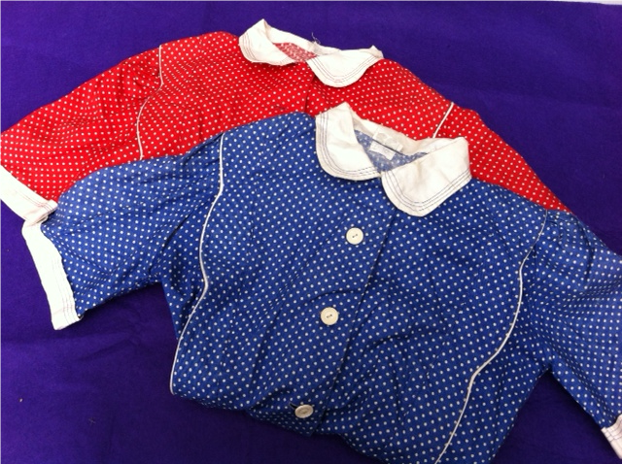
Girls’ Dresses

Girls’ Dresses

Fashion in the 1950s varied greatly from the beginning to end. Maybe not quite as extreme as the 60s, 1950s fashion saw the introduction of many new styles as well as many styles that had been around in the 1920s. Hollywood was also very influential on fashion in the 50s and many film stars like Marilyn Monroe, James Dean and Audrey Hepburn set fashion trends.

The 1950s was when teenagers became an emerging fashion voice. Fashion was changed greatly by the arrival of teenage culture with its own development of style and spending. Until then, it had been fashionable to be between the age of thirty and forty and girls up to 18 years often dressed and made themselves up to look as old as their mothers.

However, in the 1950s younger children started to have fashionable clothes. These dresses are examples of the kind of style of clothing girls would have worn. Most girls wore patterned dresses and boys wore shirts and trousers. Here is a good website showing the development of children’s fashion through the 50s. www.thepeoplehistory.com/1950skidsfashion.html

These can be tried on with adult supervision

Hand-Cranked Egg Beater
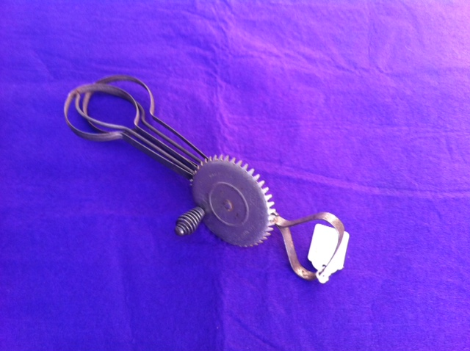

Hand-Cranked Egg Beater

Although electric mixers were available, most 1950s households still used the old style of hand-cranked mixer as these were cheaper to buy.
Eggs were rationed up til 1953. Not being allowed eggs for so long meant that once rationing was over they were used in nearly everything. They were a big part of people’s diet and most recipes contained eggs.

You can turn the handle on these but please be gentle and mind yours and other people’s fingers.
Icing Set
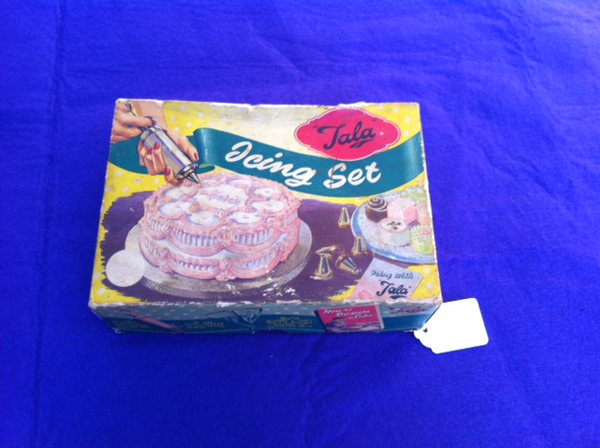

Icing Set

Icing cakes became very fashionable in the 1950s. It was a way of showing off your baking talents. Box covers, recipes, and home-making magazines showcased elaborate cake shapes and designs, and tools started to be available for you to create these at home.

You can still buy icing sets today, but they are mainly made of plastic. In the 1950s they were made of metal.

Please be gentle with both the box and its contents
Electric Iron

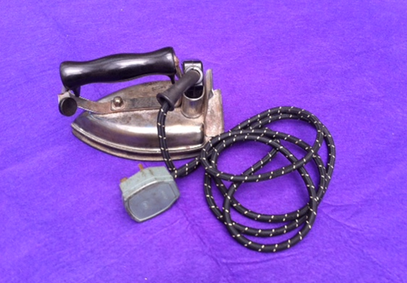

Electric Iron

Electric irons were first used in the 1930s, but did not become used by every household until the 1950s. Having electric powered irons meant that ironing was less hard work. Before electric irons, flat irons had to be heated on the stove and would start to cool as soon as they were used. Having the electricity meant that the iron would stay hot throughout the ironing process. The iron was one of many new labour saving devices which became popular in the 1950s. Other were the vacuum cleaner and the washing machine.

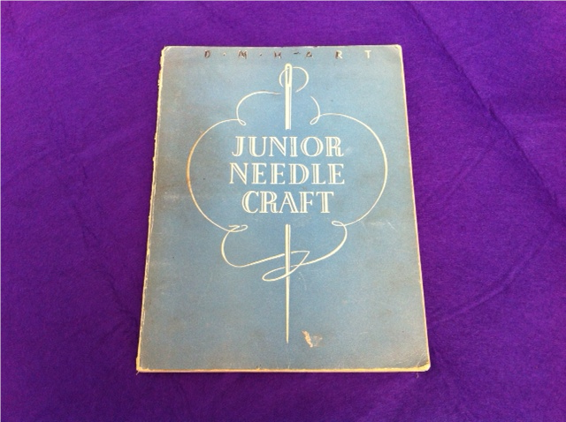
Children’s Sewing Book

Children’s Sewing Book

Girls were taught to sew in schools and sewing was often something they did for entertainment – remember most children didn’t have a television in their house and if they did there wasn’t much on TV aimed at them.
Teenagers often made their own clothes using bought patterns. There was a lot more material available since the war and so bright colours and patterns were fashionable.

Maxwell Knight Book
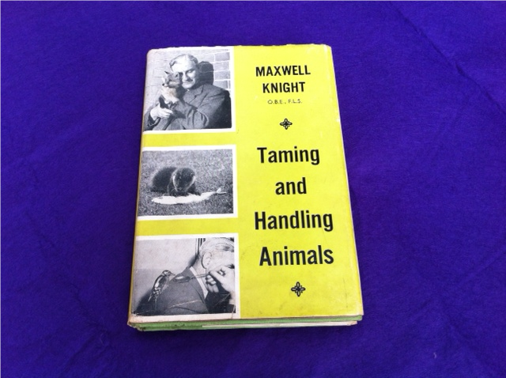

Maxwell Knight Book

This book was written by local naturalist (someone who studies nature) Maxwell Knight to accompany his very popular radio programmes, Naturalist, Country Questions and Nature Parliament. He also appeared occasionally on television in Peter Scott's ‘Look’ and Animal, Vegetable or Mineral, published 34 books and wrote magazine articles.

During World War Two he was a British spy and so came to Camberley to live in a safe house.

Milk Bottle
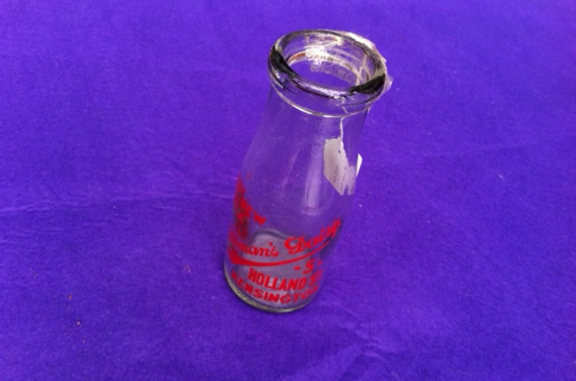

Milk Bottle

Milk bottles in the 1950s were made of glass and they had a thin metal lid. They were delivered to your doorstep everyday by a milkman who drove a milk float or a horse drawn cart. He usually came very early in the morning, whilst everyone was still sleeping, so that you would have fresh milk for your breakfast.

Nearly all people had their milk delivered to their house rather than buying it in a shop. They were expected to rinse out the milk bottle once it was empty and then leave it on the doorstep for the milkman to collect the next morning. The bottle would then be taken to a bottle washing factory before returning to the milk factory to be refilled with milk. The name of the milk factory was printed on the bottle so that they knew where to send it.

When the milk was put in the bottle, a little bit of cream would form at the top. Children in each house would often argue over who would get the creamy bit of the milk. However sometimes you might find that the birds had got the first; pecked a hole in the lid and drank the cream.

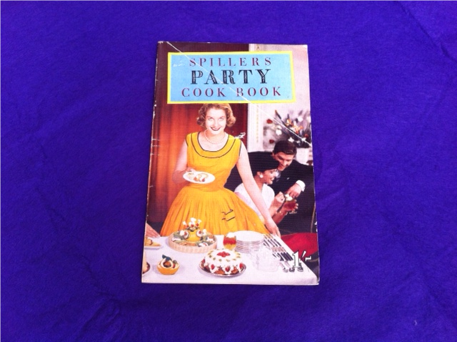
Party Cook Book

Party Cook Book

This book has lots of instructions and tips about putting on a dinner party. People wanted to show off to their friends by having the best food and the best parties. Dinner parties became fashionable in the 1950s, particularly later on in the decade when rationing stopped and more food became available. Cooking, fashion and entertaining (having friends around for a party) was very influenced by America and you can see throughout this book that ideas have been taken from what American people were doing. For example on page 14 the word ‘cookies’ is used.
It wasn’t just about the food. Making sure that everything looked good (page 5) and that your guests had fun were also important. This book even gives suggestions of how to keep the kids happy (page 6).
We also know that this book is from the late 1950s because it has a section on ‘TV Snacks’. Not many households had a TV until later on in the decade.

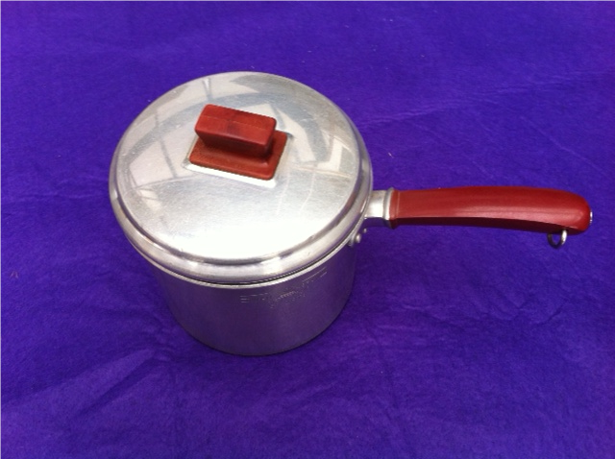
Sauce Pan

Sauce Pan

In the 1950s more and more people were using electric cookers rather than heating things on the range or stove. This meant that sauce pans could be made lighter by using aluminium, a newish metal, rather than the heavy iron ones that had been used before. Aluminium, apart from being a lighter metal than iron, was a great conductor of heat, which meant that it would stay hotter for longer. They were also a lot easier to clean than the iron ones.

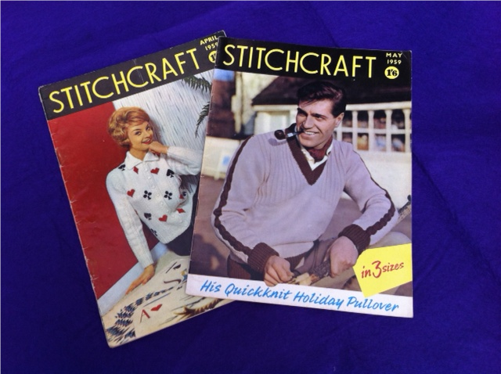
Knitting Booklets

Knitting Booklets

Knitting clothes become fashionable in the 1920s so by the 1950s a knitted jumper was an everyday item of clothing. Women (as very few men would have knitted) could buy and follow patterns, in order to make certain items or designs. New colours and styles became available and many thousands of patterns went on sale to make fashionable designs in bright colours. The twinset was an extremely popular combination for the home knitter. It consisted of a short-sleeved top with a long-sleeved cardigan in the same colour, to be worn together.
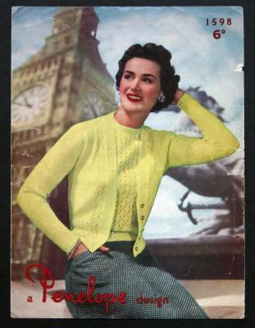

Coronation Newspaper
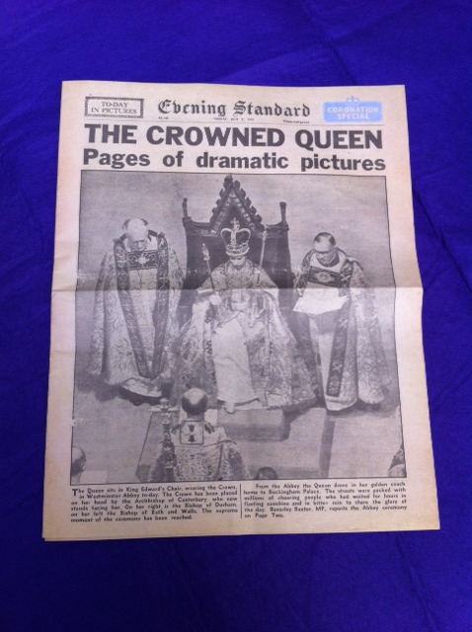
Coronation Newspaper

On the 2nd June 1953 Queen Elizabeth II was crowned at Westminster Abbey.
This newspaper was printed in 1953. It is a special coronation edition full of photographs. Unlike today, all these photographs are in black and white. It was the only way for people to see the coronation if they did not have a television so lots of people would have bought it.
The newspaper is in very good condition because whoever owned it kept it in a safe place as they felt that it was a very special moment in history.

Please be careful with this item. We would like keep this newspaper in as good a condition as its owner has since 1953.

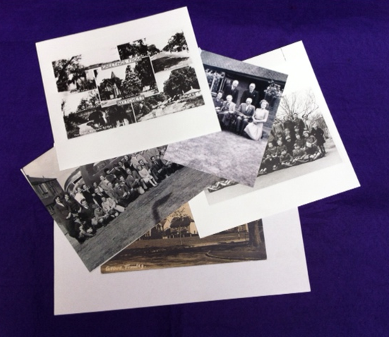
Local Photographs
Local Photographs

Here is a collection of local photographs all taken in the 1950s. Photographs could only be taken in black and white then. Look at places you might recognise. Do they look different or the same? Look at what people were wearing then too.

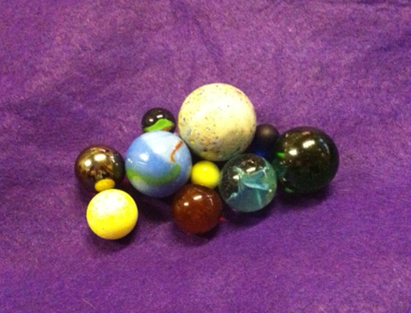
Marbles

Marbles

No one really knows where marbles originated from. They have been found in ancient civilisations all over the world. The first marbles were simply stones that had been polished smooth by a running river. Next, people made them by hand from clay, this was done up until 1884 when they were first mass produced in America. Then, in 1915, marbles were made out of glass.
Marbles were a popular playground game in the 1950s. Just like today, marbles came in different sizes and colours. Children in the 1950s would buy them with their pocket money. There were many different games you could play with marbles and no one set of rules. Girls were often more interested in collecting them rather than playing with them, because of their pretty patterns and colours. The big ones were called ‘Dobbers’.

You can play with these.

Skipping Rope
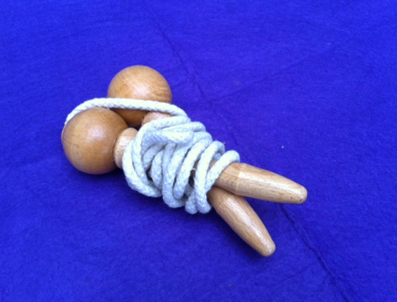
Skipping Rope
Skipping was very popular with children in the 1950s, particularly with girls. You could skip alone or in threes with two turning and one skipping, or in a large group. Whilst skipping children would chant rhymes (see extra sheet for some of the rhymes children used to chant). It kept children fit and entertained them in the playground.

This is a replica so you can play with it.
Skipping Rhymes

All in together girls,

Very fine weather girls

When I say your birthday

please run out.

January, February, March etc.

‘Teddy bear, teddy bear, turn around,

Teddy bear, teddy bear, touch the ground,

Teddy bear, teddy bear, go upstairs,

Teddy bear, teddy bear, say your prayers,

Teddy bear, teddy bear, switch off the light,

Teddy bear, teddy bear, say goodnight,

Goodnight, teddy bear, goodnight.’

‘Polly in the kitchen,

Doing a bit of stitching,

In came a bogeyman,

And frightened her away!’
Skipping Rhymes

‘Jelly on a plate,

Jelly on a plate,

Wibble wobble,

Wibble wobble,

Jelly on a plate.’

Sausages in a pan,

Sausages in a pan,

Turn them over,

Turn them over,

Sausages in a pan’.

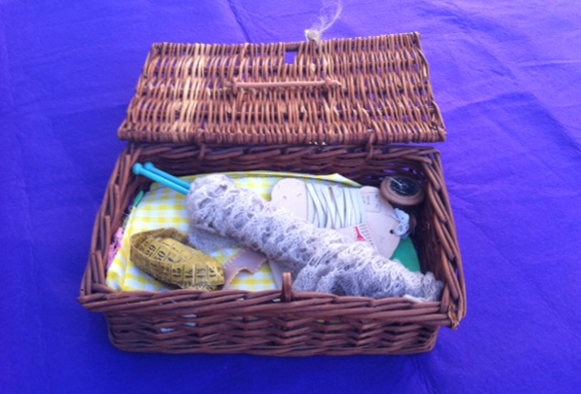
Sewing Box

Sewing Box
Nearly every household in the 1950s would have had a sewing box. Knitting and sewing was an important skill to have so that you could repair and make your own clothes. This was cheaper than buying them from a shop, and so girls were taught to knit and sew in school.
Knitting and sewing became very popular after the war years because better colours and styles of yarn and wool became available.
Magazines such as Pins and Needles in the UK showed not just clothes patterns, but also blankets, toys, bags, lace curtains and items that could be sold for profit.

Activity Idea
Write a poem about one of our objects
Why not write an acrostic poem about one of the object in our loans box. An acrostic poem takes a word, and then uses each letter in this word to start a line of poetry.

- Write the name of the object vertically on the left hand side of the page.
- Start each line with a word that begins with the letter on that line.
- Each line should describe the chosen object.
- These poems do not need to rhyme, or line length, so you can relax and have fun writing.

The why not draw the object next to your poem.

