STURMER PARISH COUNCIL
Ian Brown 72 St. Edmunds Fields
Locum Parish Clerk & Responsible Financial Officer Dunmow, Essex, CM6 2AN
Email: clerk@sturmer-pc.gov.uk Tel: 07913 514 589

Minutes of the ANNUAL COUNCIL MEETING OF STURMER PARISH COUNCIL held at STURMER VILLAGE HALL on 14 MAY 2024 AT 6:45 PM

COUNCILLOR | IN ATTENDANCE
Cllr David Porth - Chairman | YES
Cllr Alan Carter | YES
Cllr Terrie Jones | YES
Cllr Coral Fordham | YES
Cllr Sean Mercer | YES
VACANCY
Dist Cllr Diana Garrod | YES
Cnty Cllr Peter Schwier | NO – BDC Planning meeting
Locum CLERK – Ian Brown
5 Member(s) of the public

24/001 | RECEIVE NOMINATIONS FOR CHAIRMAN, VOTE TO APPOINT CHAIRMAN FOR 2024-2025  RESOLUTION – Cllr David Porth duly nominated and appointed; Proposed Cllr Alan Carter, Seconded Cllr Terrie Jones  24/001(i) – RECEIVE NOMINATIONS FOR VICE CHAIRMAN, VOTE TO VICE CHAIRMAN FOR 2024-2025  Council decided to not appoint a Vice Chairman but to appoint a meeting Chairman as and when required in the current Chairman’s absence
24/002 | CLLRS ACCEPTING THE OFFICE OF CHAIRMAN AND VICE CHAIRMAN TO SIGN THE APPOINTMENT BOOK AND ACCEPTANCE OF OFFICE (FOR SUBMISSION TO BDC)  Duly completed and signed
24/003 | NOTE AND VOTE TO APPROVE APOLOGIES FOR ABSENCE  None given
24/004 | CO-OPTION PROCESS-  RECEIVE REPRESENTATION FROM THOSE STANDING FOR CO-OPTION AND WISH TO BE CONSIDERED FOR APPOINTMENT TO THE COUNCIL  As candidates had already submitted their applications they were not required to repeat themselves  MEMBERS TO ASK ANY QUESTIONS TO CLARIFY THE REPRESENTATION FROM THE CANDIDATES  Councillors had no further questions for the candidates
24/005 | CANDIDATES ASKED TO LEAVE THE ROOM  COUNCIL TO CONSIDER REPRESENTATION(S) FROM THOSE STANDING FOR CO-OPTION AND VOTE ACCORDINGLY  Members discussed the merits of candidates, recognising they could only co-opt two new Cllrs this evening leaving the third vacancy co-option process until the next meeting
24/006 | INVITE CANDIDATES TO RETURN TO MEETING ROOM TO HEAR COUNCIL’S DECISION  Members voted unanimously for both Mrs Coral Fordham and Mr Sean Mercer but looked forward to the next round of co-option
24/007 | CANDIDATES DULY CO-OPTED TO COMPLETE AND SIGN ACCEPTANCE OF OFFICE DECLARATION  Completed and signed by candidates and the Clerk  24/007(i) – CO-OPTED CLLRS TO RECEIVE REGISTER OF INTEREST FORM TO COMPLETE AND SUBMIT INDEPENDENTLY TO BDC  Clerk to circulate  24/007(ii) – ALL CLLRS TO BE INVITED TO REVIEW THEIR REGISTER OF INTEREST AND ADVISE BDC ACCORDINGLY OF ANY AMENDMENTS  Cllrs noted  DULY CO-OPTED CLLRS TO BE INVITED TO JOIN THE MEMBERS  Both new members joined their fellow cllrs at the meeting table
24/008 | APPOINT REPRESENTATIONS FOR 2024-25  FOOTPATHS – All Cllrs  FLOOD ACTION GROUP – Cllr Alan Carter  PLAY AREA – As Parish Maintenance  PARISH MAINTENANCE – Cllrs Sean Mercer, Alan Carter and David Porth  WAR MEMORIAL – As Parish Maintenance  VILLAGE HALL & DEFIBRILLATOR – Cllr Terrie Jones  HIGHWAYS – Cllr Coral Fordham
24/009 | WITH REFERENCE TO THIS AGENDA MEMBERS ARE INVITED TO DECLARE ANY DISCLOSABLE PECUNIARY INTERESTS, NON-REGISTRABLE INTERESTS AND OTHER REGISTRABLE INTERESTS  None declared
24/010 | APPROVE THE MINUTES OF THE MEETINGS HELD ON TUESDAY 02 APRIL – 2024  RESOLUTION – Minutes of the meeting held 02 April 2024 approved; Proposed Cllr Alan Carter, Seconded Cllr Terrie Jones
24/011 | PUBLIC PARTICIPATION SESSION  This provides an opportunity for members of the public to raise questions and comment on items on the agenda or of import. Time for this session is limited to 15 minutes (03 minutes per person)  - Continual flooding issues  - Continual Speeding vehicles  - Continual inadequate / blocked drainage issues
24/012 | RECEIVE COUNTY & DISTRICT COUNCILLORS REPORTS  Dist Cllr Diana Garrod-  Full reports APPENDIX A
24/013 | RECEIVE CLERK'S REPORT & NOTE CORRESPONDENCE  Most matters covered by the Agenda items, however, council are urged by BDC to consider the parish pot and its spending before 2027 deadline
24/014 | FINANCE – RECEIVE FINANCIAL STATEMENT - AGREE PAYMENTS  Finance statement to be attached at APPENDIX B  RESOLUTION – Approve finance statement and payments; Proposed Cllr Alan Carter, Seconded Cllr David Porth  24/014(i) - APPOINT AUTHORISER  Cllr Alan carter  24/014(ii) – CONFIRM CLLRS NOTED RECONCILED BANK STATEMENT  Confirmed  24/014(iii) – CONFIRM ASSET REGISTER REVIEW  Reviewed to date, add item to next agenda to consider items on Amenity Walk  24/014(iv) – CONFIRM RISK REGISTER REVIEW  Confirmed review  24/014(v) – MEMBERS TO CONFIRM RECEIPT OF INTERNAL AUDIT REPORT  24/014(vi) – COMPLETE AND SIGN EXEMPTION CERTIFICATE – CLERK to SUBMIT  24/014(vii) – RECEIVE AND APPROVE GOVERNANCE STATEMENT  24/014(viii) – RECEIVE AND APPROVE ACCOUNTING STATEMENT  RESOLUTION – Council received and approved all Audit items; Proposed Cllr David Porth, Seconded Cllr Terrie Jones  CLERK to submit documents to PKF Littlejohn and place on the PC website  24/014(ix) – APPROVE CLERK TO MAKE PAYMENTS DURING PERIODS COUNCIL DOES NOT MEET  RESOLUTION – Approve Clerk to make payments during periods council do not meet; Proposed Cllr David Porth, Seconded Cllr Alan Carter  24/014(x) – RECEIVE UPDATE ON STREET LIGHTING ENERGY SUPPLIER OPTIONS  Awaiting comparative offer from new proposed supplier  24/014(xi) – CONFIRM PERIOD FOR THE EXERCISE OF PUBLIC RIGHTS  Clerk / RFO to produce Notice, proposed commencement 03 June
24/015 | CONSIDER APPLICATION(S) FOR THE POSITION OF CLERK & RFO, AGREE NEXT ACTION  Under review
24/016 | REVIEW & COMMENT ON CURRENT PLANNING APPLICATIONS/APPEALS  Ref. 24/00920/HH  Erection of a two storey rear extension - 14 Abbotts Cottages , The Street, Sturmer  Comment date – 29 May 2024  NO COMMENT
24/017 | RECEIVE ANY FEEDBACK FROM SITE MEETING WITH REPRESENTATIVES FOR THE LAND REAR OF ROWLEY COTTAGES  Proposed removal of 70 dead trees, following thorough survey of the ecology of site, intention to turn land into wildlife reserve area. Does not require a felling licence as dead trees, BDC has checked the site; work not to occur during bird nesting season. All works to date completed responsibly, expectation is for future works to be completed similarly. Assurances given that the area is to remain a piece of woodland / wildlife sanctuary in perpetuity.
24/018 | RECEIVE REPRESENTATIVES REPORT:  a) Footpaths – Hedge by War Memorial needs cutting back, CLERK to contact owner  b) Flood Action Group – Report APPENDIX C  c) Play Area – Annual inspection this time of year; a suggestion to replace grass area with rubberised safety surfacing using S106 funds  d) Parish Maintenance – Contractor cuts grass, previously identified tree works almost completed  e) War Memorial – General maintenance only required, tidying up  f) Village Hall – 15 June D Day hall open for refreshments  [f](i) – Defibrillator function – Working OK  g) Highways – Random potholes repaired.
24/019 | RECEIVE UPDATE ON ST MARY’S CHURCHYARD CLOSURE  No further update to report
MOTION TO BE AGREED - Approve exclusion of the public
Members of the public will be asked to leave the meeting for the next item, Exclusion of Public and Press - Under Section 100(A)(4) of the Local Government Act 1972, the public be excluded from the meeting whilst discussion takes place on the following item on the grounds that they involve the likely disclosure of exempt and commercially sensitive information

RESOLUTION – Public asked to leave the meeting for this item; Proposed Cllr Alan Carter, Seconded Cllr Terrie Jones
24/020 | RECEIVE UPDATE ON THE VG52 LAND SALE PROPOSALS  Update shared
MOTION TO BE AGREED – Approve readmission of the public
Members of the public to be readmitted to the meeting

RESOLUTION – Public invited to return to the meeting, suggested exclusion item be removed from future agenda; Proposed Cllr David Porth, Seconded Cllr Alan Cater
24/021 | CONFIRM COUNCIL MEETING DATES FOR 2024  Tuesday(s) 25 June, 30 July, 10 Sept, 22 Oct, 03 December all at 7:30pm
24/022 | ITEMS OF REPORT TO BE NOTED OR ADDED TO NEXT COUNCIL AGENDA  Co-option plus any other items mentioned in these minutes
24/023 | DATE OF NEXT MEETING - 25 June 2024 – CLOSE – 8:48pm

Signed……………………………………………………………………………………………….Date………………………………….

APPENDIX A

District Councillor's Report to Parish Councils May 2024
Cllr. Diana Garrod - Bumpstead Ward

Scheduled Temporary Traffic Regulation Orders & Roadworks
Intended closure of Wiggens Green, Helions Bumpstead on 3rd May 2024 for one day. The closure is required whilst Openreach undertakes pole testing. https://one.network/?tm=137394156

Intended closure of Finchingfield Road, Steeple Bumpstead 2nd to 10th May and 17th to 21st May. Road Surface works. https://one.network

The closure of Ains Ford Road, Sturmer, which commenced on 10th April 2024 and is in force for up to 21 days (It is estimated to be completed on 26th April 2024. Closure is required whilst Essex County Council undertakes flood damage. These works are being undertaken as an emergency, please check https://one.network/?tm=138414452.

Intended closure of the B1057 Haverhill Rd, Steeple Bumpstead from 20th May to 13th September whilst Anglian Water undertakes works. https://one.network – “permit granted and works about to start”.

PFCC Election
Elections are taking place this Thursday 2 May 2024 where residents can have their say on who the Police, Fire and Crime Commissioner (PFCC) for Essex will be. Photo ID continues to be required to vote at a polling station (original versions and not a photocopy). Accepted ID includes a passport, driving licence, blue badge, a proof of age card, travel concessionary cards, Biometric Immigration document, Defence Identity Card or National Identity Card. A full list of accepted ID is available on the Electoral Commission website: https://www.electoralcommission.org.uk/voting-and-elections/voter-id/accepted-forms-photo-id

New Chairman of Braintree District Council
Braintree District Council has announced Cllr Lyn Walters as its new Chairman for 2024-25 at its Annual General Meeting (AGM) on Monday, 22 April 2024. Cllr Lyn Walters is the ward member for Bocking Blackwater, has been a councillor since 2011. Any organisations, community groups or businesses that would like to invite the Chairman to attend an event should visit www.braintree.gov.uk/invitethechairman.

My new role is Deputy Cabinet Member to the Deputy Leader of BDC & Cabinet Member Cllr. Tom Cunningham; the Cabinet Member for Transformation, the Environment &
Customer Services. I will also be the lead member for climate change and sustainability.

Analogue Phone Lines Switching to Digital
The UK's telephone network is changing. By 2025, traditional phone lines will be replaced by a digital landline service. This means that calls will be made over a broadband line. More information at: https://www.essex.gov.uk/news/2024/your-home-phone-ready-go-digital
https://www.gov.uk/guidance/uk-transition-from-analogue-to-digital-landlines

Essex Police Talk Road Safety with Motorcyclists at Finchingfield
On Sunday 14 April, the Stanway-based Roads Policing officers were joined by colleagues from the Road Crime Team as they travelled the Braintree and Uttlesford districts’ motorcycle routes, focussing on four specific offences known as the Fatal Four and used this opportunity to advise riders how they can keep themselves safe. Head of Essex Police's Roads Policing said “Finchingfield’s a community that sees a great deal of traffic through their village because of the picturesque views, so we wanted to reassure them that we were proactively patrolling the district to tackle road safety in general, and the safety of vulnerable road users in particular. I’d encourage everyone to play a part in keeping all our roads safe for everyone so we can share them safely”.

BDC Adopts LGA Model Code of Conduct
At the AGM held 22nd April 2024, BDC adopted the LGA Model Code of Conduct with immediate effect. The Committee on Standards in Public Life carried out a review on Local Government Ethical Standards and published a series of recommendations to Government, the Local Government Association and to local authorities. In response to one of those recommendations, the LGA published a model Code of Conduct for Councillors. This was originally published in 2020 but has been subject to updates by the LGA since
that time.
Essex County Council, together with the majority of other Essex authorities have now adopted the new model Code over the past 18 months, and it is understood that the few remaining Councils in Essex plan to do so in the near future. The Model Code is a document which authorities are, nationally, being asked to adopt, however, it should be noted that there is no statutory obligation to do so.

Public Path Diversion Order Helions Bumpstead (Essex County Council)
Footpaths 20 and 21 - Helions Bumpstead
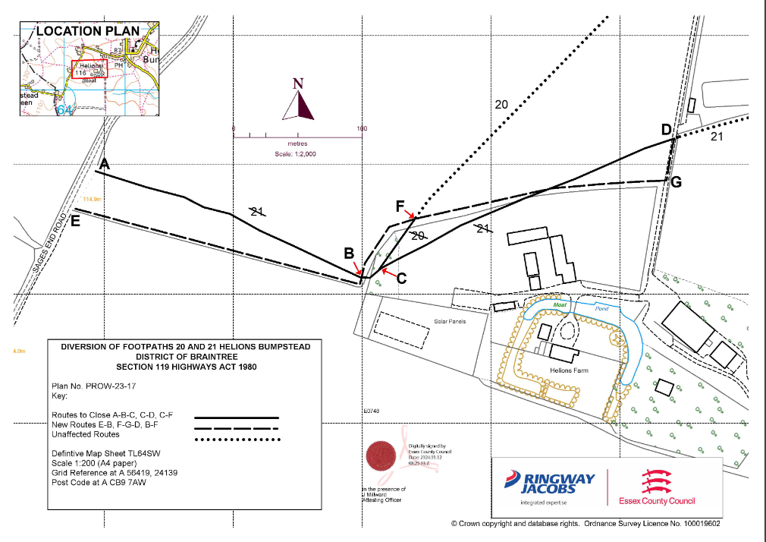

Dedham Vale National Landscape and Stour Valley
The Wilder Together in the Stour Valley partnership, are running their fourth event at RSPB Flatford Wildlife Garden, for parish and town councillors who want to work with their community for wildlife and people. Taking place on Tuesday 21st May, the event runs from 6-8pm and will include tea and biscuits. It will focus on what community projects parish and town councils can do in their local area to improve wildlife habitat with the help of their community. For more detailed information and how you can become involved visit https://dedhamvale-nl.org.uk/wildertogether. For any questions, please contact Countryside Projects Officer, Emma Black, at emma.black@suffolkandessex-NL.org.uk.

Cllr. Diana Garrod
Braintree District Councillor - Bumpstead Ward

APPENDIX B

APPENDIX C

