STURMER PARISH COUNCIL
Ian Brown 72 St. Edmunds Fields
Parish Clerk & Responsible Financial Officer Dunmow, Essex, CM6 2AN
Email: clerk@sturmer-pc.gov.uk Tel: 07913 514 589

Minutes of the COUNCIL MEETING OF STURMER PARISH COUNCIL held at STURMER VILLAGE HALL on 20 FEBRUARY 2024 AT 7:30 PM

COUNCILLOR | IN ATTENDANCE
Cllr Diana Garrod (Chairman) | YES
Cllr Alan Carter | YES
Cllr Terrie Jones | YES
Cllr David Porth | YES
VACANCY
VACANCY
Cnty Cllr Peter Schwier | NO – BDC Planning meeting
CLERK – Ian Brown
8 Member(s) of the public

23/116 | NOTE AND APPROVE APOLOGIES FOR ABSENCE  None given
23/117 | WITH REFERENCE TO THIS AGENDA MEMBERS ARE INVITED TO DECLARE ANY DISCLOSABLE PECUNIARY INTERESTS, NON-REGISTRABLE INTERESTS AND OTHER REGISTRABLE INTERESTS  Cllr Diana Garrod declared an interest in FP3; no other Cllrs declared any interests
23/118 | APPROVE THE MINUTES OF THE MEETINGS HELD ON TUESDAY 09 JANUARY – 2024  23/118(i) – SIGN THE MINUTES FROM THE PC MEETING 28 NOVEMBER 2023  RESOLUTION - Minutes approved by Cllr. Alan Carter, seconded Cllr. David Porth - unanimous approval
23/119 | PUBLIC PARTICIPATION SESSION  This provides an opportunity for members of the public to raise questions and comment on items on the agenda or of import. Time for this session is limited to 15 minutes (03 minutes per person)  - A resident highlighted been flooded six times, last three in February, with sewage on the property, Anglian Water informed to confirm drains are clear. AW monitors were placed in the drains previously, awaiting water engineers arrival within 48 hours of reporting, 24 hours left for their arrival at date of this report.  - Pictures handed to council showing the extent of garden flooding- APPENDIX C  - Concern as to when Water Lane bridge works will commence due to delays. Request PC correspond to Mr Froud, Structures at Essex County Council seeking an update.  - Hill Lane drainage onto A1017 remains a major problem.  - Flooding at Red Lion coursing into the A1017 potholes, which fill and not then visible as deep potholes and in danger of causing serious damage / accident.  - Residents group with some 20 members established due to mounting flooding issues.  - Suggested residents and PC communicate with the Environment Agency re sluice gates at Haverhill, Roger Webster of EA.
23/120 | RECEIVE COUNTY & DISTRICT COUNCILLORS REPORTS  Cnty Cllr Peter Schwier shares numerous reports and updates with the council during the month  Dist Cllr Diana Garrod – Full report Appendix A
23/121 | RECEIVE CLERK'S REPORT & NOTE CORRESPONDENCE  The office received an update from the agents working on behalf of the landowner of the Woodlands area adjacent to the Amenity walk with access from the A1017.  All other matters are covered by the Agenda.
23/122 | FINANCE – RECEIVE FINANCIAL STATEMENT - AGREE PAYMENTS  RESOLUTION – Finance statement and associated payments approved; Proposed Cllr Diana Garrod, Seconded Cllr David Porth - unanimous  Finance statement(s) attached at APPENDIX B  23/122(i) - APPOINT AUTHORISER  Cllr Alan Carter duly appointed as Authoriser  23/122(ii) – CONFIRM CLLRS NOTED RECONCILED BANK STATEMENT  Cllrs noted bank statements  23/122(iii) – RECEIVE UPDATE ON ACCOUNT OPENING WITH UNITY TRUST BANK  Two Cllrs yet to confirm access to Unity Trust Bank  23/122(iv) – CLERK & CHAIRMAN TO FORMALLY APPROVE AND SIGN PRECEPT REQUEST  Duly completed and signed – CLERK to ACTION  23/122(v) – CONSIDER GRANT REQUEST OF £150 FROM KEDINGTON BROWNIES TOWARDS A TRIP THIS APRIL  Clerk to advise refusal to both the Brownies and Guides grant award requests  23/122(vi) – RECEIVE UPDATE ON STREET LIGHTING ENERGY SUPPLIER OPTIONS  Nothing to report thus far, awaiting agent to respond with energy quote(s)
23/123 | REVIEW & COMMENT ON CURRENT PLANNING APPLICATIONS/APPEALS  Ref. 24/00323/HH & 24/00324/LBC  Alterations to loft space - Abbotts Farm , Rowley Hill, Sturmer  Comment date 13 March 2024  NO OBJECTIONS - unanimous  23/123(i) – CONSIDER ANY RESPONSE TO THE WEST SUFFOLK LOCAL PLAN  No comments to add at present
23/124 | CONSIDER TREE SURVEY REPORT AND HOW IT MIGHT INFORM A TREE POLICY  Defer to next PC meeting once report is circulated to members again due to previous Cllr email problems  23/124(i) – CONSIDER RESPONSE TO EMAIL FROM PARTNER IN ARCHITECT FIRM ADVISING TREE WORKS TO LAND REAR OF ROWLEY COTTAGES TO REMOVE 60 – 70 DEAD ELM TREES, THE FIRM HAVE OFFERED TO ATTEND A PC MEETING TO DISCUSS THEIR PLANS  Clerk to request site meeting to discuss concerns over boundaries, fencing, pubic safety, protection of historical bridge and proposed vehicle hard standing
23/125 | REQUEST FOR UPDATE ON PROGRESS ON THE LONG TERM CLOSED FOOTPATH 3  Remedial works proposed for this summer to stabilise the riverbank and improve footpath surface, noted that the pathway to continue to be closed for the safety of the public.
23/126 | CONSIDER ARRANGEMENTS FOR THE ANNUAL PARISH ASSEMBLY – 02 APRIL  Advertised in parish magazine.  PC meeting at 6:45pm followed by APA at 7:30pm – reports to be invited for presentation.  CLERK to contact previous speakers
23/127 | CONFIRM CURRENT POSITION- Light No: 01, Unit ID: 187691, Location: Popes Court, Sturmer  Awaiting to be reconnected by ECC / UKPN
23/128 | RECEIVE UPDATE ON MISSING PLANK FROM FOOTBRIDGE ADJACENT TO AMENITY WALK  PROW15 has been reported by Environment Agency to ECC, awaiting repair
23/129 | RECEIVE REPRESENTATIVES REPORT:  a) Footpaths - Consider any response to resident’s comment as a result of the PC polite request to attend to trees fallen at Bridlepath 17. Landowner removed trees - PC to share their thanks. CLERK to ACTION  FP3 tree fallen in river, Clerk to write to EA ref two trees now fallen into the river, previously notified of first tree that is still not removed. Landowner to be contacted to have them removed. Owner of Gd2 listed building Popemill is concerned about risk of flooding to their property due to the blocked river.  b) Flood Action Group – See report at APPENDIX C  c) Play Area – Some vandalism, deep water sign removed and a dog litter bin sign removed, wheelbarrow dumped on amenity walk. New signs installed advising deep water in other areas.  d) Parish Maintenance – Contract to be renewed. Write to Hanson (check EA involvement) advising they felled one of the PC trees without permission when in fact they were only meant to fell a tree on their land.  e) War Memorial – No report  f) Village Hall – One more winter warmer event  [f](i) – Defibrillator function – Training requested, more volunteers needed  g) Highways – Potholes reported adjacent to Red Lion PH and along Water Lane
MOTION TO BE AGREED - Approve exclusion of the public
Members of the public will be asked to leave the meeting for the next item, Exclusion of Public and Press - Under Section 100(A)(4) of the Local Government Act 1972, the public be excluded from the meeting whilst discussion takes place on the following item on the grounds that they involve the likely disclosure of exempt and commercially sensitive information
23/129 | RECEIVE UPDATE ON THE INCLUSION OF THE BRIDGE CROSSING THE AMENITY WALK AT PROW 1 IN THE POTENTIAL OPEN SPACE IMPROVEMENTS PLAN  Clerk submitted item for inclusion to BDC
23/130 | RECEIVE UPDATE ON LAMP NOT WORKING AT POPES COURT DUE TO DISCONNECTION FOR SAFETY REASONS PENDING REPAIR  Duplicate of item 23/127
23/131 | RECEIVE UPDATE ON THE VG52 LAND SALE PROPOSALS  No further update to report
MOTION TO BE AGREED – Approve readmission of the public
Members of the public to be readmitted to the meeting
23/132 | ITEMS OF REPORT TO BE NOTED OR ADDED TO NEXT COUNCIL AGENDA  Signage for railway amenity walk, No Motorcycling  Closed Churchyard update  Flooding update  Popes court lamp  Energy supply renewal
23/133 | DATE OF NEXT MEETING - TBA– CLOSE  21:14pm  Next PC meeting 6:45pm 02 April followed by the Annual Parish Assembly at 7:30pm  Clerk advised council of his resignation

Signed…………………………………………………………………………………………………………Dated……………………………..

APPENDIX A

District Councillor's Report to Parish Councils February 2024
Cllr. Diana Garrod - Bumpstead Ward

Scheduled Temporary Traffic Regulation Orders & Roadworks
Intended closure of Water Lane, Steeple Bumpstead 19th to 25th February 2024 (postponed from Dec ’23).
The closure is required for the safety of the public and workforce while Gas Transportation Company undertakes gas connection. Details at: https://one.network/?tm=135767707
Intended closure of Mill Road, Baythorne End on 16th February 2024 for 2 nights whilst Essex County Council undertakes carriageway patching. Details at: https://one.network/?tm=136590978
Intended closure of Brent Hall Road, Finchingfield on 26th February 2024 for 3 days. The closure is require whilst Anglian Water undertakes new connection. Details at: https://one.network/?tm=136893328
Intended closure of Wiggens Green, Helions Bumpstead on 3rd May 2024 for one day. The closure is required whilst Openreach undertakes pole testing. Details at: https://one.network/?tm=137394156
Increased Penalties: Fly-Tipping, Litter & Graffiti and Waste Duty of Care
Councillor Tom Cunningham, Cabinet Member for Transformation, the Environment and Customer Services has submitted a delegated decision to increase penalty levels for on-the-spot fines for fly-tipping, householder waste duty of care, litter and graffiti. In 2023, the Government launched an Action Plan aimed at cracking down on anti-social behaviour including environmental crimes. Proposed increases by BDC:

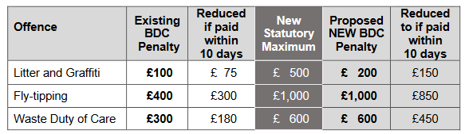

The table below shows the number of Fixed Penalty Notices the Council has issued over the past five years:
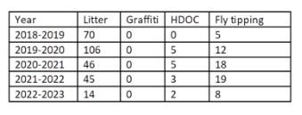
The Government is clear that council must not abuse the new powers to impose increased fines and they should take account of local circumstances such as ability to pay when setting the level of these fines. Nor must they issue a Fixed Penalty Notice in place of prosecution if the latter is the more appropriate course of action. Adopting the maximum penalty comes with a risk that more notices would be unpaid, forcing the Council to pursue legal action or civil proceedings to recover the debt. This would escalate costs of the service and take up valuable officer time with no guarantee that costs would be recovered.

Further details of delegated decisions are published on the BDC website.

Increased Fees: Pre- Application Advice Service & Planning Performance Agreements

Councillor Gabrielle Spray, Cabinet Member for Planning and Infrastructure has submitted a delegated decision. It is recommended that in January 2024: the Pre-Application Advice Service is amended (increase in the number of categories of pre-application advice, removal of standalone pre-applications for larger major applications and replacement with PPAs, and amendments to the timescales for providing written advice); and the fees charged to provide the service are increased as set out below. It is also recommended that the PPA fees are set as specified below and that these fees are embedded into the Council’s
Pre-Application Service for major application proposals.

It is also recommended that the Pre-Application and PPA fees are monitored and reviewed with any adjustments to take effect in April 2025, and thereafter reviewed annually.

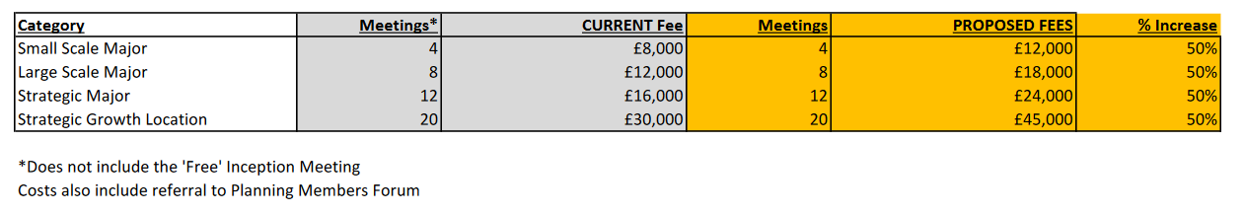

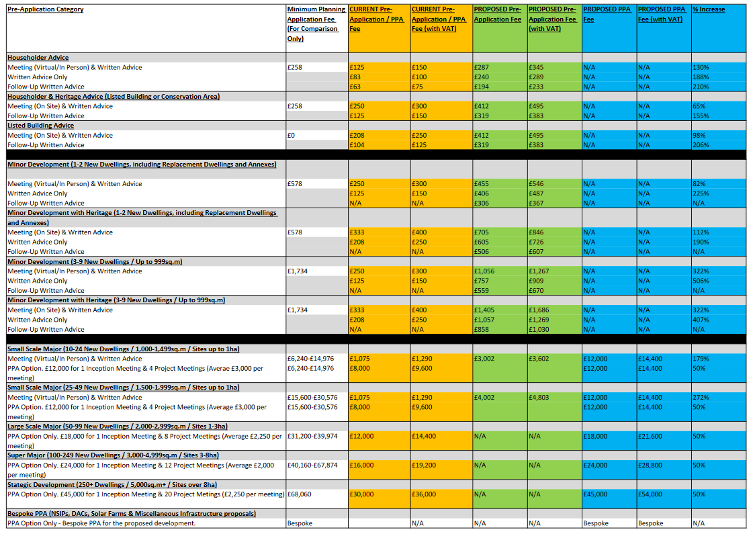

Further details of delegated decisions are published on the BDC website.

Free Electric Blankets Scheme (04/01/24)
The Cost of Living Projects Officer at BDC has sought approval to ringfence £25,000 from the Cost of Living Fund to offer free electric blankets to vulnerable residents on low incomes to help with the cost of living during the cold months. This is expected to cover approximately 500 electric blankets with VAT and postage included. A breakdown of charges is shown below.

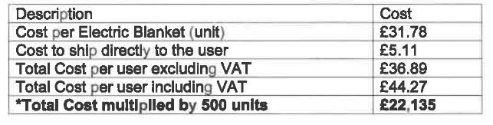

Residents will initially be identified via Local Council Tax Support as the criteria for this benefit is that a household is on a low income. Once these households have been identified, further available data will narrow the search down to households in receipt of one of the following disability benefits: Disability Living Allowance (with high rate mobility), Personal Independence Payment (with mobility part) or Attendance Allowance. The blankets will be sent directly via One Retail Group using a trackable 3-day service.

Suffolk: West Suffolk Local Plan (Regulation 19) Submission Draft – Final chance to have your say!
This submission local plan is the third and final chance for people to have their say about the development of a new local plan for West Suffolk. The consultation closes 5pm on 12th March 2024. Hard copy can be viewed at; Haverhill House, Lower Downs Slade, Haverhill, Suffolk CB9 9EE
Where possible, representations should be made using the online public consultation portal: https://westsuffolk.inconsult.uk/
Representations can also be sent by email to planning.policy@westsuffolk.gov.uk or by post to: Local Plan Submission Draft Consultation, West Suffolk District Council, Strategic Planning Team, West Suffolk House, Western Way, Bury St Edmunds. IP33 3YU

Cllr. Diana Garrod
Braintree District Councillor - Bumpstead Ward

APPENDIX B

APPENDIX C

February 2024

Dear Alan

Please give an update from SFAG to the PC next week.

Culvert at The Baulk (opposite the Red Lion pub (almost):

Please see picture below of the blocked culvert taken recently. This was reported on the Highways website and to Cllr Schwier as it has been causing flooding on the main road by the pub together with the overflowing inspection hatch outside Blackberry Cottage (now marked with a bollard).

Cllr Cunningham replied that this would be added to an ad hoc list for clearing.

Last week there was serious flooding outside the pub and in its car park when we had flood warnings.

A member of our Messenger Group took a video which was sent to ECC with a request the work be made urgent. Cllr Schwier has said he will be in touch.

The pub have been given a phone contact for SFAG as they have gullies in the car park that need clearing.

Gardens:

More pictures of flooded gardens were sent to Stuart Froud of Essex Highways Structures as he has requested these every time we flood to support funding for work on Sturmer Station Bridge.

Messenger Group;

At the suggestion of a resident we now have a Messenger Group of over 20 people (including partners) to share information on local flooding. This is in addition to our core group of 5 SFAG members. The group have provided pictures and videos of flooding and met with London and Japanese professors who are researching flooding.

The Group is open to anyone who wishes to be included - contact Linda Bevan 07503 662 926.

Routine Gully Cleaning:

This took place on gullies on the main road through Sturmer on 8th February 2024.

Thanks

Linda Bevan
SFAG

Flooding in gardens in Sturmer Oct 2023 to Feb 2024
Examples of gardens flooded in The Street, Sturmer
We believe the new bridge would allow water to flow away more quickly (as shown by EA modelling) and this would help relieve flooding in these properties. These are not all worse case scenarios or taken at the height of a flood.

