Recorders’ Report
Sturmer
2017

Weather : Weather has been dry with no flood warning since November 2016. A sharp frost early in the year destroyed some fruit crops and we were surprised by snow just before Christmas after many mild winters recently.
Church: Fundraising has included a cream tea, walk around the village and coffee morning. Donations were requested.
Parish Council: Fruit trees supplied by the Stour Valley Environment Fund were planted by Parish Councillors on the amenity walk in the village. Residents were consulted on use of Section 106 money from the Spinning Wheel site (now called Wheel Chase) by an article in the village newsletter (Sturmer Village News). Some new residents were recruited for the Emergency Plan. A new Parish Clerk, Ian Brown was appointed and Diana Garrod who is also the District Councillor was elected for a second time as Chairman of the Parish Council.
Community Speedwatch: Residents continued to monitor speeding vehicles in the village and report them to the Police for warning letters. They distributed 30 mph bin stickers purchased by the Parish Council to residents in addition to those sold or given out by the Speedwatch Co-ordinator and there is now a good display on bin collection days along the main road through the village. Some members of the Group attended a Parish Council meeting to ask for variable, flashing speed signs, additional markings on the carriageway and speedwatch signs on the village gates. The results of the Parish Council’s work on this is awaited.
Village Hall: New heaters were installed in the main hall, fluorescent tubes have been replaced with LED and new curtains were purchased (partly with a donation from the Sturmer Fayre in 2016). Cladding improved the appearance of the main hall. An open event was held in June with all the equipment available for hire on display (some in use) and a free barbeque. This small hall is ideal for clubs and meetings, children’s parties and family get-togethers. It has a fully fitted stainless steel kitchen for self catering or take-aways. There is a special rate for village organisations. The main hall holds up to 60 theatre style and there is a meeting room upstairs for 12 people.
Sturmer Village News: The village newsletter is collated, printed and paid for by the Sturmer Village Hall Charity. All but £70 was paid for by advertisements this year.
WI: Sturmer and District WI continues with about 25 members and meets on the second Monday of the month in the village hall at 7.30 p.m. Members and guests enjoy a variety of speakers, demonstrations and activities. Outings have included a meal at the Red Lion PH in Sturmer and joining the history group on a trip to the Jam Museum at Tiptree. It also offered free Ukulele lessons this year as a bursary course and a number of members took the opportunity to continue these after the course ended. Fund raising events e.g. family bingo and jazz night are arranged from time to time. Craft sessions are also held by the Suffolk West Federation of WIs in the hall. Members attend Federation and National WI events. Off shoots of the WI in recent years have included members joining a local book club and indoor bowls club, learning Nordic walking and a tap and ballet class for over 50s. All this contributes to a lively group offering fun and friendship and educational activities to local women of all ages.

Flood Action Group: This small group of residents has been promoting flood alleviation methods in the village since the last serious flood in February 2014. It reports regularly to the Parish Council which has recently helped bring about improvement work in Water Lane by Highways by approaching the County Councillor. It also comments on flood issues when new planning applications are received. Practical work this year has included keeping the ditches on the amenity walk flowing and moving dumped cement from a ditch in Hill Lane. A log of all issues is kept for monitoring purposes.
Local History Group: The Group continued its Victorian Schoolroom Re-enactment this year and ran a trip to the Jam Museum at Tiptree. It replenishes the leaflets on the heritage trail opened in 2013 with the help of a Heritage Lottery Grant. Members attend talks and conferences on a variety of history topics e.g. the Reformation and the Royal British Legion.
Community Website: A community website was set up as a result of Sturmer Fayre 2016 and contains information on all the Groups in the village.
https://www.essexinfo.net/sturmer-community-hub/
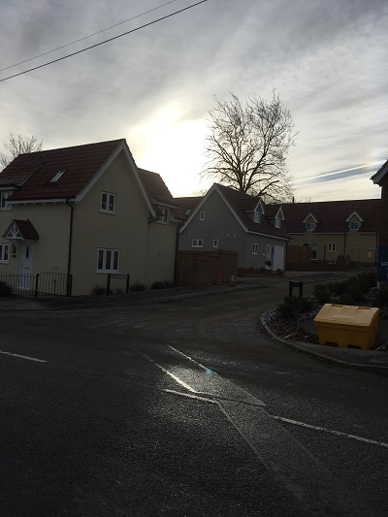

Developments and concerns: A development of 9 houses at Wheel Chase has been completed (see above) and the conversion of Dearsley Barn has begun. Residents have been concerned to see what seems to be work going ahead without planning permission adjacent to both these developments. An application has been received for the field at the back of Wheel Chase and one is awaited for the field by Dearsley Barn.
Linda Bevan

