ESSEX COUNTY COUNCIL INTERIM ANNUAL REPORT 2025/2026 Southminster Division by Councillor Wendy Stamp 20th April 2026.

It has been another busy challenging year for councils, councillors, community groups and residents within the Southminster Division.
A special thank all our residents in our wonderful diverse community- we should all be proud of the caring, helpful, inspiring living in Burnham on Crouch and our villages.
Thank you again for all your help and support I receive throughout the past year, this enables me to make a difference in all areas of responsibility and services under the remit of Essex County Council.

This annual report is interim and does not include everything that will be in my final report but due to the early date of the annual town meeting that has not been possible.

Essex County Council continues to deliver Everyones Essex strategy.
This had a £2 billion budget aiming at economic growth, improved infrastructure and enhance social care. The improvements and delivery of important life changing services included a very good CQC inspection on adult social care. I was asked to be interviewed as the opposition member representative.

I was also invited to be part of the board for year two of the Essex Caring Communities Commission and the final annual report has been finished and will be launched in April. I have no doubt this new way of taking action forward to enhance wellbeing in our communities and address health and social care pressures, will continue to improve the care we all may need at some stage in our families and own lives.
The report has been led by a team of excellent officers and professionals, including the head of ICB, chair of Active Essex, Head of Youth Practice for Children’s Society (SE) and others. This sits alongside the large number of monthly decisions approved at Cabinet and Full Council alongside new initiatives, transformation projects – consultations, strategic and spatial policies.

I reported this last year - The biggest change in local government for 50 years has commenced. Greater Essex (Essex County Council, Southend and Thurrock Unitary Council geographies) was selected to join the Devolution Priority Programme alongside 12 District Councils to deliver for the Local Government Reorganisation (LGR).
The governments reasoning for Devolution and LGR, is for a simpler, more sustainable (savings), delivery of services, and greater infrastructure delivery by devolving and transferring the powers and funding from national government to local government. Not everyone agrees with this as many feel the local voice will be lost.
On Wednesday 18th March 2026, the government minister made the decision to support the District Councils submission of 5 Unitary Authorities. This was not my preferred choice as I still have grave concerns joining with Chelmsford and Brentwood will be sufficient to deliver the complex services required without making financial cuts to non-statutory services – but time will tell.

Essex County Council has a legal responsibility to operate within a balanced budget. With the changes and reductions in Government grant funding over recent years, coupled with increasing and more complex demand for core services such as caring for the elderly, protecting vulnerable children and supporting families who need it - the financial situation continues to be very challenging.
In February, Essex County Council agreed its new Budget for 2025/26. The Council again had a stark choice in balancing its budget increasing taxes or facing unacceptable cuts in services. The budget was balanced against a backdrop of some of the most challenging times that local government has ever faced.

The budget for this financial year was agreed at February’s Full Council and although ECC has a well-established history of strong financial management unprecedented budget pressures are being experienced particularly across children’s placements and a £10.3m over spend in 2025/26 is expected at the outturn.

The Budget for 2026/27 and Annual Plan, approved the following:

- Gross expenditure to be incurred in the delivery of Council services in 2026/27 is £2,877m
- That the net cost of services be set at £1,432.5 million (m) for 2026/27
- That the net revenue budget requirement be set at £1,398.8m (net cost of services less general government grants) for 2026/27
- That the total council tax funding requirement be set at £936.8m for 2026/27
- That Essex County Council’s element of the council tax be increased by 3.95% comprising of a 1.95% increase in general council tax and 2.00% adult social care precept. This spending supports the most vulnerable in our communities including older people, people with learning difficulties, mental health difficulties and physical and sensory impairments. The precept is being used to insulate Adult Social Care from having to make higher savings, and support growth in need caused by changes in the demographics of our population and inflation, including the national living wage rise.
- This resulted in the Essex County Council element of the council tax being £1,641.96 for a Band D property in 2026/27 - this is an increase of £1.20 per household per week.

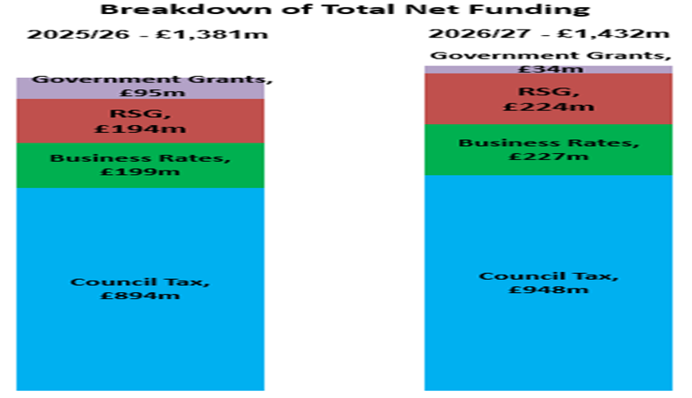

Headlines on Council tax information 2025/26

Council tax increase 3.75% including adult social care – this is amongst the lowest in any county council.
Expenditure on services:
- £897 million Supporting Vulnerable Adults. 33%
- £853 million on Education Excellence, Life long learning and Employability. 31.4%
- £269 million on services supporting Children’s Services and Early Years. 9.9%
- £161 million on Highways Maintenance and Sustainable Transport. 5.9%
- £93 million on Climate Czar, Environment, Waste Reduction and Recycling. 3.4%
- £76 million on Public Health. 2.8%
- £371 million on others which include Libraries, Coroners, Registrars and Country Parks. 13.6%

Some progress has been made on addressing the lack of SEND provision in Burnham on Crouch and our division. I can’t say any more now but at last ECC and the government has listened to us. Raising the lack of SEND provision in Burnham and The Dengie was my first question at Full Council five years ago. I will provide more detail in my full report.

Due to a great deal of hard work from Dengie Hundred Bus Users Group and Burnham on Crouch Town Council, they secured two rounds of love your bus grants – THANK YOU ALL. We still need to work on bringing a direct hospital service next.

As a positive, I must thank the clerks and officers, again, for their support and professionalism and those who have worked hard in applying for funding for important community projects from the Locality Fund allocation. I also wish to thank Essex County Council for the continued funding opportunities. Total fund allocated £5000. The awards this year are:-

 | Amount | Proposed Purpose
Dengie 100 Running Club | £1000 | Purchase of a defibrillator for Dengie 100 Running Club. Defibrillator will be stored with club committee and transported to different running events for use.
Althorne PC | £750 | This application is to repair/refurbish the parish owned benches as they are scruffy. Repairs will include replacing wooden slats and painting the benches.
Asheldham & Dengie PC | £491.58 | The parish council will purchase a Brushcutter from a local company for the grounds person of the parish who takes care of the churchyard, cemetery, verges, and green spaces
Asheldham & Dengie PC | £1547.46 | Purchase and installation of new notice board to replace one which is beyond repair.
Steeple PC | £730.00 | To remove type one shed base, level the area previously raised beds into the low way previously the shed and gazebo. To remove or distribute mound of dirt, this is unknown material and looks to contain hardcore/rubble if so, may need removing to land fill and will incur an extra cost. The cost for this is £580.00. To seed areas levelled at a suitable time, £150.00.
Mundon PC | £480.96 | To trim the hedges application for help towards the cost of tree and hedge trimming work, the information has been slow in coming I am afraid, due to various reasons outside of our control and the work is still being assessed. However, this type of work, especially with The Furze (woodland).
 | £5000

Local Community Initiatives Fund
Burnham on Crouch Rugby Club | £5,000 (6,700 total from pooled funding with other members) | Purchase of equipment, specifically:  Wall mounted baby changing table (x2) £360  Two-piece extending Scoop Stretcher & Head restraint £1,000  Defibrillator £1,200  Physio & Massage Table £1,500  Improved Audio and Visual System with hearing loop £3,000  Sanitary/Porcelain ware and general refurbishment of male facilities £3,500

Tackling the lack of Infrastructure including the NHS
The current challenges regarding the National Health Service and funding crisis have recently been reported in the media and continues causing concerns to everyone. There is now one ICB headed by Tom Abell. Discussions are continuing regarding section 106 funding – lack of expenditure on improvements and delivery mitigating growth.

I have supported residents with a huge number of issues, problems and concerns, assisted parish and town councils, whilst attending a number of scrutiny meetings, member training and council meetings at Essex County Council.
If I can help in anyway on County Council matters, please contact me Cllr.Wendy.Stamp@essex.gov.uk

