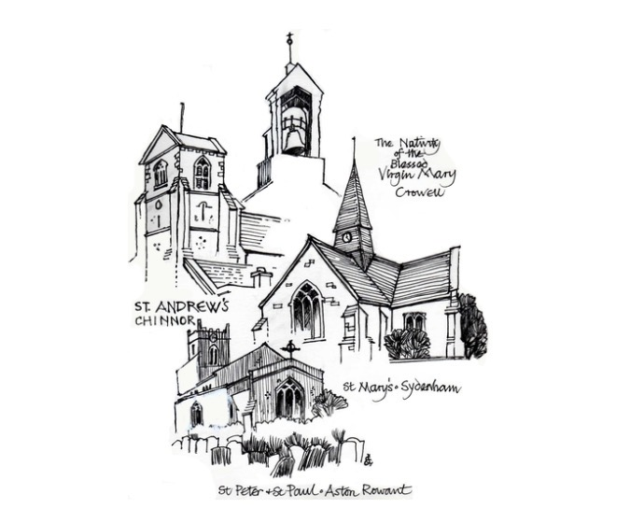
St Andrew’s Church Hall
St Andrew's Church
High Street, Chinnor, Oxfordshire OX39 4PG
SAFEGUARDING POLICY
This document has been prepared in line with good practice guidance commonly used within church premises management and Ecclesiastical-style risk management standards.
Policy Statement
- St Andrew’s Church Hall is committed to safeguarding children, young people and vulnerable adults and expects all users of the premises to share this commitment.
Responsibilities
- All hirers, volunteers and church representatives must comply with Church of England safeguarding guidance and report safeguarding concerns immediately.
Good Practice
- Appropriate supervision, safer recruitment, DBS checks where required, and safe working practices must be maintained.
Reporting Concerns
- Concerns should be reported to the Parish Safeguarding Officer or relevant statutory authority without delay.
Review and Monitoring
- This document should be reviewed annually, following any significant incident, or following changes in legislation or church guidance.
Document | Safeguarding Policy
Version | 2.0
Last Updated | 15 May 2026
Review Date | 12 months from approval

