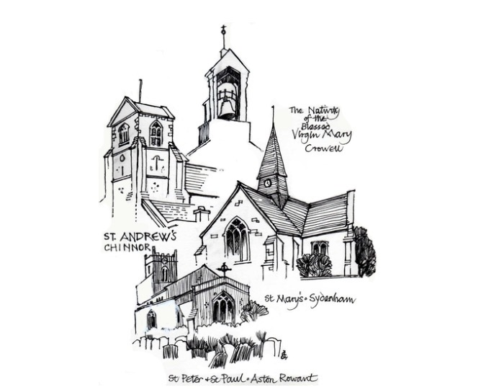
St Andrew’s Church Hall
St Andrew's Church
High Street Chinnor, Oxfordshire OX39 4PG
FOOD HYGIENE POLICY
This document has been prepared in line with good practice guidance commonly used within church premises management and Ecclesiastical-style risk management standards.
Food Safety
- Kitchen and food preparation areas must be maintained and left in a clean and hygienic condition.
Allergen Awareness
- Food allergens should be identified and communicated where applicable.
Disposal
- Food not consumed must be disposed of appropriately by the hirer after every use. No food or food waste must be left on the premises or in bins.
Review and Monitoring
- This document should be reviewed annually, following any significant incident, or following changes in legislation or church guidance.
Document | Food Hygiene Policy
Version | 2.0
Last Updated | 15 May 2026
Review Date | 12 months from approval

