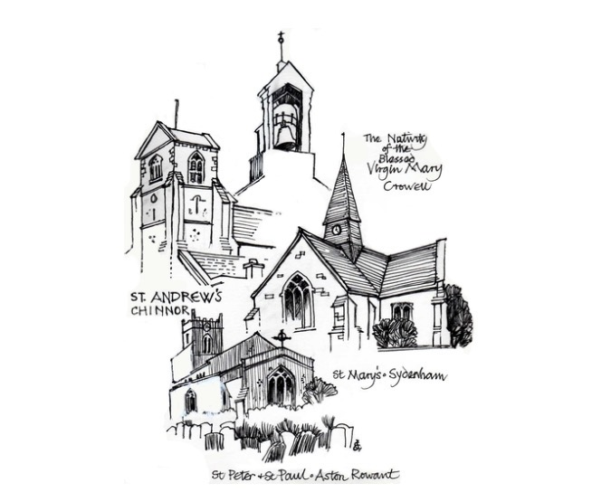
St Andrew’s Church Hall
St Andrew's Church
High Street
Chinnor, Oxfordshire OX39 4PG
FIRST AID PROCEDURE
This document has been prepared in line with good practice guidance commonly used within church premises management and Ecclesiastical-style risk management standards.
First Aid Provision
- A suitably stocked first aid kit must be available and accessible at all times.
Emergency Response
- Emergency services must be contacted immediately where required by dialling 999.
Recording
- All injuries, incidents and treatments must be recorded in the accident book.
Review and Monitoring
- This document should be reviewed annually, following any significant incident, or following changes in legislation or church guidance.
Document | First Aid Procedure
Version | 2.0
Last Updated | 15 May 2026
Review Date | 12 months from approval

