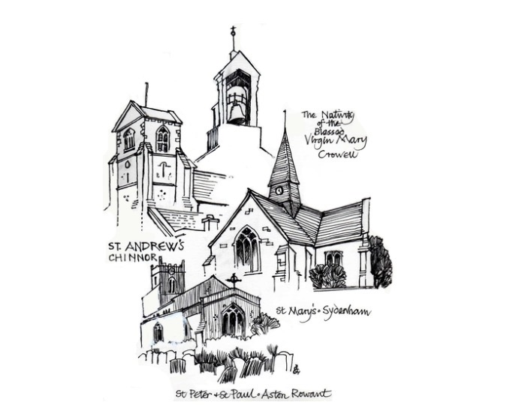
St Andrew’s Church Hall
St Andrew's Church
High Street, Chinnor, Oxfordshire OX39 4PG
ACCIDENT REPORTING PROCEDURE
This document has been prepared in line with good practice guidance commonly used within church premises management and Ecclesiastical-style risk management standards.
Reporting Arrangements
All accidents, incidents and near misses must be reported promptly to the hall management.
The location of the nearest A&E hospital is:

Stoke Mandeville, 01296 315000
Mandeville Road
Aylesbury
Buckinghamshire
HP21 8AL

The location of the nearest GP Surgery is: Chinnor Surgery, Church Road, 01844 344488

The First Aid Box is located in:……………………………………………………………………
The person responsible for keeping this up-to-date is: …………………………………………………

The accident book/forms are kept with this file. This must be completed whenever an accident occurs.

Any accident must be reported to the member of the management committee responsible, who is:

The accident book/forms are kept within this file. This must be completed whenever an incident occurs

Please report any near misses as a result of hall property or building to the Parish Committee at your earliest convenience

RIDDOR
Incidents reportable under RIDDOR must be notified to the Health and Safety Executive.

The person responsible for completing RIDDOR forms and reporting accidents is:

Name (Capitals) …………………………………………Position………………………………………….

The following major injuries or incidents must be reported on RIDDOR forms:

- fracture, other than to fingers, thumbs or toes
- amputation
- dislocation of the shoulder, hip, knee or spine
- loss of sight (temporary or permanent)
- any penetrating injury to the eye (including chemical)
- injury from electric shock/burn leading to unconsciousness or requiring resuscitation or admittance to hospital for more than 24 hours;
- any other injury leading to hypothermia, heat – induced illness or unconsciousness or requiring resuscitation or requiring admittance to hospital for more than 24 hours.
- unconsciousness caused by asphyxia or exposure to harmful substance or biological agent
- acute illness requiring medical treatment or loss of consciousness arising from absorption of any substance by inhalation, ingestion or through skin
- acute illness requiring medical attention which may have resulted from a biological agent or its toxins or infected material.

Relevant examples of reportable dangerous occurrences include:
- electrical short circuit or overload causing fire or explosion
- collapse or partial collapse of a scaffold over 5m high
- unintended collapse of a building under construction or alteration, or of a wall or floor
- explosion or fire.

Review
Incidents should be investigated to reduce future risks.

Review and Monitoring
This document should be reviewed annually, following any significant incident, or following changes in legislation or church guidance.
Document | Accident Reporting Procedure
Version | 2.0
Last Updated | 15 May 2026
Review Date | 12 months from approval

