SOUTHMINSTER PARISH COUNCIL

New Parish Room, Queenborough Road, Southminster, Essex. CM0 7AB
Tel: 01621 773868
Fax: 01621 773868
E-mail: southminsterpc@yahoo.co.uk
Website: www.essexinfo.net/southminster-parish-council

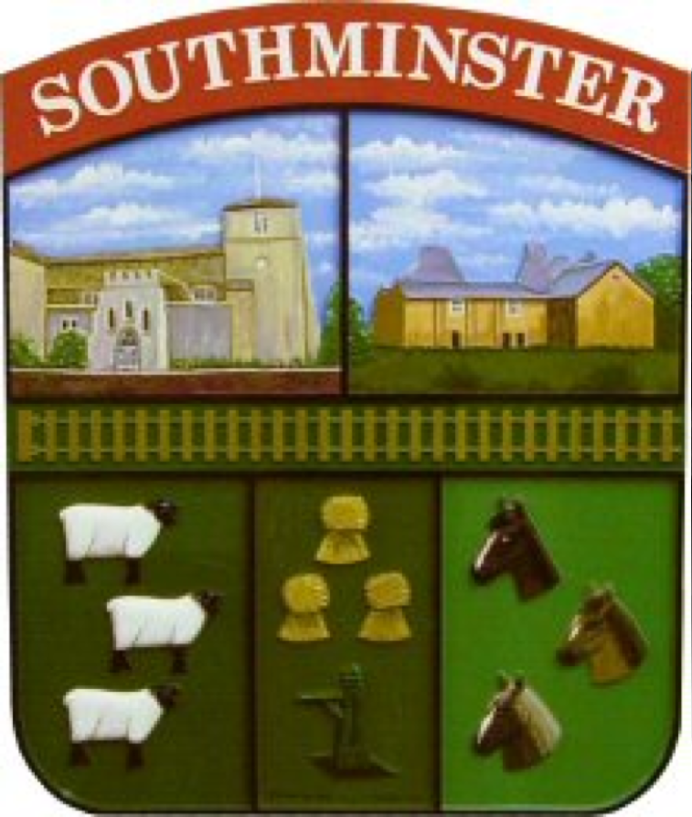

Minutes

The Parish Meeting of Southminster Parish Council
21st November 2022, held at Community Hall 2, King George V Memorial Field, Station Road, Southminster, Essex.

Present: Cllr J Anderson, Cllr G Harrold, Cllr D Noonan, Cllr Pratt, Cllr Fluker and Cllr Mische.

In attendance: Joanna Jeffery, Clerk/RFO and eight members of the public.

22/220 Apologies for absence.
Apologies were received from Cllr Wyn-Davies.

22/221 Co-Option
To co-opt two Parish Councillor’s.
Cllr Anderson proposed the co-option of Emma Connor, seconded by Cllr Pratt
Cllr Anderson proposed the co-option of Katherine Wilson, seconded by Cllr Pratt.
RESOLVED: Emma Connor and Katherine Wilson were co-opted to
Southminster Parish Council. The Acceptance of Office was duly signed by
Cllr Connor and Cllr Wilson in the presence of the Clerk.

22/222 To receive and note any declarations of interest:
A Disclosable Pecuniary Interest was received from Cllr Noonan relating to item
226 HOUSE/MAL/22/00594.
A Non-registerable Interest was declared by Cllr Pratt relating to item 226
FUL/MAL/22/00922.

22/223 To receive and approve Minutes of the Parish Council meeting held on 10th October 2022.
Proposed by Cllr Pratt, seconded by Cllr Harrold.
RESOLVED: The minutes of the meeting held on 10th October 2022 were duly signed by Cllr Anderson.

22/224 Introduction and presentation to the Energy and Low Carbon Programme
in Southminster.
Presentation from Carol Randall, The Energy and Low Carbon Development Officer at Essex County Council.
Carol Randall apologies for not attending the meeting, this item will be deferred to
next meeting.

22/225 Public Session – opportunity for members of public to speak:
Kings Road – A resident read the following:
I notice on the agenda that a resident has asked Councillors to consider if Kings
Road can be made into a cul-de-sac. I am sure Councillors have already looked at
this request on the agenda prior to tonight and I realise why the resident has
requested this. They want Kings Road to be a quiet road.
My husband and I live in Burnham Road which isn’t a quiet road under normal
circumstances, and if Kings Road were to be made into a cul-de-sac, Burnham
Road would be a whole lot noisier.
I am sure the resident noticed how much traffic had to use Kings Road when
Burnham Road was closed due to water main work a few weeks ago. Fortunately,
water main work is not, and I hope not a usual occurrence, but at the moment it
seems to be the case. When water main work closes Kings Road the traffic using
Burnham Road is enormous.
If Kings Road, where there are 8 roads leading off it, plus the possibility of two
more housing developments, were turned into a permanent cul-de-sac, the
vehicular impact on Burnham Road, the junction at the Church onto the High Street and the increase of traffic through the High Street would be huge. Not forgetting
that at school times the dangers of increased traffic for the children and parents
who need to cross Burnham Road.
Therefore, I would ask that given what I have said when this item comes up for
discussion, that Councillor’s seriously consider refusing the request.
A Kings Road resident commented that they would not support the road becoming
a cul-de-sac.

A further discussion was had regarding the High Street pavements, Essex County
Council have suggested that the pavement surface is ok. Cllr Fluker proposed that
a letter is sent to the Cabinet Member regarding the pavements, vehicles crossing
the pavements and the health and safety concerns. A letter will also be sent to the
shops to ask for the freeholder details. Cllr Fluker asked that highways is a
standing item on the agenda.

A resident reported issues with the following streetlights:
Kings Road opposite the chase – Light out
Opposite 38 The Chase – Light out
Princes Avenue – Light always on.
The Clerk will report all defects.

22/226 Planning
To discuss and respond to the following planning applications.
Cllr Pratt asked for Old Heath Road Diversion be added to the agenda as an
urgent item of business, seconded by Cllr Fluker.

Cllr Pratt informed that a 12 week diversion is to be put in place for works to be
carried out at the Carbunckle Development. A concern has been raised that
residents will use Old Heath Road as a cut through. The road is not big enough for
large vehicles or large volumes of traffic. It was agreed that Cllr Pratt will work with
the Clerk to creat a letter to Cllr Lee Scott.
RESOLVED: The Clerk will write to the Portfolio Holder at Essex County
Council to ask for an engineering solution and a Highways meeting with
Southminster Parish Council.

Week ending: 14th October 2022
FUL/MAL/22/00922
Replacement dwelling
Mayhaven Scalby Road Southminster Essex
Southminster Parish Council SUPPORT this planning application.

Week ending: 21st October 2022
FUL/MAL/22/00298
Single storey rear extension; installation of chimney stack within existing rear projection and timber weatherboarding to the side and rear of property.
The Old School House 8 Hall Road Southminster Essex
Southminster Parish Council SUPPORT this planning application.

Week ending: 28th October 2022
FUL/MAL/22/01005
New medical practice with dispensary retail unity and other ancillary uses
together with access onto David Fisher Way; associated car parking facilities
and other hard and soft landscaping works.
Land at Theedhams Farm David Fisher Way Southminster Essex
Southminster Parish Council SUPPORT this planning application. It was felt that
Councillor’s support the design and feel it is an appropriate property for the
gateway of the village.

Week ending: 4th November 2022
TCA/MAL/22/01092
G1 Sycamore (x2) - 2 metre height reduction, 1.5m lateral reduction, 1.5 crown lift over adjacent gravestones. All dead wood to be removed. Ivy severed at
base.
The Manor Bungalow 1 Station Road Southminster Essex
Southminster Parish Council SUPPORT the Tree Officers recommendation.

Planning Decisions
Week ending: 7th October 2022
LDP/MAL/22/00920
Claim for a lawful development certificate for a proposed single storey infilling extension between two adjoining factory wings & replacement roof sheeting.
Allen Brothers Fittings Limited 1-3 Hallmark Industrial Estate Hall Road
Southminster
APPROVE

Week ending: 14th October 2022
HOUSE/MAL/22/00594
First floor rear extension
23 Station Road Southminster Essex CM0 7EW
APPROVE

OUT/MAL/22/00817
Change of use from an industrial site to 7 flats with associated open
space/allotments.
Land Adjacent Theedhams Farm Steeple Road Southminster Essex
REFUSE

Week ending: 21 October 2022
OUT/MAL/21/00030
Proposed 7 no. New dwellings comprising 6 no. Two bed two storey and 1 no
two bed single storey properties
Land Adjacent to 55 Kings Road Southminster Essex
APPROVE

HOUSE/MAL/22/00940
Single storey front extension. Two storey front and full side extension.
Removal of existing lean-to rear extension.
Eastalea 5 Burnham Road Southminster Essex
REFUSE

Week ending:11th November 2022
HOUSE/MAL/22/00960
Single storey rear extension. Conversion of outbuilding to dining space.
Fenestration changes.
71 High Street Southminster Essex CM0 7AY
APPROVE

22/227 Finance Matters: -
a: To receive and approve payment and receipts reports for October & November 2022.
Proposed by Cllr Noonan, seconded by Cllr Pratt.
b: To approve payments and to sign cheques. Proposed by Cllr Noonan,
seconded by Cllr Anderson.
c: To receive and approve the budget status for October & November 2022. Proposed by Cllr Harrold, seconded by Cllr Noonan.
d: To receive and approve the Bank Reconciliation Statement to 30th September and 30th October 2022. Proposed by Cllr Harrold, seconded by Cllr Noonan.
e. To discuss the provision of a Multi Card with a set limit of £500 for ad
hoc emergency expenditure. Proposed by Cllr Harrold, seconded by Cllr
Pratt.
To discuss and pass any resolution as necessary.

22/228 Precept 2023/2024
To discuss and agree precept for 2023-2024.
Cllr Pratt proposed that the precept for 2023/2024 be set at £140,990.00,
seconded by Cllr Harrold. Recorded vote, 3 for, 1 against, 1 abstain.
RESOLVED: The precept for 2023/2024 will be set at £140,990.00

22/229 Dist Cllr’s Report
Local Development Plan - Review
Meeting with members to discuss the 5 Year Housing Land Supply has been rescheduled to 26th October.
Allocation of Sites
Following the concerns, I raised with other members at the last Council meeting an Extraordinary meeting of the Council has been called for 3rd November.
The LDP Process has stalled.
Budget
The forecasted budget gap from April 2023 of minus £270,000 has now been updated to minus £789,000. Anticipating that this was likely to happen given the Council’s likely financial outturn some months ago I called for an Autumn Budget at the time request was refused. I am trying to get the Council to agree to a meeting to discuss the budget.
Regents Court
Parking Court to the rear of numbers 1-6. Residents have raised concerned with me with regard fly tipping and abandonment in the area. I am working with the EH Team at MDC and Estuary Housing to rectify the issues and clean up the area.
Devolution
The devolution and levelling up process is continuing. It is unclear where this will lead to but it is unlikely that MDC will continue in its existing format after 2027.
New Medical Centre
I have spoken to Kerry Harding Director of Estates NHS Mid and South Essex Health Trust and she has confirmed that the project is progressing as planned and that a planning application will be submitted in the near future.
Highways
David Fisher Way is now open, the final part of resurfacing of North Street should be happening today

News From MDC - More information on the MDC Website
Residents and Business Survey (Closes 25th November)
Cost of Living Crisis – In depth information regarding support and help for residents and businesses is available via the website
Bird Flu – MDC is withing the Bird Flu Prevent Zone – Special rules now apply to keeping poultry outside – more information is on the DEFRA Website.
South Eastern Area Planning Committee meetings have now returned to Burnham Town Council Offices, the next meeting is this Wednesday
Meeting with the Parks Team – I’m still trying to organise the second meeting

22/230 Proposed new building at King George V Memorial Field
Update from Cllr Anderson.
The planning application was heard at South East Area Planning Committee.
Cllr Pratt informed that the live streaming cannot be heard, Cllr Pratt will write to
Paul Dobson at Maldon District Council to express concerns regarding sound
Quality.
Cllr Anderson informed that planning permission has now been granted for the new community building.
Cllr Anderson asked for Members to join a working party to move forward to
discharge the planning conditions. Cllr Anderson, Cllr Harrold, Cllr Fluker and Cllr
Connor all volunteered to join.

22/231 Fireworks and Christmas Lights
To discuss fireworks expenditure and event debrief.
To receive an update regarding Christmas Lights, switch on to be held on 27th
November 2022 at St Leonard’s Church.
To discuss and pass any resolution as necessary.
A breakdown of income and expenditure was prepared by the Clerk, it was
informed that the event had come in under budget. Cllr Harrold informed that due
to the weather it had been hard work to create the event, but the rain finally
stopped, and the event was a success. More helpers are needed if the event is to run in future years.

The Christmas lights will be switched on at 5pm, Cllr Wyn-Davies has been
practising carols with local groups who will be attending to sing.
It was agreed to ask Cllr Wyn-Davies to provide a running list for the day, Cllr
Fluker, Cllr Pratt and Cllr Harrold will assist with the gazebo and lights.

It was reported that Remembrance Sunday was very well attended, the Clerk
Thanked Cllr Pratt for bringing District Councillor Beale to church.

22/232 Kings Road
A request has been made from a resident regarding the possibility of Kings Road being made into a Cul-de-Sac.
To discuss and pass any resolution as necessary.
Cllr Fluker proposed based on the information given, Southminster Parish Council
do not support the request to make Kings Road a cul-de-sac, seconded by Cllr
Wilson.
RESOLVED: Southminster Parish Council will not support a request to make Kings Road a cul-de-sac.

22/233 Bloor Homes – Section 106 Agreement
To discuss and agree a response to Bloor Homes from Southminster Parish
Council regarding what the Council would like to see written into a Section 106 agreement for the benefit of the parish should the proposed planning permission to be submitted by Bloor Homes be granted.
Cllr Fluker suggested a meeting with Bloor Homes. Ideas were discussed, but as no indication of Section 106 value has been given it was hard to determine what Bloor Homes would consider.
The Clerk will email Bloor Homes to arrange a meeting.

22/234 Community Hall 2
To discuss the provision of additional hot water to the disabled toilet.
To discuss and pass any resolution as necessary.
It was agreed to obtain quotes.

22/235 Public Session– opportunity for members of public to speak:
Cllr Connor and Cllr Wilson gave a brief introduction of themselves to all attending.
Cllr Fluker advised he will be emailing Richard Holmes at Maldon District Council to arrange a meeting with FOSCOS.

22/236 Date of the next meeting:
Monday 19th December 2022.

22/237 Close of business:
Meeting closed at 9.20pm.

