SOUTHMINSTER PARISH COUNCIL

New Parish Room, Queenborough Road, Southminster, Essex. CM0 7AB
Tel: 01621 773868
Fax: 01621 773868
E-mail: southminsterpc@yahoo.co.uk
Website: www.essexinfo.net/southminster-parish-council

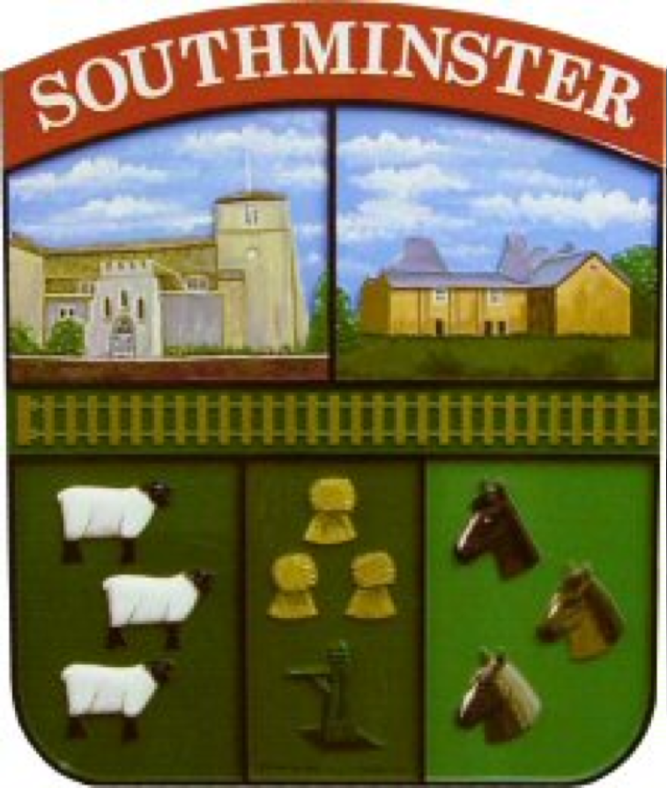

Minutes

The Parish Meeting of Southminster Parish Council
10th October 2022, held at Community Hall 2, King George V Memorial Field, Station Road, Southminster, Essex.

Present: Cllr J Anderson, Cllr G Harrold, Cllr D Noonan, Cllr Pratt, Cllr Fluker, Cllr Wyn-Davies and Cllr Mische.

In attendance: Joanna Jeffery, Clerk/RFO and six members of the public.

22/204 Apologies for absence.
No apologies were received.

22/205 To receive and note any declarations of interest:
No declarations were received.

22/206 To receive and approve Minutes of the Parish Council meeting held on 26th September 2022.
Acceptance of minutes of meeting held 26th September 2022 were proposed by Cllr Pratt, seconded by Cllr Noonan.
RESOLVED: The minutes of the meeting held on 26th September 2022 were duly signed by Cllr Anderson.

22/207 Public Session – opportunity for members of public to speak:
Allotment review, a resident asked for the proposed increase in allotment rents to be justified.
A resident commented that David Fisher Way road signs are confusing, drivers are still using Steeple Road as they are unaware it is now a Cul-de-Sac.

22/208 Presentation from Bloor Homes
Bloor Homes representatives informed they have held two events and a questionnaire, feed back from these have proved useful.
It was informed that an outline planning application for 249 homes comprising maisonettes, bungalows and 1-to-4-bedroom homes are planned for the site, two and a half story houses will be in the mix.
There will be a 30% mix of affordable housing and 5.6 hectares of open space.
Essex County Council have held preapplication discussions and have given approval.
Following concerns raised regarding school places, Bloor homes gave the following information:
Ormistan Rivers Academy is currently at 118% capacity, Plume Academy 105% capacity and William De Ferrers 60% capacity.
It was commented that a GATSO speed camera would be welcomed.
A discussion was had after it was informed there would be no bus routes on the development site.
Bloor Homes asked what Southminster Parish Council would like to see written into the Section 106 agreement for the benefit of the parish. Cllr Pratt proposed considering the question and Southminster Parish Council will respond accordingly.

22/209 Planning
To discuss and respond to the following planning applications.
Week ending: 23rd September 2022
22/00960/HOUSE PP-11507303
Single storey rear extension. Conversion of outbuilding to dining space.
Fenestration changes.
71 High Street, Southminster, Essex
Southminster Parish Council SUPPORT this planning application.

Week ending: 7th October 2022
22/00314/OUTM PP-11430366
Outline planning application with all matters reserved except for access, for a phased residential-led mixed use development including: Up to 750 dwellings (Class C3) including affordable housing; upto 1,000sqm commercial space (Use Class E); Early years facility (Use Class E (f));Education provision (Use Class F1 (a)); A 16ha District Park (including associated amenity provision, community orchard, landscaping, car parking and access); A 2.4ha Local Park (including recreation provision, community orchard, landscaping and access); Allotments: Access enhancements (including a new pedestrian footbridge over the railway line, enhancements to Althorne Station, upgrades to Station Road, new spine road, modified junction at Station Road/B1010 Fambridge Road and upgrade to Station Road level crossing); Pedestrianisation and relandscaping around the War Memorial; Green and blue infrastructure including sustainable urban drainage, mobility routes (footways and cycleways), biodiversity enhancements (new hedgerow and tree planting, woodland and reinstated historic hedgerows) and neighbourhood amenity space/play areas; and Public Art.
Land South of Fambridge Road Burnham Road and East West of Station Road
Althorne Essex.
Southminster Parish Council recommend the REFUSAL of this planning application due to building in the countryside. Recommendation to ask Highways Authority to
look at capacity particularly at Kitts HIll.

Planning Decisions
Week ending: 23rd September 2022
HOUSE/MAL/22/00654
Single storey rear & single storey side extension
26 Pump Mead Close Southminster Essex CM0 7AE
REFUSE

Week ending: 30th September 2022
FUL/MAL/22/00766
Replacement of windows to the first floor and the ground floor front
(Station Road facing) east window.
46 Station Road Southminster Essex
APPROVE

22/210 Finance Matters: -
a: To receive and approve payment and receipts reports for October 2022. Defer to next meeting.
b: To approve payments and to sign cheques. Defer to next meeting.
c: To receive and approve the budget status for October 2022, defer to next meeting.
d: To receive and approve the Bank Reconciliation Statement to 30th September 2022, defer to next meeting.
e. Allotment rent review
The Allotments Chair has suggested a rent increase of 4% due to rising costs, It was suggested for rents to remain under review for the coming year.
RESOLVED: It was agreed to increase the rents by 4% for the year 2022 – 2023, rent increases with be annually from 2023-2024 at retail price index rate.
22/211 Dist Cllr’s Report
Report from District Councillor Adrian S Fluker

Local Development Plan - Review
Meeting with members to discuss the 5 Year Housing Land Supply has been rescheduled to 26th October.
Allocation of Sites
Following the concerns, I raised with other members at the last Council meeting an Extraordinary meeting of the Council has been called for 3rd November.
The LDP Process has stalled.
Budget
The forecasted budget gap from April 2023 of minus £270,000 has now been updated to minus £789,000. Anticipating that this was likely to happen given the Council’s likely financial outturn some months ago I called for an Autumn Budget at the time request was refused. I am trying to get the Council to agree to a meeting to discuss the budget.
Regents Court
Parking Court to the rear of numbers 1-6. Residents have raised concerned with me with regard fly tipping and abandonment in the area. I am working with the EH Team at MDC and Estuary Housing to rectify the issues and clean up the area.
Devolution
The devolution and levelling up process is continuing. It is unclear where this will lead to but it is unlikely that MDC will continue in its existing format after 2027.
New Medical Centre
I have spoken to Kerry Harding Director of Estates NHS Mid and South Essex Health Trust and she has confirmed that the project is progressing as planned and that a planning application will be submitted in the near future.
Highways
David Fisher Way is now open, the final part of resurfacing of North Street should be happening today

News From MDC - More information on the MDC Website
Residents and Business Survey (Closes 25th November)
Cost of Living Crisis – In depth information regarding support and help for residents and businesses is available via the website
Bird Flu – MDC is withing the Bird Flu Prevent Zone – Special rules now apply to keeping poultry outside – more information is on the DEFRA Website.
South Eastern Area Planning Committee meetings have now returned to Burnham Town Council Offices, the next meeting is this Wednesday
Meeting with the Parks Team – I’m still trying to organise the second meeting

22/212 Proposed new building at King George V Memorial Field
Update from Cllr Anderson.
It was reported that further highways documentation has been submitted to Maldon District Council.
It was noted that the National Lottery are keen to invest in Essex.

22/213 Fireworks and Christmas Lights
To discuss preliminary outline plans and budget.
To receive an update from the Events Committee.
To discuss and pass any resolution as necessary.
It was agreed that the Clerk would notify the insurers regarding the fireworks event and apply for the relevant licences.
Cllr Wyn-Davies informed that the licence for the Christmas lights had been granted.
Cllr Harrold informed that a Bag Piper has been booked for Remembrance Sunday, the procession will leave Chapmans Store at 9.30am.

22/214 Public Session– opportunity for members of public to speak:
It was questioned why the fireworks event is being held on Sunday 6th November 2022, the response was that it was cheaper for the event to be held on the Sunday and that many of the vendors would be going to larger events on the Saturday which would restrict what could be on offer at the event.

Cllr Fluker informed that there has been a call for sites, there is a potential allocation of 2500 for Southminster.

22/215 Exclusion of Press and Public:
To determine a proposal that the press and public should now be excluded from the meeting in accordance with The Local Government Act 1972, ss100.
Proposed by Cllr Pratt, seconded by Cllr Noonan.
RESOLVED: The exclusion of press and public.

22/216 Public Building Maintenance
To discuss and agree a programme of maintenance for all public buildings.
To discuss and pass any resolution as necessary.
A discussion was had regarding essential maintenance for council owned buildings, Cllr Fluker proposed the acceptance of quote from Fisk, seconded by Cllr Harrold.
RESOLVED: Essential work to be carried out to all council owned buildings.

22/217 Leases and Agreements
To discuss and pass any resolution as necessary.
Cllr Fluker has spoken with Fothegill’s, it was agreed that any historic documents are forwarded to Cllr Fluker.

22/218 Date of the next meeting:
Monday 21st November 2022.

22/219 Close of business:
Meeting closed at 9.27pm.

