

Ardal Genhedaeth Rhos a Mynydd Mission Area

Elusen/Charity: 1210118

Adroddiad Blynydol
Annual Report

Ar gyfer y flwyddyn yn diweddaru 01.01.2025
For the year ending 31.12.2025

Contents
CHAIRPERSONS REPORT 3
ADMINISTRATIVE INFORMATION 4
STRUCTURE, GOVERNANCE AND MANAGEMENT 6
MEMBERSHIP AND ATTENDANCE 6
REVIEW OF MAC ACTIVITIES AND ACHIEVEMENTS 7
REVIEW OF CHURCH ACTIVITIES AND ACHIEVEMENTS 8
All Saints (Bistre) 8
Emmanuel (Bistre) 9
Emmanuel (Penyffordd) 10
St Cecilia’s (Bistre) 11
St Cynfarch and St Cyngar’s (Hope) 12
St John’s (Penymynydd) 12
St Matthew’s (Buckley) 13
St Michael’s (Llanfynydd) 14
The Church of the Good Shepherd (Drury) 15
The Church of the Holy Spirit (Ewloe) 16
Treasurers Report 17
Financial statements 18

CHAIRPERSONS REPORT

Formed in April 2024, this Mission Area is governed by the Church in Wales Constitution and the Mission Area Conference (MAC) has the same powers as a Parochial Church Council (PCC).

We have 10 Churches in our Mission Area with a population of around 33,000 people. As with many other Mission Areas there are some large churches and some small churches and each has its own identity and individualism.

It has been quite a learning curve to embrace the changes required and we are still very much on a journey of discovery of working together, to share ideas, resources, knowledge and support in order to achieve our aim to advance the Christian religion through mission.

There have been a number of challenges in relation to clergy vacancies that we have had to contend with in this first year but we look forward to this next year as a year of new opportunities with hope and faith.

The Church reports included within this annual report offer an insight into the excellent work being carried out throughout the Mission Area and we hope that through working together we can achieve more and reach further into our communities.

I offer my grateful thanks to the MAC Executive Team who have all taken on their new roles with great enthusiasm and willingness to share their professional and personal experience which is helping to shape the structure, governance and management of the MAC.

Our continued thanks also go to our Mission Area Administrator without whom we would not function.

Helen Jones (Mrs)

Lay Chair

ADMINISTRATIVE INFORMATION

The Rhos a Mynydd Mission Area (registered charity number 1210118) is a Mission Area of the Church in Wales situated in the Archdeaconry of Wrexham within the Diocese of St Asaph.

The geographical area of the Mission Area lies in South Flintshire and begins in the East at Ewloe and ends in the South West at Llanfynydd.

Contained within the Mission Area are the communities and churches of:

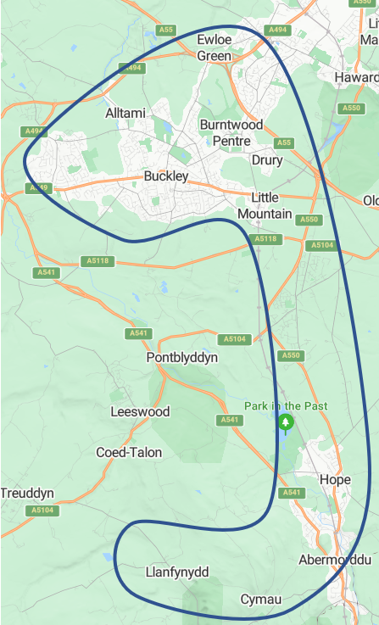
All Saints (Bistre)
Emmanuel (Bistre)
Emmanuel (Penyffordd)
St John’s (Penymynydd)
St Cecilia’s (Bistre)
St Cynfarch and St Cyngar’s (Hope)
St Matthew’s (Buckley)
St Michael’s (Llanfynydd)
The Church of the Good Shepherd (Drury)
The Church of the Holy Spirit (Ewloe)

The Mission Area can be contacted in a variety of ways:
Post: Bistre Emmanuel Church Hall, Mold Road, Buckley, Flintshire. CH7 2NH
Telephone: 07423 519002
e-mail: rhos_a_mynydd.maa@churchinwales.org.uk

Membership of the MAC of Rhos a Mynydd Mission Area is as follows:

Mission Area Leader Mrs Helen Jones (undertook role from June 2025)
Lay Chair Mrs Helen Jones
Mission Area Wardens Mr Andrew Bronnert, Mrs Helen Dalrymple
Mission Area Treasurer Mr David Dalrymple
Mission Area Administrator Mrs Janet McTear
Mission Area Secretary Mrs Pat Cole
Mission Area Safeguarding Officer Miss Lacey Jones

Trustees elected to the MAC at the Annual Vestry Meeting:

Delyth Lee – All Saints - since 28 April 2024
Lacey Jones - Emmanuel Bistre - since 28 April 2024
Helen Dalrymple – Emmanuel Penyffordd - since 28 April 2024
Philip Culver – St Cecilia’s - since 28 April 2024
Sue Hughes - since St Cecilia’s AVM 2025
Blodwen Ellis – St Cynfarch’s - since 28 April 2024
Valerie Aldcroft – St Matthew’s- since 28 April 2024
Andrew Bronnert – St John’s - since 28 April 2024
Hazel Hughes – St Michael’s - since 28 April 2024
Pat Cole – The Good Shepherd - since 28 April 2024
Dave Mackie – Holy Spirit - since 28 April 2024 - 11 February 2025
Pam Smith – Holy Spirit – since 23 March 2025

Ex-Officio Members of the MAC:

Father Paul Wheeler - 28 April 2024 – 20 April 2025
Reverend Christopher Lawton - 28 April 2024
Reverend Jenny Clarke – since 19 June 2025
Reverend Simon Piercy – since 2 September 2025

Co-opted Members of the MAC:

David Dalrymple – Emmanuel Penyffordd - since 28 April 2024
Helen Jones – Emmanuel Bistre - since 28 April 2024
Ann Bronnert - St John’s - since 28 April 2024

STRUCTURE, GOVERNANCE AND MANAGEMENT

The Church in Wales is governed by its Constitution, set up under section 13(1) of the Welsh Church Acts 1914, as amended from time to time by its Governing Body. Due to organisational changes currently underway within the Church in Wales, the MAC has the same powers as a Parochial Church Council (PCC) with the main difference being the size and coverage of a MAC being much larger than a traditional PCC. The MAC is not a body corporate. Its composition, procedures and powers are regulated by the Constitution, which provides that before assuming office, every member must sign a declaration that he or she will be bound by the constitution.
The Constitution also provides that the members of the MAC shall be the MA Leader, Vicars and Assistant Curates, two Mission Area Wardens, one appointed by the MA Leader and one elected at the Annual Vestry Meeting (AVM); up to 25 lay members elected at the AVM, one co-opted Secretary and Treasurer and up to seven further co-opted members.
The elected MAC members are elected at the Annual Vestry Meeting by the members of the congregation who are on the electoral roll of the Mission Area. All persons over the age of 18 who attend services and are members of the congregation are encouraged to register on the electoral roll and seek election to the MAC.
A copy of the Church in Wales Constitution can be accessed here:
https://www.churchinwales.org.uk/en/clergy-and-members/constitution/

MEMBERSHIP AND ATTENDANCE

Average Sunday church attendance (figures from Membership App)

All Saints (Bistre) 16
Emmanuel (Bistre) 44
Emmanuel (Penyffordd) 10
St Cecilia’s (Bistre) 28
St Cynfarch and St Cyngar’s (Hope) 52
St John’s (Penymynydd) 22
St Matthew’s (Buckley) 40
St Michael’s (Llanfynydd) 13
The Church of the Good Shepherd (Drury) 12
The Church of the Holy Spirit (Ewloe) 17

REVIEW OF MAC ACTIVITIES AND ACHIEVEMENTS

The Church in Wales is a Province within the Anglican Communion and seeks to advance the Christian religion through world-wide mission. The Mission Area Conference’s (MAC) objectives are to ensure that Church life and work within the Rhos a Mynydd Mission Area help to fulfil that mission, both locally and more widely. The MAC is aware of the Charity Commission’s guidance on public benefit in ‘The Advancement of Religion for the Public Benefit’ and have regard to it in their administration of Rhos a Mynydd Mission Area. The MAC believes that, by fulfilling its responsibility to work together with the Mission Area Leader and co-operate in all matters of concern and important for the promotion of the whole mission of the Church, pastoral, evangelistic, social and ecumenical, it provides a benefit to the public by:
• Providing resources and facilities for public worship, pastoral care and spiritual, moral and intellectual development, both for its members and for anyone who wishes to benefit from what the church offers;
• Promoting Christian values, and service by members of the Churches in Pool Mission Area to their communities, to the benefit of individuals and society as a whole.
The MAC is responsible, inter alia, for the Mission Area budget and all expenditure.
In this first year of the MAC, the priority has been to ensure a smooth transition for the Churches from being part of the larger Borderlands Mission Area to becoming a smaller Mission Area. There has been a focus on ensuring that appropriate governance procedures are in place and that good communication systems are in place throughout the mission area.
The MAC has introduced CARE reports which enable each church to update the MAC on Celebrations – so anything good that has been achieved, Anxieties, - so anything that isn’t quite so good, summarise a Revitalisation Plan – a few ideas you have to tackle the anxieties and finally anything for Escalation.
The MAC also feels that it is important for congregations to know what has been discussed in the Mac and therefore after each MA a bulletin is send out to each church which can be acknowledged and displayed for all attendees to see.
Support for all Wardens is provided on a regular basis through warden forums and this has been welcomed especially by people new to the position of being a warden.
Support has also been provided for our treasurers as we look to work more closely together in order to develop ways of becoming more efficient.
There has been a strong focus on safeguarding and ensuring that all Trustees and relevant church officials have attend the right level of training.
The MAC has started to develop its Vision, values and mission statement.

REVIEW OF CHURCH ACTIVITIES AND ACHIEVEMENTS
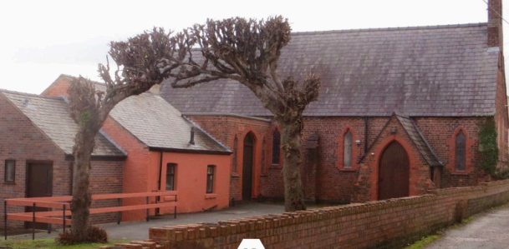

All Saints (Bistre)

Achievements
We have maintained a steady congregation of 15 to 20 for our fortnightly services including visitors from St Cecilias (when they are not worshipping) and Craft Classes are held every Friday with increasing numbers. The Bistre Churches held a Christmas Day Service at All Saints which proved to be a big success. We also held a Christian Aid Service and a Celebrating Christian Unity Service on behalf of Cytun – both being well attended.

Challenges
The damp in the kitchen has been addressed by the purchase of a dehumidifier and a gift of another one. We have also installed a French Drain to try to alleviate future damp events.
Gates and wings have been repaired following an accident and hopefully made more accident proof for the future. A damaged water pipe has been repaired and the damage it caused to the gully and tiles repaired as well.

Growth
Our numbers have remained basically the same despite losing some regular members. New members come in. A few of our members are feeling their age and unable to attend as regularly as they would wish so we visit them as often as we can and offer pastoral care.
We had no weddings or baptisms as these are usually done at Emmanuel our Mother Church

Plans
We join with the other two Churches in Bistre by having ‘Lent and Advent Prayer and Reflection’ led by our Deacon in Emmanuel Church.
After success last year we hope to hold ‘Stem’ learning Science and Faith sessions during August.

Encouraging young people and families
We join with the other two churches in Bistre to offer joint events.
This year we repeated last year’s Easter Egg hunt that brought in even more families.
We worked with the Elfed School Choir initially running with the Fron Male Voice Choir, but since then running their own shows.

Engaging Local Community
We are heavily involved with events for the community along with the other two Churches in Bistre.
We work closely with Cytun, the Jubilee Committee and The Town Council in providing exciting events and community care for the people of Buckley.

Vision for 2026
We are hoping that the French Drain will at last solve the issue of damp in the kitchen. We have shown that we can hold joint Bistre Church and Cytun services with ease at All Saints. Something which we hope to develop in the future.
We also hope that our Church can be used more as a resource in the community.

Emmanuel (Bistre)
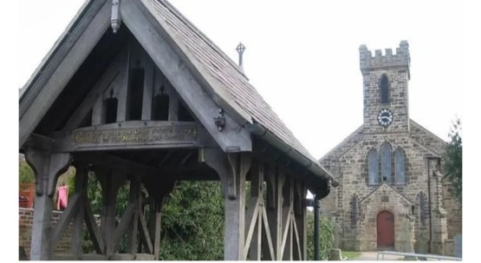
Achievements
We have worked closely with our daughter Churches, sharing resources and gifts to the glory of God.
This has resulted in being able to meet our Diocesan Share commitment and though working together we have delivered some great events that have reached out into the community as well as bringing in some much-needed funds.

We are part of a group of three very busy Churches who work hard to meet our financial obligations and be a loving witness in the community.

Challenges
Though we have a fantastically equipped Church Hall just a couple of hundred yards away the Church is suffering because of a lack of kitchen and toilet facilities.
We have therefore employed an architect to look at how toilet facilities and a kitchen can be installed in our Church.

Growth
There has been a marked increase in the number of new people coming and then regularly attending our Church services. What is even more encouraging is that they are also getting involved in Church activities as well.
Our Baptisms services have levelled off to about two a month. Fewer families want to have their child baptized during the main service preferring to have a private service on a Sunday afternoon. We had just one wedding and two blessings during 2025.

Plans
We joined with the other two Churches in Bistre by holding ‘Lent and Advent Prayer and Reflection’ led by the Deacon in our Church.

Encouraging young people and families
We worked together with the other two churches in Bistre in offering joint events.
This year we repeated last year’s Easter Egg hunt at the Church Hall that brought in even more families.
We worked with the Elfed School Choir initially running with the Fron Male Voice Choir, but since then running their own shows here at Emmanuel including Harvest and Christmas Services.

Our congregation members have been involved with other parish events such as Messy Church and ‘Open the Book’ in 2025, working with local schools.

We have regular visits from Southdown School including Christmas and Easter School Services and have started to reconnect with the local uniformed organisations.

Engaging Local Community
We work closely with Cytun, Buckley Jubilee and the Town Council. And this year we held the Mayor’s Annual Service.
We hold monthly coffee mornings, and special events such as ‘Mama Mia’ sing along, Hog Roasts, Beetle Drive and Bingo events. Although these events are primarily to raise funds, they are becoming more and more community focused.

Vision for 2026
To continue to be a witness of God’s love to the people of Bistre through what we do and Say. We are planning to run a Start Course after Easter. We very much hope to advance the need to install a kitchen and toilet facilities from just a pipedream to a definite plan of action.

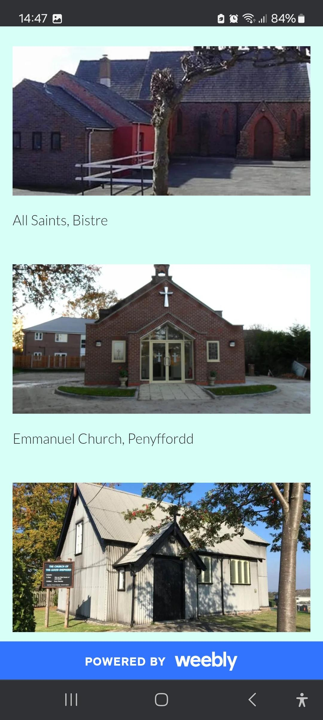
Emmanuel (Penyffordd)

Achievements
The appointment of a new incumbent Rev Simon has brought consistency.
Links with Ysgol Penyffordd have been reformed and they came into Church for their Christmas service.
We have paid our share and have agreed to an increase for the next year.
We have seen a slight increase in the hiring of the building for community events including Penyffordd Toddlers using the Church building for 3 months.
Our Ladies Guild meet once a month and have a good regular attendance.

Challenges
Due to an ageing congregation, we have a lack of volunteers to set up new initiatives and support any new growth projects. There is also a lack of volunteers to take on roles within the Church.

Growth
Our numbers have remained stable however, we don’t have any growth.
We have no baptisms or weddings booked in.

Plans
A Lent course and a ‘youth’ course are being run currently in cooperation with St Cynfarchs and Emmanuel, Penyffordd.

Encouraging young people and families
The open the book team goes into Ysgol Penyffordd on a regular basis.
The Penyffordd Toddler group used the building for 3 months whilst their regular meeting place undergone renovation work. We are looking at how we can encourage further groups like this to meet in Church and to build links.

Engaging Local Community
As mentioned, the toddler group met in Church this year. We are taking part in the community’s best kept village initiative.

Vision for 2026
To form a plan to look at what mission and growth can look like at Emmanuel.
To continue to form links with the local school.

St Cecilia’s (Bistre)
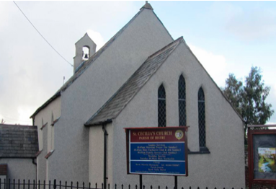
Achievements
Our collective fundraising efforts as a church community have continued to be a highlight. We continue to have many willing volunteers, and our community outreach has also strengthened in 2025.
Miriam Shepherd led a Remembrance Day service on November 9th in the memorial gardens opposite the church which was well attended by the local community. Refreshments were served afterwards in the WI Hut.

Challenges
The main challenge has been the need for a ramp to help those with mobility issues access the Church easily.

Growth
Our bi-monthly Sunday service has kept a steady congregation of about 30 (in line with 2024) with a similar congregation (about 8) on Tuesday mornings.
We had no weddings or baptisms as these are usually done at Emmanuel our Mother Church

Plans
We join with the other two Churches in Bistre by having ‘Lent and Advent Prayer and Reflection’ led by the Deacon in Emmanuel Church.

Encouraging young people and families
We join with the other two churches in Bistre to offer joint events.
This year we repeated last years Easter Egg hunt that brought in even more families.
We worked with the Elfed School Choir initially running with the Fron Male Voice Choir, but since then running their own shows.
Our congregation members have been involved with other parish events such as Messy Church and ‘Open the Book’ in 2025, working with local schools.

Engaging Local Community
Events held in the community included our St Cecilia’s Day concert in the Caffi Isa community hub attended by 80, entertained by St John’s Community Choir and raising £448. In December our candle lit carol service was also well attended by 80 adults. We held three coffee mornings in St Cecilia’s and in May hosted a quiz night on behalf of the parish.
In April we organized a parish day out to Lichfield Cathedral and the National Arboretum. Following this success a second day trip is planned in 2026.
Our Quiz Night in Caffi Isa in May involved about 60 people from across the community.
Our congregation members have been involved with other parish events such as Summer fete, a Beetle Drive, Bingo sessions, Hog Roast and Harvest lunch.
Vision for 2026

To continue to be a beacon of Christs love in Mynydd Isa.

With our plans for the Church ramp now prepared by our architects we will be presenting them to the next Mission Area meeting and looking forward to the DAC response to our Faculty Application.

St Cynfarch and St Cyngar’s (Hope)
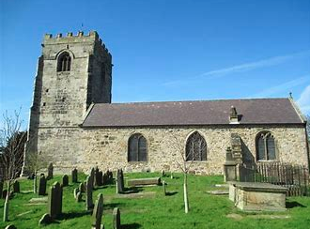
Achievements
We have a new incumbent, Rev Simon Piercy, who has been well received by the Church and community.
Our festival services and events at Christmas and Easter were very well attended by many non-Church goers.
We have invested in a card machine to support electronic giving and have seen it well used.
Rev Simon has reformed links with the local schools, who then came into Church for Christmas services.
We have a strong group of volunteers who are willing to commit to helping out at various Church events including fundraising

Challenges
Finance – Despite holding lots of fundraising events we only just paid our annual share. We have met with Jonathan Morris from the diocese to look at ways of increasing our income. We are going to look at ways of making the community aware of the financial situation of the Church as we have seen how much they value the Church as part of the community with the request for funerals, baptisms etc.
We are going to look at grants that are available to support Church projects such as updating technology.

Growth
Since the appointment of Rev Simon our numbers have become more consistent again. We saw an increase at our Christmas and Easter services.
There has been an increase in the number of funerals held in Church. We have an increase in the number of baptisms and weddings booked into the diary for the coming months.

Plans
A Lent course and a ‘youth’ course are being run currently in cooperation with St Cynfarchs and Emmanuel, Penyffordd.

Encouraging young people and families
We are working closely with the toddler group who meet in the Church Hall and have supported them recently with grant funding applications.
The open the book team attend assemblies in the primary schools.
Rev Simon goes into the local primary and high school.
Our contemporary service Hope4all is a service where families attend with children.

Engaging Local Community
Links with community groups who meet in the Church Hall including Brownies, craft group and toddlers.
We hold a weekly pop in coffee afternoon which brings members of the community together including residents from the local care home.
Links with the community for the annual Remembrance Sunday service.
We have regular fundraising events booked in for the year including quiz nights, bingo and Christmas fayre.

Vision for 2026
We plan to start a young disciple’s group in Feb 2026. This should encourage the younger people to have a connection with the Church.
To continue to grow our links with the local community including schools and community groups.
To form a mission plan for the next 3 years.
To share the Gospel message with our Church family and community.

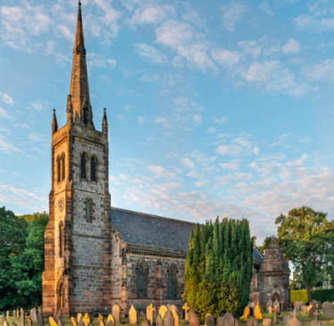
St John’s (Penymynydd)
Achievements
The appointment of Simon as our full-time vicar has made a great difference to our church life.
We have significantly reduced our income/expenditure imbalance
We have started our internal building renovation early steps.

Challenges
Although attendance has increased it is still difficult to see a long-term future for churches, let alone our church.

Growth
We have seen an increase in general attendance and Community Choir membership, the latter showing a reduction in average age.

Plans
A Lent course and a ‘youth’ course are being run currently in cooperation with St Cynfarchs and Emmanuel, Penyffordd.

Encouraging young people and families
The church has close links with the local church school.

Engaging Local Community
A Community Choir has been started and has performed at many events in Church and in the local community.

Vision for 2026
To further engage with our local community with open days.
Our vision is that we will become a place where people feel free to heal, learn and express

St Matthew’s (Buckley)

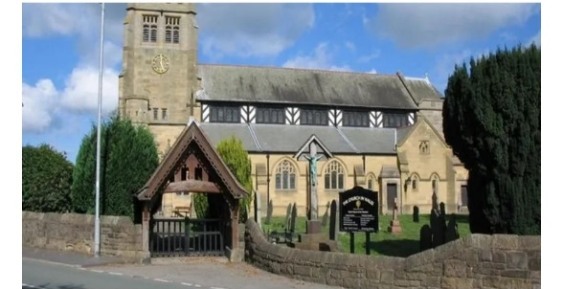
Achievements
The Church was delighted to receive their new Priest in Charge, Rev Jenny and host her licensing service.
St Matthews also hosted the civic service of the High Sheriff of Clwyd, Mrs Julie Anette Gilbanks of Buckley.
The choir and congregation have introduced a new mass setting which has been well received.
Christmas was particularly well supported with higher numbers at every service compared to recent years, possibly in response to a door drop of 1500 Christmas cards giving a Christmas greeting and times of services. Mountain Lane School were involved in Christmas again and have been involved on a couple of other occasions.

Challenges
Financial pressure is an ongoing issue in St Matthews, as in many other churches. St Matthews is having to draw on its reserves to pay the regular outgoings. The congregation is also aging, and some key people can no longer attend or volunteer as they once did.

Growth
Attendance at Sunday service remains steady and the 8am service has resumed on a bi-weekly basis, as has the Wednesday midweek Eucharist. Both have small but steady congregations.
Weddings and baptism numbers remained steady in 2025.

Plans
It is proposed to explore running the LYCIG course and possibly an Alpha course.

Encouraging young people and families
We are trying to develop a family friendly eucharist service and develop relationships with Mountain Lane school further.

Engaging Local Community
The Church Hall is used regularly by a variety of hirers, bringing them into the wider community of the Church. The Church hosted Buckley Civic act of Remembrance in 2025 and the Celebration service for the High Sheriff of Clwyd.

St Matthews continues to:
- Participate in Buckley Jubilee
- Participate in CYTUN
- Join local World Day of Prayer events, area Mothers Union events, Week of Prayer for Christian Unity and others
- Publish the Messenger Magazine quarterly
- Supporting various charities and organizations both local and international.

Vision for 2026
To increase our numbers and continue to develop the family service.

St Michael’s (Llanfynydd)
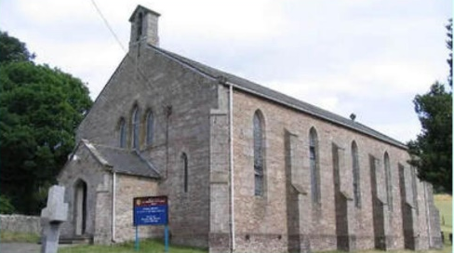
Achievements
Our highlights were a joint Carol Service with the Clwyd Special Riding school and our harvest service and supper. Both were well attended by the congregation and community.
Café Church continues. The Christmas service was well attended and the treasure hunt brought in children and was much appreciated.
Our settled pattern of services week by week works well and we are very grateful to Rev Gail and Alan Griffiths and Ann Williams.
The Community payback team look after the grounds and do an excellent job week by week.
We have been very appreciative of Andrew Bronert’s help in progressing plans and grant aid for refurbishing the Hall.

Challenges
Of course we would still welcome a long-term arrangement for a priest.
We were disappointed not to have any services during Holy Week but now understand that help can be requested.
Concerns about the fabric of the church. We have had some useful meetings with Ryan Marsh but do not have sufficient people to progress the issues of dampness.

Very disappointed that sale of the Church in Cymau is not making any progress and members have to regularly visit to check it is secure.

Growth
We are delighted to have a young volunteer who plays the organ once a month and serves the chalice at Eucharist. A few new worshippers.

Plans
We are too small to organise our own study courses and have appreciated sharing with other churches in the MA .

Encouraging young people and families
Very limited numbers in Llanfynydd. Café Church in Ffrith brought in some younger families to the informal Christmas café.

Engaging Local Community
Carol service was worthwhile and appreciated.
Community café on Friday once a month brought in very good support from community for diocesan appeal. Strong and regular support from community pay-back workers for church yard maintenance.

Vision for 2026
Continue with our regular pattern of worship and focus on continued growth.

The Church of the Good Shepherd (Drury)
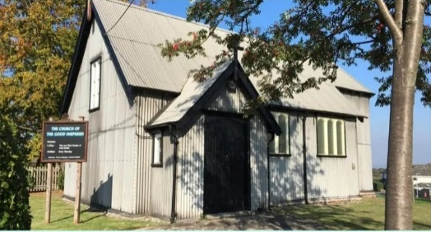
Achievements
Church growth – new congregation members. Worship Leader, Sophie Hunter licensed, congregation diversity including younger congregation members. We now have an organ and an occasional organist. Successful fundraising with the fashion show.

Challenges
The threat of closure – Good Shepherd has become part of the diocesan program to explore the revitalization of the church with good feedback so far.
Financial insecurity and lack of knowledge of the financial deficit.

Growth
Congregation growth including young people and men. 2 confirmations.
No baptisms or weddings (not licensed), some funerals.

Plans
Yes, we have delivered an Alpha course, and we are looking to repeat or do something similar, possibly the Start course.
We now have a weekly bible study group.

Encouraging young people and families
First ever Crib service in 2025, Christingle service and improved Christmas decorations in the church.
The friendly and welcoming atmosphere made people feel relaxed.

Engaging Local Community
Local walks on summers evenings led form the church, new events such as fairs, coffee mornings and various open / welcome events. The diocesan program is enabling considerable community engagement.

Vision for 2026
More of the same! Walking in the jubilee for the first time under our own banner.

The Church of the Holy Spirit (Ewloe)

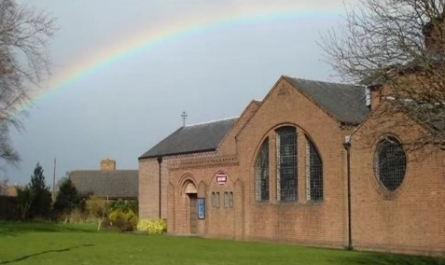
Achievements
We have survived the vacancy and have a new priest. The very popular Christmas leaflets distributed to the community.

Challenges
No new people joined the congregation, there is an ageing congregation. We are running out of money.

Growth
No change, no weddings or baptisms. Some new contacts secured.

Plans
Possibly to deliver a Lycig or Alpha course.

Encouraging young people and families
We are rebuilding the connection with Ewloe Green School

Engaging Local Community
Weekly Coffee morning and fundraising events which bring in visitors.

Vision for 2026
To survive, get the hall demolished and start on the reordering of our Church to include kitchen and toilet facilities.

Treasurers Report
Introduction
In the 2025 financial year, the Mission Area’s expenditure exceeded income by £47,519, more than double the previous year's deficit, meaning that, once more, churches have used reserves to cover day-to-day running costs. I would like to thank the church Treasurers for all their hard work throughout the year to minimise the deficit, the generosity of our members and the careful stewardship of resources.

Income Overview
Over the past year, the total income for the Mission Area was £313,050. This figure represents an increase of 8.2% from the previous year. The main sources of income for our Mission Area are as follows:
- Regular Contributions (Tithes and Offerings); This remains our primary source of income, contributing £197,640, which accounts for 63% of the total income. We are grateful for the faithful support of our congregations.
- Occasional Offices; Fees for Occasional Offices, weddings and funerals, contributed £41,618, reflecting the continuing need to serve the community.
- Fundraising Activities; A series of fundraising events, including annual summer fairs, Christmas markets, and various community initiatives, contributed £21,350. We appreciate the time and effort put in by volunteers to organise these events, which continue to foster fellowship while raising necessary funds.
- Grants, Donations and other Income; We received £18,342 from grants, donations and other income.
- Rentals and Investments; The income generated from the rental of church facilities for events and services amounted to £27,335. Additionally, investments in long-term assets provided £6,765.

Expenditure Overview
Our total expenditure for the year was £360,868. While we remain committed to maintaining financial discipline, we have also sought to ensure that our funds are directed toward furthering the mission and vision within our church. The key areas of expenditure include:
- Diocesan Share; The Diocesan Share accounted for £183,669 or 51% of our overall expenditure.
- Mission and Outreach; £11,354 was spent on mission-related activities, such as the youth programmes, adult education courses and the support of local and international charities. This reflects our ongoing commitment to outreach and our mission to serve beyond the walls of our church.
- Building and Maintenance; Maintaining and improving our church buildings has cost £13,531, which needs to be increased next year. Careful consideration will be given to prioritising the works required.
- Operating Costs; General operating expenses, including utilities, insurance, office supplies and technology, totalled £152,314. Energy costs account for a significant part of the 25% increase from last year.

Looking Ahead
As we look to the future, we should continue to focus on our mission while remaining vigilant to the running costs of each of the churches. We will continue to explore new fundraising opportunities, monitor our expenditure closely, and seek out additional sources of income to support our vision and mission. We are also considering investing in additional outreach activities to ensure we continue to serve the community and potentially attract new parishioners.
In conclusion, we are deeply grateful for the efforts of all involved within the church and the continued support they provide, which enables us to have the impact both within our church family and beyond.

Financial statements
To be added once received from the Auditor

