Please see ECC report:

National Grid Norwich to Tilbury – Statutory Consultation:
I am tabling a motion at the 14th May County Council meeting, to oppose the current NGET proposal - see full text below. It would be helpful if members of the public or Parish council attended and spoke during the public open session – see website https://www.essex.gov.uk/running-council/get-involved/council-meetings on how to speak at County Council meetings.

Chelmsford City Council will be reviewing their response at the Policy Board 11th June. I have spoken to both Spatial Planning and Heritage Officer to understand the City Council response. Again, members of the public can attend and give their views.

ECC Motion - National Grid’s Proposed Norwich to Tilbury Project

Moved by Cllr Mike Steel and seconded by Cllr Lesley Wagland

‘National Grid Electricity Transmission (NGET) have launched their third and statutory consultation, running until 18th June, following two non-statutory consultations in 2022 and 2023. ECC commented on the previous 2 consultations with a view that their strong preference was for an off-shore grid thus avoiding the harm to the local economy, environment and the health and wellbeing of their communities caused by 180km of 50m steel latticed pylons.

Following the previous consultations, little has changed in the latest proposal in terms of the route of pylons through Essex (except some minor shifting) and the addition of a new 400 kV East Anglia Connection Node (“EACN”) substation, on the Tendring Peninsula.

This Council expresses its deep concern that the proposal by NGET remains unchanged given the opposition and that the latest proposals by NGET:

- Dismisses the Electricity System Operator (ESO) 2024 East Anglia Network Study that considers 9 alternative options and timescales, including off-shore and HVDC underground alternatives. All of these options are Norwich to Tilbury, and did not include an off-shore grid
- Dismisses the Hiorns Smart Energy Networks review published Nov 23, commissioned jointly by Essex, Suffolk, and Norfolk County Council and challenged the delivery date of 2030, and suggested that the need for additional transmission capacity would be closer to 2035. Therefore, it would allow consideration of more acceptable options. All three county councils expressed their concerns that the currently proposed option will harm the local economy, environment and the health and wellbeing of their communities
- Dismisses the Offshore Coordination Support Scheme (OCSS) and reduces the consideration to just Norwich to Tilbury power transport, assuming that the power from the wind farms is already transported to Norwich, when the reality is that it isn’t, but such contracts may be in place.

This Council therefore calls upon:

- NGET to reconsider their proposal of an exclusive Overhead Line (OHL) solution for Essex as presented in the statutory consultation, on the basis of the devastating effect of 50m of steel lattice pylons on residents, businesses, communities and the local environment, and that they further consider the alternative options from the ESO study and the case for delay from the Hiorns report.
- ESO and Govt widen the ESO Options report and not restrict the starting point for all options as Norwich, which has the pre-emptive effect of making the OHL solution the most economical, and restricts consideration of a strategic off-shore grid.
- ESO and Govt ensure that the OCSS is brought into consideration along with the extended timetable of the Hiorns report, which would then enable lower impact solutions for the residents, businesses, communities and local environment of Essex’

Essex Highways wraps up winter service after wettest recorded winter in 130 years
Essex Highways have wrapped up this season’s winter service following the wettest recorded winter in 130 years. High levels of rainfall brought significant challenges, with frozen conditions and icy roads meaning additional work for crews. Working closely with local, city, parish, and town councils to overcome the winter conditions, including two major storms, this winter Essex Highways crews have:
- Carried out gritting runs across Essex over 80 times, spreading salt to melt away ice and stop it from forming into hazards
- used over 10,000 tonnes of salt to keep roads ice-free and safe following wet conditions
- gritted approximately 40% of the total road network in Essex, over 2,000 miles
- deployed 55 gritting lorries, including 10 new ones, along with two mini gritters
- covered each of the 51 gritter routes across Essex, ensuring critical routes remained safe and accessible for all highway users
The county’s gritters will return for the 2024/25 winter season later this year. You can even track the gritters via the Essex Highways website!

Update on member Led Defects
As previously reported, I get to direct the extra defect teams for 6 weeks throughout the year. Belo0we is a progress report on the defects I entered for the it round.
I need a photo and a Track-It ref number, if you want me to add to future work.
https://www.essexhighways.org/track-it

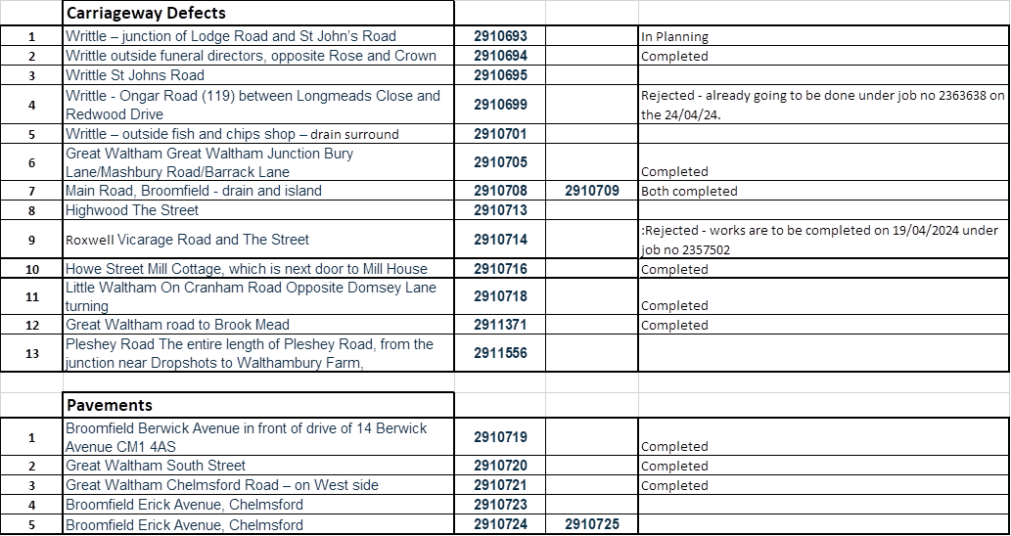

Woolmers Mead Drainage.
Drainage issue on Grange Road

I have been chasing on this and the only update I have from Enforcement is – “Sorry about the slow update, I am speaking with the Enforcement lead about Woolmers mead at the moment. As for the other site I hope to pick that up soon.”

Broomfield and Writtle LHP schemes agreed for funding in 24/25
- LCHE226001 – School Lane, Broomfield – SCP –addition of wig wags.
- LCHE212007 – Chignal Smealey – implementation of gateways and 40mph marking
- LCHE212015 – LW – 20mph past school + wig wags

Cllr Mike Steel
Member for Broomfield & Writtle

