Chair D. Loudfoot
Vice- Chair G. Howeson
Clerk: W.J. Adshead-Grant

Posted: 11.11.2022

The Public and Press are invited (Public Bodies admission to Meeting Act 1960) and all Councilors are hereby summonsed to attend the meeting of Pleshey Parish Council to be held at Pleshey Village Hall on Wednesday 23 November 2022 at 8pm. For transacting the following business:
W.J. Adshead-Grant

2022/776 Chair’s Welcome
Chair:
Councillors:
2022/777 Apologies for absence

2022/778 Declarations of interests (existence and nature) regarding items on the agenda.

2022/779 Public participation session for anyone with an interest in the Parish
(Item does not need to be on the agenda)

Finances:

2022/780 Status of the bank account – The Golden Jubilee Playground Refurbishment Fund

Reports and Updates:

2022/781 Clerk's Report and actions to be undertaken.
- Clerk to Digitise the records of any loose-leaf minutes - Started
- Clerk to assist two members on getting online with latest bank statement. (Cllrs Gunn and Loudfoot)
- Clerk to Book training days for Councillor Groves
- Bridge at Rooters Hill – LHP request on signage of a shared space Motor traffic and pedestrian.

2022/782 Update on the Golden Jubilee Playground equipment refurbishment and fundraising

Planning

2022/783 Local Planning Authority updates

2022/784 Planning Applications:
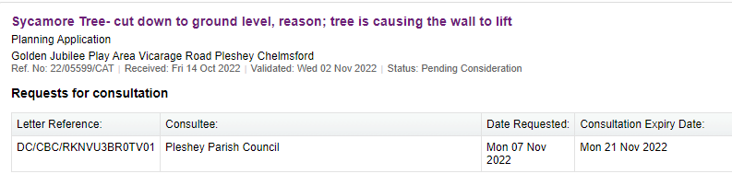

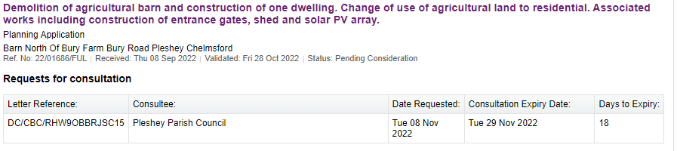

2022/785 Items for the next agenda – All

11.01.2023 Monthly Meeting @ 8PM
08.02.2023 Monthly Meeting @ 8PM
08.03.2023 Monthly Meeting @ 8PM
12.04.2023 Monthly Meeting @ 8PM
04.05.2023 PARISH ELECTIONS
10.05.2023 AGM & Monthly Meetings @ 8pm
14.06.2023 Monthly Meeting @ 8PM

