Contributor Guidelines
Space for a picture
How to use this template:
Just type your text in the title box above, and here and send by email to kenning@pleshey.net.
This template is designed so that what you see here should (in theory) look exactly the same in the magazine – that way you can write your text so it fits exactly and we don’t have to edit it.
We try to avoid editing contributor work, but we can’t promise that we won’t have to make any changes at all if it doesn’t fit, or if there’s a typing error.
You can save this as a template to use every month if you’re a regular contributor.
Length of articles
Generally, we publish stories that are no more than one page long. It’s much more difficult to write a short article than a long one!
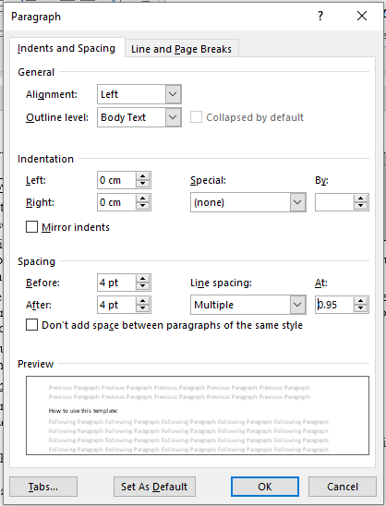
It’s still easier for you to edit down to size and produce a piece of writing with which you’re happy, than to let somebody else do it for you.
1 page = about 250 – 350 words
This depends on how many paragraph-breaks you have, whether you use long or short words and whether you’d like to include a picture.
For anyone who’s interested, the font is Garamond 12pt, and the paragraph settings are as shown in this box:

