October

1 | Opening night – Annual General Meeting  Presentation of certificates from 2024/25 season.
8 | I wish I’d taken that!  Members are asked to bring along 3 or 4 images that they wish they had taken
15  mtg room | Exhibition planning  Bring along your favourite images of the Bay.
22* | Monthly Competition.  Judge: David Goodier
29 | Across Australia – Clive Bond  Our own member will present images from a journey across Australia

November
5 | Outdoor Meeting – venue tbc  Firework displays
12 | Other People’s Art – Graham Dean
19* | Monthly Competition  Judge: Miles Turnbull CPAGB, BPE1*
26 | Practical workshop – Exhibition preparation

December
3 | Picture Quiz  Members should send 6 “puzzling” images in advance. Subjects should be familiar objects or places taken from unusual angles or showing very close up detail.
10 | Christmas Social – Midland Hotel
17 | Monthly Competition.  Judge: Harry Emmett CPAGB
24 | No Meeting – Christmas eve
31 | No Meeting – New Year’s eve

January

7 | Print Exhibition opening
14* | Monthly Competition.  Judge: Sally Sallett ARPS CPAGB AFIAP BPE3*
21 | Travels without a Donkey – Dan Johnson
28 | L&CPU Annual Club Competition – video from 2025

* indicates a raffle
** These are evenings which could include demos and/or short talks from members.

Version 3 – 7/10/26
February

4 | Members’ Evening
Mon8* | 4 way “Battle” at Lancaster  We shall be competing against Lancaster, Arnside & Silverdale (formerly jctn 36) and Garstang. Judge – Steve Hitchen
11 | Monthly Competition  Judge: Richard Nicholson BPE2* CPAGB
18 | Members’ Evening
25 | “Battle” vs Kendal  Judge: Adrian Hendley CPAGB

March
4 | Members’ Evening
11 | Monthly Competition  Judge: John Smith APAGB, Hon LCPU
18 | Members’ Evening
25* | Annual Competition  Judge: Nicki Ellis Greenwood DPAGB BPE2*

April
15 | Easter Social Evening
22 | Annual General Meeting

Competition Information
Entries should be emailed to:
competitions.mcc@gmail.com
Please name the files so they are the title of the
photograph. Ideally images should be no wider than 1600 pixels and no taller than 1200 pixels (but don’t worry if they’re not).
Competitions usually have 3 sections: Nature, a set Theme and Open. Members can enter up to 4 images spread across the 3 sections. All elements of an image should be the work of the author. Nature images should not include pets, domesticated animals or cultivated plants. Only limited manipulation is allowed in Nature section.
It is assumed that winning images may be used on the club’s website unless the member indicates otherwise and that any entries may be used by the club in inter-club competitions.
October Comp – Straight Out of the Camera | 11th Oct
November Comp – Shadows | 8th Nov
December Comp – Unusual Viewpoint | 6th Dec
January Comp – Negative Space | 3rd Jan
February Comp – Diptych or Triptych | 31st Jan
March Comp - Doors | 28th Feb
Annual Competition | 14th March

For more information visit our website:
https:/morecambecameraclub.co.uk
or
https://e-voice.org.uk/morecambe-camera-club/

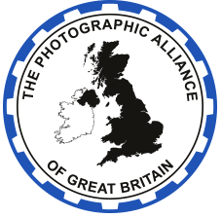
Find us on Facebook
https://www.facebook.com/morecambecameraclub

Morecambe Camera Club is a small, friendly group - we welcome anyone with an interest in photography - you don't need a fancy camera to join, just an interest in taking pictures.

Our members have a range of skills, and a range of ages, so come along and see what we do!
If you want to find out more, please drop us an email at morecambecameraclub@gmail.com

We usually meet on Thursdays at 7:15pm.
Main season meetings are held in Heysham Library, from October to Easter.
We also run summer Programme which includes day and evening outings.

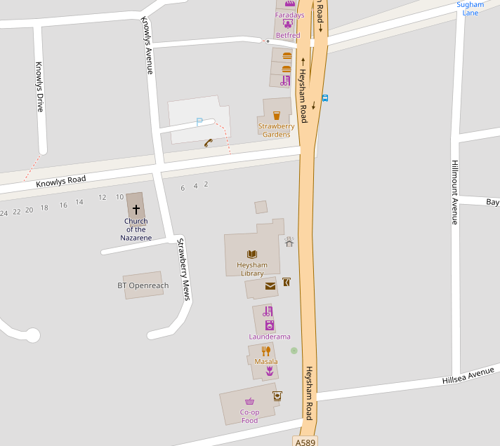
Heysham Library, 396 Heysham Road, LA3 2BJ (please use side entrance)
(map © OpenStreetMap.org)
Morecambe Camera Club
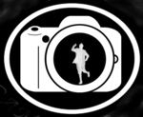

Programme 2026/27
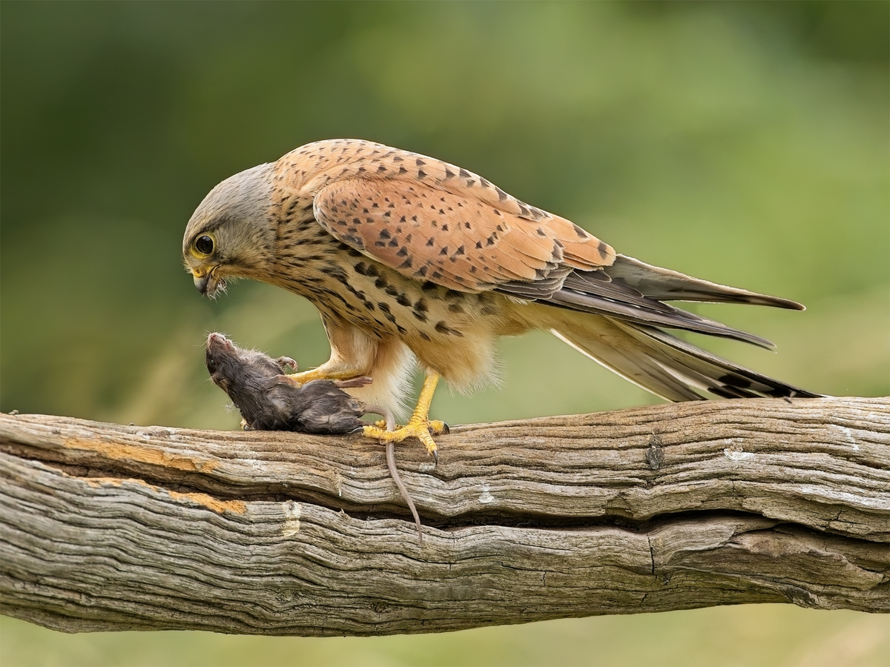
Image: Looking Death in the Face
by John Hughes

