
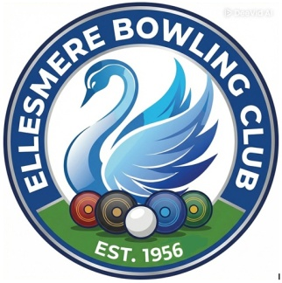
Ellesmere Bowling Club

Clubhouse Appeal
Our story …
The Ellesmere Bowling Club, located in Shropshire, boasts an incredibly rich and diverse history, with its top green in use since 1698 on land that was formerly part of the Brownlow Estate. This site is, in fact, the Motte of the original Ellesmere Castle, which was built in 1177, making it the oldest Crown Green in Shropshire and possibly in England. The lower green was created in 1986 following the club's purchase of the land from the Council, allowing for the addition of a small, "compact & bijou" wooden clubhouse.
The Goal: Modernizing for the Future

The Club's current aim is to replace the existing, small clubhouse on the lower green with a larger, warmer, and more welcoming space for members and visitors. Key improvements include:
- Improved Accessibility: Providing better access, particularly for those with mobility issues.
- Modern Facilities: Including a disabled access toilet instead of the current outside toilet.
- Community Use: Creating a space that can be used for meetings and functions.
- Attracting New Members: Enhance facilities to attract new members and secure our future.

The club is keen to emphasize that it is not just for seniors, with a Wem league team averaging 28 years old and including several competitive teenagers. The new clubhouse aims to be ready for the 2027 season.

How You Can Help: Crowd funding & Sponsorship

To achieve this goal, the club has launched a Crowd Funding appeal with a total target of £30,000. Sport England has pledged to match funds pound for pound up to £15,000, meaning donations will have double the impact.

Donation Tiers:
Individuals (Friends of EBC): |  | Companies & Businesses:
 | Bronze: Minimum £20 donation |  | Bronze: Minimum £100 donation
 | Silver: Minimum £50 donation |  | Silver: Minimum £250 donation
 | Gold: Minimum £100 donation |  | Gold: Minimum £400 donation
 | All Friends of EBC will have their name listed on the club's website. |  | Companies will receive an advertising sign around the green. Plus their logo and details on the club’s website

Please support the Ellesmere Bowling Club in preserving this historic site and enhancing it for future generations. Donate now to:
https://www.crowdfunder.co.uk/p/ellesmere-bowling-club

