
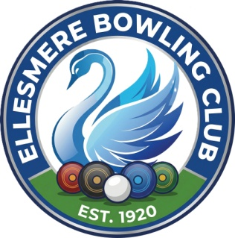
Ellesmere Bowling Club

Press Release

22nd March 2026

7up Cup - Elliott beats his Grandparents!

Elliott Mochan is becoming a bit of a local legend, or at least the undisputed "family villain" on the Bowling Green. Defending a title is hard enough, but having to knock out your own Grandma (Barbara) by a whisker and then take down your Grandpa (Keith Pritchard) in a tense final is some serious "no mercy" match play.
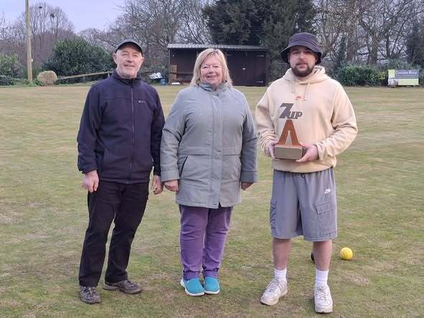
Winning the ‘7up Cup’ back-to-back is a massive achievement, even if it makes Sunday lunches a little awkward for a while.

2026 - 7up Cup

Winner: Elliott Mochan Runner Up: Keith Pritchard

