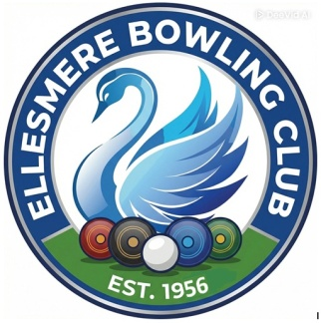
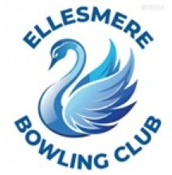
Ellesmere Bowling Club

Press Release

2nd May 2026

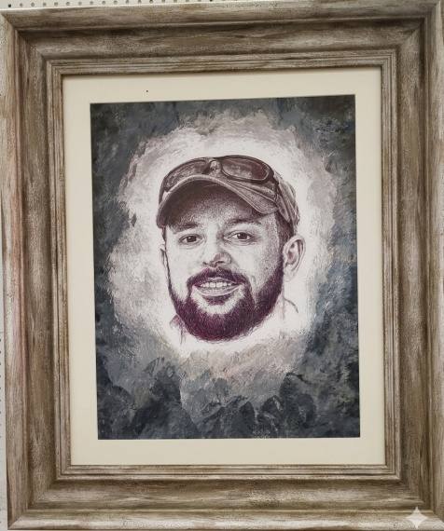
Elliott Mochan – EBC’s ‘Top Bowler’ & Resident Artiste
Ellesmere’s very own bowling prodigy with a ballpoint pen / pencil is exhibiting a selection of his artwork at the Market Hall, Ellesmere; open now until Monday 4th May.
Elliott produces hand-drawn portraits of people and pets, and he also takes on custom commissions created directly from your photos. If you’ve ever wanted your face immortalised by the club’s most talented bowler-artist, now’s your chance.

‘The Webmaster’ – EBC’s ‘Mediocre Bowler’ & Wind-Up Merchant
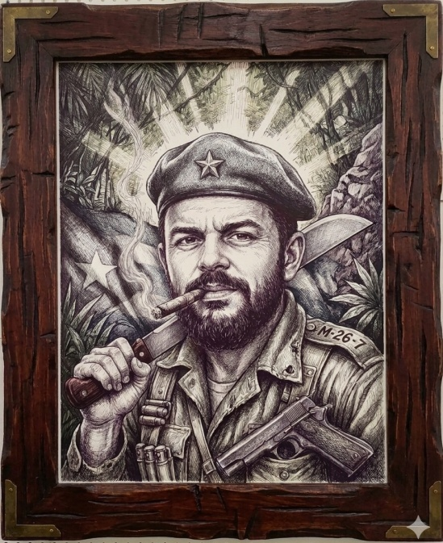
Meanwhile, over on the club website, The Webmaster is proudly displaying a curated selection of his finest windups, pranks, and digital mischief.
He is now accepting commissions for his next major project: EBC Superheroes – launching 1st June. If you know an unsuspecting soul who deserves to be transformed into the next heroic club legend, simply send their photo to the email address below. The more unsuspecting the victim, the better the result.

