

Ellesmere Bowling Club

Press Release

1st April 2026

Druid Burial Site Discovered in Ellesmere…
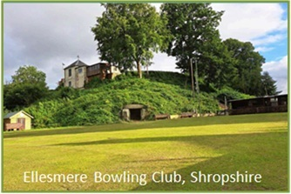
Archaeologists from the heritage organization ‘Heneb’ have recently undertaken a program of geophysical surveys on the top green at Ellesmere Bowling Club. A preliminary ‘electrical resistivity survey’ carried out in 2025 uncovered the outline of what is thought to be the remains of a Mott and Bailey castle dating back to the 11th Century.
The latest survey conducted in early March mapped the sub-surface archaeological remains and discovered the foundations to the castle some 1.5 meters below the bowling green. A further more powerful magnetic gradiometry survey discovered a large subterranean chamber in the centre of the mound some 7 meters below the surface.
The survey indicated a "polygonal-shaped chamber" of approximately 5 meters with a height of 2 meters. It also revealed an entrance vestibule facing the exact direction of the equinox sun rise. A further investigation and an invasive archeological dig uncovered an entrance to the chamber which needed to be reinforced after centuries of decay. The entrance looks toward the rising sun from within which suggests a site with significant ritual or symbolic importance, predating the Norman castle.
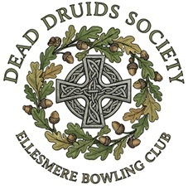
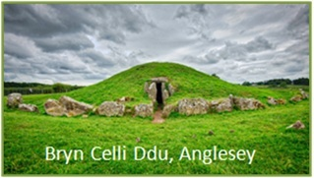
Within the large or main chamber there appears a small chamber which is sealed by a large oval shaped Stone. The small chamber remains sealed as we await expert advice on how to proceed. There are artifacts of historical interest scattered around the main chamber which is indicative of a ritual or burial site. The polygonal architecture of the chamber and the remains are evocative of the Druid burial mound ‘Bryn Celli Ddu’, a Neolithic passage tomb located on the Isle of Anglesey in Wales, constructed around 3000 BC. The Ellesmere site is not currently open to the public as we await a license from English Heritage and the relevant safety certification.
*Ellesmere Bowling Club is in the process of establishing the “Dead Druids Society”. Further details & launch date available from: DeadDruidsSociety@gmail.com

