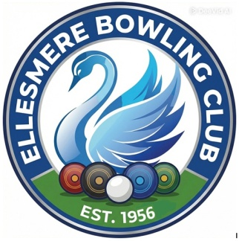

Ellesmere Bowling Club

Press Release

27th April 2026

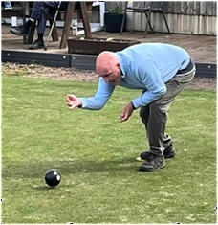
Ellesmere Bowlers Shine at Newby Competition

Two rising stars from Ellesmere Bowling Club made their mark at the Newby Competition held at Hodnet Bowls Club on Sunday, 26th April. Tim Evans and Daniel Barney delivered standout performances in the tournament, which is exclusively designed for bowlers with less than two years of experience in the sport.
Both players dominated the early stages of the competition, each topping their respective qualifying groups with a perfect record of four wins. Their clinical play secured them well-deserved spots in the knockout rounds.

In the quarter-finals, Tim Evans was involved in a nail-biting contest that went down to the wire. Despite a valiant effort, he narrowly lost 19–21 to the player who eventually finished as the tournament runner-up. Daniel Barney continued his winning streak into the knockout stage, securing a hard-fought 21–19 victory in his quarter-final match. His impressive run came to an end in the semi-finals, where he fell 18–21 to the eventual tournament winner in a high-quality encounter.
Ellesmere Bowls Club is incredibly proud of Tim and Daniel. To see both players top their groups and compete so closely against the finalists shows the depth of talent emerging at our club. They have represented Ellesmere with fantastic spirit. The Newby Competition remains a highlight for newcomers to the game, providing a competitive yet welcoming environment for those in the early stages of their bowling careers.

