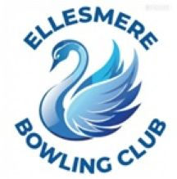
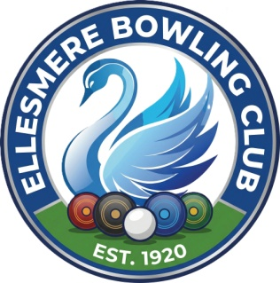
Ellesmere Bowling Club

Press Release

11th April 2026

Bowling Barney Brothers Big Bowls Breakthrough!
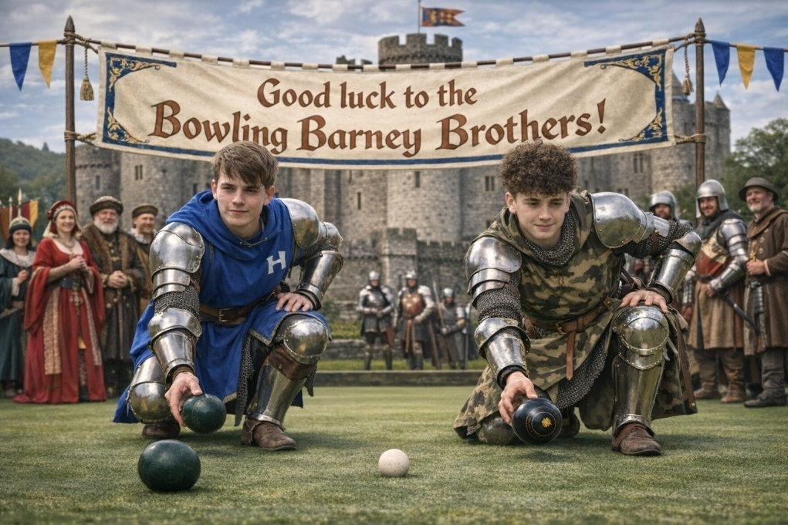
Daniel Barney, the newest knight of the realm, has been summoned to join his brother, Sir Alex, in the prestigious Norman Ford Classic. On the 12th of April, they shall descend upon the hallowed turf of the Prees Bowling Ground to face thirty-two of the fiercest warriors North Shropshire has ever seen.
The elders of Ellesmere Bowling Club have issued a decree of unwavering support for these two Gallant Young Men. As they prepare to lock antlers with the provincial elite, the war horns sound in their honour.
To the green, brave brothers! May your aim be true, your bias be steady, and your opponents crumble before your might.
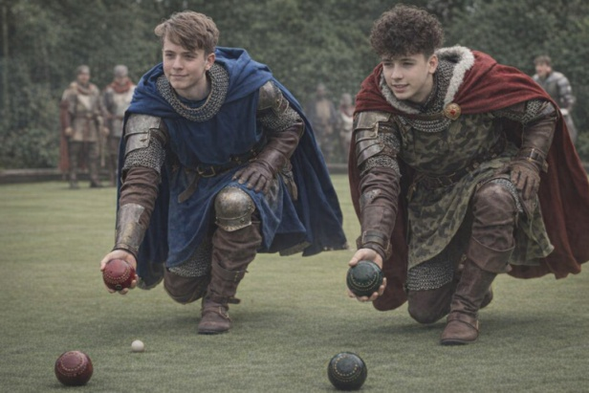
Go get 'em, boys—for Ellesmere and for glory
