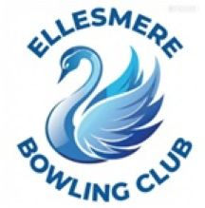
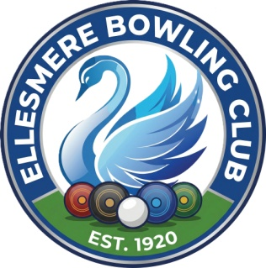
Ellesmere Bowling Club

Press Release

14th April 2026

Honorary Lifetime Membership Awarded to Alf Johnson
Ellesmere Bowling Club (EBC) is immensely proud to announce that Alf Johnson has been awarded an Honorary Lifetime Membership, the highest honor the club can bestow. This award recognises Alf’s extraordinary 45-year tenure of support, leadership, and tireless dedication to the club's community and facilities.
Presentation Highlights
The presentation took place on Tuesday, 7th April, held fittingly on the Bowls Green just before the highly anticipated ‘A’ team vs. ‘B’ team derby.
- Presented by: Mike Baldwin, Club Treasurer.
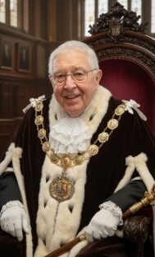
- Media Coverage: The ceremony was filmed by a crew from Ellesmere College, ensuring this milestone is preserved in the club’s historical archives.
A Legacy of Service
Alf’s contribution to EBC spans nearly half a century and includes a variety of vital roles:
- ‘Mayor of the Green’: A title reflecting his respected presence and deep-rooted knowledge of the clubs history and culture.
- Team Captain: Providing leadership and mentorship to players across decades of competitive play.
- Grounds & Facilities Maintenance: Playing a role in the upkeep of our historic site, which includes maintenance of grounds and facilities.
A Pillar of the Club
Beyond his formal roles, Alf is cherished for his effervescent smile, sense of humor, and good nature. His presence is a morale booster for any team, and his hard work behind the scenes has been fundamental to the club’s continued success and welcoming atmosphere.
Congratulations, Alf, from everyone at Ellesmere Bowling Club. This honor is richly deserved.

