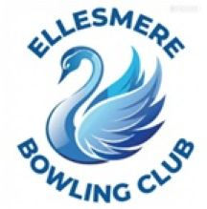
Ellesmere Bowling Club
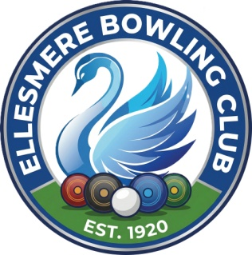

Press Release

2nd April 2026

Alex Goes Big!

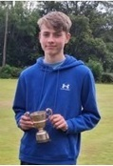
Alex has been invited to play in the Norman Ford Classic Competition on 12th April at Prees Bowling ground. Some of the best male and female, over 60 and junior players have been invited to attend this prestigious knock out competition open to just 32 competitors. Everybody at Ellesmere Bowling Club are very proud of Alex and are wishing him good luck and every success on the day.

Bowling Barney Brothers Big Bowls Breakthrough!


Daniel is the latest of the ‘Bowling Barney Clan’ to be invited to pay in the prestigious Norman Ford Classic Competition. He joins his Brother Alex on the 12th April and will do battle with 32 of the best junior and senior bowlers in north Shropshire at Prees Bowling ground.
Ellesmere Bowling Club wishes these two gallant young men every success as they lock horns with some of Shropshires finest.

