MARGARETTING NEWS
May 2011

Inside this issue:

Parish Council | 2
Fundraising Support Day Surgery - 8th June | 2
Tandridge - Letter to the good people of Margaretting | 3
Prescription Collection Service | 3
Easter Lilies | 3
A12 By-pass - Update on Programme of Repairs | 3
Family Fun Day - 2nd July at the village hall | 3
Tree planting ceremony | 4
Village Hall News and Diary Dates | 4

MARGARETTING FRIENDS
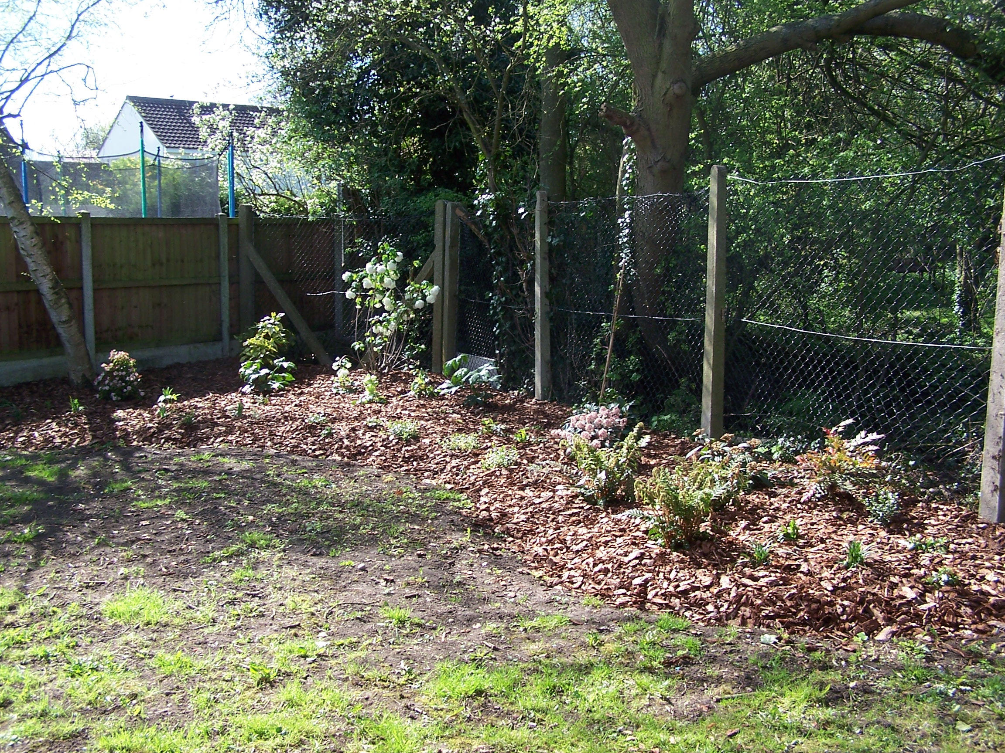
The woodland garden in the photograph above is situated along the boundary fence behind the Black Bull at the top of Orton Close. Local Air Cadets, working alongside neighbours, members of Margaretting Friends and the parish council prepared the ground and planted the shrubs and ferns during the weekend of 26 and 27 March. The garden was designed by Helen Boem. Funding was arranged by Margaretting Friends through grants obtained from Chelmsford Council, the Parish Council, and Chelmer Housing Partnership. A really big thank you is due to the neighbours who have been watering the plants during the recent dry weather.
Margaretting Friends meet every 3rd Monday in the month at 7.30pm in the Chelmer Room in the village hall. On Monday, 16th May we have a talk by Mr Fred Sheldrake on ‘Do you know your birds?’ If you are interested in joining Margaretting Friends and taking part in local projects and activities please contact Rosemary Carter on 350553

CHURCH SERVICES DURING MAY

1st May 10am - Parish Communion
8th May 10am - Morning Prayer
15th May 10am - Parish Communion
22nd May 11am - Holy Communion
29th May 3.30pm - Rogation Sunday - Buttsbury

ST MARGARET’S CHURCH NEWS
I hope you have had a joyful Easter. When I was a child, my brothers and I were each given a coloured (dyed) hard boiled egg each Easter and one chocolate egg. After church, still wearing our ‘Sunday best’ we were taken out to the park so that we could roll our hard boiled eggs. It was important that we found a small hill or slope. We stood at the top, and together, would roll the eggs down the hill. The idea was to try and keep your egg from cracking. The winner was the person whose egg didn’t crack. They then went back up the hill to start again. Usually I was out first as, being the youngest, my egg seem to bounce more often than roll smoothly!!! At Sunday School we were told that this egg rolling represented the stone being rolled away from the tomb but perhaps this is just a Scottish tradition. The eggs would then either given as egg sandwiches or egg salad at tea-time.
Development Project update - I am pleased to tell you that we have raised over £23,000 towards the project to date. We have had a more detailed estimate that has come out at £41,868. We will, of course, be asking for other estimates, but now we have a realistic figure. Thank you to those who have sent a donation towards this work and it is still possible to give a donation, small or large. We hope that the work will be completed by the end of this year and I will keep you updated of our progress ech month.
We will be praying for the following places in the community on:
1st May - Private Road
8th May - The Tye
15th May - Over 60’s Club
22nd May - Margaretting Friends

This month has five Sundays so there is a Benefice Sercie at Buttsbury Church on 29th May. This service is at 3.30pm and will be a Rogation Service when we walk into the fields, bless the crops, the river, gardens and then end up back at the church for refreshments. You are very welcome to join us.

Thank you. Revd Jean Halliday 01277 354359

To all contributors to the Newsletter.
The next edition will be a combined June/July issue. Please let us have your entries by May 20th.

SELF LOCKING SNARES - ILLEGAL
The use of self-locking snares is prohibited under the Wildlife and Countryside Act 1981. Although illegal in the UK, self-locking snares are still used and cause severe injuries to a variety of animals species. A self-locking snare is a wire loop device which continues to tighten by a ratchet action as the animal struggles. Its aim is to catch the victims around the neck, so that they die through strangulation or by dislocation of the neck.
But, snares do not only capture animals by the neck. Some animals get their legs caught in snares, and end up with the snare cutting down to the bone. Such animals may attempt to escape by gnawing off their own limbs. Other animals are caught around the body. Both badgers and foxes have been found with snares that have almost cut them in half, the snares around their bodies having tightened to around five centimetres in diameter inflicting terrible injuries. Some of these animals were still alive when found.
PCSO Kay Fleming Tel: 0300 333 4444

FUNDRAISING SUPPORT DAY SURGERY
Wednesday 8th June 2011
Margaretting Village Hall
10.00 hrs – 16.00 hrs
Thanks to funding by the Big Lottery, Chelmsford CVS is able to offer charities and community groups within the Chelmsford District specialist fundraising support.
To book your FREE
appointment please contact:
Peter Brooks 01245 351 888
funding@chelmsfordcvs.org.uk
For more information http//chelmsfordcvs.btck.co.uk

PARISH COUNCIL - APRIL’S MEETING
DEMOCRATIC TIME
Three members of the public were present. Issues raised included:
Blocked Ditch in Maldon Road
Contact has been made with the registered landowner and plans are in hand to clear the ditch.

VILLAGE SITES
Maldon Road Railway Bridge: Our request for improved signage has been passed to Essex County Council Highway’s new Minor Schemes and Improvement Team. Works of this nature are prioritised and subject to funding.
Village Pond: Ecologia is still monitoring the effect of the oil in the pond. We agreed quotes of £390 for making good the path surrounding the pond and £180 for the repairs to the bench facing the road.
Village Trees: A copper beech has been planted in recognition of Mr Radley’s term of office as our village tree warden. See back page
Whites Bridge: Repairs and the reopening of the bridge to traffic have been delayed due to vandalism - new coping stones were smashed and a large section of one of the newly built walls pushed into the river.

VILLAGE PROJECTS
War Memorial: The improvement works, to be completed by FJ French, will begin after the Easter holidays.
Village Gateways: Discussion deferred to our May meeting.
Whites Bridge Walk Boards: Nothing further to report.
Parish Council Office: Agreed to follow Chelmsford Council’s advice and apply for Full Planning rather than Outline Planning.

REPAIRS & MAINTENANCE
The following maintenance schedule was agreed:
Treating the bus shelter opposite the Black Bull.
Treating three benches and painting iron work.

MALDON ROAD RECREATION FIELD AND ALLOTMENTS
A heavy duty drain cover in the playing field was stolen. The cost to replace and install totalled £300.
The annual ROSPA inspection will take place in May.

ACCOUNTS
Financial Year 2010/11: Received end of year statement comprising: £16,064 income and £11,086 expenditure.
Financial Year 2011/12: The following expenditure was agreed:
£17 - N Marshall (allotment padlock)
£54 - BT (village hall broadband)
£80 - H Blurton (emergency supplies)
£100 - Margaretting Friends (garden)
£155 - A Gibbons (grass verge)
£214 - EALC (subscription)
£300 - Lisnick (drain cover)
£439 - MDL (grass cutting)

PLANNING
The following applications were received for comment:
11/00426/FUL & 11/00427/LBC - The Parsonage, Parsonage Lane: Demolition of existing garage, to be replaced with oak framed garage/storage building.
11/00369/FUL - Little Cedars, Maldon Road: Two storey rear extension and loft conversion with front dormer window.
11/00531/FUL - Sycamore, Maldon Road: Single storey rear extension.

The following decision was received:
11/00233/FUL - Whites Place Farm, Main Road: Installation of a roof mounted solar photo voltaic electricity system. Grant Planning Permission

ANY OTHER BUSINESS
Tandridge, Maldon Road: The owners have apologised for any inconvenience the heavy lorries accessing their property may have caused. See next page. We agreed to write a letter to the owners supporting their plans to tidy up Tandridge.
The Spreadeagle, Main Road: The new owner has confirmed his preferred option for the site is residential development. We would like to see the site developed as a village amenity, e.g. doctor’s surgery, petrol station, convenience store.

PARISH COUNCIL ELECTIONS
A vote of thanks was given to Mr John Currie for his many years of service as a parish councillor. Mr Currie will not be standing as a parish councillor in the forthcoming elections.

MARGARETTING BY-PASS PROGRAMME OF REPAIR AND OTHER WORKS
Following a recent enquiry, the Highways Agency has reported as follows:

“As stated previously, the A12 Margaretting Bypass major maintenance scheme is on our forward programme of works for the future. It was anticipated that these works would begin in 2013/14 subject to funding being available. As you are aware, the Government has made clear that the first priority must be to tackle the deficit, and that we will have to scale back spending across the whole of government. Therefore, the opportunities to make improvements to the network in the near future will be limited. Consequently, it is unlikely that any major maintenance schemes will be funded during the Comprehensive Spending Review period. We therefore anticipate that the design work for the A12 Margaretting Bypass major maintenance scheme will be started in 2014/15 and works on the ground will begin in 2015/16.
In the meantime, we plan to undertake a low cost maintenance scheme on the A12 Margaretting Bypass, this scheme will mostly comprise of concrete repairs to the carriageway and crack sealing to keep this length of road in a serviceable condition. These works have been indicatively funded for the forthcoming financial year (2011/12) subject to final approval of our budgets.
Following our letter of the 14 April 2010, we completed an initial scoping report last year that highlighted Margaretting would receive a quiet thin surfacing overlay as part of the major maintenance scheme and thereby reduce noise.”

TANDRIDGE MALDON ROAD
To the good people of Margaretting.
It has come to our attention there have been concerns about the number of trucks running through the village to Tandridge.
We do have Todd Brockwell trucks delivering topsoil to Tandridge to reinstate the bottom field which as you know was in a mess two years ago. We apologise for any inconvenience this is causing. We have cut the lorries down to one or two a day whilst Whites Bridge is out of action. Hopefully, in the near future the field will be completed and everything back to normal.
On behalf of Rowland Ellis,
Sincerely yours,
David Jones and Karen Burder.

200 CLUB
200 Winners for the March draw:

£100 – Mrs J Philp
£50 – Mrs A Nixon
£30 – Mrs E Chapman
£20 – Mrs D Henderson
£15 – Mrs I Hands
£5 – Mrs W Sears

Thank you to all the renewing members and also the new members who joined this year. Memberships closed for this year with a total of 198 members. Good luck for the rest of the year. The next draw will take place at the Horticultural show in July.

MOTHERS UNION
Meetings are held in St Margaret’s Church on the third Thursday in the month at 2.30pm.
Contact Jill Needs 01277 627078

PRESCRIPTION COLLECTION SERVICE
Shadworth Pharmacy offers a free collection and delivery service for patients aged 60 plus registered with The New Folly Surgery, Ingatestone. For more information please telephone 01277 352125

BOOK CLUB
Our next meeting is on Friday, 13 May. We will be discussing ‘Water for Elephants’ by Sara Gruen and ‘Rebecca’ by Daphne Du Maurier.
Contact Penny Savill 356182
FAMILY FUN DAY 2nd JULY 2011
Margaretting Family Fun Day, incorporating the Horticulture Society show 1pm to 4pm. Including Blue Falcon Gymnastic Display, farmers market, arts and crafts, children’s games, sideshows and for the first time...SCRUFFY DOG SHOW...bring along your 4 legged friend for a brand new competition!!!!

MAY COLLECTIONS

Black bins

Wednesday 4th and Tuesday 10th Then normal Monday collection until

Spring Bank Holiday

When bins will be collection on

Tuesday 31st

Brown bins

Wednesday 4th and Monday 16th

Green box, paper and plastic sacks
Thursday, 5th

Green box, cardboard, paper and plastic sacks
Tuesday, 17th

ALLOTMENTS
An allotment has become vacant. For more details please contact Keith Young, telephone 354516.

EASTER LILIES
Joy would like to thank all those who contributed to the lily fund. She is very appreciative of the continued support that has been given again this year but due to a busy time she has not sent a personal 'thank you' to individual contributors. However, you might like to know that the purchased lilies were displayed in church and were much appreciated by the congregation. Those of you who asked for a personal tribute to a loved one, will be pleased to know that Rev. Jean read out all of the names in Church on Easter Sunday so all were remembered. Again, many thanks for your support.

0VER 60s CLUB
Following a fish ’n chip lunch at our AGM last month the entertainment was led by Rosemary and Roy with major contribution from the assembled company. On the 4th May we look forward to a talk on ’My Sunshine Children’ by Anne O’Riordan, and the 18th will be a regular club afternoon.
Tickets are still available for the Music Hall afternoon at The Queens Theatre on Thursday, 30th June and the Clacton Summertime Special Show on Thursday, 28th July, but do book early as they are limited in number! Contact Roy Savill 356182

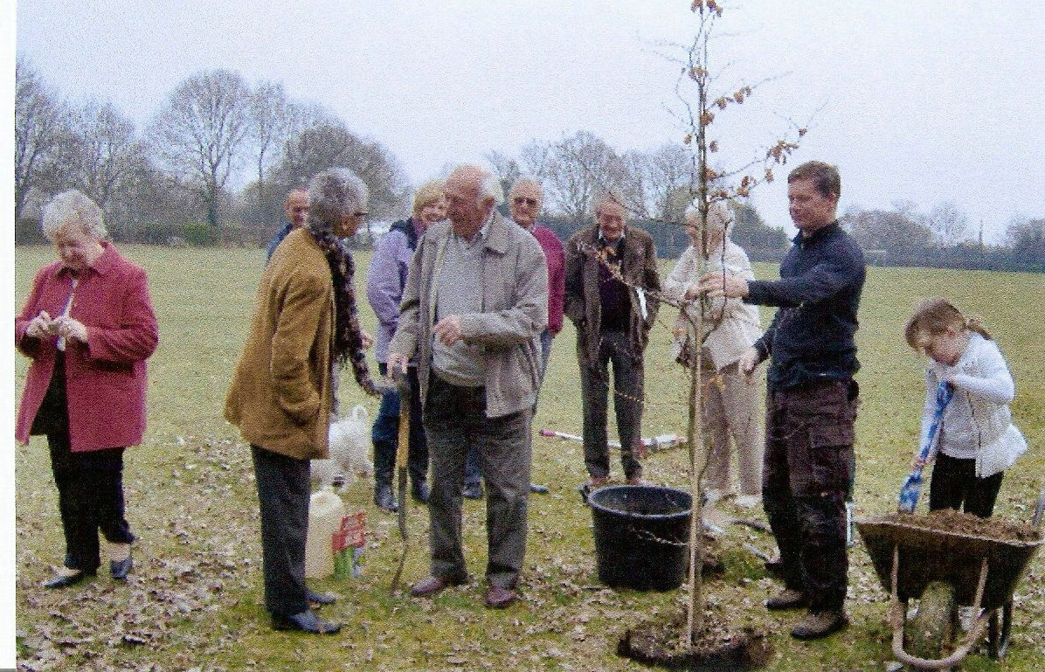
A copper beech tree was planted in the village hall recreation ground on Saturday, 26 March to pay tribute to the hard work and commitment by Mr Arthur Radley in his capacity as Margaretting’s Tree Warden over many years.

MARGARETTING VILLAGE HALL
Following the Easter break, regular meetings of the Art Class, French, Margaretting Friends, MS Society, Over 60s, Ladies Dance to Fitness, Bingo, Essex Handicraft, Pilates, Stitch and Chat, Ballroom and Latin American Dance will resume as usual. If you are interested in any of these activities, please ring April on 07794187741 for details.
Meanwhile, as the football season comes to a close, Margaretting cricket club will be opening with their first fixture playing Rayleigh at 1.30pm on 7th May. New players are very welcome. Please telephone Steve Robinson on 0775 396 3704.
As well as providing the venue for voting on Thursday, 5th May, and as noted opposite, the village hall will be hosting the annual Parish Assembly, a much acclaimed performance by ‘Eastern Angles’, an ‘indoor’ boot sale and the AGM of the village hall management committee this month. As to the latter, it is clear that the hall and playing fields are an extremely valuable community asset, whose maintenance and promotion involves a level of dedication and concern for its ongoing success. If you feel willing and able to contribute to its management and ongoing operations, do feel free to join us at our AGM on Thursday, 19th May in the Chelmer Room.

DIARY DATES

PARISH ASSEMBLY - TUESDAY, 3 MAY
This year’s parish assembly will take place on Tuesday, 3 May in the village hall at 8pm. Come along and hear what the parish council has being doing and intends to do on your behalf!

UP OUT O’ THE SEA - TUESDAY 10 MAY at 7.30pm
Eastern Angles’ new Spring production by Andrew Holland
Margaretting Village Hall
Tickets £8 from Jennie Scott 01277 354821

FUNDRAISING SUPPORT DAY SURGERY - Wednesday 8 June - 10 to 4pm
Margaretting Village Hall
*

Tuesday 21 June - 2 to-8pm
PEACOCKS garden - OPEN EVENING
*
ST MARGARET’S CHURCH - OPEN WEEKEND
Saturday 25 June and Sunday 26 June

Saturday 2 July - FAMILY FUN DAY
Incorporating the HORTICULTURAL SOCIETY SHOW
Margaretting Village Hall - 1pm to 4pm

MOBILE LIBRARY Fortnightly on Thursday afternoons
5th and 19th at 3.20-3.35pm in Maldon Road
- in the lay-by opposite the playing field.

SHOPPER BUS Margaretting to Tesco Supermarket, Wood Street
Thursday mornings leaving Orton Close at 11.00am,
Maldon Road at 11.02am, Main Road at 11.04am.

TRUST BUS Margaretting to Ingatestone
Friday mornings leaving Orton Close at 10.00am

COPY FOR THE JUNE/JULY EDITION BY 20 MAY PLEASE
‘Margaretting News’ is published by the PCC of St Margaret’s Church. Editors Roy and Penny Savill, ‘The Martins’, Main Road, CM4 9JB. Tel /Fax 01277 356182 or email: penroy.savill@virgin.net. Distribution to every household in the village is accomplished by a team of volunteers.

Printed by

Supporting the local community for all its property needs, including sales, lettings, surveys, financial services and commercial.
Offices throughout Essex, Greater and Central London - Pall Mall.
Ingatestone Office 01277 350505

