MARGARETTING NEWS
September 2011

Inside this issue:
Stained Glass Windows Presentation - 24 September
Margaretting Website
Queen’s Diamond Jubilee Celebration - 2 June 2012
Changes to the opening times for recycling centres
Maldon Road Playing Field - Dogs on Lead Only
Plastic Recycling Bags - Storage Location Wanted
Margaretting War Memorial
Diary Dates
Village Hall Information & what’s on in September
Margaretting Cricket Club Fixtures

ARTHUR AND JOY RADLEY
On Wednesday 10th August it was with mixed emotions that village friends said farewell and thank you to Arthur and Joy Radley for the support they have given to the village throughout their 45 years in Margaretting. They have been involved with many village projects through their voluntary work with the Village Hall Trust, Margaretting in Need Trust, Parochial Church Council and Parish Council. All who were there agreed their presence in the village will be sadly missed.
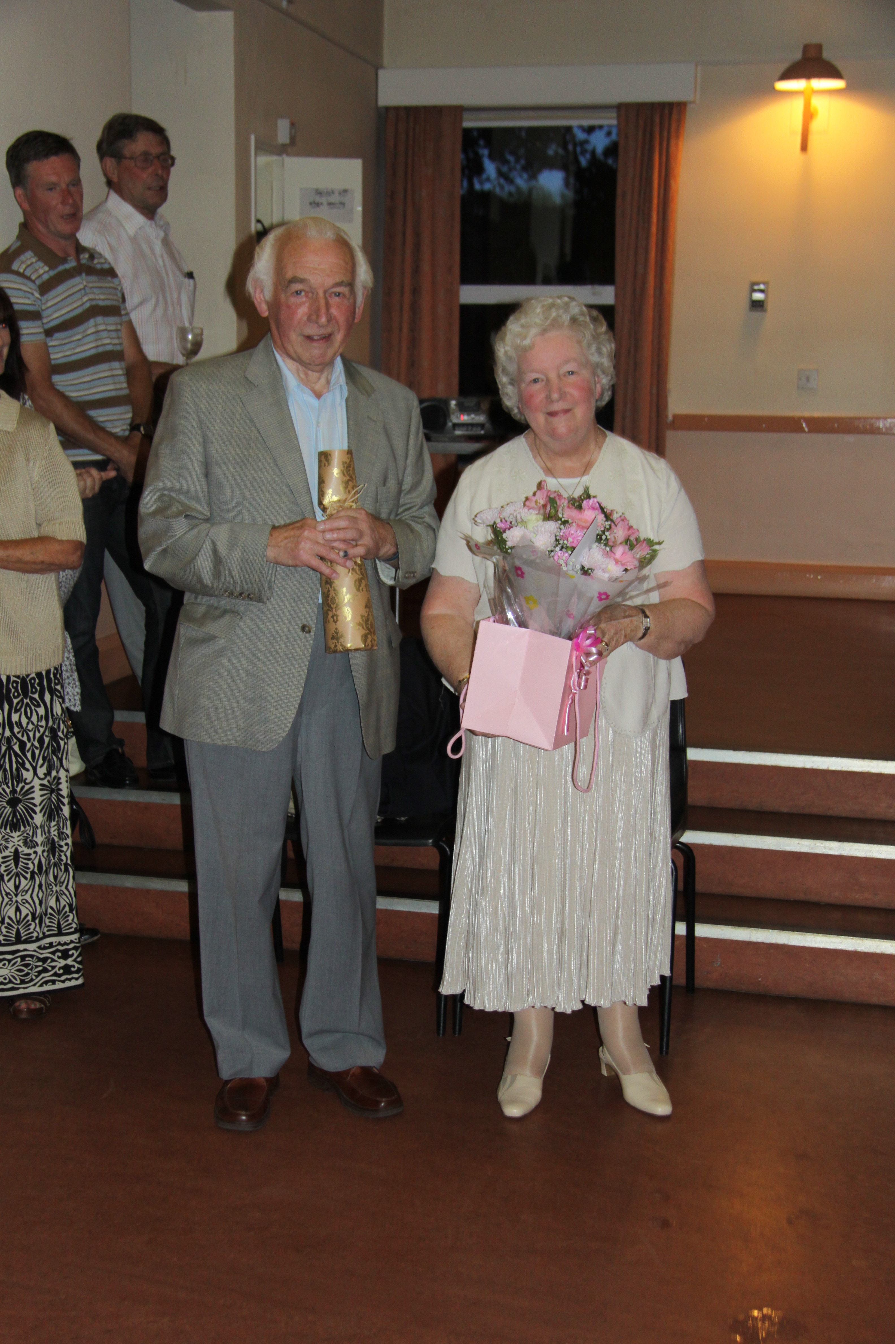
ST MARGARET’S CHURCH NEWS
I hope you have had a good summer and if you have been away for a holiday, I hope you have had a lovely time and hopefully in some sunshine.
The progress with our Development Project (toilet and small kitchen area) has been slightly delayed due to the DCA requiring more detailed drawings. This is now in hand and we will be progressing forward as quickly as we can. The new drawings, when completed, will be displayed on the church notice boards for you to see. The plan is still the same and the drawings will be much more specific.
I am pleased to say that Christopher Parkinson will be at Margaretting Church on the 24th September between 2.00 and 4.00 to give us a presentation about stained glass and the Jesse Window in particular. This event is open to all and, if you are able to come, you may have friends you can invite and I’m sure the afternoon will be very interesting and informative. Refreshments will be on offer afterwards and Chris is producing a small leaflet with information about the window. These will be available for £1.00. Chris is giving his time for free and I hope that there will be a good audience for him.
We are once again coming into the Autumn and looking towards the Harvest services.
The school service will be in the church on Friday 30th September at 11.15 am and the church harvest service is on the 2nd October at 10.00 am. You are very welcome to join us as we give thanks for God’s goodness to us as well as giving for all those who are suffering severe famine abroad. This we are donating our food gifts to the same charity as the school – Harvest for the Hungry – so dried produce will be gratefully received.
The benefice Harvest Supper and Barn Dance is on the 1st October in Mountnessing Village Hall. There is also a competition for the best scarecrow and the best ‘harvest jam jar’ for a table decoration. There are posters with details on the church notice board.
The parts of the village community prayed for during September are:
4th September – Jennings Place
11th September – Killegrews
18th September – The Red Lion
25th September – London Road, Widford
Please remember to let me know if you have someone you would like to be prayed for each week during our services.
Revd Jean 354359

ST MARGARET’S CHURCH SERVICES IN SEPTEMBER

4th September 10am - Parish Communion
11th September 10am - Morning Prayer
18th September 10am - Parish Communion
25th September 11am - Matins
30th September 11.15am- School Harvest Festival Service

DOGS ON LEAD ONLY
NEW RULE FOR MALDON ROAD PLAYING FIELD
A new sign on the Maldon Road playing field gate reads ‘dogs must be kept on a lead in the playing field and allotments’. This new rule for dog owners/walkers has been introduced by the parish council because there have been an increasing number of complaints about dogs in the playing field being exercised off the lead causing problems to other users of the field. These problems include dogs chasing, barking and jumping up at children and dog owners failing to pick up their dog’s faeces.

The parish council is aware that the majority of people exercising dogs in the playing field are responsible dog owners who do keep their dogs under control and clear up after them.
However, the safety of the children using the playing field is paramount.

Remember, if you plan to walk your dog in the Maldon Road playing field

NEVER leave the house without a plentiful supply of dogs bags to clear up mess.

ALWAYS clean up after your dog and deposit the bags in the red bin provided at the entrance to the playing field.

Remember also it is an offence to allow a dog under your control to foul in a public place. This means the owner/person in charge of the dog is required to remove the faeces and dispose of them in a suitable sanitary manner.

Free dog litter bags are available from Roy Savill - 01277 356182.

HOW TO REPORT INCIDENTS OR
ANY SUSPICIOUS ACTIVITY TO THE POLICE
Listed below are some helpful tips that may assist you when calling Essex Police.
What number do I use to call Essex Police?
If someone is committing a crime at the time call 999
The Non Emergency number is 101
If you are victim of crime try to touch as little as possible until the police arrive.

What information will help the Police?
A description of the suspect(s)
Male/Female, Ethnicity
Clothing (any patterns or logos)
Age, Height, Build, Hair colour/style
Was the suspect holding anything, goods/backpack?
Tattoos, Glasses, beard
Give any directions that the suspect is heading towards.

Do not worry if you do not have
answers to all the above, just try to remember as much as you can.
Keep and pen and pad to hand if it helps you.

Vehicle information
Try to make note of the following
Index number
Make
Model Number
Was the vehicle sign written?
Direction of travel.
What can you do to help reduce incidents of crime?
Be extra observant. The only people who really know the area in which you live are those who live there. The police may not note a suspicious person within your road, but you probably would.
Have you noticed anyone hanging around the area? These persons may be on foot, on a bike or in a vehicle.
Have you noticed a tool or a piece of equipment that has been discarded? This may have been used to commit a crime. Have you noticed anything in an odd location and thought it strange? Then report it 101

Did you hear something?
Perhaps you may have heard a noise during the evening or at night. Have a look out your window. If you note someone or a vehicle acting suspiciously then please call Essex Police straight away. Do not think that you are wasting Police time.

Did you over hear something?
Perhaps you may have over heard someone talking about a burglary or crime and can share the information with us.

Brenda Cross, Essex Police,
Essex Watch Administrator
Telephone 101 ex 484813

BEAT SURGERY
PCSO Kay Fleming will be at the village hall on Wednesday, 21st September from 2.30pm until 3.30pm.

STAINED GLASS WINDOWS
Saturday 24th September at 2pm - 4pm in St Margaret's Church a talk by Mr Chris Parkinson on 'Stained Glass Windows', with special interest in our Jesse Window. Refreshments will be available on a donation basis, and an information leaflet £1.

PROPOSED CHANGES TO ESSEX COUNTY COUNCIL’S RECYCLING CENTRES FOR HOUSEHOLD WASTE (RCHW)
The proposed changes for the
Ingatestone centre include a reduction in the standard opening hour - opening at 09:00 every day as opposed to the current 08:00 opening. The site will be open 6 days a week - closed on Tuesdays.
Changes to be implemented by the end of 2011.

QUEENS DIAMOND JUBILEE - 2012
The parish council is planning a whole day village event to celebrate the Queen's Diamond Jubilee. The village hall and grounds have been booked for Saturday, 2nd June 2012.
Ideas received so far include entertainment for children - a magic show and a ‘hog roast’.
Ideas, suggestions and people to help plan the day are needed.
Contact Caroline Kochan 353181

VILLAGE WEBSITE
Margaretting parish council is currently putting together a parish website which will have links to local community groups and organisations. If your group has a website or is interested in providing information for the Margaretting Parish website please contact:
Michael Scott on 354821 or email michael_john_scott@hotmail.com
Penny Savill on 356182 or email penny.savill@virgin.net

THANK YOU
Joy and Arthur Radley would like to express their deepest appreciation to the group of people who conceived the idea of giving us a farewell party at the village hall on the 10th August and who then went on to provide delicious food and wine and to assemble so many of our village friends gained during our 45 years in Margaretting. For us, such an event was quite unexpected but an occasion we will always remember. It has taken us some time to recover from such generous expressions of friendship and from the quantity of gifts bestowed.

We thank everyone concerned for their part in providing the gifts of champagne and wine, the church engraved glasses from which to drink them, the excellent book on Trees, Jenny Scott’s typically original artistic card, the bouquet of flowers and the very generous number of garden tokens which will enable us to stock our new garden.

We leave Westridge with some reluctance, but at our age it is no longer sensible to try to manage 2.5 acres of garden. We leave with many happy memories and of friendships made and hopefully retained in the years to come. We will take solace in being near to our daughter and her husband and our baby grand-daughter in Cambridgeshire but we will remain close enough to maintain some connection here.

In conclusion we would like to say that Margaretting is a wonderful place to live – it is almost unique in that it is one of the few villages in this part of the County not to have been swamped by development. It has lost its shop, post office and filling station but it retains its school, village hall and three pubs. It deserves to be cherished and we hope that those who have arrived here more recently will ‘take up the torch’ and actively support the life blood of the village through the activities of the Parish Council, the Parochial Church Council, the Village Hall committee and the school.

ALLOTMENTS
I am afraid that this month I have to report that there have been disturbances on the allotment plots in Maldon Road. Vegetables have been pulled up and people have run over various plots. I do have a very good image of a trainer print and if the individual is found they will possibly be prosecuted for criminal damage. This in turn could result in a criminal record. These plots are leased by members of the village and surrounding areas and a lot of time and effort goes into them. If this damage keeps occurring matters will have to be taken further.
Kay Fleming Police Community Support Officer 71329
Email: kay.fleming@essex.pnn.police.uk
Direct Dial: 101 Fax: 01245 329551

BOOK CLUB
Our next meeting is on Friday, 16th September. We will be discussing Daphne Du Maurier’s Jamaica Inn and Jeremy Paxman’s The Victorians. The book chosen for our October meeting is Wylkie Collins ‘The Woman in White’.
Contact Penny Savill 356182

MOTHERS UNION
Meetings are held in St Margaret’s Church on the third Thursday in the month at 2.30pm.
Contact Jill Needs 627078

MARGARETTING FRIENDS
We meet every 3rd Monday in the month at 7.30pm in the Chelmer Room. Apart from our regular meetings we also offer opportunities to become involved in local projects, social activities and outings. Our latest being a London Duck Tour on 3 September. We meet next on 19 September for a members’ crafts evening when we will be sharing and discussing ideas for our stall at the Christmas Bazaar.
Contact Rosemary Carter 350553

MARGARETTING WAR MEMORIAL
Bakers of Danbury start work on the memorial at the beginning of next month. The renovations (cleaning the coping stones, the granite plinth, column and cross and renewing the paving surrounding the memorial) will take about two weeks.

SEPTEMBER COUNCIL COLLECTIONS

Black bins - Mondays

Brown bins - Mondays

5th and 19th

Green box, cardboard, paper and plastic sacks
Tuesday 6th
Green box, paper and plastic sacks
Tuesday 20th

PLASTIC RECYCLING
Rolls of bags for recycling plastic are delivered to residents on a yearly basis. Any additional rolls may be collected from certain locations. A new location is needed for Margaretting. Are you willing to be a contact point for Margaretting and store one box of bags? Box is roughly 30cms x 30cms in size. Contact :Penny Savill 356182

BUS SHELTER
The new shelter outside the Black Bull will be installed this month. The delay is due to Essex County Council (who prepared the site for the shelter) forgetting to inform Chelmsford Council (the providers and installers of the shelter) that the site was ready. This lack of communication caused further delays. Arrangements for transporting the shelter had to be put on hold until September because the Leicester firm which manufactures the shelters closes for two weeks in August .

0VER 60s CLUB
We meet this month on the 7th and 21st from 2-4pm as usual. On the 21st there will be ‘bring and buy’ sale - so get busy with your jam making and preserves and make sure you make a couple of extra jars! We always welcome new members, so do come and join us. If you need a lift to the village hall just contact Roy on 356182.

MARGARETTING VILLAGE HALL
Refurbishment of the playing field benches is in hand together with the replacement of the drainage man-hole cover in the car park.
This month the committee will be conducting an interior inspection of the complex to identify any defects and necessary refurbishment projects. We welcome comments and suggestions from regular users on the facilities provided and as the diary below shows, the hall is well used for a wide range of recreational activities as well as providing an ideal venue for family parties and celebrations.
If you feel you could help in the management of this complex by joining the committee - do get in touch!

ACTIVITIES IN SEPTEMBER
WEEKLY UNLESS OTHERWISE INDICATED

Mondays Pilates 10.30-11.30am and 6.45-7.45pm

Tuesdays Stitch and Chat 6th and 20th 9.30-12.00 noon in the Chelmer Room
Art Class 13th, 20th and 27th 2-6pm in the Chelmer Room
M/S Society 6th, 13th, 20th and 27th 7.00pm
(for new members - Getting to Grips)

Wednesdays Dance to Fitness 7th, 14th, 21st and 28th 9.30-10.30am
Over 60s Club 7th and 21st 2-4pm.
Evening Bingo 14th and 28th 7.30-9.30pm

Thursdays Pilates 1st, 15th, 22nd and 29th 9.30-10.30am and 7.15-8.15pm
Village Hall Committee Meeting 1st 7.30pm in the meeting room
Local Election Day 8th - 7am-10pm
Parish Council Meeting 8th 7.30pm in the Chelmer room
Essex Handicraft 29th 7pm in the Chelmer room
Demonstration of sliver clay jewellery

Fridays Stitch and Chat 9.30-12noon in the Chelmer Room
Hindu Society 30th 7pm

Saturdays Whole Body Yoga 6th August 10.00 - 1pm.
Pilates 20th August 9.30 - 11am

Sundays Loose Threads Patchwork Group 4th 9.30-6pm
(All welcome - bring own material and sewing machine)
Hindu Society 18th 9.30am-1pm

For further details or queries for private functions
please contact April Nixon on 07794 187741

MARGARETTING CRICKET CLUB FIXTURES FOR SEPTEMBER

Saturday XI Sunday XI
3rd September Writtle II Away - 1.30pm 4th September Mountnessing Away 1.30pm
11th September Woodham Mortimer Away - 1.30pm
18th September Willingale Away - 1.00pm

MOBILE LIBRARY Fortnightly on Thursday afternoons
8th and 22nd September at 3.20-3.35pm in Maldon Road
- in the lay-by opposite the playing field.
SHOPPER BUS Margaretting to Asda Supermarket, Chelmer Village - Tuesday mornings
Margaretting to Tesco Supermarket, Wood Street, - Thursday mornings
leaving Orton Close at 11.00am, Maldon Road at 11.02am, Main Road at 11.04am
.
TRUST BUS Margaretting to Ingatestone, Friday mornings leaving Orton Close at 10.00am

DIARY DATES

COUNTY COUNCIL BY-ELECTION
Stock Division, Thursday, 8th September, 7.00am - 10.00pm
Polling Station Margaretting Village Hall

STAINED GLASS WINDOWS TALK
Saturday 24th September, 2pm - 4pm
St Margaret's Church, a talk by Mr Chris Parkinson on 'Stained Glass Windows'
Refreshments available

HARVEST SUPPER
Saturday 1st October at 7.30pm Benefice Harvest Supper
and Barn Dance, Mountnessing Village Hall
Tickets £10
available from Sam 01277 354077

HARVEST FESTIVAL
Sunday 2nd October
Harvest Festival Service 10am
St Margaret's Church.

CHRISTMAS BAZAAR
Saturday 26th November 2pm - 4pm Margaretting Village Hall.

COPY FOR THE OCTOBER EDITION BY 20 SEPTEMBER PLEASE

‘Margaretting News’ is published by the PCC of St Margaret’s Church. Editors Roy and Penny Savill, ‘The Martins’, Main Road, CM4 9JB. Tel /Fax 01277 356182 or email: penroy.savill@virgin.net. Distribution to every household in the village is accomplished by a team of volunteers.

Printed by

Supporting the local community for all its property needs, including sales, lettings, surveys, financial services and commercial.
Offices throughout Essex, Greater and Central London - Pall Mall.
Ingatestone Office 01277 350505

