MARGARETTING NEWS
March 2011
JANUARY 2011 - RIVER WID FLOOD
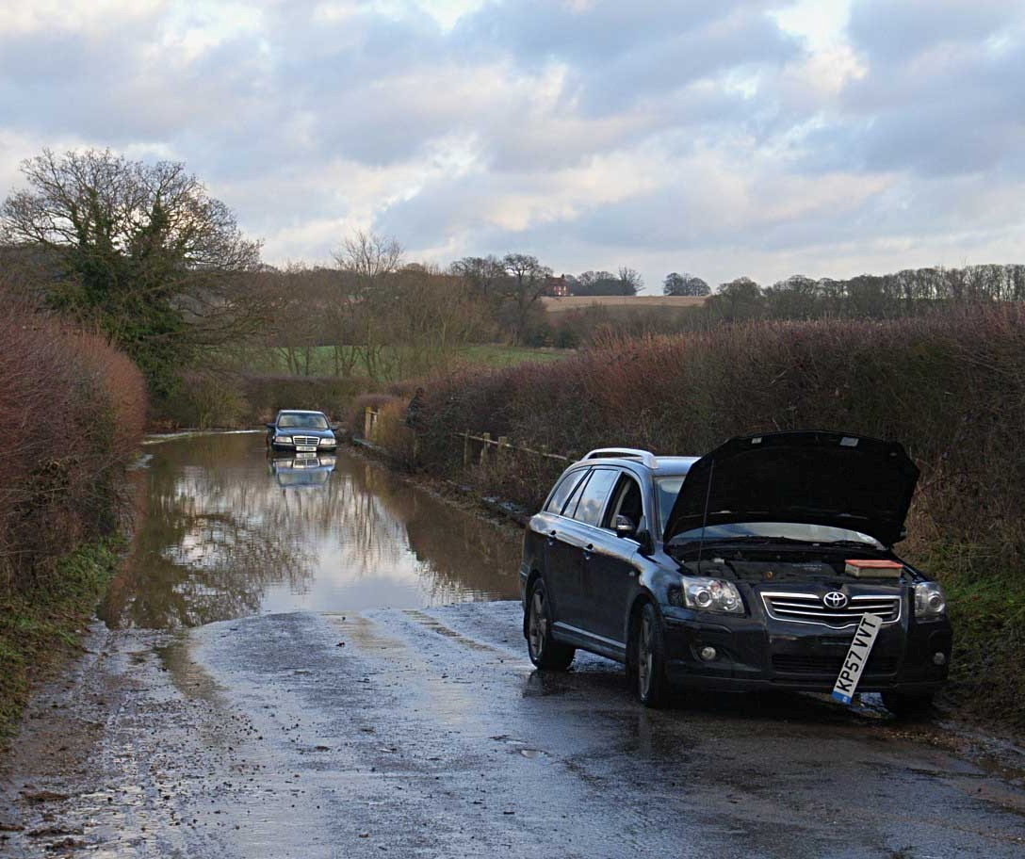
January’s flooding of Whites Bridge, Maldon Road captured on camera by Rosemary Carter.
In this photo the water has almost reached the height of the walk boards. The car with its bonnet up is just one of many cars that broke down.

SUNDAY SERVICES IN ST MARGARET’S CHURCH DURING MARCH
6th March - 10am Parish Communion
13th March - 10am Morning Prayer
20th March - 10am Parish Communion
27th March - 11am Matins

ST MARGARET’S CHURCH NEWS
In March we begin our Lenten journey, this beginning with Ash Wednesday on the 9th March. There is a service in the church at 10.00am and during the service there will be The Imposition of Ashes. This is when those who wish to can receive the sign of the cross on their forehead when these words are said: ‘Remember that you are dust, and to dust you shall return. Turn away from sin and be faithful to Christ’. The ashes are made from burning palm crosses that people received last year on Palm Sunday. Our journey begins as we follow Christ through Lent to the foot of the cross. The liturgical colour changes from green to purple as this is a visible reminder that we are in a penitential period and there are no flowers decorating the church until we reach the joyful celebration of Easter and the risen Christ.

We are also continuing our journey with our re-development project to install a toilet and small kitchen area. The leaflet with your newsletter has information about the project and where we have reached with our fundraising efforts. There will also be a plan of the church, identifying the changes, on the church and village notice board if you care to look at these. The plan of the porch shows how the exterior will look when the work is completed. The panels, to imitate a door, will be carefully chosen in keeping with the historic appearance of the building.

In Lent, we begin our journey with Christ as he goes into the desert to communicate with God. May we feel able to communicate with God, wherever our journey takes us.
The areas in the community to be prayed for in March are:

6th March - London Road
13th March - Main Road
20th March - Maldon Road
27th March - Larmar Engineering

Please remember, if you have anyone you would like to be included on the prayer list, please let me know. Thank you. Revd Jean Halliday 01277 354359

REGULAR REMINDERS
Beware Burglaries - Police continue to warn of burglaries in Essex, involving car key burglaries, burglaries of dwellings, outbuildings, and sheds. Report suspicious vehicles you may see to the Police: always telephone 999 if you believe there is a crime occurring, or call 0300 333 4444 to report a non-emergency suspicious person or vehicle.
Beware Purse-dippers - Continue to be on your guard when out and about shopping, relaxing, etc: purse-dippers and handbag snatchers may be close by. Keep purses, wallets, bags - other valuables secure. Never leave shopping exposed in cars - if you can’t use the car boot, cover with something to make them less obvious.
Have you noticed a tool or a piece of equipment that has been discarded? This may have been used to commit a crime. Have you noticed anything in an odd location and thought it strange? Then report it 0300 333 4444
Brenda Cross, Essex Watch Administrator, Chelmsford District – Tel 0300 333 4444 email: brenda.cross@essex.pnn.police.uk

MARGARETTING BEAT SURGERY
PCSO Kay Fleming will be at the village hall on Wednesday, 23rd March between 14:30 - 15:30.

NEIGHBOURHOOD ACTION PANEL
The next meeting is on Wednesday, 2nd March - 7.30pm in The White Horse Public House at Ramsden Heath.
These meetings provide opportunities to bring matters of concern to the attention of the Police. For further information please contact PCSO Fleming. Tel: 0300 33 4444
email: kay.fleming@essex.pnn.police.uk

PARISH COUNCIL - FEBRUARY’S MEETING
DEMOCRATIC TIME
Two members of the public were present. Issues and concerns raised included:
Grass verges/bollards in Main Road:
Grass growing round the bollards looking unsightly. We agreed to contact our contractor and, cost permitting, to include strimming or spraying the grass in next year’s contract.

Verges not maintained by volunteers or the parish council being neglected by Essex County Council (ECC).
ECC cut the grass only once last year and the footpaths have become overgrown. In previous years the grass had been cut twice. We agreed to contact ECC Highways.

VAS located near The Saddlery:
The 40 mph sign is still not working properly. It is only activated by speeds of 49mph and over. We agreed to contact ECC Highways.

VILLAGE SITES
Railway Way Bridge (Maldon Road):
ECC Highways has been reorganised and it is proving difficult to obtain an answer to queries. Noted engineers who were dealing with our concern about the signage for the bridge are now employed by other organisations.
Bus Shelter (Black Bull): If we apply for an ECC grant towards the costs for a new bus shelter we will have to use their recommended supplier. Our current reserves do not allow for the costs of a replacement bespoke structure.
Agreed to pursue the grant option.
Village Pond: The dead vegetation surrounding the pond is to be cut back and removed. Agreed to seek quotes for the felling and removal of the dead conifer tree situated to the rear of the pond.
Village Trees: There have been no further reports of diseased oak trees. Noted ECC is offering a tree inspection service. Agreed to enquire what fees if any will be charged for this service.
Whites Bridge (Maldon Road): Noted work by the local Environment Agency clearing out silt from the River Wid is almost finished. We were shown photographs of the state of the river before and after the clearance and some views of the flooding at the bridge which took place earlier in the year. Thanks were expressed to Angela Smith and Rosemary Carter for capturing these scenes.

VILLAGE PROJECTS
War Memorial: We are still waiting to hear from the contactors as to when they can start the improvement works.
Our application to ECC for a grant of £1,000 towards the costs of this project is to be considered this month.
Gateways: Received further costings for gates made in hard wood. The preferred design, size and medium will be discussed at our March meeting.
Whites Bridge Walk Boards: Nothing further to report.
Grass Verges: Agreed to check with the contractor to see when he plans to make good the verge to the Maldon Road green outside numbers 55 to 61.

VILLAGE SPRING CLEAN
Saturday, 12 March at 10.30am

MALDON ROAD RECREATION FIELD AND ALLOTMENTS
Received latest inspection reports and discussed whether or not to install a notice board at the entrance to the allotment area. Quotes are to be obtained for further discussion at our next meeting.

CYCLE LANES
Agreed to invite Highways Cycling Infrastructure Engineer to our next meeting. See next page.

PARISH ASSEMBLY
Tuesday, 3rd May at 8pm.

PLANNING
The following applications were received for comment:
11/00077/FUL - Woodview, Maldon Road: Single storey side extension and replacement double garage.

The following decisions were received:
10/01890/FUL - Langdons, Maldon Road: Single storey rear extension.
Grant Planning Permission

10/01837/FUL - Land Adjacent to Broadoaks, Maldon Road: New 3 bed detached bungalow.
Grant Planning Permission

10/0165/FUL - Chywoone, Maldon Road: Single storey rear extension
Grant Planning Permission

CYCLE LANES
Enquiries made on behalf of local residents have revealed there are no plans to provide a cycle route from Margaretting to Hylands House.
However, the cycling infrastructure engineer for Highways has volunteered to come and speak to the parish council and listen to any suggestions as to route and possible options and to see what can be done.

PEDESTRIAN REFUGE ISLANDS
The parish council has been informed that works will begin before the end of April to install a pedestrian refuge island on the Chelmsford side of the cross roads in Main Road. The island will be outside P&P garage with new parking restrictions applied between the cross roads and the island. This is being done to prevent parked vehicles obscuring the visibility between drivers and pedestrians wishing to cross the road, this will minimise the risk pedestrians face when using the new crossing point. A plan of the proposed position of the island can be seen on the village notice board.

BOOK CLUB
Our next meeting is on Friday, 4th March. We will be discussing Diane Setterfield’s novel ‘The Thirteenth Tale’. Contact Penny Savill 356182

MARGARETTING FRIENDS
We meet on the third Monday of the month at 7.30pm at the village hall in the Chelmer Room. Apart from having a varied programme of speakers and events lined up for the year we will be supporting a number of village projects and fund raising for charity. Our chosen charity for 2011 is ‘Help for Heroes’- a charity formed to help those who have been wounded in Britain's current conflicts. Our next meeting is on 21st March when we have a talk on Bee Keeping. Contact Rosemary Carter 350553

MOTHERS UNION
Meetings are held in St Margaret’s Church on the third Thursday in the month at 2.30pm.
Contact Jill Needs 01277 627078

PARISH COUNCIL 5 MAY ELECTIONS
Notices of the election will be placed on the village notice boards and in the village hall. The nomination period for candidates wishing to stand for election begins Monday, 28 March and ends Tuesday, 5 April. Nomination papers are available from Mrs Kochan, Clerk to the Parish Council telephone 0782 453 1306

Help make a difference and stand for election to the parish council. As a parish councillor you can become a voice for your community and effect real change.

MARGARETTING SCHOOL NEWS
January and February have been quite quiet months at the school this year. However, the children are continuing to enjoy the chance to learn ‘Fencing’ at one of the many ‘After School Clubs’.
The Reception class have been really enjoying their topic on Dinosaurs and the arrival of a new Interactive White .board in their classroom.
We were pleased to welcome a German student on work experience and Chiara treated us all with her beautiful piano playing. We were all sad when she returned home.
VILLAGE SPRING CLEAN
SATURDAY, 12 MARCH at 10.30am
The annual spring clean will take place on Saturday, 12 March. Please come along and help even if it is only for an hour. Litter picks, gloves and sacks will be provided.
Volunteers are asked to meet outside the Black Bull at 10.30am.

MARCH COUNCIL COLLECTIONS

Black bins - Mondays

Brown bins - Monday 7th and 21st

Green box, paper and plastic sacks - Tuesday, 8th

Green box, cardboard, paper and plastic sacks - Tuesday, 22nd

OVER 60s CLUB
On Wednesday 9th March we have a regular club afternoon led by Rosemary and on the 23rd we look forward to a talk on ‘The Secret Lives of Garden Birds’ by Mike Logan Wood of the RSPB. As we start another year of social afternoons, do invite new friends and neighbours to join us in our various activities.

A SHOPPER BUS SERVICE FOR MARGARETTING!
Essex County Council shopper-buses are a timetabled weekly service providing access for residents of a village or collection of villages to local services. The bus is usually a minibus, more suitable for narrow roads and has wheel chair access.

Before setting up Margaretting’s service Essex County Council, Accessibility Planning Team will work with the parish and local residents to establish the most effective route, pick up points, day of week, times and destinations. There will be a set start and destination time and place but otherwise it will be a flexible service allowing the driver to give a more personal service picking up residents with mobility problems close to their home.

To use the service passengers must first become a member of The Margaretting Bus User Group. This will be free to join. They will be given a pass which must be shown whenever they use the service. Any person wishing to travel on the Margaretting Shopper Bus will be able to pay for their fare on the bus.

The cost of the journey will be £2:00 flat fare (single or return).

Children aged 5 to 16 travel half price.

Children under 5 travel free

If you hold a concessionary bus pass you will need to show your pass to receive free transport.

If you would like to use a weekly mini bus service. Please complete and return the enclosed questionnaire by 12 March.

MARGARETTING VILLAGE HALL - MARCH 2011

ART CLASSES
Monday and Tuesday afternoons at 2-4pm
Contact Susan Keeble on 01277 353973

BALLROOM AND LATIN AMERICAN DANCE CLASSES
Mondays (Intermediate) 7.45-8.45pm (Beginners) 8.45-9.45pm
Contact Kasia 0781 510 8477

BINGO
Fortnightly on Wednesday evenings - 2nd, 16th and 30th at 7.30-9.30pm

ESSEX HANDICRAFT
Thursday, 31st March in the Chelmer Room at 7.30pm
Contact Avril Ellis 01245 266140

FRENCH CLASSES ADVANCED LEVEL
Wednesday mornings 10.00-12.00 in the Meeting Room
Contact Jane Adams 01245 355448

MARGARETTING FRIENDS LADIES CLUB
Monday 21st March in the Chelmer Room at 7.30pm
Contact Rosemary Carter 01277 350553

MS SOCIETY
Tuesday Social Evenings for families and friends at 7-9.30pm
Contact Mr Morris 0797 341 1309

OVER 60s CLUB
Fortnightly on Wednesday afternoons - 9th and 23rd at 2-4pm
Contact Roy Savill 01277 356182

PARISH COUNCIL
Thursday 10th March in Meeting Room at 7.30pm

PILATES
Mondays 9.30-11.30am and 6.45-7.45pm
Thursdays 9.30-11.30am and 7.15-9.15pm
Contact Kasia 0781 510 8477 or Chris 0794 765 0809

PORTRAIT PAINTING DEMONSTRATION
Wednesday 16th March at 10.00 - 12 noon. Entry £5 at the door

STITCH AND CHAT
Fortnightly on Tuesday mornings - 8th and 22nd at 9.30-12.00
Contact Mrs Howard 01277 230438

VILLAGE HALL COMMITTEE
Thursday 3rd March in the Meeting Room at 7.30pm

Availability and prices for village hall bookings contact the Booking Secretary on 0779 418 7741

MOBILE LIBRARY
Fortnightly on Thursday afternoons 10th and 24th at 3.20-3.35pm in Maldon Road in the lay-by opposite the playing field.

TRUST BUS
Margaretting to Ingatestone - Friday mornings leaving Orton Close at 10.00am

Margaretting Art Group presents
A Portrait Painting demonstration by Hashim Akib (SAA Artist of the Year)
Wednesday, 16th March - 10.00am to 12.00noon at the Village Hall
Everyone welcome. Entry £5.00 at the door or tickets from
Jennie Scott (354821) or Susan Keeble (353973)
We look forward to seeing you there.

DIARY DATES FOR MAY

PARISH ASSEMBLY - TUESDAY, 3 MAY
This year’s parish assembly will take place on Tuesday, 3 May in the village hall at 8pm. Come along and hear what the parish council has being doing and intends to do on your behalf!

UP OUT O’ THE SEA
Eastern Angles’ new Spring production by Andrew Holland
TUESDAY 10 MAY at 7.30pm
Margaretting Village Hall
Tickets £8 from Jennie Scott 01277 354821

COPY FOR THE APRIL EDITION BY 19 MARCH PLEASE

‘Margaretting News’ is published by the PCC of St Margaret’s Church. Editors Roy and Penny Savill, ‘The Martins’, Main Road, CM4 9JB. Tel /Fax 01277 356182 or email: penroy.savill@virgin.net. Distribution to every household in the village is accomplished by a team of volunteers.

Printed by

Supporting the local community for all its property needs, including sales, lettings, surveys, financial services and commercial.
Offices throughout Essex, Greater and Central London - Pall Mall.
Ingatestone Office 01277 350505

