MARGARETTING NEWS
December 2012
Inside this issue:

Page 2
Village Hall and Parish Council Reports

Page 3
Neighbourhood Watch

Page 4
Margaretting School - Christmas Fair Thursday, 6th December
Margaretting Riding School 1934
What’s On at the Village Hall
Diary Dates for 2013

CHARITY BINGO
Wednesday, 5th December at 7.30pm

Bring a prize, win a prize. All welcome to come and enjoy a fun evening with the Bingo Club Members. All proceeds go to a charity chosen on the evening.

SAMARITAN’S PURSE
Very many thanks to all those who have given me completed boxes for the Operation Christmas Child appeal. Margaretting has contributed ten boxes ready to go. In addition some people gave me items to go in other boxes such as Marie and her box of teddies. The boxes were collected on Friday 9th November. Please pray for their safe journey and that they bring joy to those who are given them. Please continue to pass me empty shoe boxes, hats etc. I have now started collecting for next year.
Lynn Cameron

CHILDREN IN NEED
A big ‘thank you’ is due to everyone in the village who raised funds for Children in Need this year.
Lexie Wood, one of our younger residents, raised £42.50. Lexie achieved this by making and selling sixty decorated cupcakes around the village. Well done Lexie! Lexie would like to thank everyone who bought her cakes or gave her donations.
The Black Bull once again pulled out all the stops - customers and friends for the tenth year running raised £1,000.
Julie would like to thank everyone who donated raffle prizes, bought raffle tickets and helped her to raise money for the Children in Need charity this year.

MINCE PIES & SAUSAGE ROLLS AT THE BLACK BULL
Don’t forget to pop in to the Black Bull on Christmas Eve. Julie, Mary-Ann and the staff invite friends and customers to join them from 3pm to 8pm for mince pies and sausage rolls. A good opportunity to catch up on all the local news.

ST MARGARET’S CHURCH SERVICES IN DECEMBER
2nd December - 10.00am Holy Communion with Revd Canon Richard Moore

9th December - 4.00pm Family Service
We will be making a large Christmas picture for the church

16th December - 10.00am Holy Communion Bishop Stephen will be celebrating and preaching

23rd December – No service

24th December - 5.00pm Crib and Christingle Service
- 11.00pm Christmas Communion Followed by mulled wine and mince pies

30th December - 6.00pm Nine Lessons and Carols

ST MARGARET’S CHURCH
We are all aware of the crowds of people in shops buying their Christmas presents to give to friends and family. The church is no different as we travel through Advent in preparation for the celebration of Christmas when we give thanks for the best present of all – the gift of God’s Son.
This year we will be carol singing in the Black Bull and the Red Lion on Thursday, 13th December. Bishop Stephen is joining us and I am sure we will be very grateful for his good singing voice! We will meet at Bishopscourt at 6.00pm and cars can be left there. We will arrive at the Black Bull for 6.30pm and spend about an hour before we walk to the Red Lion for 7.30 pm. You are very welcome to join us at either or both pubs for carol singing. We do hope that there will be some children with their families who can join us at the Black Bull. When we have finished we will walk back to Bishopscourt to collect our cars. All you need to bring is a singing voice and carol booklets will be provided.
Any donations collected during this evening will be given to CHESS, the charity in Chelmsford that helps the homeless in our area.
Christmas is a family time and if you know anyone in the village who will be on their own on Christmas Day, please can you let me know. We will contact these people before Christmas to ask if they would like a Christmas dinner and this will be arranged for them.
I hope you all have a joyful and peaceful Christmas.
The parts of the village being prayed for during December are:
2nd December – Lamar’s and the Saddlery
9th December – Orton Close
13th December – Private Road, Widford
24th December – Bishopscourt
The services for Christmas are listed separately.
Revd Jean 354359
jeanhalliday456@btinternet.com

Village hall report on November meeting
Before reporting on the meeting held in November I would like to sing the praises of the committee members, they remain cheerful, helpful and full of ideas. I would particularly like you all to know that Penny Doyle, as well as being an astute accountant, is an excellent advisor on all matters and on top of that has been doing the minutes. I would also like to sing the praises for John Minns as he is forever sorting things out and is extremely knowledgeable. We are also fortunate to have April Nixon who is an excellent booking secretary. Also, Pat Jamnitzky who is a super cleaner and carer of the hall.
At the opening of the meeting we had a few thoughts about dear Roy and Penny Savill.
The asbestos report will be made available by April to anyone working on the building and they will be asked to sign when they have read it. This makes the hall a safer place.
We discussed the action on the external review and decided to go ahead with repairing pot holes in the car park. We did not think we should resurface the rear of the car park as it was too costly. We would like to clear the perimeter ditch and received a quote for £900, but Angie Kelly said she would see if she could find some volunteers. Other minor repairs were agreed. The main hall will be decorated, starting with the ceiling before Christmas and the bar area after. The Chelmer carpet has been cleaned. John is to raise the cooker as it is a risk factor at the moment - the surrounding counter top is higher and could catch a pan and spill it. The five year electrical test identified nearly £2,000 worth of work required just to bring the hall up to “satisfactory”. Work for next year identified. Hire charges to be reviewed. Income from hire about £2,000.
The treasurer reported the finances were sound. Annual insurance paid and annual Charity Commission report submitted.
To make the burden lighter on members it was agreed that with all the advances in communication that it is not necessary to meet every month. The next meeting will be decided at the end of each meeting.
A request from a representative of the Over 60’s for the chairs and tables to be put out for them, as it was such a struggle, was considered and it was agreed that this is a service we would like to provide for everyone.
Concern over sudden increase in water usage.
Next meeting Thursday, 3rd January 2013
Michael Scott (Chairman, Village Hall Committee)

MARGARETTING PARISH COUNCIL - OCTOBER MEETING
DEMOCRATIC TIME: One member of the public present.

FLOOD ALLEVIATION SCHEME: Chelmsford Council is to hold a briefing meeting on 3 December for our neighbouring parish councils. Margaretting will be invited to nominate a parish councillor to attend. This meeting to be followed by a site visit. The Environment Agency’s survey work in Swan Lane beginning Monday, November is scheduled to last two weeks.

MALDON ROAD ALLOTMENTS: Essex & Suffolk Water will be conducting a water supply survey.

MALDON ROAD PLAYING FIELD: Any planning gain monies received from the development of The Spreadeagle site will be earmarked for the purchase of toddler swings.

VILLAGE PROJECTS: Whitesbridge Walk Boards: Awaiting new date for a meeting with the landscape architect.

ACCOUNTS: Agreed the following expenditure:
£55 - RCCE (subscriptions)
£572 - MDL (grass cutting - August)
£35 - H. Blurton (maintenance costs)
£68 - Ever Edge (tree protection)
£26 - Essex & Suffolk Water
£90 - A. Gibbons (bin installation)

PLANNING: The following decisions were noted:
12/00384/FUL - The Oaks, Wantz Road - APP/W1525/A/12/2177930 - Retrospective application to retain building and its use as an office.
Appeal dismissed
12/00459/FUL - Elm Cottage, Main Road - APP/W1525/D/122/2182077 - Single storey side and rear extensions.
Appeal dismissed

12/01307/FUL - Paddocks, Main Road - Land part of Eweland Hall Cottage. Amendment of Permission Reference: 11/01855/FUL (Demolition of existing dwelling and construction of replacement three bedroom dwelling) to create a basement, alterations to fenestration including altering location of dormer windows.
Granted Planning Permission

12/05605/CAT - Sycamore Cottage, Main Road. Conifer x 1 – rear garden close to boundary with Rosemount Cottage – reduce by 4 meters.
No objections Trees in Conservation Area
12/05604/CAT - Rosemount Cottage, Main Road. 5 x Conifer – rear garden – reduce by 4 meters 1 x conifer – fell to ground level.
No objections Trees in Conservation Area

VILLAGE SITES:
Bus Shelters: The estimates received for the repairs to the shelter opposite the Black Bull were noted as follows: The highest was £5,874 and the lowest was £5,250.
The replacement of the shelter outside the Black Bull with a larger shelter will depend on whether there is sufficient ground room to install a larger shelter. Arrangements are in hand to measure the area.
Village Pond and Trees: Nothing further to report.
Lavender Bank: Discussed options for edging this bank to keep the soil from falling onto the pavement.
The preferred option would be to use reclaimed railway sleepers. Costs were not available at the meeting.
Garden opposite school: Awaiting one further quote for the repairs to the railings. A decision is to be made at our December meeting.

DATE OF NEXT MEETING: Thursday, 13th December at 7.30pm. Meetings are held in the meeting room in the village hall.
Time is allowed at the beginning of each meeting for parishioners to bring and discuss matters of concern and interest to the attention of the parish council.

MARGARETTING FRIENDS
In November we enjoyed a fascinating talk given by Chris Parkinson on costume in stained glass. Chris very generously donated his speaker’s fee to the Essex branch of ‘The Rainbow Trust’. On 1st December we will be planting bulbs in the lavender bank. On 10th December we will be starting our Christmas celebrations early with our annual dinner at a local hostelry.
Our next regular meeting is on 21st January 2013.
Contact: Rosemary Carter 350553

ST MARGARET’S CHURCH BAZAAR
Thank you to everyone who braved the wet weather on Saturday 24th November and supported this event by buying gifts, tombola and raffle tickets and afternoon tea and cakes. The total amount raised for church funds was £1,090.

DECEMBER REFUSE COLLECTIONS

Black bin and food waste every Tuesday except Christmas Day

This collection will be Thursday 27th

Brown bin, paper sack and bagged plastics & cartons - Tuesday 11th and Thursday 27th

Green box and card sack - Tuesdays 4th and 18th

Margaretting Tye

Black bins and food waste every Wednesday except Boxing Day

This collection will be on Friday 28th

Brown bin, paper sack and bagged plastics & cartons - Wednesdays 5th and 19th

Green box and card sack - Wednesday 12th and Friday 28th

NEIGHBOURHOOD WATCH
The Tye. 17 Oct 17:00 - 19 Oct 06:30: Fuel stolen from outside tank

Pennys Lane. 26 Oct 00:40 - 00:55: Attempted burglary - open kitchen door - when disturbed ran across decking.

Maldon Road. Between 11 Nov 16:00 and 13 Nov 11:15: Criminal Damage - two cars were damaged. One was keyed and the other had a nail in the tyre. They belong to the same family. If anyone saw or heard anything please let PCSO Kay Fleming know.

The Tye. 16 Nov evening: Car moved about 20 yards possibly disturbed but a quad bike stolen from this same address at the time but not discovered immediately.

The Tye. 18 Nov 10:00 - 19 Nov 13:00: (different address) containers opened by cutting locks nothing removed and doors shut again but not secured.

PCSO 71329 Kay Fleming, Maldon & South Woodham NPT, 101 Ext. 421500

ACT OF REMEMBRANCE
George White, a Burma Star veteran, closed this year’s ceremony on Sunday, 11th November with the moving and well known words ‘When you go home, tell them of us and say for their tomorrow we gave our today’. Two wreaths and a posy were laid at the war memorial by representatives of the Over 60s Club, Margaretting Friends and on behalf of the community by St Margaret’s Church.
A wreath from Margaretting School had already been laid at the memorial by the pupils during their Act of Remembrance on Friday, 9th November.

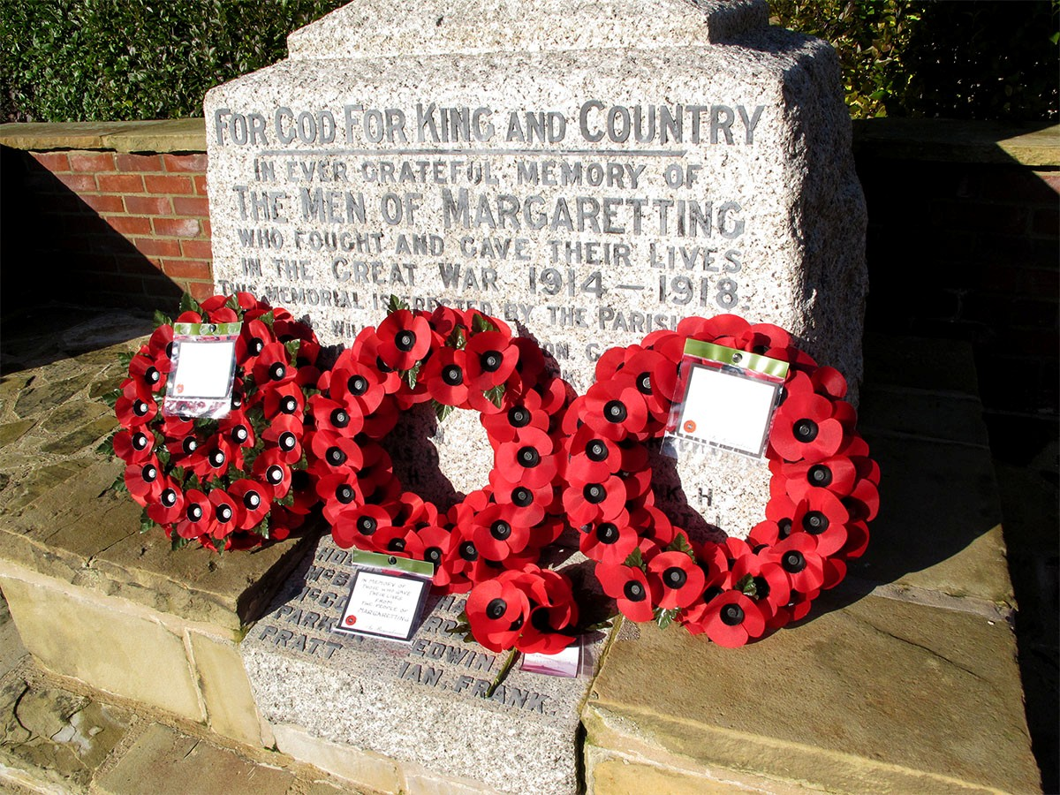

MARGARETTING FRIENDS
In November we enjoyed a fascinating talk given by Chris Parkinson on costume in stained glass. Chris very generously donated his speaker’s fee to the Essex branch of ‘The Rainbow Trust’. On 1st December we will be planting bulbs in the lavender bank. On 10th December we will be starting our Christmas celebrations early with our annual dinner at a local hostelry.
Our next regular meeting is on 21st January 2013.
Contact: Rosemary Carter 350553

OVER 60S CLUB
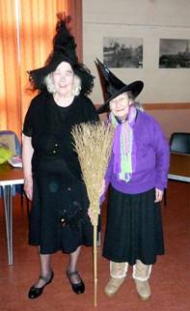
Many members attended the funeral of Roy Savill on Friday, 9th November. He was instrumental in getting the club started and although not the first chairman, he held that position for many years giving much pleasure to those attending the club. He will be sadly missed.
In October club members celebrated halloween - the photo on the left was taken by Don Moore.

During November we have enjoyed a Beetle Drive and a visit from the RSPCA. One of their rescued dogs was brought along to the meeting and the club made a donation to support the good work the association carries out.
We have only one meeting in December when we shall enjoy singing carols and eating mince pies. It will be led by Revd Jean on Wednesday 12th from 2pm – 4pm at the village hall and we would be pleased to welcome everyone to this meeting.

MARGARETTING SCHOOL CHRISTMAS FAIR
Thursday, 6th December 1.30pm in the school hall. All are welcome - bring your pennies with you!

BOOK CLUB
Vikas Swarup’s ‘Q & A’ and Maeve Binchey’s ‘Tara Road’ were given mixed reviews - some enjoyed reading the books and some did not. Our book for December is Barbara Taylor Bradford’s ‘The Ravenscar Dynasty’. We were hoping (bearing in mind the holiday season) to borrow ‘Christmas Carol’ by Charles Dickens from the library. Unfortunately, the library service did not have enough available copies for our book club.

HELP BEAT THE BURGLAR
The evenings are getting darker earlier each week, so be mindful to check that your home looks like someone is at home. Don’t forget to alter any lights that you have on timers.

DIARY DATES
Eastern Angles - Margaretting Village Hall - 9 April (7.30pm)
Cello Concert - Margaretting Church - 23rd June (afternoon)

FULLER CUP - OPEN JUMPING EVENT - M.R.S. HORSE SHOW 1934
Does anyone have any information about this event?
Does anyone know where the Margaretting Riding School used to be located?
Joy Rawlings would love to hear from you c/o Penny Savill tel no 01277 356182.

THANK YOU MESSAGE
I would like to thank everyone for all their messages of support, telephone calls, letters and cards. The family and I were comforted by the warmth and high regard for Roy shown by the community at Roy’s funeral. This helped us to get through a very difficult time. Thank you.
If you would like to sign Roy’s memorial book please let me know. Penny Savill

MOBILE LIBRARY:
Fortnightly on Thursday afternoons - 13th and 27th December at 3.20-3.35pm in Maldon Road in the lay-by opposite the playing field.

SHOPPER BUS:
Margaretting to Asda Supermarket, Chelmer Village - Tuesday mornings Margaretting to Tesco Supermarket, Wood Street - Thursday mornings leaving Orton Close at 11.00am, Maldon Road at 11.02am, Main Road at 11.04am.

TRUST BUS:
Margaretting to Ingatestone - Friday mornings leaving the Pond, Main Road at 9.55am, Orton Close at 10.00am and returning from Ingatestone at 11.15am

VILLAGE HALL - ACTIVITIES IN DECEMBER
WEEKLY UNLESS OTHERWISE INDICATED
Mondays Pilates 3rd, 10th, 17th & 31st 9.30-10.30am 10.45-11.30am in the Main Hall
Pilates 3rd, 10th and 17th 7.00-8.00pm in the Main Hall
Hindu Society 31st 6pm in the Main Hall

Tuesdays Stitch & Chat 11th 9.30-12.00 noon in the Meeting Room
Art Class 4th and 11th 2-6pm in the Chelmer Room

Wednesdays Dance To Fitness 5th and 12th 9.30-10.30am in the Main Hall
French Classes 5th, 12th and 19th 10-12noon in the Meeting Room
Charity Bingo 5th 7.30pm in the Main Hall
Over 60s Club 12th 2-4pm in the Main Hall

Thursdays Pilates 6th and 13th 9.30-10.30am&7.30-8.30pm in the Main Hall
Pilates 20th and 27th 9.30-10.30am&7.30-8.30pm in the Chelmer Room
Parish Council Meeting 13th 7.30pm in the Meeting Room

Fridays Stitch and Chat 7th and 14th 9.30-12noon in the Main Hall

Saturdays Pilates 8th 9.30 - 11am in the Chelmer Room

Sundays Pilates 16th 9.30 - 11am in the Main Hall

For further details or queries for private functions please contact
April Nixon on 07794 187741

COPY FOR THE JANUARY 2013 EDITION BY 16 DECEMBER PLEASE

‘Margaretting News’ is published by the PCC of St Margaret’s Church. Editors Roy and Penny Savill, ‘The Martins’, Main Road, CM4 9JB. Tel /Fax 01277 356182 or email: penroy.savill@virgin.net. Distribution to every household in the village is accomplished by a team of volunteers.

Printed by

Supporting the local community for all its property needs, including sales, lettings, surveys, financial services and commercial.
Offices throughout Essex, Greater and Central London - Pall Mall. Ingatestone Office 01277 350505

