MARGARETTING NEWS
August 2011

In side this issue
Parish Council - June and July Meetings
Dogs and Public Rights of Way
Queen’s Diamond Jubilee - 2012
The Big Tree Plant
200 Club - Latest Draw
Family Fun Day - Thank You
Village Website
Margaretting Cricket Club Fixtures
Margaretting School News
Village Hall Information and what’s on in August

CHURCH SERVICES IN AUGUST

7th August 10am - Parish Communion
14th August 10am - Morning Prayer
21st August 10am - Parish Communion
28th August 11am - Matins

ST MARGARET’S CHURCH NEWS
There is a sign on the main road that tells people there is a 15th century church at the end of Church Lane. We know that but perhaps have forgotten how special our church building is. Every time I enter the church I think about the many occasions that services have taken place – the weekly services, many baptisms, weddings and funerals – for people in the village.

However, our church is very special as it is only one of eight churches in England that has a stained glass Jesse Window. This window is behind the altar. I was recently asked by Chris (who lives in Colchester) if he could come and bring someone from Oxford to look at the window and photograph it. What a very interesting visit that turned out to be.

Both visitors had such knowledge about stained glass and, particularly, about Jesse Windows. They were able to tell me how the stained glass was made (remember this happened many hundreds of years ago) and Chris showed me a very old book he had brought with him that had St Margaret’s Church detailed in it. The book was so old, I wasn’t allowed to hold it!
I am trying to arrange another visit with Chris and have asked him if he is willing to give a presentation about stained glass and particularly about our special window. I will advertise this when the date is confirmed.

There were tears as well as laughter at the school as we said goodbye to Fiona Reid and we wish her well in her new venture. A new Headteacher has been appointed, Andy Gillett, and we look forward to getting to know him. Fiona was a committed member of the PCC and I hope that Andy will be willing to become part of the PCC and our church life.

The areas in the community being prayed for during August are:
7th August The Black Bull
14th August Handley Green Lane
21st August Staff and pupils of Margaretting School
28th August Ivy Barns Lane and the Ivy Hotel

Revd Jean 01277 354359

SPONSORED SHAVE AT THE VILLAGE FUN DAY

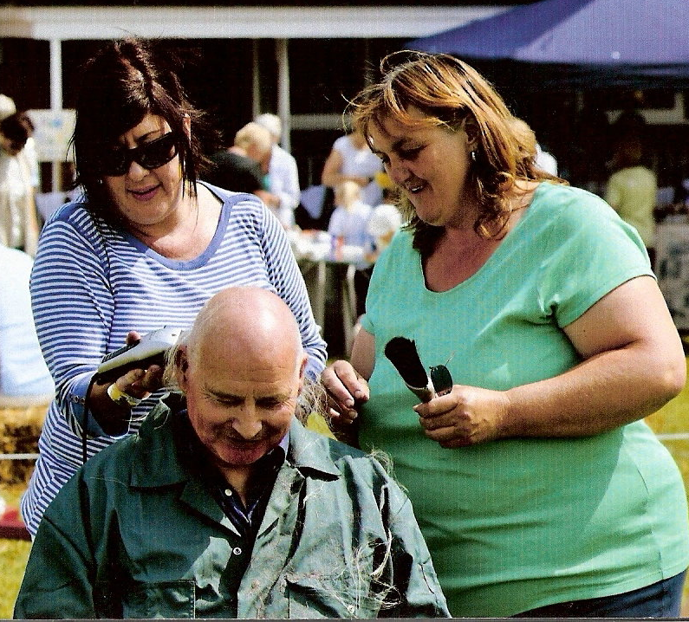
Brian Smith’s sponsored shave raised £193.76 at the Family Fun Day. Brian, seen here before Julie and Karen in the photo below did their stuff, had been growing his hair and beard for over six months in aid of St Francis Hospice and the chemotherapy unit at Broomfield Hospital. In total Brian’s sponsored shave raised £1,700 for St Francis and Broomfield.

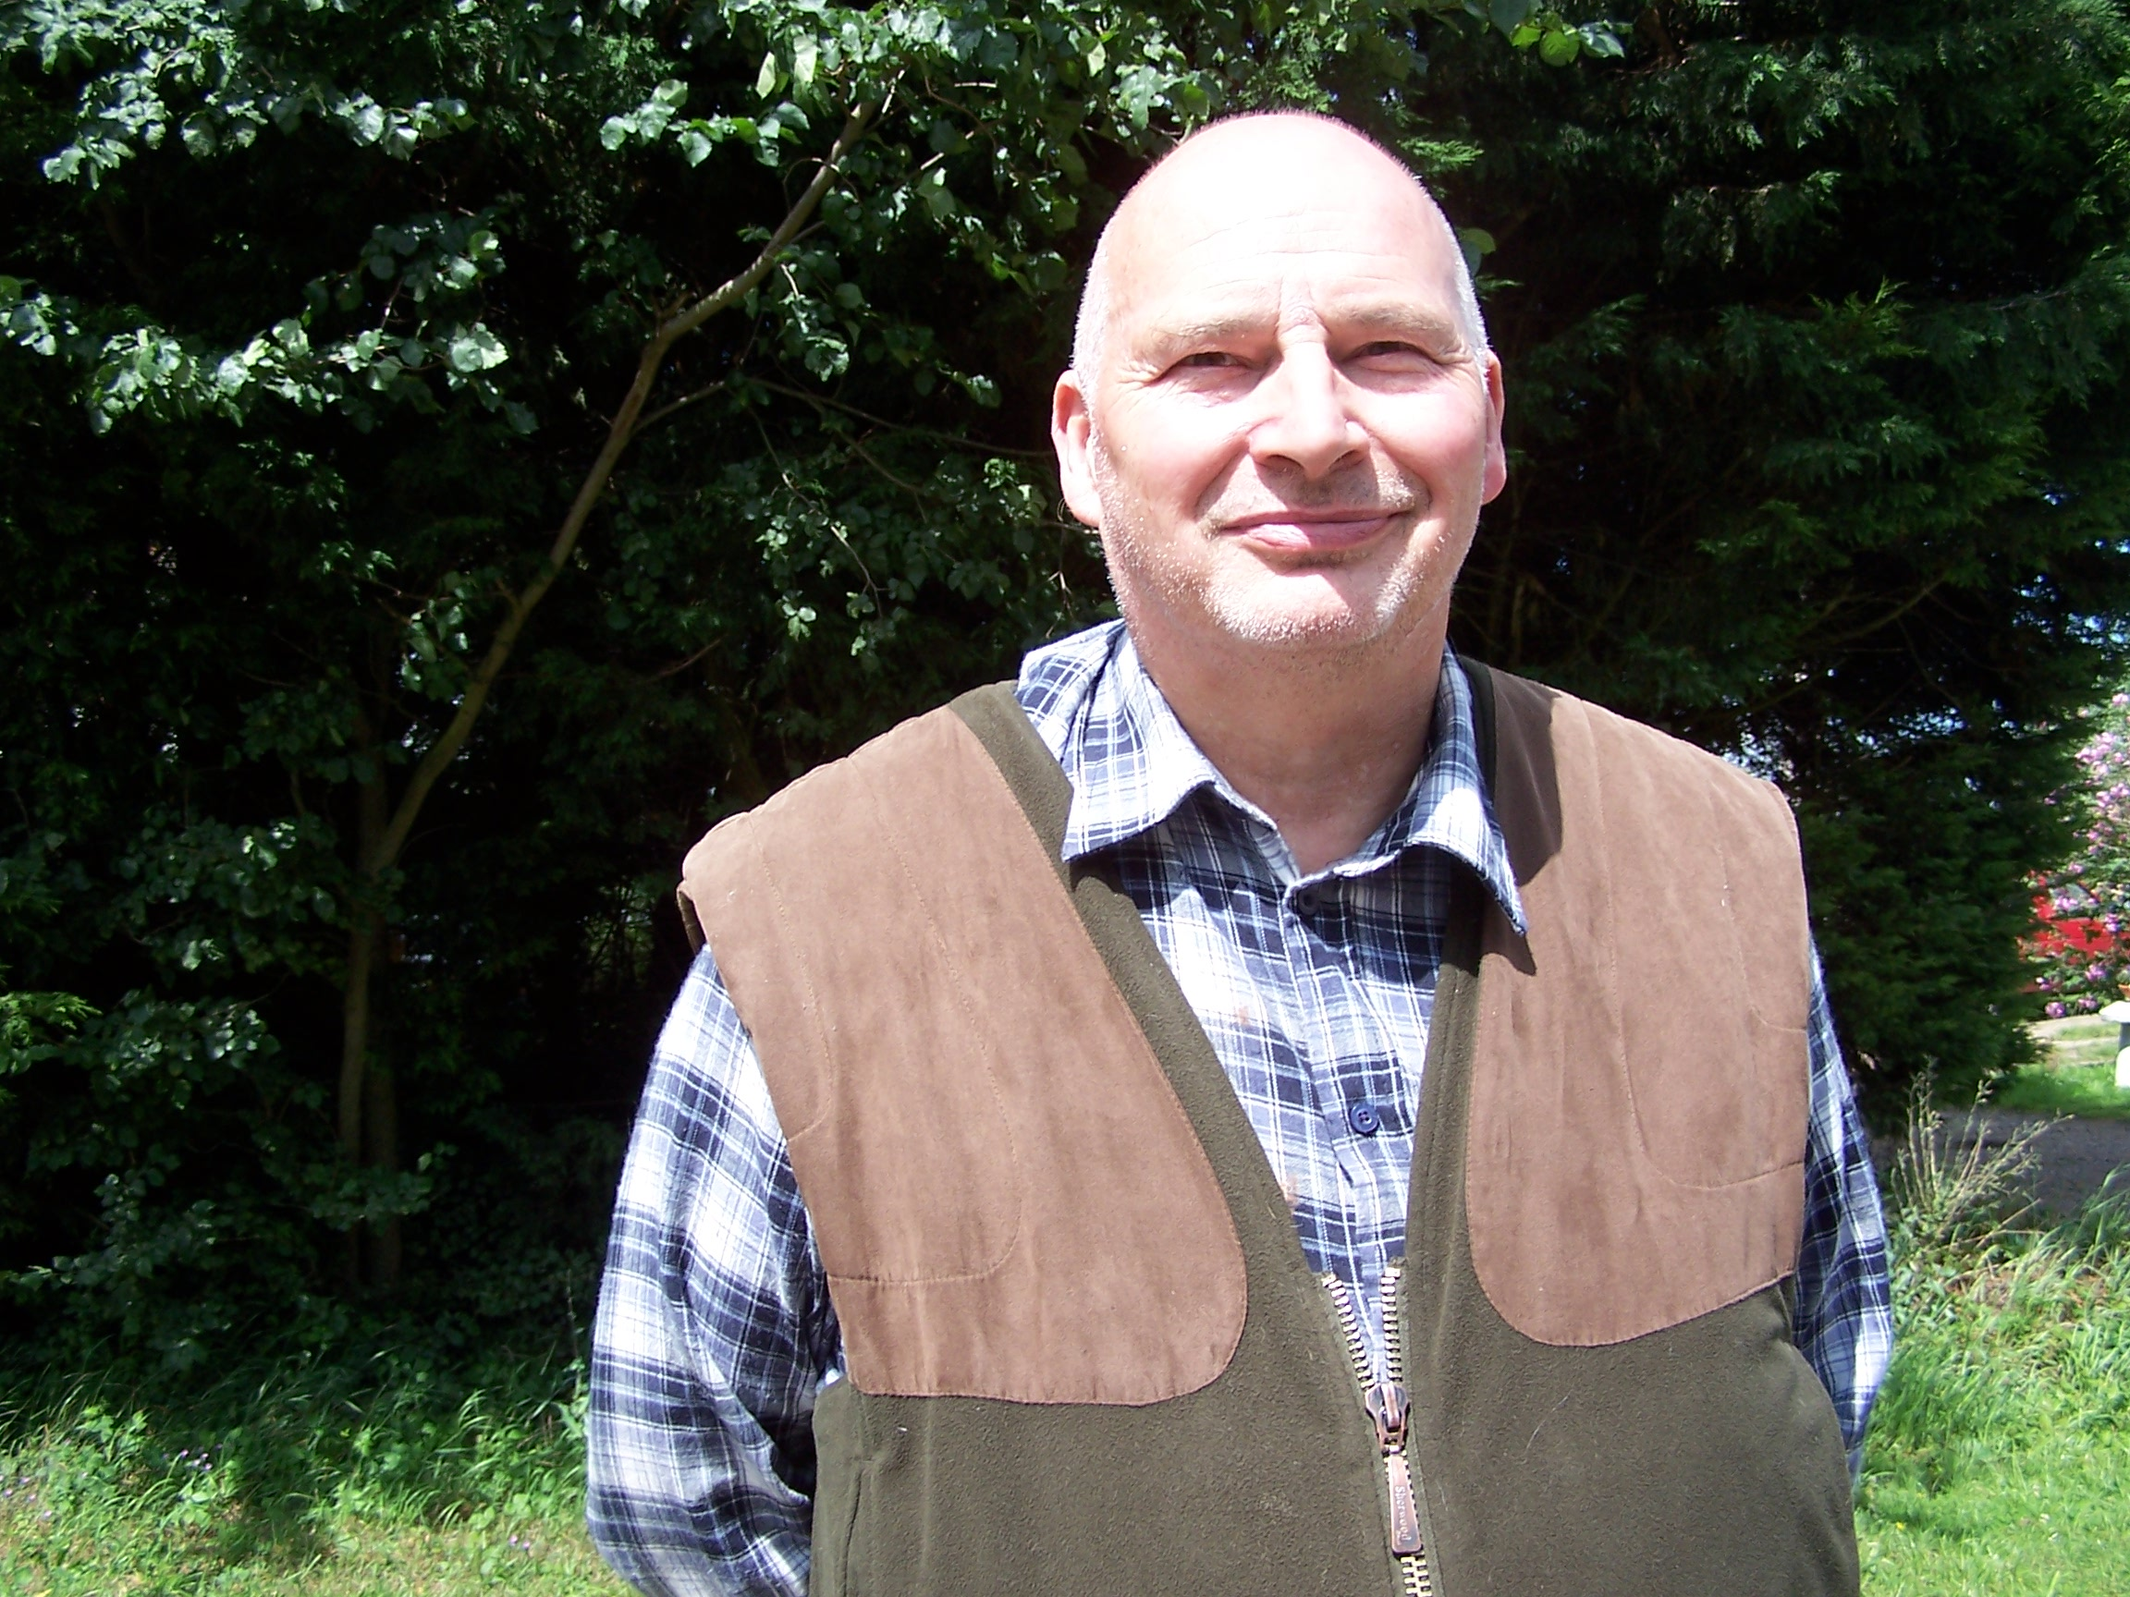
What a difference a shave makes!
PARISH COUNCIL - JUNE & JULY MEETINGS
DEMOCRATIC TIME
No issues were raised in June or July.

EMERGENCY PLANNING
Mr Gerry Richardson, Chelmsford’s Emergency Planning Officer attended the June meeting to give a presentation on emergency planning. Acts of terrorism, flood and fire, aircraft and motor accidents and pandemic flu were included in his list of emergencies.

CRIME FIGURES - MAY TO JULY
16th May - Main Road, criminal damage to fence.
18th May - Ivy Barn Lane, arson to industrial unit.
20th May - Orton Close, suspicious vehicle, two males arrested later that evening.
23rd June - Orton Close, theft of vehicle.
5th July - Main Road, theft of purse from car.
9th July - Main Road, two houses broken into. Both houses unoccupied.
14th July - Maldon Road, burglary.

VILLAGE WEBSITE:
Agreed to look at format for parish council websites offered by Essex County Council (essexinfo.net).
See next page.

MALDON ROAD RECREATION FIELD AND ALLOTMENTS
The stop valve to the water supply has been repaired. The youth shelter seating is showing rust. Agreed to seek estimates to repaint the seating. The annual ROSPA inspection reported the site is well maintained.

VILLAGE SITES
Grass Verges: The verges recently reseeded (one opposite P&P and one fronting 55-61 Maldon Road) are not showing any signs of new growth. Agreed to reseed if necessary.
Red telephone box by the pond: BT is aware there are missing glass panes and that the phone does not work.
BRIDLE WAYS AND FOOTPATHS
Received reports that a landowner had erected fences and gates across Bridle Way 22 and exposed retaining wire and a missing bollard on footpath 43. Both reports were investigated. The land owner has been asked to adjust the gates so that riders are able to access the bridleway. Concerns expressed that the gates were to remain. Agreed to consult horse riders over this matter.
Received reports that dog walkers are not respecting the Countryside Code. See below.

VILLAGE PROJECTS
War Memorial: Bakers of Danbury will be undertaking this project.

Village Gateways: Nothing further to report.

Whites Bridge Walk Boards: ECC Highways has confirmed it will support our project. See next page.

Parish Council Office: Plans have been submitted to Chelmsford Council for approval. Information can be found on CBC’s website. The next stage is to draw up costings and look into funding opportunities.

ACCOUNTS
The following expenditure was agreed:
£540 MDL (grass cutting)
£68 Chelmsford Council (parish council uncontested election costs)
£475 Mrs Kochan (salary and expenses)
£599 National Signs (various signs)
£108 BT (rental and broadband)
£83 Playsafety (ROSPA inspection)
£55 RCCE
£70 A Gibbons (installation of litter bin)
£468 Lisnick (repairs to pond path)
£1,090 MDL (grass cutting)

PLANNING
The following applications were received for comment:
11/00886/FUL - 1, Ottley Place:
Retrospective application for single storey summerhouse in rear garden.
11/01050/FUL - Whites Bridge Farm:
Change of use of farm building to provide retail area for agricultural supplies and country store.
11/00768/FUL - Elm Cottage:
Single storey garage extension to side and conservatory to rear.
The following decisions to grant planning permission were received:
11/00548/FUL - Whites Place:
Retrospective application for the replacement of an existing brick frontage boundary wall with a new brick wall.
11/00428/FUL - Tollgate Farm:
Construction of Ménage.
11/00089/FUL & 11/00122/FUL - Nos 41 & 50 Orton Close: Installation of air source heat pump to provide heat supply to new system radiators emitters.
11/00586/CLEUD - Wells Farm: Residential garden - considered within the cartilage of the dwelling house.

ANY OTHER BUSINESS
The following matters were raised:
Pedestrian Refuge Island: The missing ‘keep left’ sign on the centre pole is to be reported to CBC.
The Big Tree Plant: Funding is available for all community and civic groups, or other non-profit organisations to encourage community driven tree planting projects. Noted there may be local land owners who may be interested in this initiative . Agreed to include information about the project in the parish newsletter. See next page

DOGS ON PUBLIC RIGHTS OF WAY
Many of our local public rights of way pass over farm land including pasture land used for grazing livestock. Although legislation does not require that dogs be on a lead whilst on a public right of way, owners must ensure that their dogs stay under close control and not allowed to stray off the path. Owners should not let their dogs roam where they cannot see them or roam so far away that they cannot hear their commands. But, as a general rule, keep your dog on a lead if you cannot rely on its obedience.
One of the main complaints received with regard to dog walkers using paths on farm land is that they allow their dogs to foul and do not pick up after them. Not only is this very unpleasant, but diseases can be transmitted to livestock, other dogs and humans.
Remember worm eggs in dog faeces can cause health problems. It is advisable for all owners to worm their dogs regularly as well as picking up and disposing of their dog’s faeces.
Don’t forget that under The Control of Dogs Order 1992, whilst in a public place, dogs must wear a collar with an identification tag bearing the owner’s name and address. This would apply also whilst walking on a public right of way.

200 CLUB
The July draw 200 club winners were:
£100 – Mrs E Chapman
£50 – Matthew Pearce
£30 – Mrs L Cameron
£20 – Mrs M Chapman
£15 – Mr M Brewers
£5 – Mrs E Ife

BEAT SURGERY
PCSO Kay Fleming will be at the village hall on Wednesday, 17th August between 14:30 - 15:30.

ESSEX POLICE NON EMERGENCY NUMBER
As of Friday 1st July the NEW Non emergency number for Essex Police will be 101. The previous number of 0300 333 4444 will still accept calls, but will be phased out over the next 18 Months. Call costs will be 15p. This charge will be for the length of the entire call.

BOOK CLUB
Our next meeting is on Friday, 16th September. We will be discussing Daphne Du Maurier’s Jamaica Inn. Books for our October meeting are ‘The Victorians’ by Jeremy Paxman and Wylkie Collins ‘The Woman in White’.

MARGARETTING FRIENDS
We meet every 3rd Monday in the month at 7.30pm in the Chelmer Room. Apart from our regular meetings we also offer opportunities to become involved in local projects and social activities.
Our July meeting was an informal meeting with members bringing and sharing an interesting selection of party food. Our evening ended with an urgent call from PCSO Fleming for The Friends to provide refreshments for the police officers who were attending an incident in Ivy Barn Lane. Messages received later confirmed that the coffee, tea, biscuits and savouries provided had been well and truly appreciated!
Contact Rosemary Carter 350553

MOTHERS UNION
Meetings are held in St Margaret’s Church on the third Thursday in the month at 2.30pm.
Contact Jill Needs 627078
80 AND NOT OUT!!
A great time was had by both young and old at my 80th birthday Party on July 17th. It was a fantastic afternoon, made all the more special because of the wonderful venue of the Margaretting Village Hall, the hard work by Helena and Heather with the catering and the warmth and friendship of everyone who came. It was village life at its finest.
Also, a special mention must go to our resident host Mr Billy Henry who made the afternoon go with a swing with his rendition of very old, old and not so old songs which delighted everyone who came.
Thank you all for your gifts and your company. It was such a special and memorable day for me. You are all invited to my 90th!! Douglas Bashford

QUEENS DIAMOND JUBILEE - 2012
The parish council is planning a whole day village event to celebrate the Queen's Diamond Jubilee. The village hall and grounds have been booked for Saturday, 2nd June 2012. Ideas and suggestions and people to help plan the day are needed.

AUGUST COLLECTIONS

Black bins - Mondays except August 29th bank holiday which will be collected on

Tuesday 30th August

Brown bins – Mondays - 8th and 22nd

Green box, cardboard, paper and plastic sacks - Tuesday 9th
Green box, paper and plastic sacks - Tuesday 23rd

THE BIG TREE PLANT
The Coalition Government has made £4.2m available over the term of this parliament for community and non-government organisations to plant trees in areas where people live and work.
Trees associated with The Big Tree Project must be planted in streets or open places that are accessible to the whole community or where the local people will benefit from them
If you own land which is accessible to the public and would be interested in planting some trees on the this land please contact Cllr Tim Boem (Tree Warden) on 01277 355499.

FAMILY FUN DAY
The Margaretting family fun day and horticultural society committee would like to express their thanks to all who gave their time on July 2nd. We hope all who came had an enjoyable afternnoon. We would, also, like to thank all those who generously gave donations for the raffle and tombola. The weather was perfect for us this year and, due to the number of people who attended, we had a very successful day. We are already planning next year’s event.

WHITES BRIDGE
A recent meeting between representatives of the parish council and an Essex County Council Highways structural engineer has confirmed that Highways would have no objections to the parish council reinstating the walk boards. Although Highways is unable to provide financial support for this project it can give professional support and guidance. An ECC approved contractor is currently drawing up estimates of the costs and work required.

0VER 60s CLUB
Following a much enjoyed cream tea at Hylands and a trip to Clacton last month we look forward to an entertaining talk on ‘Music Hall’ from Arthur Brooks on 10th August, and a club afternoon with chat and a cuppa on the 24th. This will probably include a ‘see it, touch it, smell it test’ so do come with all your senses alert! We always welcome new members, so do come and join us. If you need a lift to the village hall just contact Roy on 356182.

VILLAGE WEBSITE
Essex County Council’s ‘essexinfo.net’ is provided for the benefit of the community of Essex. It enables parish and town councils and community groups to establish and publish their own websites.
Margaretting parish council is currently putting together a parish website which will have links to local community groups and organisations. If your group has a website or is interested in providing information for the Margaretting Parish website please contact:
Michael Scott on 354821 or michael_john_scott@hotmail.com
Penny Savill on 356182 or penny.savill@virgin.net

MARGARETTING SCHOOL NEWS
We recently had our annual Summer play in our school hall. This year the children performed the 'Wizard of Oz' which was a great success.
Margaretting School enjoyed a lovely morning on John Currie's land playing in the woods on Tuesday 19th July. They built dens, climbed trees, went mini beast hunting and played in glorious mud. They all had a wonderful time and then came back to school for a picnic in the playground. The weather stayed kind and was beautifully sunny for us.
On Wednesday 20th the school held a special assembly for Mrs Fiona Reid, our headteacher, who left at the end of the term. This was followed by a tea party in the school playground which was attended by parents and members of the community.
On Thursday 21st, our last day of term, we held another special assembly, this time for Year 6 who were leaving and heading for senior school in September.
We wish Mrs. Reid, Emily, Angel, Olivia, Mate, James, Louie, Stevie, Chloe, Alex and Callum the best of luck for the future and hope they will come back and visit us.
In September we will be welcoming the new reception class, planning for the Harvest Festival, looking forward to our annual Pantomime trip and dare I say it, thinking about our Christmas Bazaar. From Margaretting School we wish everyone a wonderful summer and see you in the Autumn Term.

MARGARETTING VILLAGE HALL
At the June committee meeting it was agreed to replace the faulty changing room boiler as soon as possible, this work was completed in early July allowing the cricket teams a much needed shower! The provision of baby changing facilities and provision of sanitary bins to the main toilets is being pursued and it was also agreed to place a notice board in the Chelmer Room to keep users informed of village activities.
Roy indicated that he will be standing down as chairman of the hall committee at the end of the year and it was also noted that the School, PCC and Horticultural Society remain unrepresented on the committee. This is a matter for considerable concern as the hall provides such a vital pivot for community clubs, classes and events, and is in desperate need for ‘new blood’. Do contact any member of the committee if you feel that you could contribute to the operation of this village facility.

ACTIVITIES IN AUGUST - WEEKLY UNLESS OTHERWISE INDICATED

Mondays Pilates 9.30-11.30am and 7.00-8.00pm
Latin American and Ballroom Dance 8.00-10.00pm
(Bite-size best bits of Ballroom and Latin American taught in a fun
and easy way by All England Professional Ballroom Championship
Grand Finalist, Paul Bottomer and with lots of personal attention.
Admission £8 (refreshments included)

Tuesdays Stitch and Chat 9th and 23rd 9.30-12.00 noon in the Chelmer Room
M/S Society 30th 7.30pm

Wednesdays Over 60s Club 10th and 23rd 2-4pm.
Evening Bingo 3rd, 17th and 31st 7.30-9.30pm

Thursdays Pilates 9.30-10.30am and 7.15-9.15pm

Fridays Stitch and Chat 9.30-12noon in the Chelmer Room

Saturdays Whole Body Yoga 6th August 10.00 - 1pm.
Pilates 20th August 9.30 - 11am

Sundays Sewing Workshop 7th August 9.30-1pm (All welcome)

For further details or queries for private functions please contact April Nixon on 07794 187741

MARGARETTING CRICKET CLUB FIXTURES FOR AUGUST

Saturday XI Sunday XI
6th August Tillingham III Away - 1.30pm 7th August Walton Hall Home - 2.00pm
13th August Mountnessing Away - 1.30pm 14th August Chrishall Away - 2.00pm
20th August South Weald II Home - 1.30pm 21st August Stock Away - 2.00pm
27th August Southend EMT II Away - 1.00pm 28th August Wickham Home - 2.00pm

MOBILE LIBRARY Fortnightly on Thursday afternoons
11th and 25th August at 3.20-3.35pm in Maldon Road
- in the lay-by opposite the playing field.
SHOPPER BUS Margaretting to Asda Supermarket, Chelmer Village
- Tuesday mornings
Margaretting to Tesco Supermarket, Wood Street
- Thursday mornings
leaving Orton Close at 11.00am,
Maldon Road at 11.02am, Main Road at 11.04am.
TRUST BUS Margaretting to Ingatestone
Friday mornings leaving Orton Close at 10.00am

COPY FOR THE SEPTEMBER EDITION BY 22 AUGUST PLEASE
‘Margaretting News’ is published by the PCC of St Margaret’s Church. Editors Roy and Penny Savill, ‘The Martins’, Main Road, CM4 9JB. Tel /Fax 01277 356182 or email: penroy.savill@virgin.net. Distribution to every household in the village is accomplished by a team of volunteers.

Printed by

Supporting the local community for all its property needs, including sales, lettings, surveys, financial services and commercial.
Offices throughout Essex, Greater and Central London - Pall Mall.
Ingatestone Office 01277 350505

