ANNUAL PARISH MEETING
Thursday 9th May, 2019

All parishioners are warmly invited to attend
the Annual Parish Meeting
of the Parish of Little Chesterford on
Thursday 9th May, 2019
at 8.15pm at Little Chesterford Village Hall,
hosted by Little Chesterford Parish Council.

AGENDA
- Chair`s welcome.
- Chair`s report.
- District and County Councillor updates.
- An update on Gigaclear.

Followed by an opportunity to meet your Councillors.

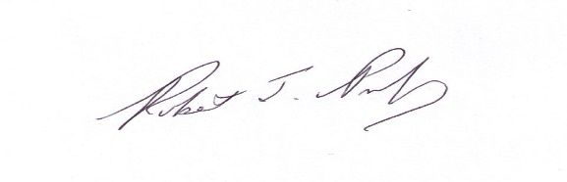
Robert Pumfrey
Chair –Little Chesterford Parish Council

