Minutes of a Parish Council Meeting held on Thursday 21st September 2023 at 7.30pm

Present: Cllr Robert Pumfrey, Cllr Wilkinson, Cllr Lez Davison, Cllr Ian Couchman Cllr Paul Osborne.

In Attendance: County Cllr Gadd, District Cllr Gregory, District Cllr Pavitt

23/052APOLOGIES FOR ABSENCE
Apologies for absence were received and noted from Cllr Helen Rayner.

23/053 DECLARATIONS OF INTEREST
Cllr Wilkinson, Cllr Ian Couchman additional matters bullet 6 - consider response to planning inspector for UTT/22/3321/OP Land Rear of Woodene.

23/054 MINUTES OF THE LAST MEETINGS
The minutes of the July and August 2023 Parish Council Meeting were approved by Councillors as an accurate representation. Chair signed the minutes.

23/055 COUNTY AND DISTRICT COUNCILLOR REPORTS
County Cllr Gadd – 20mph speed limit for village. Positive comments received from village following consultation lead by Cllr Davison.
There is a requirement for a 30mph speed limit prior to the start of the 20mph, this will be picked up in the planning and design being undertaken by highways. Cllr Pumfrey requested that the old road marking indicating “slow” on the road surface be replaced, Cllr Gadd asked if photographs could be supplied, Cllr Pumfrey agreed to provide these.
Cllr Wilkinson to check what the conditions are relating to the release of the monies for the work to be undertaken and completed.
District Cllrs Pavitt and Gregory – Local plan moving forward but work still required to get the plan in the proper format.
Nature Recovery Plan is now a statutory obligation – what can be done to recover nature and bio-diversity.
Grants for assisting in Climate Change projects will be open again in November.
Chesterford Research Park back to committee next Wednesday 27th September, seeking transport mitigation measures. Regular meetings required between CRP/District /Parish. For mitigation measures the total investment plans for CRP should be considered not on a project by project basis for Section 106 proposals.
Alternative cycle and walking route should connect CRP to major transport hub – Chesterford rail station and major town – Saffron Walden.

23/056 PLANNING
The following responses were agreed to be returned to Uttlesford District Council relating to planning:

None received.
23/057 | PLANNING DECSION  To note the following planning decisions:  - UTT/23/1761/HHF Proposed single storey annexe ancillary to the main house  Springwell Place Walden Road Little Chesterford Essex CB10 1UE  Delegated Decision Approve with Conditions - 4th September 2023
23/058 UPDATE ON PLANNING APPLICATIONS
- UTT/23/2014/DOC Manor Lodge High Street Little Chesterford Essex CB10 1TS
Application to discharge condition 3 (materials), 4 (landscape), 5 (additional drawings), 6 (Great Crested Newt Method Statement), 7 (Biodiversity enhancement strategy) and 8 (lighting design) attached to UTT/23/0865/HHF. Open for comment icon
Received: Mon 07 Aug 2023 | Validated: Mon 07 Aug 2023 | Status: Awaiting decision

- UTT/23/1933/NMA Meadowcroft High Street Little Chesterford Saffron Walden Essex CB10 1TS
Non-material amendment to UTT/22/2618/FUL - Amendment to the wording of the description of development to include "and other associated works". - Minor fenestration alterations to the North Elevation. - Minor fenestration alterations to the East Elevation. - Minor fenestration alterations to the South Elevation. - Minor fenestration alterations to the West Elevation. - Inclusion of the approved bike shelter and bin store on the As Proposed Floor Plans and Elevations.
Ref. No: | Received: Mon 24 Jul 2023 | Validated: Mon 24 Jul 2023 | Status: Awaiting decision.
- UTT/23/1621/DOC Building 800 Chesterford Park Little Chesterford Saffron Walden Essex CB10 1XL.
Application to discharge condition 7 (offsite flooding) attached to UTT/22/1248/FUL. Open for comment icon
Received: Mon 26 Jun 2023 | Validated: Mon 26 Jun 2023 | Status: Awaiting decision
- UTT/23/0456/OP Chesterford Research Park Little Chesterford Essex CB10 1XL
Hybrid planning application - Outline planning permission with all matters reserved except access for construction of a research and development building (Class E(g)), works to improve estate road, car parking, landscaping and associated works on Plots 1400, 1500 and 1600, Plots 1700 and 1800, Plot 500 and Plot 1. Full planning application for construction of a research and development building (Class E(g)), works to improve estate road car parking, landscaping and associated works on Plot 1100/1200 Open for comment.
Received: Wed 22 Feb 2023 | Validated: Thu 23 Feb 2023 | Status: Awaiting decision
- UTT/22/3192/SCO Chesterford Park Little Chesterford Essex
Request for screening opinion - for a hybrid planning application related to the remaining undeveloped plots within the adopted Masterplan area at Chesterford Research Park
Received: Wed 23 Nov 2022 | Validated: Wed 23 Nov 2022 | Status: Unknown
- UTT/21/1485/SCO Chesterford Park Little Chesterford Essex
Screening Opinion for the development of a Solar Farm and associated infrastructure to provide energy for Research Park.
Received: Fri 30 Apr 2021 | Validated: Fri 30 Apr 2021 | Status: Unknown
23/059 | Finance  - Approved of cheque payments to Parish Clerk  - Chair signed the AGAR Form 2 for submission.
23/060 | Additional Matters  - Signing of Cllr forms and LGA Model Code returns – these were duly signed by the Cllrs and returned to the Clerk.  - Feedback from the letter drop concerning proposed 20mph. – discussed under the County report.  - Land to the east of London road - planning committee decision and location of playground – discussed in the District Cllr report.  - Chesterford research park – discussed in the District Cllr report.  - Land opposite rectory barns – Foot path access required from Walden Road to the development site. This land owned by UDC. District Cllr request to see what the progress is within the planning department.  - Appeal - consider response to planning inspector for UTT/22/3321/OP Land Rear of Woodene. – this was discussed and the response from the Council agreed. Should this appeal be lodged prior to the next Council meeting this agreed position will be forwarded to the Planning Inspectorate.  - Update on Parish Boundary changes. – Cllr Wilkinson presented the boundary change proposal to the Council  The parish boundary has already been changed for the 76 houses on London Road such that the residential development is in Gt C. We now need to do the same for the 111 houses.  The UDC officer plans to put the following proposal into the first step of the process which stats 298 Spet. There will be a consultation period and a timetable for adoption.  Southern boundary 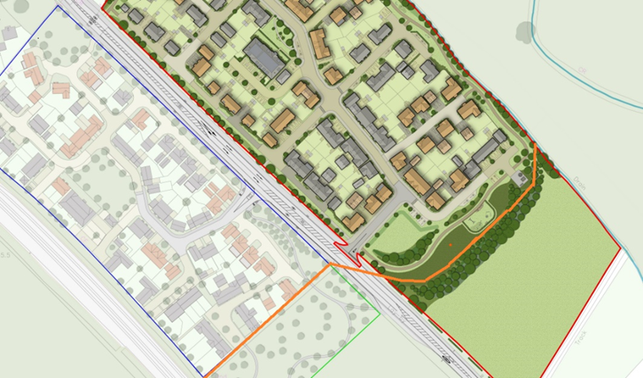  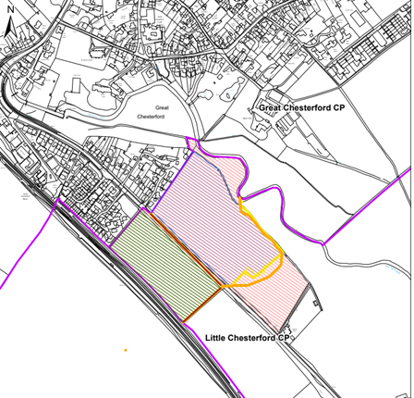  - Clerk to write to the Manor re heras fencing.

23/061 DATE OF NEXT MEETING
The next meeting of the Parish Council will be held at 7.30pm on Thursday November 9th

The meeting closed at 20:47

