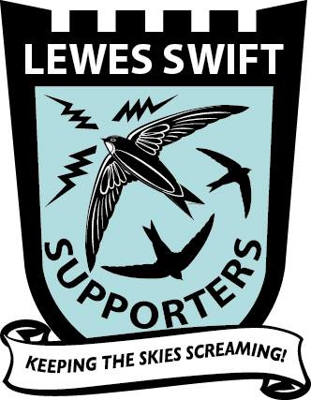
Celebrating Swift Awareness Week!
3rd to 11th July 2021
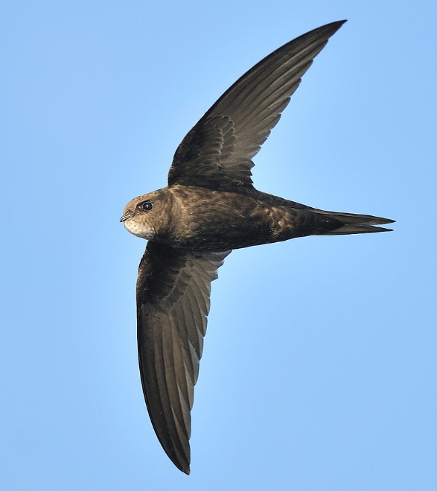
Photograph by David Moreton, courtesy of Swift Conservation

You can join our Lewes Swift Watch!
E-mail: lewesswifts@gmail.com
Twitter: @LewesSwifts
Facebook Group: Lewes Swift Supporters
Website: https://e-voice.org.uk/lewesswiftsupporters/swift-watch/
